V-Smart, V-Smart+ and V-Auto Power Supply Exchange
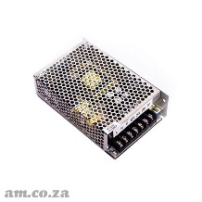 | V3-POWER.2013 | Power Supply Unit (5V/12V/36V) for V-Smart Series Vinyl Cutter 2013+ Model
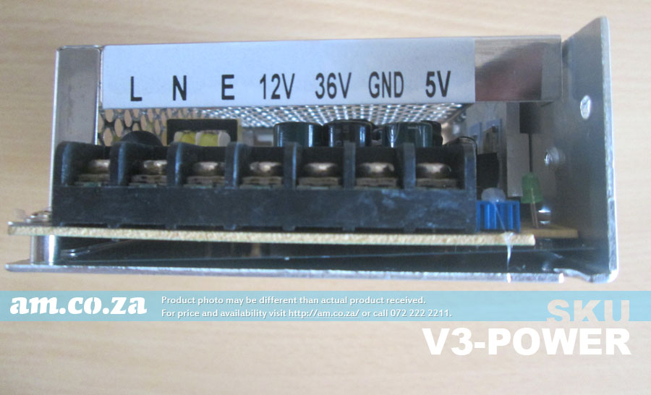
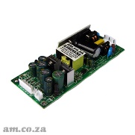 | V3-POWER.2018 | Power Supply Unit (5V/13V/36V) for V-Smart, V-Smart+, V-Auto Vinyl Cutter 2018+ Model
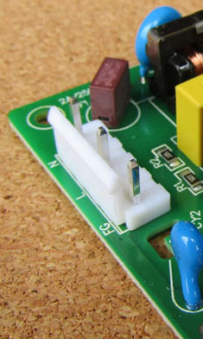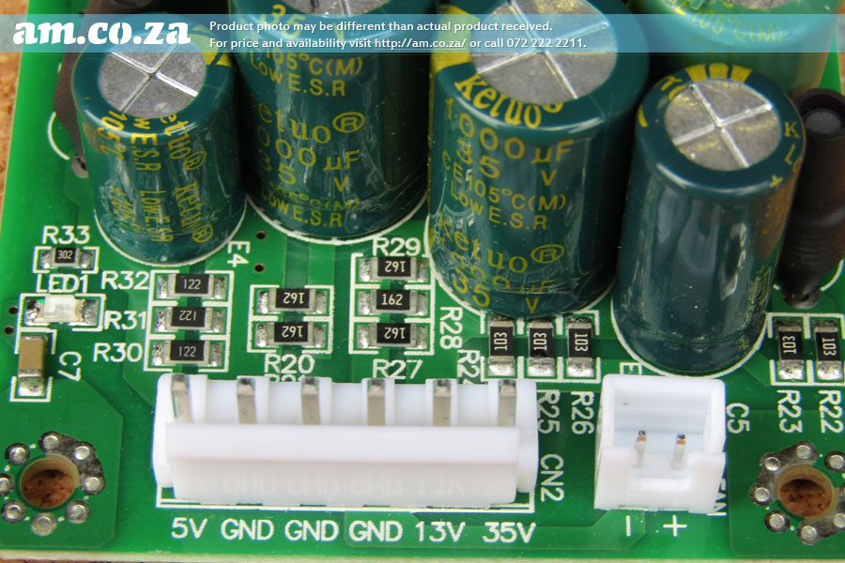
Rewire as:
AC L = Live (220V+) N = Neutral (220V-)
E = Earth = PE = Protective Earth = FG = Frame Ground
DC 5V = 5V 13V = 13V 35V = 36V GND = GND

