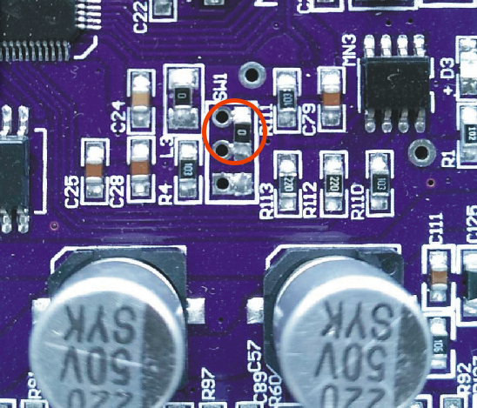
The inner links in the red circles as shown above are in burn mode

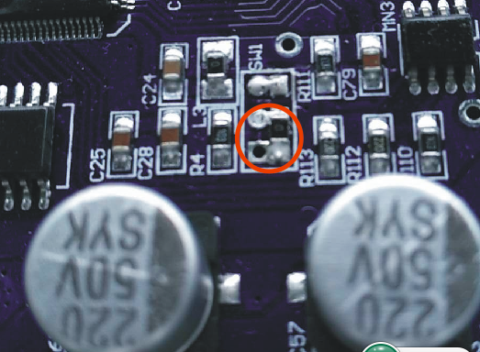
The inner connection in the red circle shown above is the running mode
Step 1 properly connect the computer and motherboard via USB and COM cables

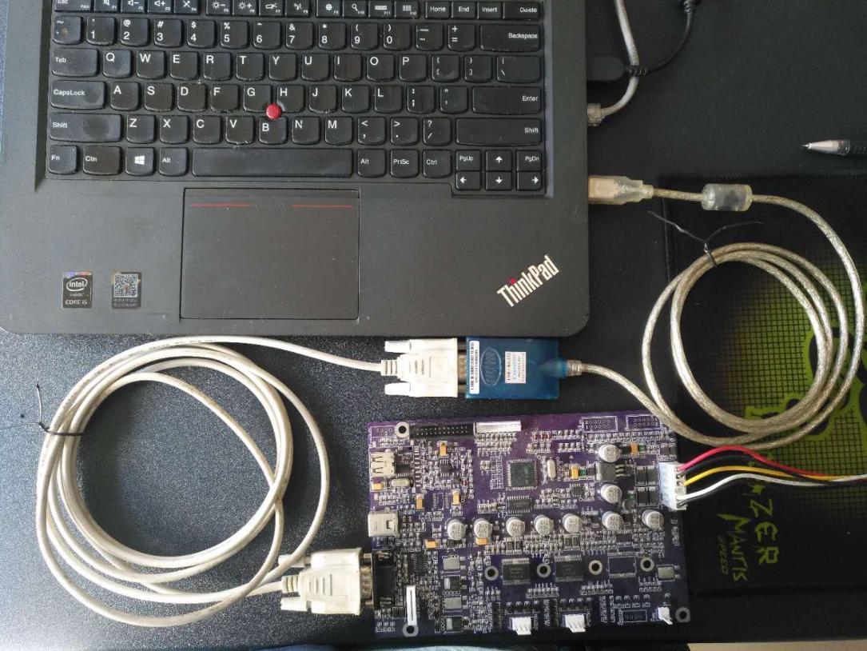

Step 2: Short-circuit the burning procedure mode shown in the diagram
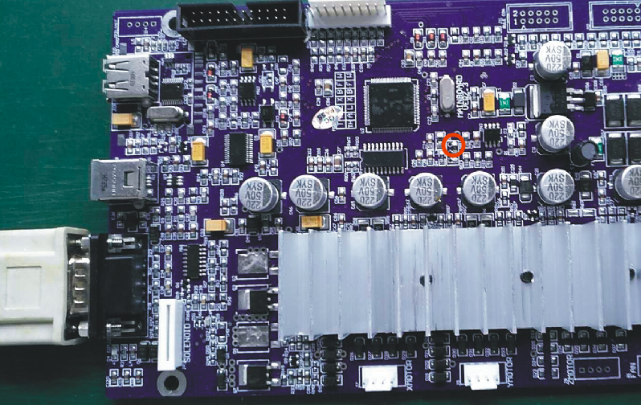

Step 3: Turn on the power

Step 4, open the download software “update_fw_2.1.exe”
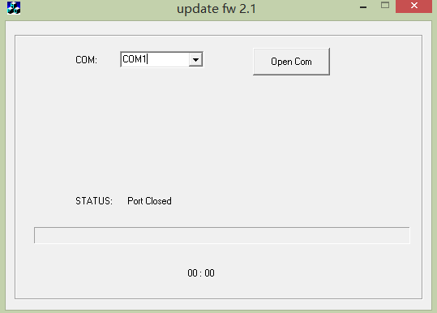

As shown in the figure, the COM port with good connection is selected.
Click the button "Open COM" to start downloading 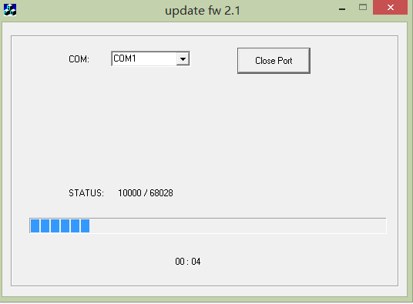

Waiting for the download to complete
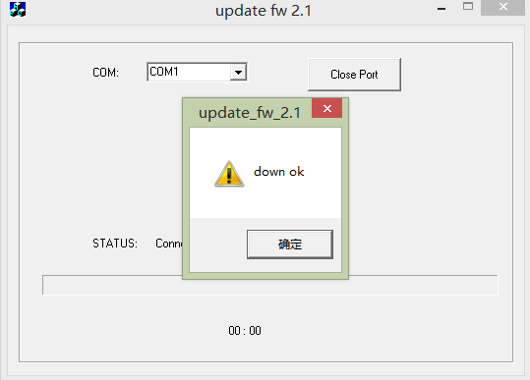
Note: after downloading, be sure to turn off the power of the machine before turning off the software

Step 5 Jump the resistance into the running mode as shown below, and the update program is completed.

