HOW TO DISTINGUISH BETWEEN MOTHERBOARDS USING DIFFERENT CHIP SEQUENCES
V-SMART Motherboard, SKU: V3-MB
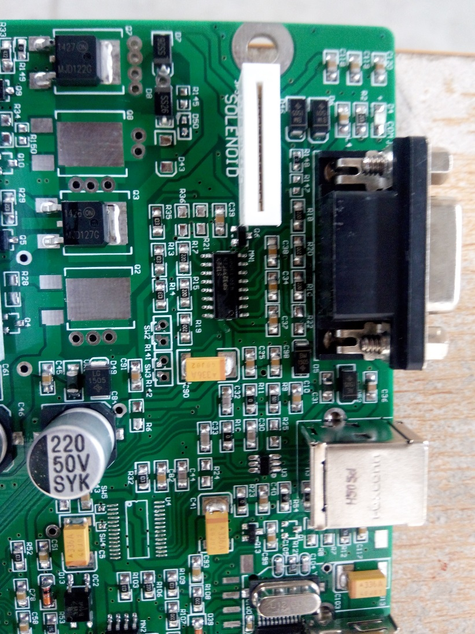
V-SMART PLUS Motherboard, SKU: V3-MB/P
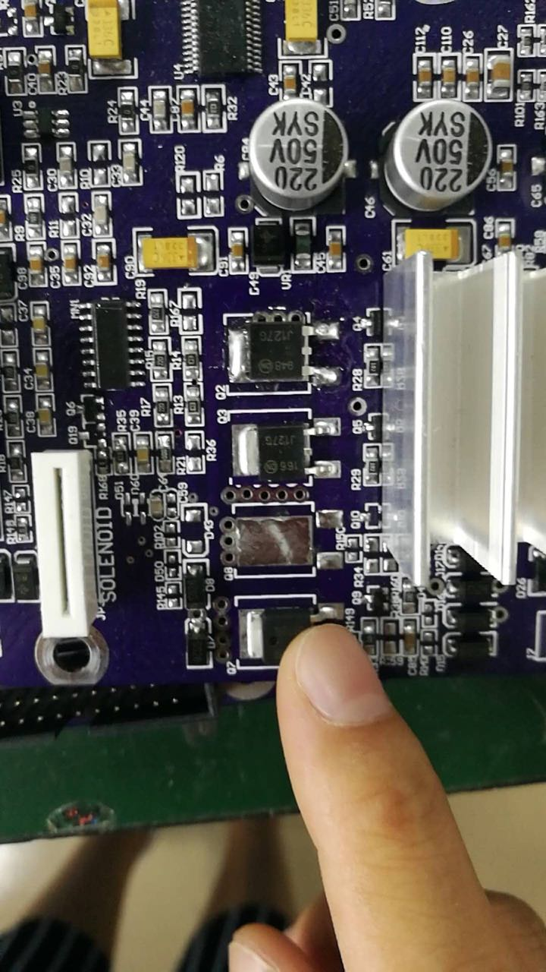
(please note, for new stock, no chip difference for V-Smart and V-Smart=)

V-AUTO Motherboard, SKU: V6-MB
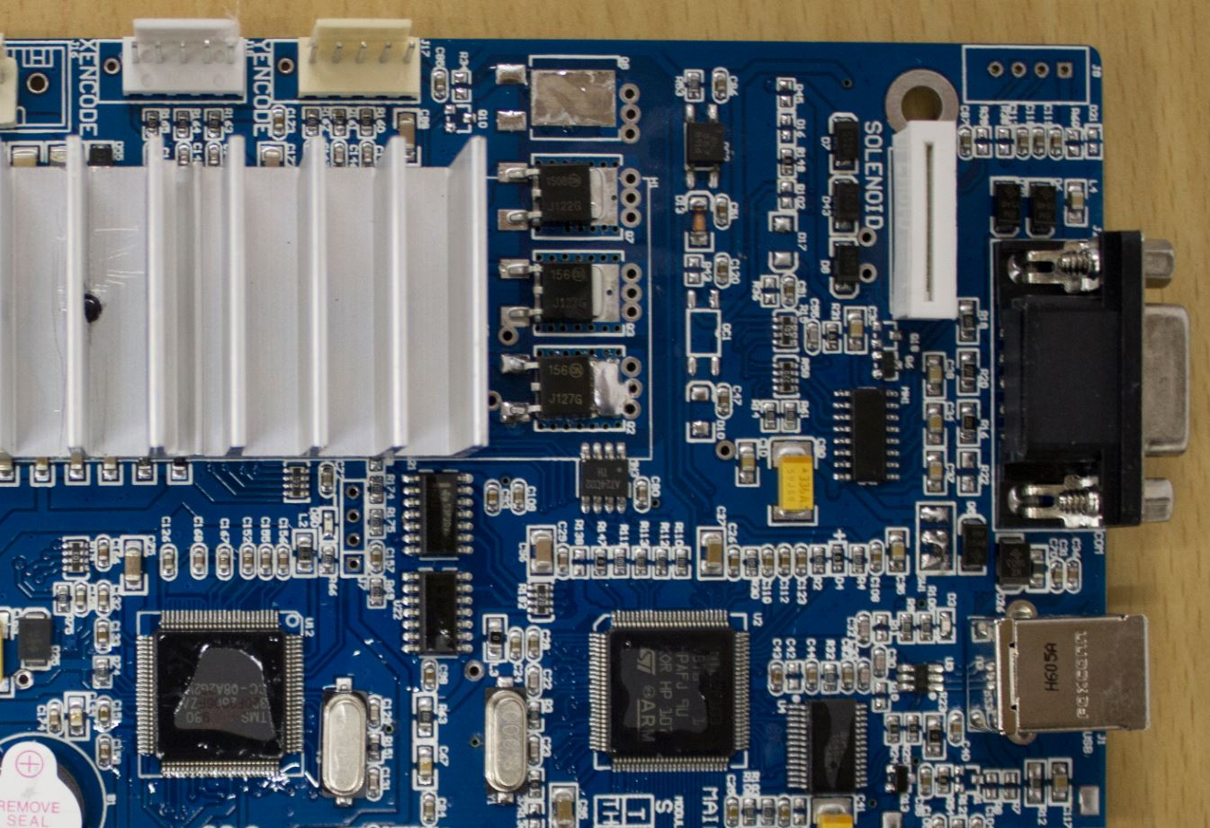

V-AUTO Label Cutter Motherboard
(TBA)

USB 2.0 / FTDI (USB TO SERIAL)
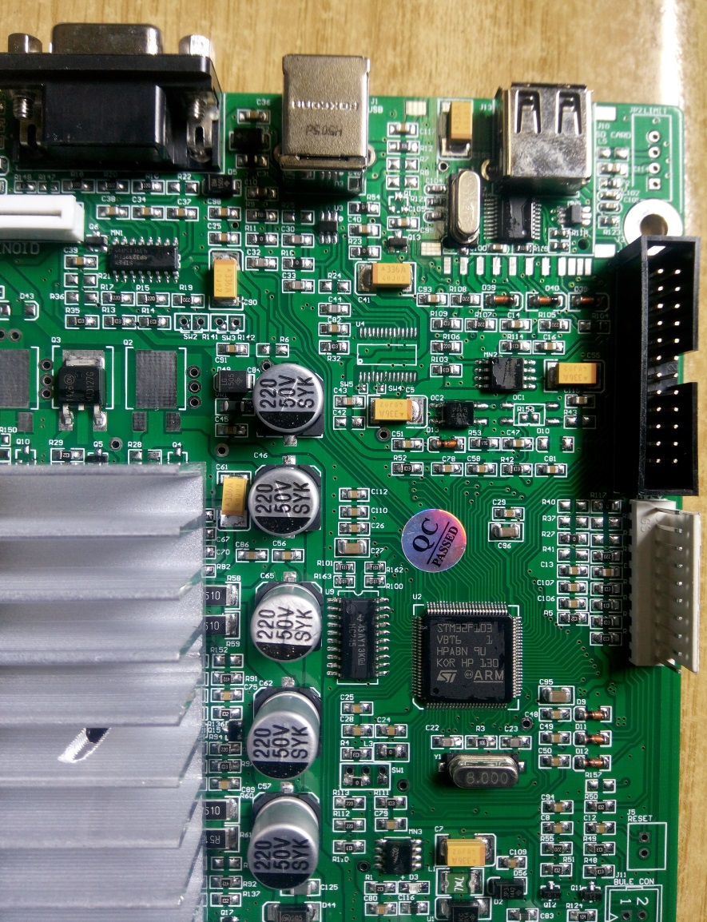
The presence of a chip here denotes the motherboard using USB to Serial Connection (FTDI), otherwise USB 2.0

