This is not for normal situation. Do not use this for Scale and Offset Adjustment.
----------------

Put the PLT files on your Flash Drive.
Print the Auto-Mark Calibration Sheet on A4 paper and use ICQ-2.plt to check the alignment using a pen plotter and adjust the Offset X and Y accordingly until it plots right on the highlighted line.
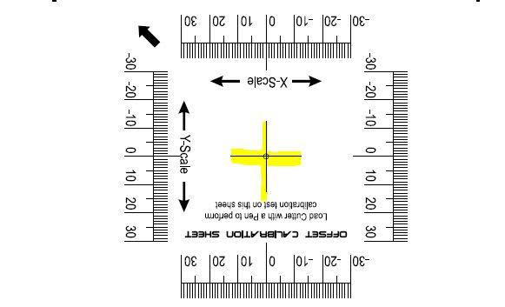

Then use the ICQ.plt and Auto-Mark Practice Sheet to test.

AM.CO.ZA Technical Support 076 666 6655
Technical Videos www.SortIT.co.za

