V AUTO VINYL CUTTER FIRMWARE UPGRADE TO VERSION 004.32F
1. On the V-Auto start up screen take note of your current Firmware version before proceeding. (V 004.XXF )
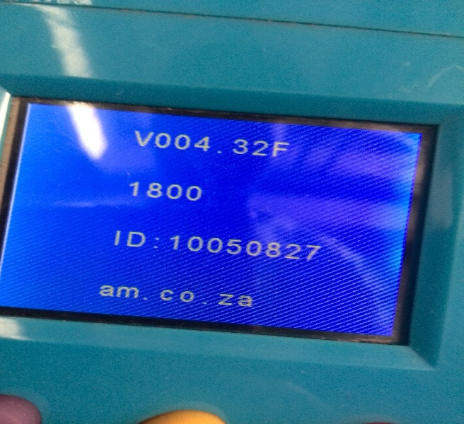

2. Move Resistor from original position and solder it across contacts A and B(Writing mode).
Resistor A B

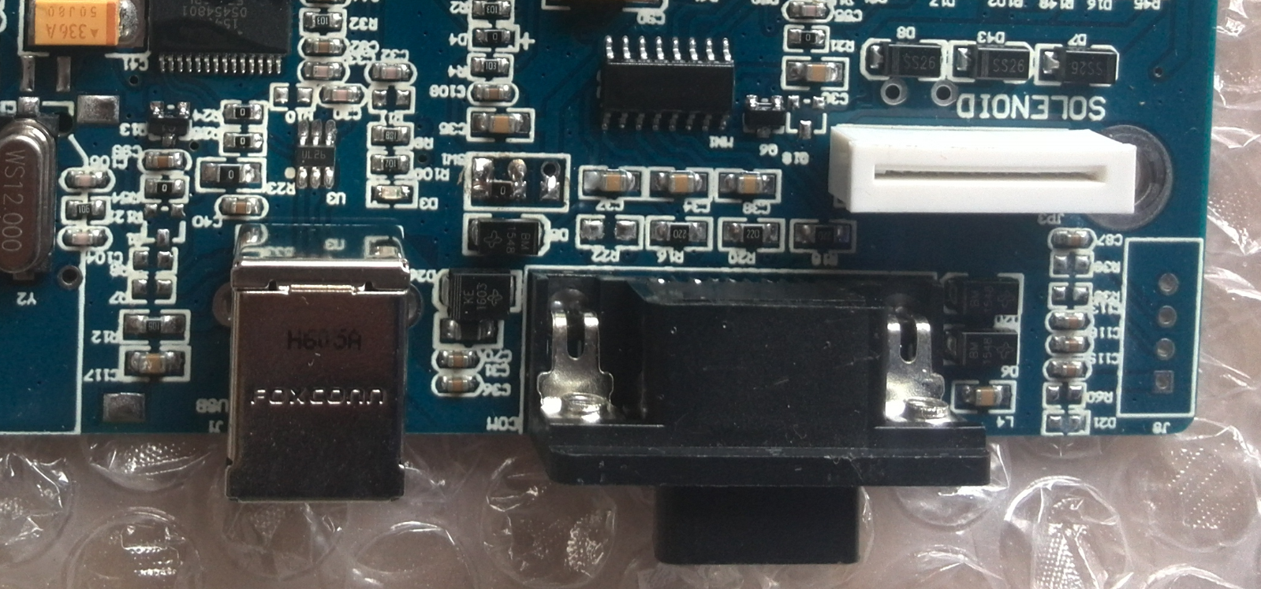
3. Connect the motherboard to your computer via USB or Serial Cable and power it up.
4. Take note of the COM Port on which the motherboard is connected on.
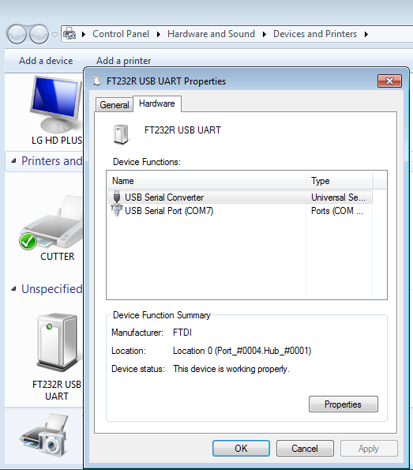

5. Download the “Firmware Upgrade Software” from the link given below.
https://drive.google.com/drive/folders/0B7txahny5oSFMGtwOVQtc0YwNTA?usp=sharing

6. Run update_fw_2.1 executable file.
7. Select the COM port as per your specific connection and click on “Open Com”.
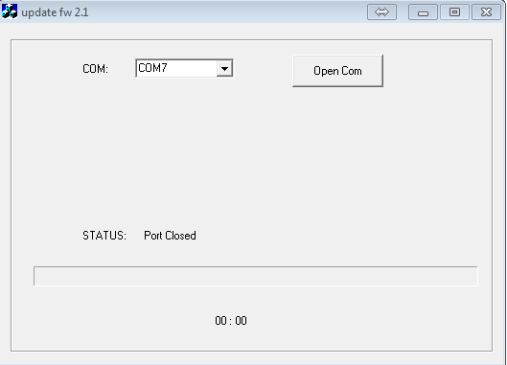
8. The Firmware update tool will automatically start downloading the necessary files on to the motherboard.
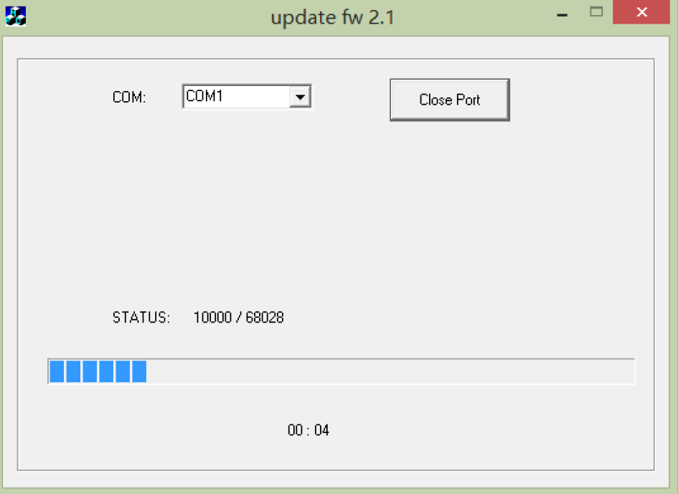

9. Once completed you should get a “down ok” notification.
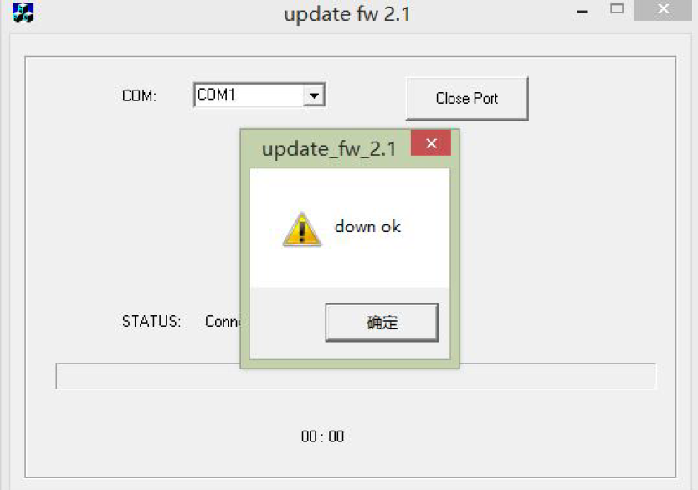
10. Disconnect the motherboard and solder the resistor back onto its original sitting position.
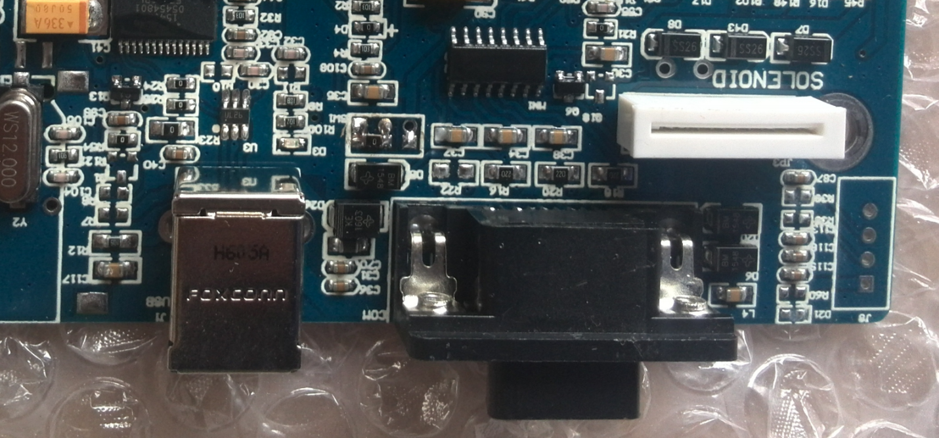

11. Connect and power up the Vinyl Cutter. You should get a change in the Version on the startup screen. (V 004.XXF )

