About Film Cutter Account Details

Please note,
Each machine is bound to a single account. Your account details are located at the bottom of the machine (e.g., on a sticker or label).
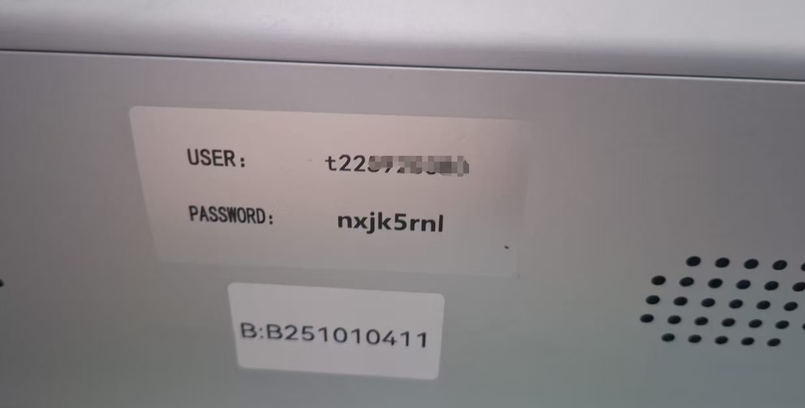
You will receive 1 year of unlimited access to the Mobile Device Shape Libraries, starting from the date of your first login to this account.

Before your access expires (or once it has expired), you can purchase another year here:
https://buythis.co.za/v6-film-access

For more usage details, please visit:
https://filmcutter.co.za/

Alternatively, search for am.co.za on YouTube to find our official channel, then search for "Film Cutter" to view instructional videos.

