Install Steps：
- Open the folder
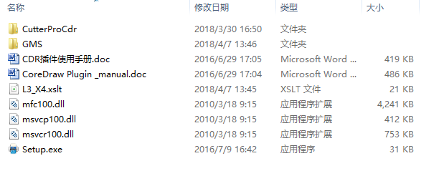
- Very important:A: Copy the CutterproCdr folder into your computer C disc.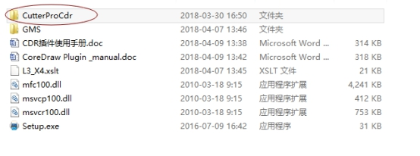 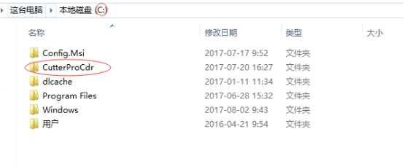 B: Copy the 5 files inGMS folder in plugin to your Coreldraw software GMS folder.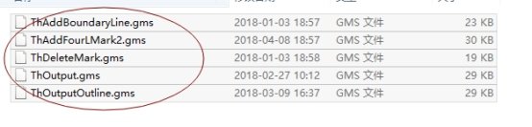 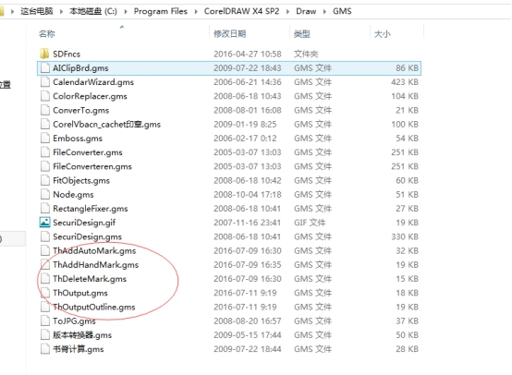
- Open the CorelDRAW，click“tools—>>customization…”
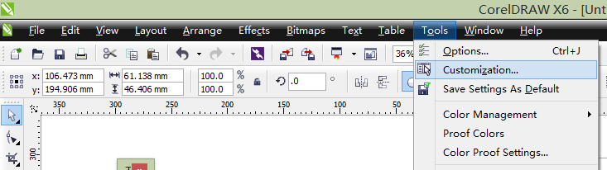
Show dialog
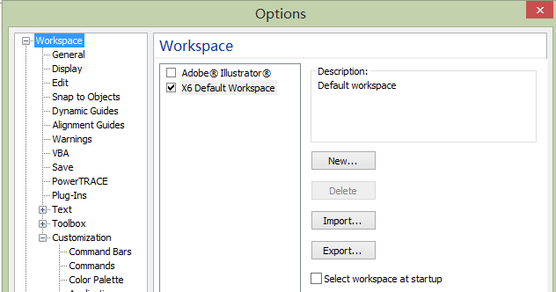
Click select “workspace”，click button，show dialog
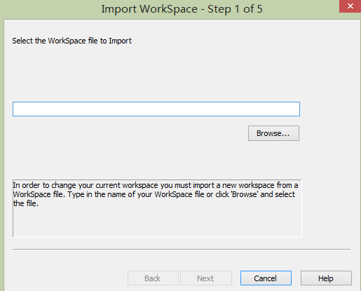，click button “Browse…”
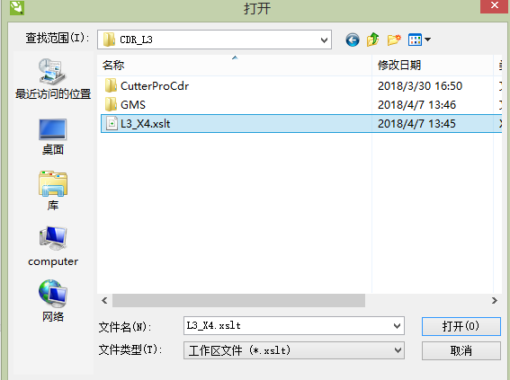
X3，X4，X5，X6 Select file“L3_X4.xslt”,
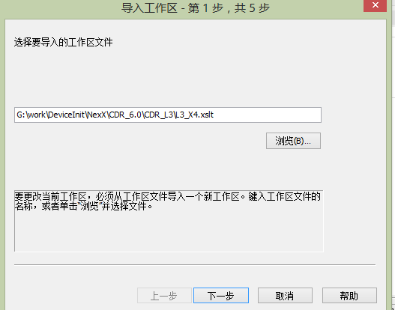
Click “next”
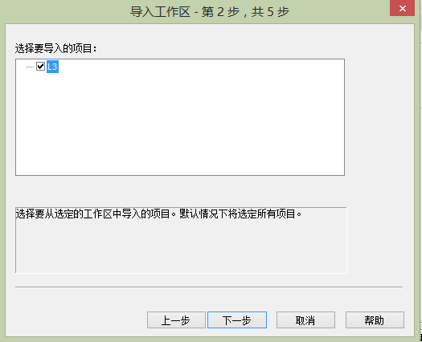
Click “next”
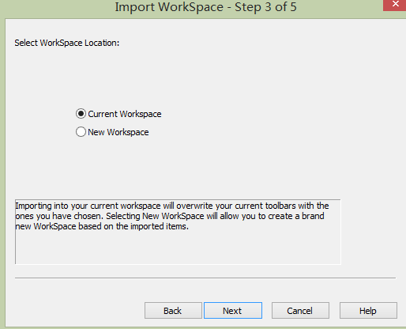
Click “next”
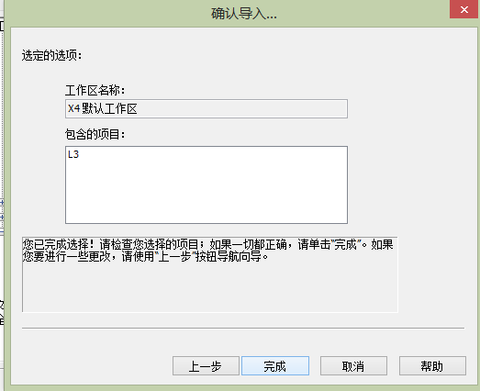
Click “finish”
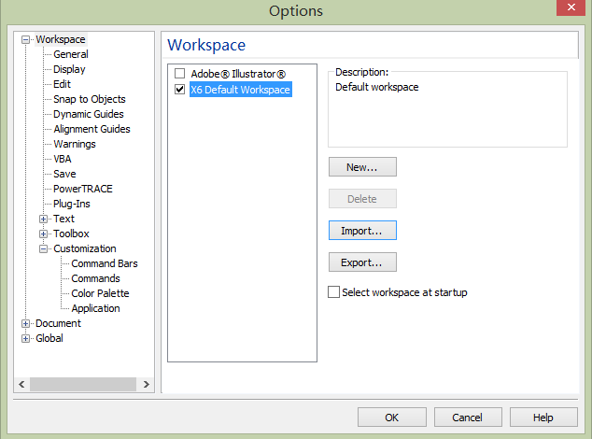
Click “ok”，
If Install Ok, you can see the new tool bar
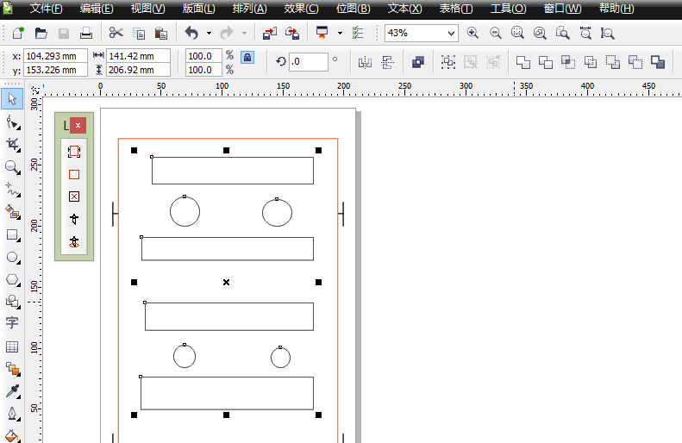

NOTICE：Install finished, if the new tool bar no display ,click mouse right button at tool bar blank , show dialog
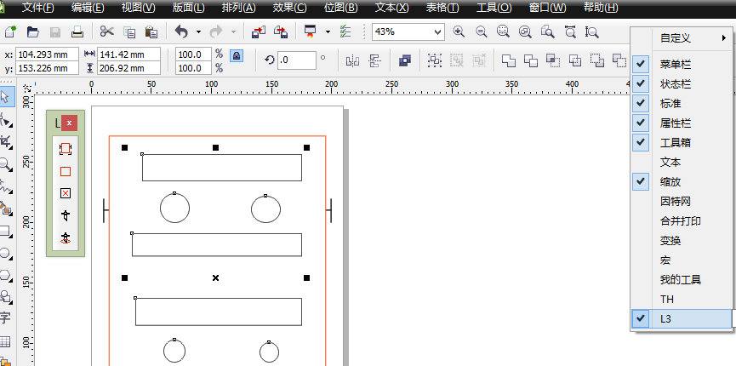，select “L3” tool。

