Back to Default Interface (Try Press “ESC”/”STOP” and Back Default Interface as this)
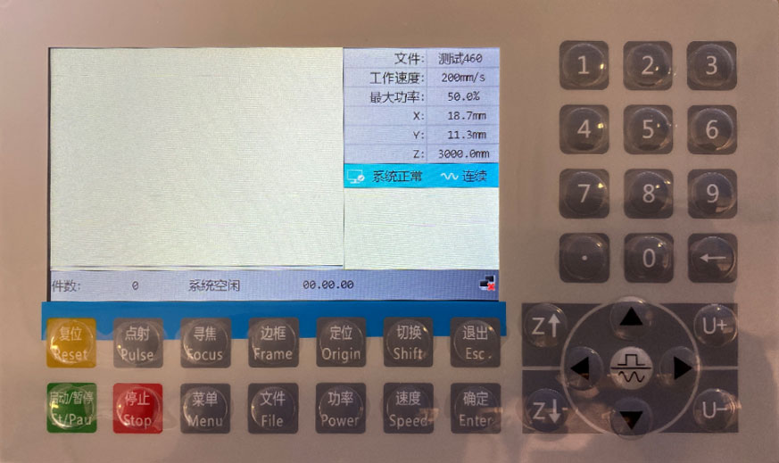

Press “Menu” button:
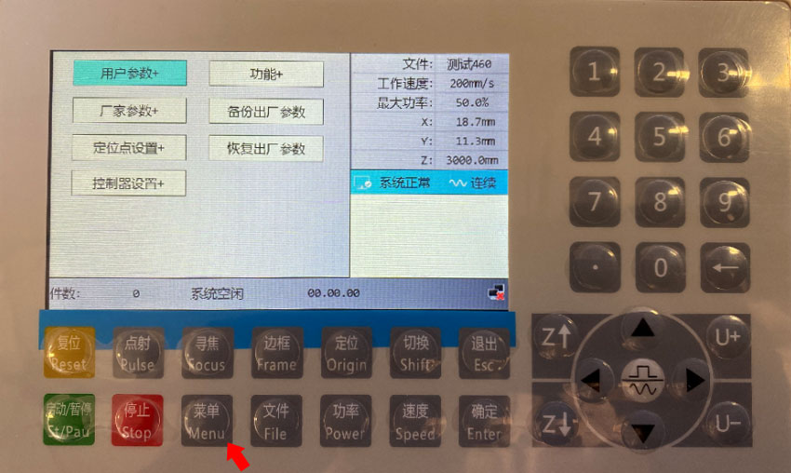

Press “Down” button to select the Controller Setup (+ means has sub-menu)
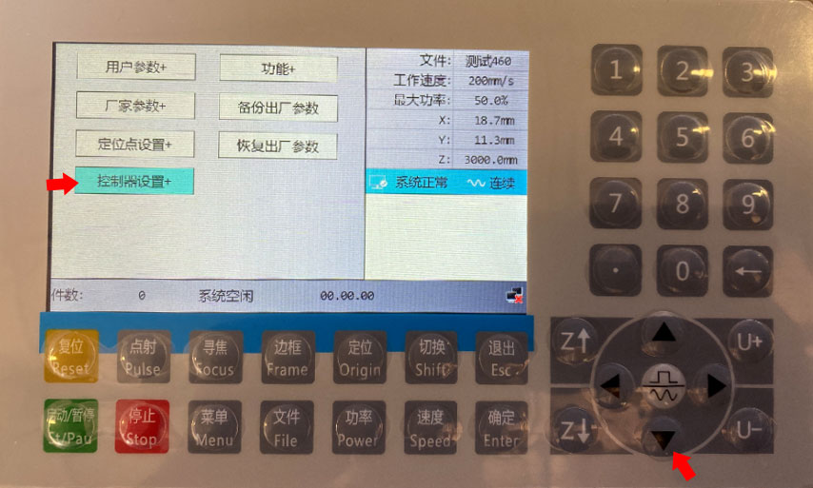

First one is Language setting:
