How to Update TruCUT 2016+ Model Laser Cutter Firmware Version
1. Copy the update file of .8FH extension to the root of a USB Mass Storage Device. Remove any other files from the device.
2. Check the current firmware version.
Click on File then Version Check
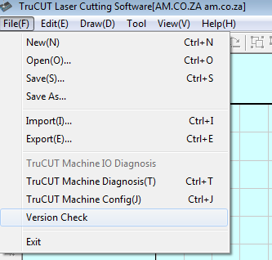

Click on Ver Check to check current firmware version
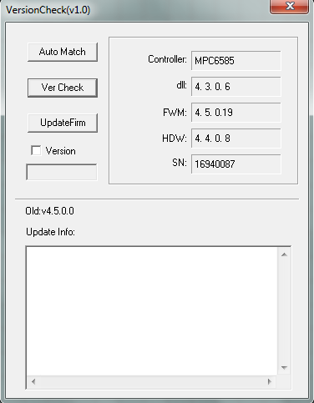
3. Power off the laser cutter.
4. Plug the USB Mass Storage Device onto the laser cutter USB port.
5. Power on the laser cutter.
6. Leave the USB Mass Storage Device plugged on the machine for about 1 minute.
7. Remove the USB Mass Storage Device from the laser cutter.
8. Reboot the Laser Cutter and repeat step 2 to confirm final firmware version.
