目 录
Catalog

- 机器简介------------------------------------------------------03
Machine brief-------------------------------------------------03
- 技术参数------------------------------------------------------03
Technique parameter------------------------------------------03
- 面板操作说明-----------------------------------------------04-05
Panel operation illustrate-----------------------------------04-05
- 简易故障排除法---------------------------------------------06-07
Simply fault check method----------------------------------06-07
- 机器电路图----------------------------------------------------07
The machine circuit diagram-----------------------------------07
- 机器各部分结构祥细说明-------------------------------------08-12
Each part specification of the machine-----------------------08-12
- 机器调较------------------------------------------------------13
Screen printer Accessories ------------------------------------13
八．机器保养------------------------------------------------------16
Machine Adjustment------------------------------------------ 16

一、机器简介 Machine brief
这是一款小型的台面式平面丝印机，外形小巧,操作极其方便，初学者也可以快速入门；它运行速度快，性能稳定，可在较小的厂房空间组成丝印生产线；特别适合小批量打样印刷，印刷的图案清晰逼真，美观适用，尤其适用手机按键，镜片印刷，以及其它小型产品的图案LOGO印刷，如：CD盒，礼品盒等。
This model is a small desktop flat screen print machine, with the features of Pawley shape, simply operation, and can be easy operate by new user; It’s speed quickly, and the property steady. which can compose the screen print line in small workshop or in small room; it suit for small quantity sample print, and the printed LOGO clearly, aesthetic. It suit for the mobile keyboard, the eyeglass and the other small produce’s LOGO printing, such as the CD box print, the gift box print and so on.
二、技术参数 Technique parameter:
机型号  Model | HY -3050T | HY-3050C | HY -3050P | HY3050X | HY -3050Q
机型特点  Features | T槽型T slot | 吸气型 air-breathing | 跑台型 moving-table | 旋转台Rotary table | 曲面型 curved
电源  power | 220V | 220V | 220V | 220V | 220V
印刷面积  Print size | 250X400MM | 250X400MM | 250X400MM | 250X400MM | 250X400MM
左右行程transverse stroke | 400MM | 400MM | 400MM | 400MM | 400MM
上下行程 vertical-stroke | 160MM | 160MM | 80MM | 80MM | 80MM
工作气压  air pressure | 5－7BAR | 5－7BAR | 5－7BAR | 5－7BAR | 5－7BAR
机器重量  weight | 60KG | 60KG | 80KG | 150KG | 65KG
印刷速度  speed | 800次/小时800Pcs/h | 800次/小时800Pcs/h | 500次/小时500Pcs/h | 1200次/小时1200Pcs/h | 800次/小时800Pcs/h
网版尺寸  frame size | 400X600MM | 400X600MM | 400X600MM | 400X600MM | 400X600MM
工作台面积Work-table | 300X500MM | 300X500MM | 300X500MM | 500MM | 圆面circular

三．面板操作说明Panel operation illustrate
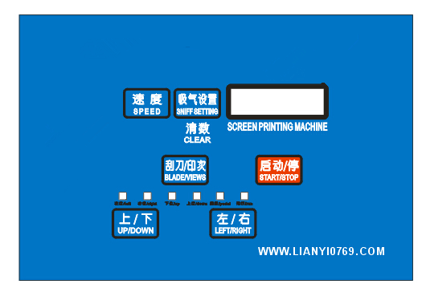

各按键说明： All key-press illustrate；
{ 启动/停 }键 Start/Stop key
( 1 ) 面板上按此键启动机器，机器进入自动运行状态，除非再按一次此键或者脚踏开关，可停止机器
Press the Start key the machine going automatic running; press this key again or press the Foot switch can stop the machine.
（2）用脚踏开关启动机器则进入半自动状态，完成一个循环后停止
Press the foot switch the machine will go in self-automatic running, finish a working circle stop.
{ 刮刀/印次 }键 Blade/Views key：
此键有两个功能：This key have two functions:
( 1 )印刮及回墨刮转换：在停机状态下按此键，印刮及回墨刮转换一次，方便检查胶刮及回墨刮的位置状态
Print-blade and ink blade convert: press this key when the machine stop, the print-blade and ink blade convert once, it facility to check the position and state of the print-blade and ink blade.
( 2 )印2次功能：用手按此键5秒不放手，机器进入印两次状态，就是在一个印刷循环里，机器连续印刷两次产品后，再将网版升起，在停机状态下，再按此键5秒，再回到印一次状态
Print twice function: press this key about 5 seconds, the machine will going twice printing state, which means in one print circle, the machine will print 2 times, rise the screen print plate, when the machine stop press this key 5 seconds again, the machine will going to once print state.
{左/右}键 Left/Right key:
此键有两个功能，均需在停机状态下完成
This key have two function, it will activated when the machine stop：
( 1 )按一下此键，如果印头是在右边，印头就会向左滑行到左位，如果印头是在左边，印头就会滑行到右位，属于是印头左右滑行的点动按键
Press this key once, if the print principal in the right, the print principal will slip to left side, if the print principal in the left, the print principals will slip to right side; it is the print principals left and right crawl control key.
( 2 )点击此键，印头停在左边，在半自动状态下，再按启动键时，一个印刷循环完成后，印头会停在左边，不回油，只有再启动的时候，印头才会回油印刷，如果印头停在右边，在半自动状态下，再按启动键，一个印刷循环完成后，印头会停在右边，等待下一个循环开始.
Press this key, the print principal stop in left hand, in self-automatic state, press the start key, after one print circle finished, the print principal will stop in left side, not oil return; when startup it again, the print principal will oil return and printing. If the print principal stop in the right side, in self-automatic state, press the start key, after one print circle, the print principal will stop in right side, wait the next print circle start.
{上/下}键 UP/Down key：
在停机状态下点击此键，丝印机或上或下滑动一次
Press this key in the machine stop situation, the machine will slide up or down once.
{速度}键 Speed key:
0-9级速度选择 0—9 speed select：
如果您要在全自动的模式下工作，您需要设置工作的速度，0－9级的速度选择，代表的是每个印刷循环完成后，到一个印刷循环开始的停留时间，0是最快，9是最慢，具体数值需要根据实际的印刷产品及工人的熟练程度设定
If you want to working in automatic state, you need to select the working speed, 0-9 speed can select, which stand for the stay time between every work circle finished, to the next work circle start. 0 is the fastest speed,9 is the slowest speed. The accurate speed need to detect as the different product and the worker’s skill.
｛吸气/设置｝键 (机器具有真空吸气功能时才有作用)
{Sniff setting key} （it will have this function if machine have vacuum inspiration action）
此键有两个状态，开机状态下，是自动吸气，跟随机器动作，自动吸气及关闭，按一下此键，变成长吸气，不管停机还是开机，机器会处于一直吸气状态，再按一下，就又进入自动吸气状态，如果不需要吸气，在控制箱侧有一个吸气关闭按扭，关闭就可以了，如果在停机状态下，长按此键，计数器自动清零
The key have two status, when the machine running, it will inspiration automatic, as the machine running, inspiration closed; press this key once, it will be inspiration both the machine run or stop; press this key again, the machine will going to automatic inspiration status, if not need inspiration ,at the side of the control panel have a inspiration close key, press this key closed; if press this key when the machine stop, press this key overtime, the counter will reset.
｛辅助器｝键 (HY2030P / HY -2030X 这两款机才有此功能)
这个按键只有在停机状态下才有作用,按此键,转盘旋转一个工位停止,跑台往前移动后停止.
- 简易故障排除法 Simply fault check method:
1. 面板无显示/the panel not display
a.检查保险丝是否烧坏，在线路板及电源插座处各有一个保险丝，请检查清楚,如有烧断，请更换相同型号保险丝
check the fuse burn-out or not, in the breadboard or the power socket have one fuse; check clearly, if burn-out change a new one with same model.
b.电源异常，根本没有外电进入机器控制电路，检查电源线的通电状态
The power unusual, have no electricity coming to machine control circuit, check the power wire have electricity.
c.如上面两项都排除，没有故障，则机器线路板损坏，请联系供货厂商售后服务
If the two item above have no problem. It maybe the breadboard of the machine damaged. You can contact the supplier give after buy service.
2、机器无动作The machine no action:
a.检察机器面板显示有无异常，如完全无显示，请参照第一项的处理方法
Check the panel display correct or not, if it not display at all, please reference as the NO.1 item above.
b.检察进气气压表有无压力，机器是否处于通气状态
Check the input air barometer have pressure or not, check the machine at the venting status.
c.感应开关是否损坏及是否感应到位：最简单的方法，面板上有六个小灯，每个小灯代表不同的位置状态，具体的显示 如下：
Inductive switch damaged or full induce or not: the simply method is, check the six light in the panel, every light deputy different location. The detail display as below:


将机器的进气气源关闭，将印头推到右边，看面板上右位感应灯是否亮起，依次类推，
如果三个位置到位，有灯没亮，则说明该位置的感应开关损坏或者没感应，请现场具体判断，如果感应开关都显示没故障，有可能电路板损坏，请联系厂家处理
If have three light display, but other light not display, it means the inductive switch damaged or no inductive.Fot this situation please estimate as the situation. If the inductive switch display no problem, it maybe the damage of the circuit board, you can contact the supplier.
d.检察电磁阀蕊和线圈是否有问题，处理方法：断开电源，不断气压按电磁阀上的小蓝色按钮，如不动作则阀蕊坏，更 换同型号的电磁阀测量线圈阻值是否在50欧姆左右，若有问题则更换同型号的线圈。
Check the solenoid valve and the coil have the problem or not. Solve method: turn off the power, keep the air pressure and press the blue key in solenoid; if it not action the solenoid valve damaged. Then changed the same model solenoid valve and measure coil resistance in 50 ohm more or less, if have problem please changed the coil.
3. 机器动作不正常 The machine movement unusual；
机器运行中，没完成印刷循环，在一半突然回位，时不时出现此类情况，并不是每次都这样，有两种情况：
In the movement of the machine, not finished the print circle, stop in the half circle, appearance this problem often, not appearance this problem every time, it have two situation:
a.线路板程序错乱，The program of the breadboard wrong.
b.外部电磁干扰，移动机器位置到车间的另一位置测试效果。
External electromagnetism affect, move the machine to another station and check the effect.
4. 机器运转震动大/The movement shake violently:
a.检察气压是否调得过高，处理方法，气压调到5-6公斤
Check the air pressure is higher or not. Solve method is adjust the pressure to 5-6 KG
b.左右油压缓冲器是否漏油Check the left and right oil buffer not leak.
C.气缸是否有漏气Check the cylinder air leakage or no
- 机器电路图 The machine circuit diagram

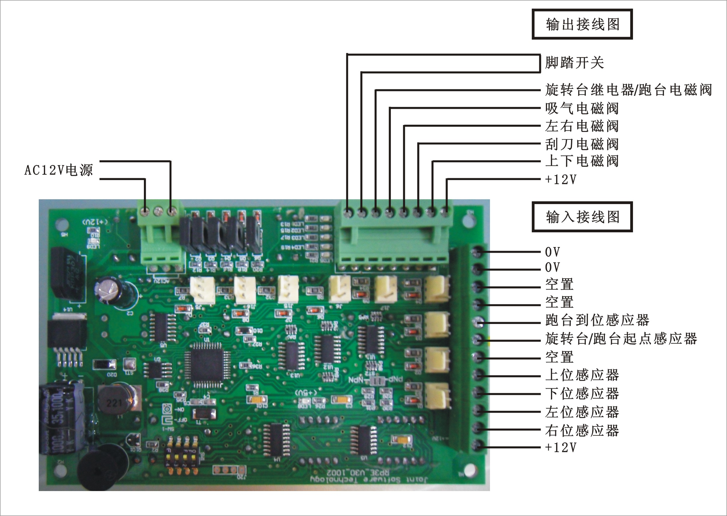

注意Notice:
1.维修接线时请注意输出电磁阀线圈及输入开关的电极特性，正负极不能接反，输出部分的共正极，输入均 为共负极
When maintain and connect the wire, please attention the output solenoid valve Coil electrode, positive and negative electrode correct; all of the output is positive electrode and all of the input is negative electrode.

六、机器各部分结构祥细说明Each part specification of the machine：
1

2
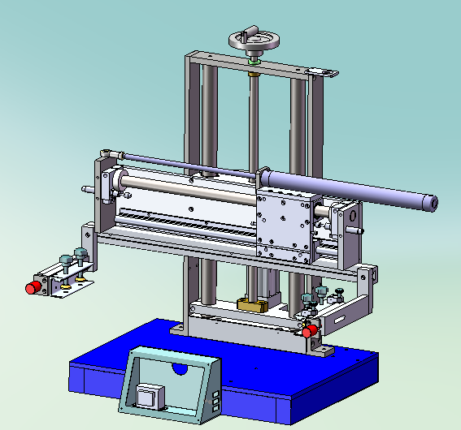

3
4

5

6

7

8

9
10
11

序号 | 组件名称Fittings name | 功能Function
1 | 升降扳手  lefts spanner | 调节整个机架与工作平台的高度距离,适应不同高度工件的要求Adjust the machine frame higher distance with the worktable, adapt different higher parts
2 | 升降丝杆 elevated-screws | 控制升降的速度及精度Control lifting speed and accuracy
3 | 左右限位块  Left-right limiting stopper | 限制左右滑行的距离，实现不同的印刷行程  Limiting the left and right slit distance, implement different printing stroke
4 | 左右感应器  Left right sensor | 检测印头的左右位置  Check the position of the print head
5 | 网版调节块PlateAdjustBlock | 调节网版的大小长度  Adjust the larger and length of the screen plate
6 | 网版调节组件PlateAdjustParts | 控制网版前后移动  Control the screen plate moving forward and backward
7 | 前后调节旋扭FrontBackAdjustKey | 微调网版前后移动不同的距离  Fine-tuning the Stencil moving distance front and back
8 | 升降底板  Lift Table | 固定气缸及锁紧整个升降的机架  Fix the cylinder and locking the lift frame
9 | 升降气缸  Lift cylinder | Φ50X125气缸，控制升降的速度及高度Φ50X125  cylinder, control the lift speed and high
10 | 升降主轴  Lift spindle | 机架升降的精密导向  Control the precise of the frame lifting
11 | 左右滑行轴LiftRightMoveAxis | 印头左右滑行的精密导向  Control the precise of the print-head moving left-right
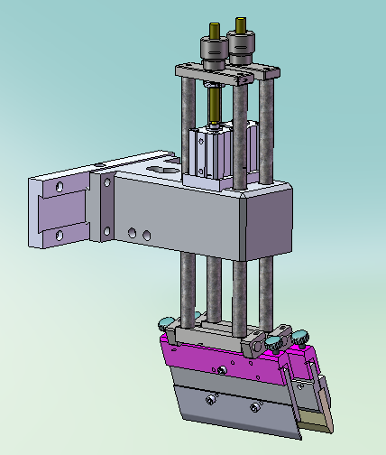
12
22

13
21

14

15
20

16

17

18

19

12 | 升降旋扭  Lifting knob | 调节胶刮的高低位置  Adjust the ink roller higher distance.
13 | 升降轴  Lifting Axis | 胶刮的上下导向及精度控制  Control the ink roller vertical guide and precision
14 | 印头气缸  Print-head Cylinder | SDA25X25 控制胶刮的升降动作  SDA25X25 control the print-head vertical moving
15 | 印头座  Print-head base | 整组印刷头的支座,铸铝材质  Global print-head cradle, aluminum material
16 | 水平调节旋扭Horizontal-knob | 调节胶刮的前后方向水平位置  Adjust the ink roller front and back horizontal position
17 | 胶刮夹Ink-roller Holder | 夹紧胶刮作用  Using clamp the ink roller
18 | 丝印胶刮  Screen roller | 丝印的主要耗材,放油墨刮到产品上  Main screen consumable, scrape the ink on the product
19 | 回墨片Ink reclaiming blade | 铝质,将网版上的油墨回到起点位置  Aluminum, let the ink in screen plate to starting point
20 | 左右调节燕尾槽Adjust-Left-right dovetail groove | 曲面机专用,平面机没有此组件,调节整个印头的左右位置  only for curved screen printer, flat screen printer no this parts. it use to adjust the printing-head lift-right
21 | 回墨气缸Ink reclaiming cylinder | 控制回墨片的升降动作  Control the movement of the ink reclaiming blade
22 | 升降线杆Lifting pole | 胶刮及回墨上下位置  Let the ink-roller and ink-reclaiming perfect
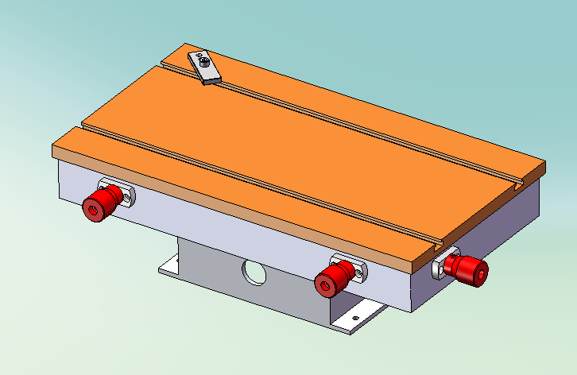
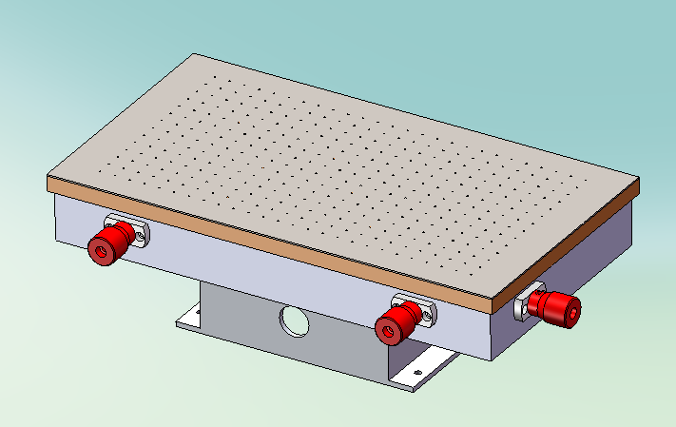

23
24
25
26
27

23 | 调节旋扭  Adjust knob | 调节工作台前后位置  Adjust the work table front and back position
24 | 调节旋扭  Adjust knob | 调节工作台前后位置  Adjust the work table front and back position
25 | 调节旋扭  Adjust knob | 调节工作台左右位置  Adjust the work table Lift-right position
26 | 工作面板  Working panel | T型槽台板,固定产品印刷  T-slot bedplate, fix the product printing
27 | 吸气面板Inspiration-panel | 吸气型面板,专印薄型PVC,纸张及各种片材使用  Inspiration panel, Mainly printing thin PVC, paper and kinds of sheets

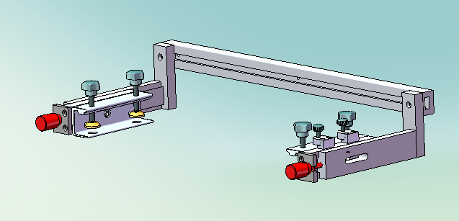

28
29
30
31
32
33
34

28 | 调节旋扭Adjust Knob | 调节网臂前后位置Adjust the front-back position of frame
29 | 网夹Frame holder | 夹紧丝网版Clamp the screen frame
30 | 压紧旋扭Press knob | 压紧丝网版Press the screen plate
31 | 网版左右调节块  Plate adjust device | 调节网版的左右调节位置  Adjust the left-right position of the screen frame
32 | 网臂横梁Frame beam | 固定网臂组件Fix the frame parts
33 | 水平旋扭Horizon knob | 调节网版的前后水平位置Adjust the screen plate front-back position
34 | 锁紧旋扭Locking knob | 锁紧网版的前后位置Locking the screen plate front-back position

七．机器调较/Machine Adjustment:
1．准备事项/Arrange matter
■事前按所需印刷图案的大小,制作一个完善的丝印网板。
Do a perfect screen plate as the print LOGO size before printing.
■购买好所用油墨。/Assure have already buy the ink for print.
■准备适量的洗网水和碎白布，以便开工印刷中清洁网板及被印件用。
Prepare the silk screen clean water and sift fabric which will use in clean the screen plate and the product in printing.
2．开机前的调节/Adjustment before print
◎推拉阀/ :Push-pull valve
■接入压缩空气到手拉阀入口(OFF)处,检查是否有漏气,如有请排除问题。
Access the air pressure to the hand-pull valve entry (off) position, check it air leakage or not, if leakage please solve the problem.
◎空气过滤组合/ air filter combination
■空气过滤组合包括手推阀、空气过滤器、调压阀、气压表，如下图（图6-1）所示。
Air filter combination contain: Push-pull valve, air filter, pressure -regulator valve, air pressure gauge, such as the picture below(picture 6-1)：
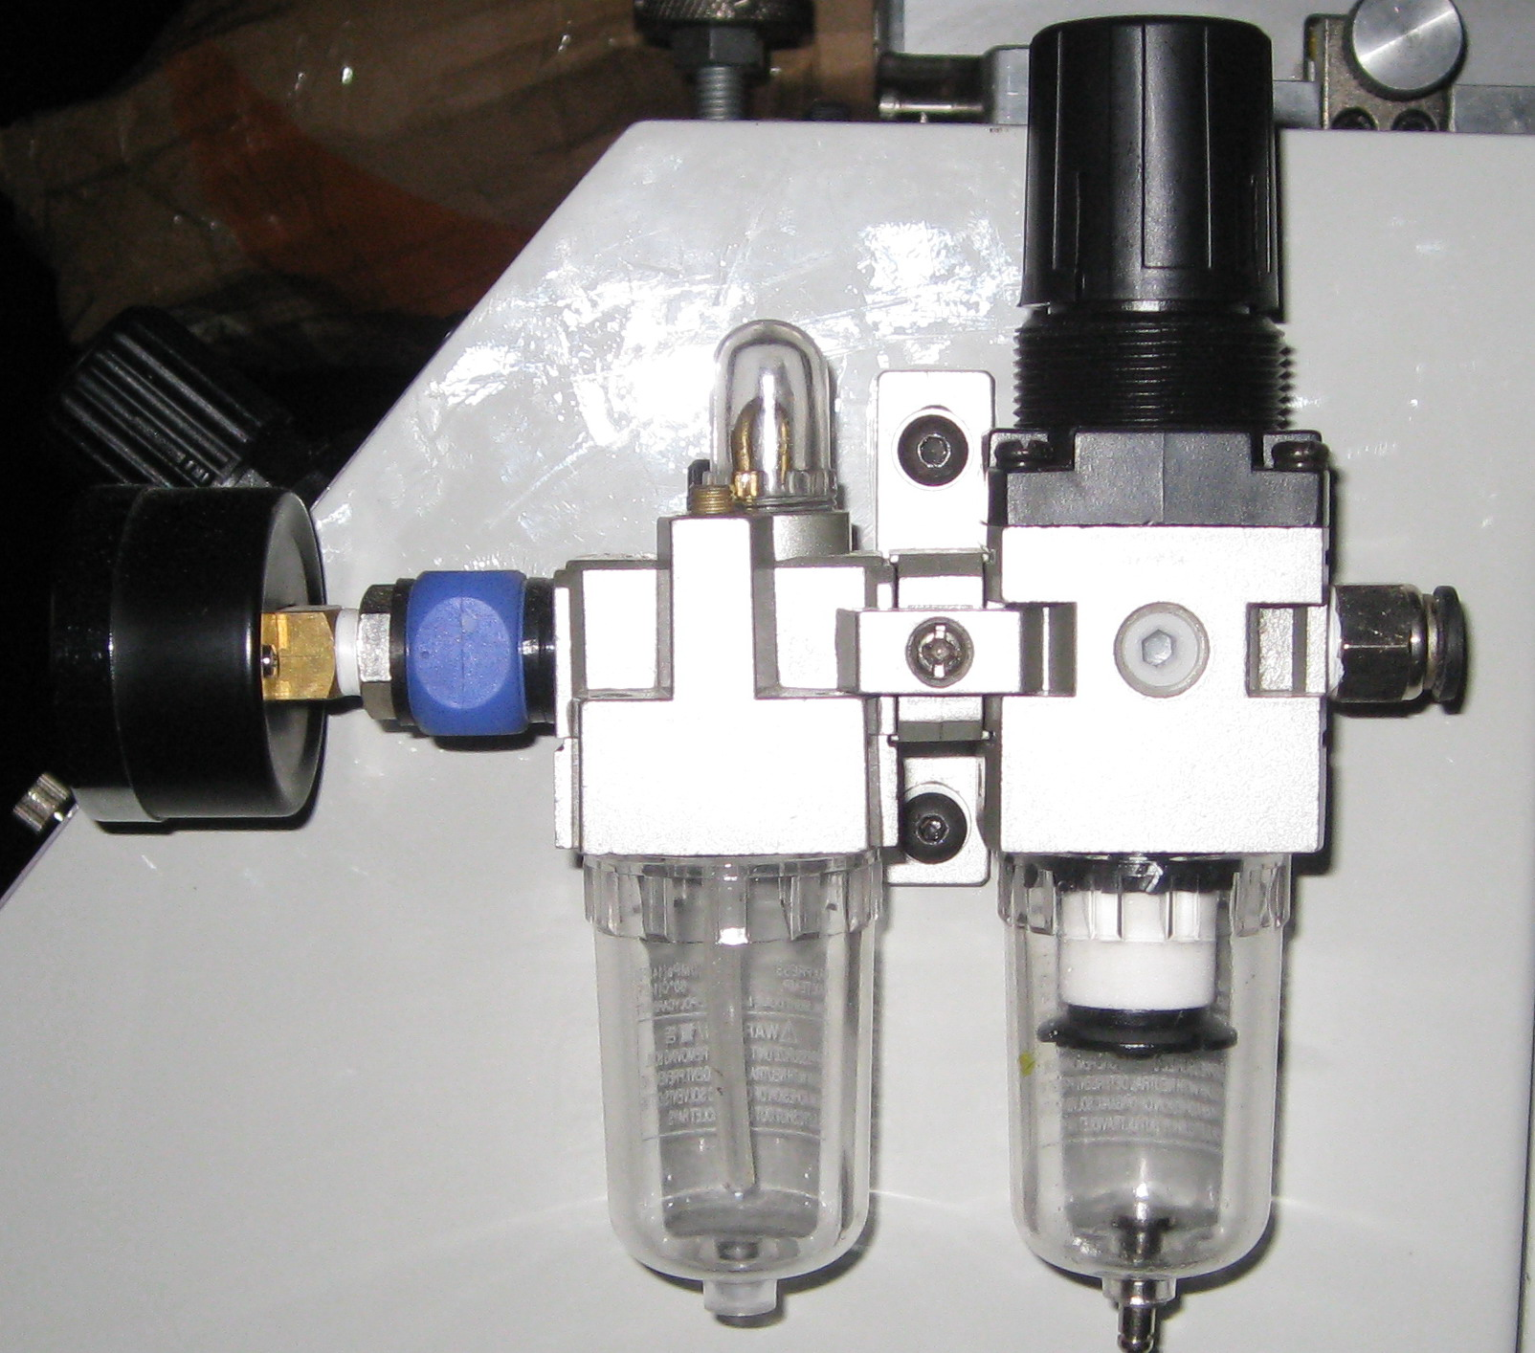

(1).压缩空气调压阀/ pressure -regulator valve:
■调节压缩空气压力大小.调节方法是将蓝色胶旋钮向上拉起,俯视顺时针方向压力增加,反之减小,调整完毕将旋钮按下固定即可。
Adjust the pressure of the air, the adjust method is draw the blue knob, overhead view and clockwise is increase the pressure, conversely is reduce the pressure. Finished the adjust please depress the knob.
(2).压缩空气压力表air pressure gauge /:
■显示压缩空气压力大小/Display the press of the air pressure.
(3).过滤器油雾器/Filter Oil Mist Separator :
■过滤压缩空气中的所有水分,杂质。为气缸加入润滑油。
Filter the water, the impurity in air pressure. Inject the lubricating oil in cylinder.
(4).快速接咀Quick connect spur/
■压缩空气入口/The entry of air pressure。
3．开机/Starting Up
■将手拉阀推到开(ON)的位置。
Let the hand-pull valve in start (on) position.
■调整压缩空气压力至4-6Bar之间。
Adjust the air pressure as the press 4-6 Bar.
■插上电源插头/Plug in。
■开启电源开关/Open the power switch。
■等待几秒后，检查机器网框或印头是否已回到左边的位置，机器是否发生报警。
Wait a litter seconds, check the frame or the head print back to left position, and check the machine have whistle or not.
Print squeegee adjust have two ways: level adjust and vertical adjust.
▲垂直调节：如下图（图6-6）所示，用两个杯头螺丝调节印刮角度，调整到合适的角度后锁紧杯头螺丝即可。 Vertical adjust: see as the picture below (picture 6-6), use two hexagonal socket head cap screw adjust the angle of squeegee, adjust it to the suitable angle then fixed hexagonal socket head cap screw is ok.

■印刮气压调节：为使印刮在印刷时具有一定的弹性，一般使用气压为2-4Bar。印刮越长，压力相对加大。
Squeegee air pressure adjust: to let the print squeegee have some elasticity, usually use the air pressure is 2-4Bar. The print squeegee more long, the press need more.
八．机械保养/Machine maintenance:
■ 机器的维护与保养,涉及多方面的管理。这里仅指出保持机器正常运行必须达到的基本要求、其它各方面的管理，如机器内部的、外表的、机器周边的、以及工作场地的清洁卫生，环境状况等，尚需由用户自行制订相应的规章制度予以规范。
The maintenance of the machine refer too many management. Here only indicate keep machine normal operation must meet require. The other management ,such as the inner of the machine, the surface, the around of the machine , the working place clean , the working situations and so on, which need the user keep the management own.
■ 在每日开机运行前、运行时，都应察看机器运行有无异常。如有动作不正常，或有异常的声音，即及时检查并加以排除。检查时，如无机械故障，或仅属润滑不良，则需马上在各有关的传动部位，查看并添加润滑剂。每日结束工作时，需进行机器的表面清洁。
Every day before starting should check the machine have anomaly or not. If have the anomaly moving or sound, should check it immediate and solve the problem. In check, if have no machine fault, or only lubricate not enough, must check the transmission parts and add lubricating oil. Every day in work finished, need to clean the surface of the machine.
■ 机器运行到每月底时，应察看各活动关节部位，并添加润滑剂，如有润滑剂凝固情况，则应擦除并用汽油清洗，重新注新的润滑剂。
Every end of month, should check every transmission parts and add lubricating oil, if the lubricating solidification, clean it with gas and add new lubricating oil.
■ 正常情况下，机器每半年彻底维护一次。必须全面检查各活动关节部位，在无生锈磨损、润滑剂凝固等现象，如有应及时予以处理。
In under control situation, the machine should all snidely maintain every half year. Must check every move joint parts. Check it have rust, abrasion, lubricating solidification and so on, if have the problem should solve it.
■ 机器运行时到一年，应全面检查机器。其中机械部分需要的检查，包括有无生锈磨损、润滑剂凝固等现象，如有应及时予以处理。同时要检查所有气管气喉，如有破损，应立即更换。
When the machine used about 1 year, should check the machine. The machine parts need checking parts contain: have rust, abrasion, lubricating solidification and so on, if have the problem should solve it. At the same time should check every windpipe, if abrasion should change it at once.

