How to Adjust CMA ITV1000/2000/3000 Electro-Pneumatic Regulator
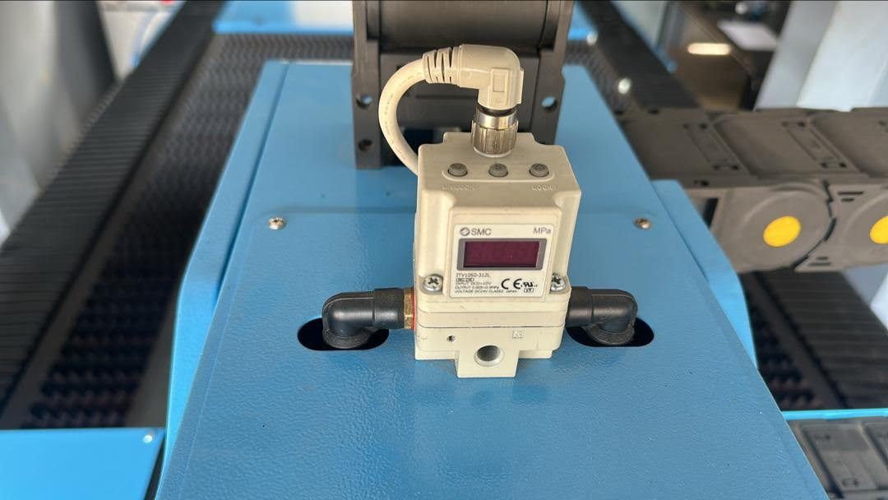
Video is here: https://www.youtube.com/watch?v=ZdLlOVKGWkE
1. Engage blow setting to switch on the valve.
2. ⁠Hold unlock button for 5 seconds (far left button). Once unlocked, select S
button (middle button) to set parameters.
- F_1 parameter = minimum output pressure.
- F_2 parameter = maximum output pressure.
3. Use arrow keys to set the pressure values for minimum and maximum output.
4. ⁠ once set press the S button (middle button) and disengage Blow function.

