Notice
1. Do not place the printer in an environment with high vibration or instability.
2. Do not touch the nozzle or parts that are running at high speed when the printer is working. Be careful to avoid injuries caused by burning or pinching your hands.
3. Routine maintenance needs to be carried out when the power is off, mainly cleaning the dust on the table; regularly maintaining the machine track. When the machine is not in use, it is recommended to cover it with a cloth to prevent dust.
4.In case of emergency, please turn off the power directly.
contents
Parameter introduction
Machine display
Machine installation
Display introduction
Introduction to automatic leveling
Introduction to disassembly and installation of print head
Common troubleshooting
parameter
Print parameters
Printing principle: FDM (fused deposition modeling)
Print size: 800mmX800mmX65mm
Printing accuracy: 0.1mm
Nozzle diameter: 0.8mm
Printing speed: 20-80mm/s
Connection method: SD memory card; USB basin

Machine features
Machine size：JH-120(162cmX112cmX50cm）； JH-80X（122cmX112cmX50cm）
Net weight：JH-120(70KG); JH-80X(50KG)
Power ：JH-120(1200W); JH-80X(800W)
Input Power：100-120V; 220-240V
Output power：24V

Maximum nozzle temperature: 258°C

Maximum temperature of hot bed: 70°C

Software paraemeters
Slice Software：3D PRINTING; Cura
Input format：SVG; DXF
Output format：G code

Machine constitute
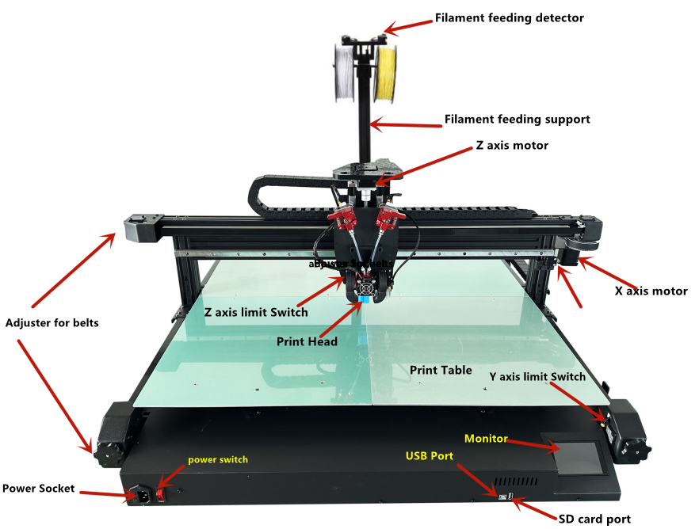

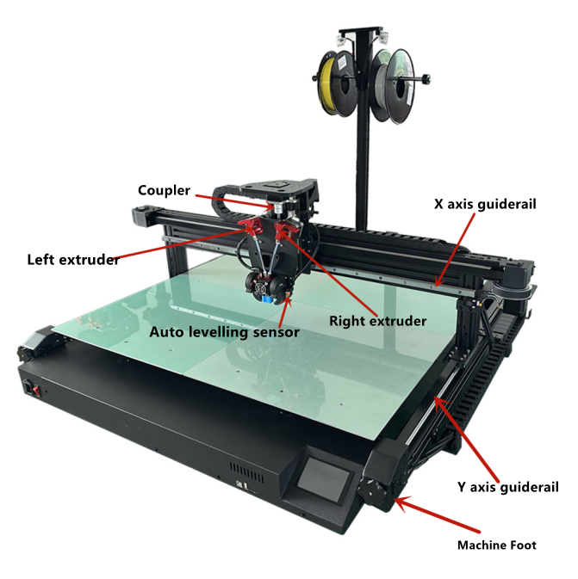

Machine Installation

We will provide installation video in the CD card
1. Use black screws M5*25 (2pcs) to fix the material rack
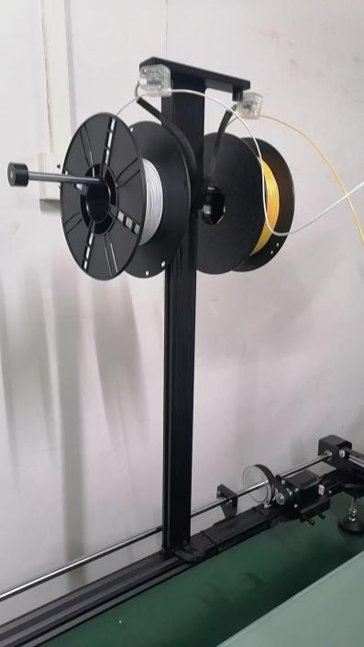
- Remove the two securing screws and foam at bottom
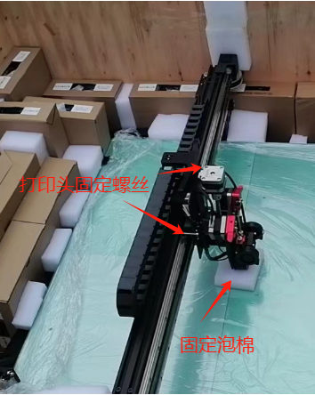

Supplementary instructions:

The printing platform has been debugged before leaving the factory. After receiving the machine, do not need to level it . After installing the machine, you can first turn on the power and then load and print for testing. If printing table reaches the nozzle and can not print out . If the head is much higher than the table, the material cannot stick to the table, and re-leveling is required.

Monitor
Note: It is recommended to use fingernail clicks when operating the display
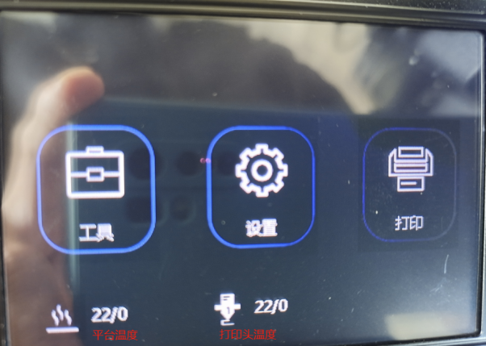
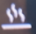 stands for platform temperature , left is current temperature , right is setting temperature
 Stands for nozzle temperature .left is current temperature , right is setting temperature
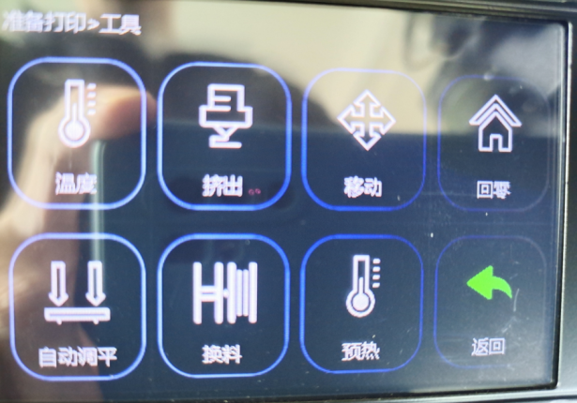
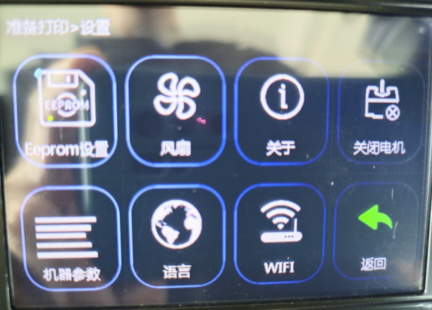
Set interface
Eeprom set: This is for setting auto leveling , no need to click it normally.
Fan : Manually control the controllable fans on the left and right sides of the print head. 100% means strong wind, 50% means medium wind, and 0% means turning off the controllable fans. This function is rarely used. Its main function is to dissipate heat for small prints alone.
About: information of the Motherboard type
Motor close : Unlocking the X/Y/Z axis motor , it is the same as turning off the motor in the home function of the tool interface.
Machine parameter :
The machine settings are acceleration professional settings and cannot be changed; the motor settings are pulse professional settings and cannot be changed .
Auto leveling setting : Manual leveling coordinate settings, automatic leveling command settings, extrusion head and leveling switch offset settings) are professional settings and cannot be changed .

BL-Touch Probe Detect and correct the height distance between the print head and the table. It can be changed by operation. This function is rarely used.；
Advanced setting , professional settings and cannot be changed .

Language: Click to enter to switch the display language, including Simplified Chinese, Traditional Chinese, English, Russian, Spanish, French, and Italian. The WIFI :function is currently not turned on and cannot be clicked to enter the operation.

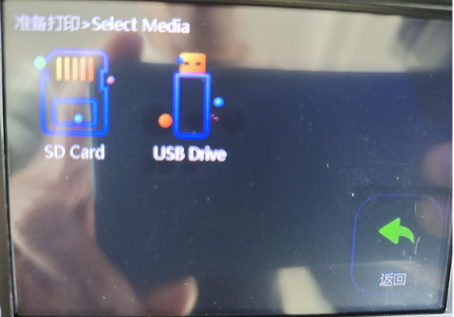
Printing interface: save the connection method of printing files.
If you insert an SD memory card, you can click on the SD Card to enter the search file and click on Print.

The connection method for saving and printing files. If you insert a USB flash drive, you can click USB Drive to enter the search file and click Print.

Additional instructions: Before starting to print, you need to insert the material first. Pay attention to insert the left material to the bottom and the right material in the middle of the transparent tube. If you find that the right material is at the bottom of the print head, you need to preheat the print head to 200. °C, manually quickly pull out the right material and reinsert it to the middle of the transparent tube, and insert the left material to the bottom again. Otherwise, it will easily to be blocked when printing.

Introduction of autolevelling function
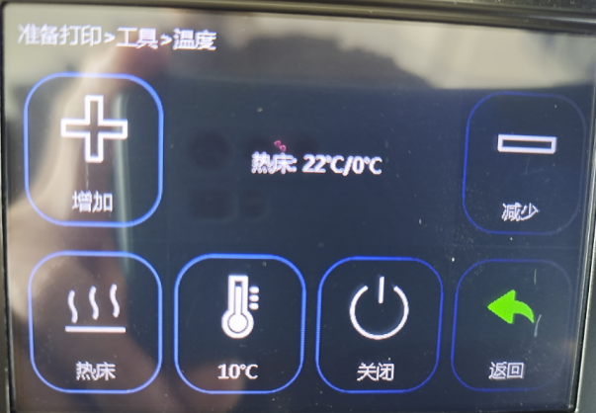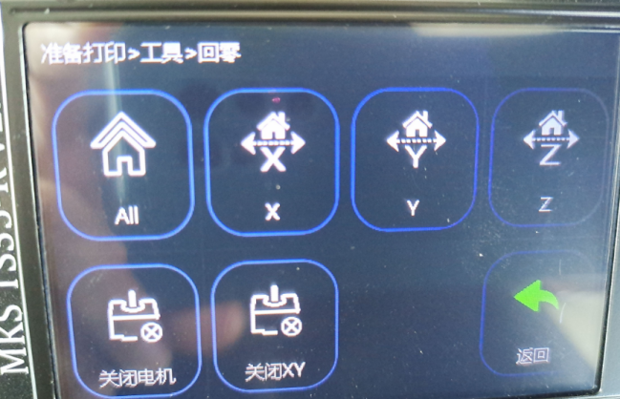
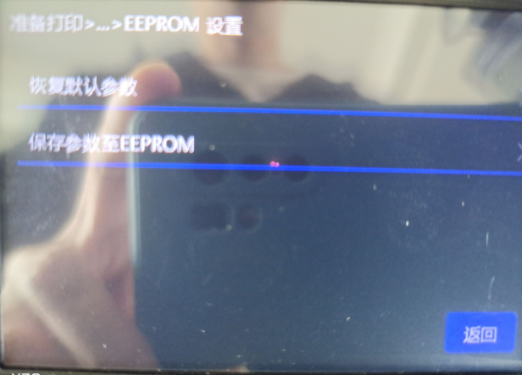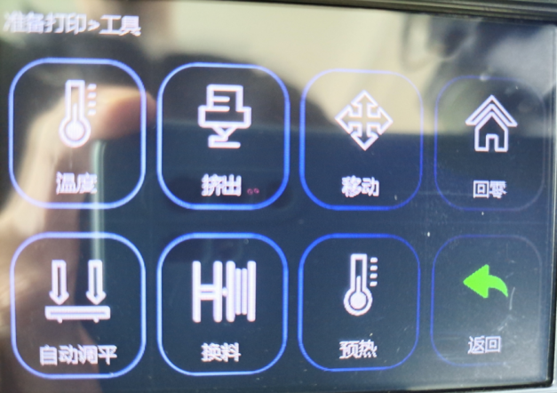
Automatic leveling operation steps:
Main interface--Tool interface--Temperature--Switch to the hot bed in the lower left corner and click Add+ to set the hot bed temperature to 50°C--Return--Return to zero--All--All--Return--Return- -Main interface--Setting interface--Eeprom settings--Restore default parameters--OK--Save parameters to EEPROM--OK--Return--Return--Main interface--Tool interface--Automatic leveling

(Note: After starting the automatic leveling, you need to check whether all the countertops have been tested. If not, or other abnormalities occur, please contact the technician.)
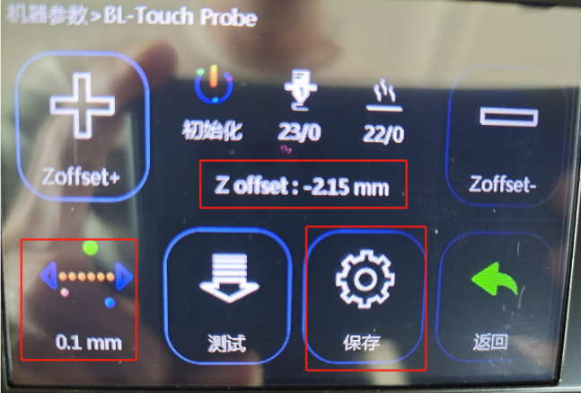
After the automatic detection is completed, the print head will automatically move to the middle of the table. You need to use a piece of A4 paper and place it in the middle of the table in advance. After the print head reaches the middle of the table, it will drop to the A4 paper. At this time, you need to go to the display operation and click the lower left corner to switch. Progress to 0.1mm, and then click +/- to correct and adjust the distance between the print head and the A4 paper on the platform (+ means to raise the print head, - means to lower the print head) so that the distance between the print head and the A4 paper just touches the height. . Adjust +/- to match the value in the middle of the display. Click Save after the adjustment is completed. The print head will automatically return to zero, and then click to return to the main interface to complete the leveling.

Supplementary note: If the printing is uneven after the automatic leveling is completed, it may be that the distance between the nozzle and the A4 paper has not been calibrated (the line width of the first layer of printing is 0.8mm-1.6mm as normal line width). You can print the first layer during the printing process. Click operation - Leveling adjustment - Click the upper right corner to switch to 0.1mm - Then click Z+ or Z- to adjust the distance between the print head and the table, so that the line width of the first layer of printing is within the range of 0.8mm-1.6mm. If printing the first layer is finished and printing has started and the second layer has not been adjusted yet, you need to click Return to stop printing, restart printing the first layer and adjust the print head height again, and then click Return directly without saving.
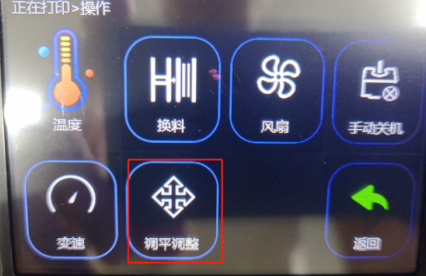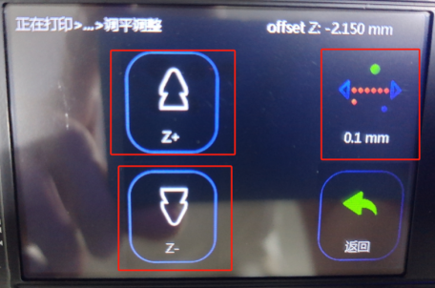

Printing head disassemble , assemble
Note: Don’t try to disassemble the print head unless there is no way to clear the blockage by pushing the material manually, then you need to disassemble the print head. There is no need to remove the entire sheet metal like in the picture, just follow the instructions below.
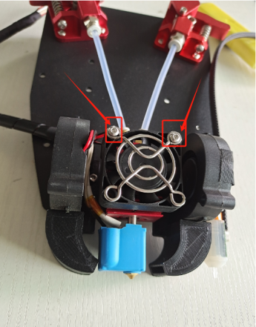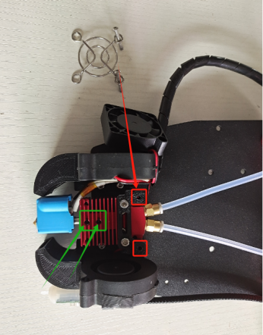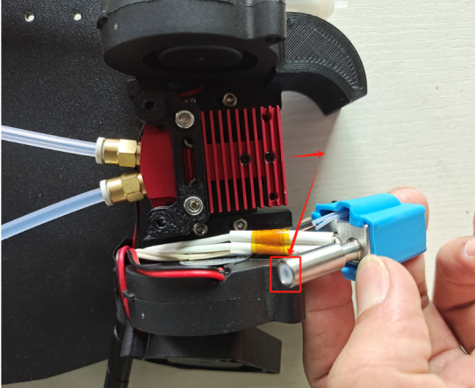
- First, remove the main fan in the middle. You can see that there are 2 black top wires in the middle of the red heat sink. You only need to loosen it to separate the lower print head from the red heat sink. Then heat the print head to 220°C. °C, clean out the debris blocked in the print head, and then insert the material from the extruder position to try to see if it can be unclogged to the bottom. Use the same method to check the left and right extrusion sides. Only when it is finally confirmed that there is no problem can you restart. Install it back; when installing the print head, you need to pay attention to the print head that has just been heated to 220° to prevent burns; you can turn off the machine and wait for the temperature of the print head to drop before operating the installation.、
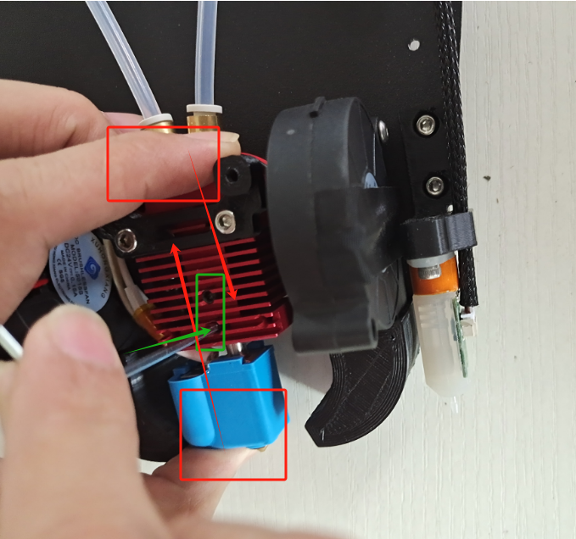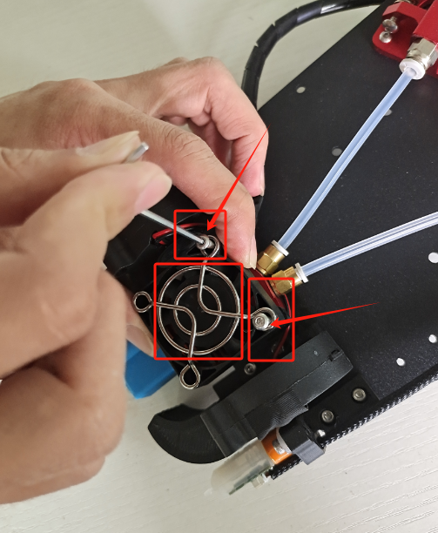
In the first step of installation, please pay attention to see if the direction is correct. When installing the print head, you need to push it hard towards the red heat sink. At the same time, use the other hand to lock the black top wire in the middle to prevent the print head from sliding down and causing damage inside the heat sink. The gap will affect the print quality. Install the print head before installing the main fan. Be careful not to install it in the wrong direction. The direction of the fan label is toward the inside of the red heat sink.

Additional instructions:
Installation pictures of print head thermistor and heating tube
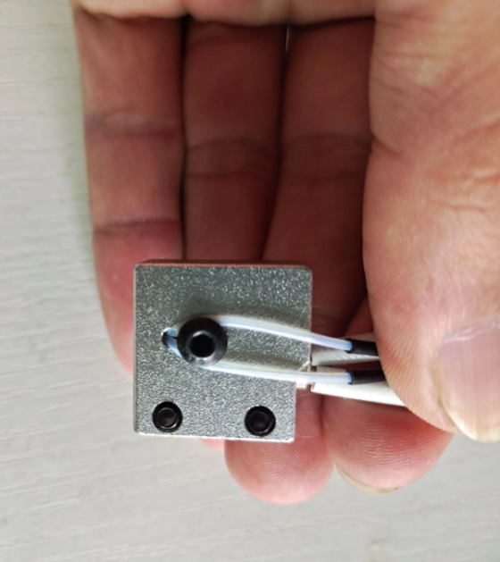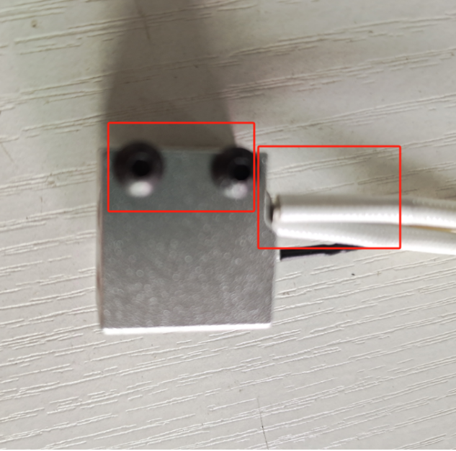
2Print head throat and nozzle installation pictures and instructions
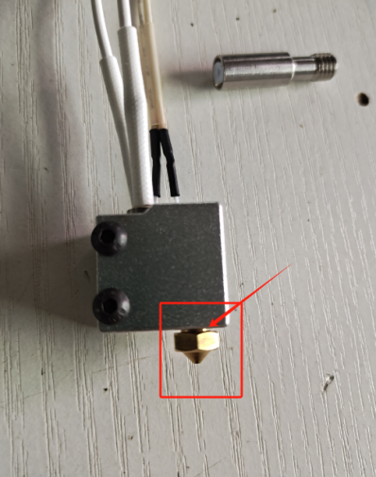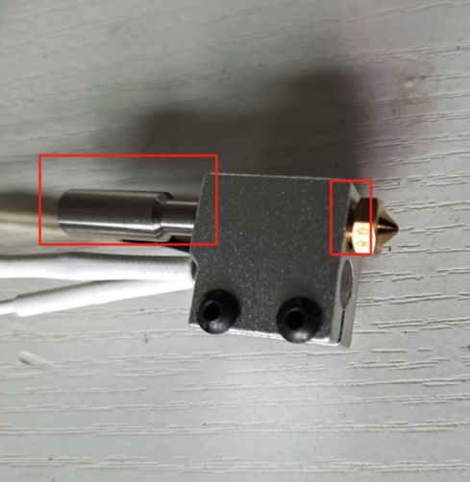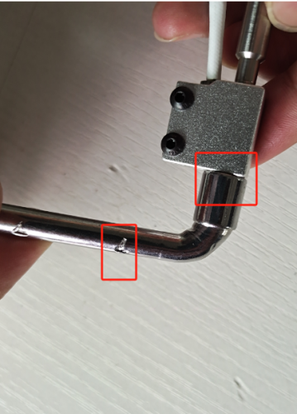
First screw the print head into the heating block, be careful not to lock it, leave a 1mm gap, then install the pipe, tighten it manually without using tools, then use the No. 7 socket wrench tool to reinforce it, and finally tighten it The print head is installed on the red heat sink and fixed. Just sort out the wires and plug them in.

Common troubleshooting

The X/Y/Z axis motor does not move or makes abnormal noise when returning to zero.

1. Check whether the motor wire is loose

2. Check whether the corresponding limit switch can be triggered normally or whether the limit line is loose.

3. Check whether the corresponding axis is blocked by interference objects

4. Check whether the gear jackscrew on the motor shaft or optical axis is loose, causing slippage.

Nozzle extrusion abnormality

1. Check whether the extrusion motor wire is loose

2. Check whether the top screw of the extrusion gear is locked to the motor shaft

3. Check whether the main fan in the middle of the print head rotates normally

4. To block the print head, first heat the print head temperature to 220°C, confirm whether it is blocked on the left or right, and then quickly pull out the material on both sides manually; if it is blocked on the left, first pull out the right side and then the left; If the material is blocked on the right side, first pull out the left side and then the right side; then manually insert the material and push it hard to squeeze out the blocked material.

If the material cannot be squeezed out by manual pushing, make a mark first and then manually pull out the material quickly, and then compare the length on the periphery to roughly determine the location of the blockage so that you can disassemble the nozzle later (try not to disassemble the print head unless necessary)

5. Regularly check whether all the screws on the print head extruder are loose to prevent printing failure or head clogging.

The printed word case will not stick to the table or have edges that warp.

1. Check whether the platform is adjusted. When printing the first layer, the distance between the nozzle and the table should not exceed 0.2mm (the thickness of 2 A4 papers. Or when printing, you can observe the output line width of the first layer at a distance of 1mm to 1.5mm to determine the distance between the nozzle and the table. The distance between the table and the table), exceeding this distance will affect the adhesion of the printed word shell to the table, which may easily cause non-stick to the table or edge warping, and requires re-leveling.

2. If there is no problem with platform adjustment but non-stick or warped edges still occur, you can set the grid or elephant legs in the software to help strengthen the attachment surface and prevent warped edges.

3. Check whether there is dust on the countertop that has not been cleaned or whether the countertop is coated with platform glue.

4. You can also try to increase the countertop temperature setting to 60°C

5. After confirming that all the above problems are correct, finally confirm whether the platform glue and consumables coated on the table are purchased by the original manufacturer of the machine. The problem may be caused by the platform glue or consumables. If purchased by the original manufacturer, please contact the manufacturer's technical personnel as soon as possible.

Printed word shell is misaligned

1. Idle driving speed or too fast printing speed may cause printing misalignment. You can try to reduce the speed.

2. The X/Y axis belt is too loose or the synchronization wheel can lock the jack screw

3. The driving current is too small, causing the motor to be unable to move due to insufficient strength.

4. You can check according to the treatment method of X/Y/Z axis motor not moving or making abnormal noise when returning to zero.

Drawing is serious

1. The retraction distance is short. Set the retraction distance larger in the software parameters.

2. The retraction speed is slow. Set the retraction speed higher in the software parameters.

3. The printing temperature is high. Lower the printing temperature setting in the software parameters.

The starting point of the printing interface is leaking or there is a lot of extruded material.

1. If there is a lot of material pushed at the starting point of the interface, you can adjust the software parameters to set a smaller extra loading amount or a smaller compensation length.

2. The starting point of the printing interface is leaking and cannot be connected. First confirm whether the print head has been disassembled before, and then modify the parameters. Before modifying the parameters, confirm whether the interface leakage is caused by a lot of wire drawing the day before yesterday. If so, adjust the wire drawing parameters first. , if there is not too much wire drawing and it also causes interface leakage, you can adjust the software parameters to set the additional loading amount to be larger or the compensation length to be larger.

3. If there is no problem after adjusting the previous parameters, but the printing interface still cannot be connected and leaks occur, and the print head has been disassembled before, you can check again whether the print head is installed properly and whether the nozzle is loose or sliding down. Check whether the Teflon tube under the extrusion is inserted all the way or if the tube is short.

