**How to avoid Visual C++ or Trojan messages in Eset Nod32**

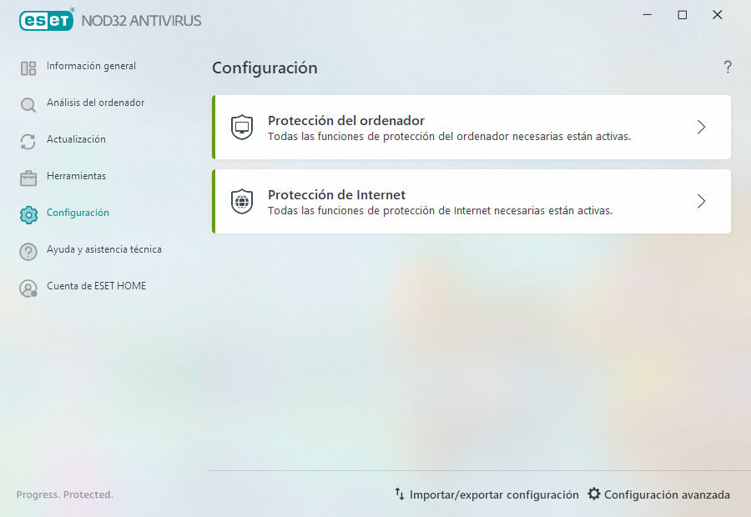

1

2

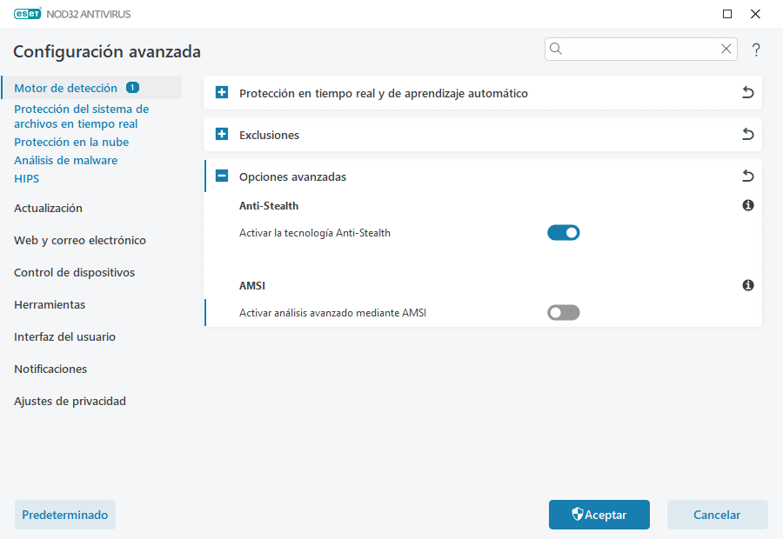

3

4

5 Disable this option

6