How to avoid Visual C++ or Trojan messages in Eset Nod32
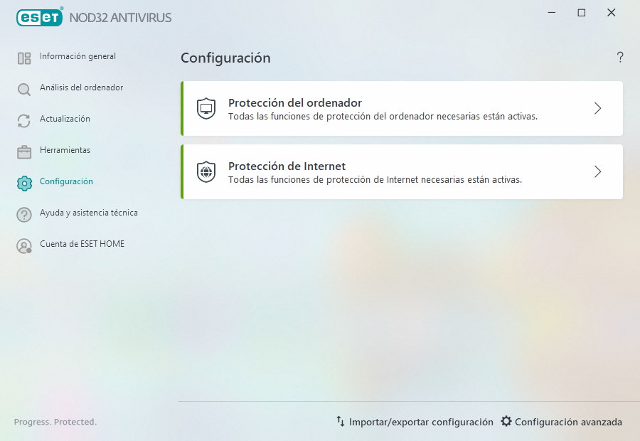
1
2
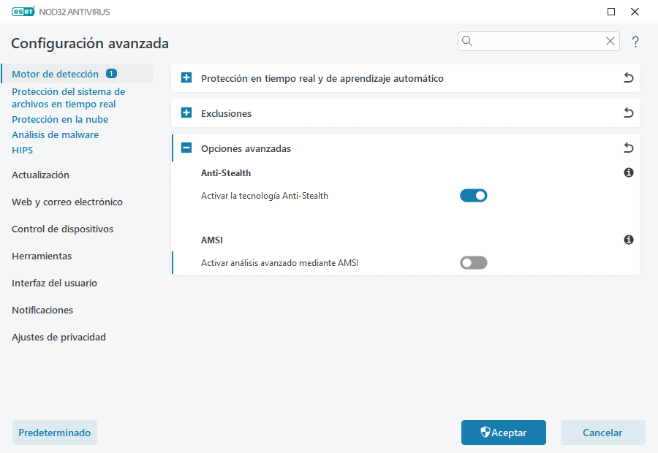
3
4
5 Disable this option
6

