**切割雕刻一体控制系统**

**- 上层软件说明书 -**

Cutting engraving integrated control system

-Upper software specification -

Shenzhen ZHIYUAN [numerical control](javascript:;) limited company

深圳市智远数控有限公司

Directory

Upper-layer software operation instructions

Chapter 1 Overview **错误！未定义书签。**

1.1 introduction to numerical control system software 4

1.2 Composition of control system 4

1.3 Software Installation requirements 4

1.4 Installation Introduction： 4

（1）Software installation **错误！未定义书签。**

（2）Set the network IP address 7

1.5 Software Features 9

1.6 Interface Description 10

Chapter 2 Menu Items 12

2.1 File menu items 12

2.2 Edit menu items 13

2.3 Set menu items 16

2.4 See about menu items 17

2.5 View menu items 18

2.6 Help Menu Item 19

Chapter 3 Standard Tools 20

3.1 Create a file 20

3.2 Open the file 20

3.3 Save the file 20

3.4 Import 20

3.5 Export 21

3.6 Cutting 21

3.7 Copy 21

3.8 Paste 21

3.9 Undo 21

3.10 Restore 21

3.11 Shift 22

3.12 Zoom in on all objects 22

3.13 Shrinking all objects 22

3.14 Displaying the Page 22

3.15 Local amplification 22

3.16 Set parameters 23

3.16.1 Display Parameters TAB： 23

3.16.2 Process Parameters TAB： 25

3.16.3 Device Parameters TAB： 26

3.16.4 User Parameters： 30

3.17 Connecting Devices 31

Chapter 4 Creating/Modifying the Graphical Toolbar 32

4.1　Creating a Toolbar 32

4.2　Modifying the Toolbar 35

Chapter 5 Layers/Alignment Toolbar 46

5.1　Layer Toolbar 46

5.2　Align the Toolbar 46

Chapter 6 Work Panel 48

6.1 [Device attachment](javascript:;) 48

6.2 Layer Management **错误！未定义书签。**

6.3 Path Optimization 52

6.4 Device Control 53

6.5 Manual Control 59

Chapter 7 Operation process 60

7.1 Step 1: Install the machine and its accessories 60

7.2 Step 2: Install the software 60

7.3 Step 3: Draw and process graphics 60

7.4 Step 4: Set processing parameters 60

7.5 Step 5: Judge the focal length 60

7.6 Step 6: Start processing 61

# Chapter 1 Overview

## 1.1 introduction to numerical control system software

Cutting is shenzhen far CNC carving a whole control software co., LTD., set many years of industry experience, the famous r&d team to establish a compatible laser cutting engraving of CNC products. The software is easy to learn, mature and stable motion control algorithm, cutting and engraving process is complete, friendly man-machine interface, applies to clothing, acrylic, furniture and other non-metallic laser cutting engraving control.

## 1.2Composition of control system

Control system consists of hardware (movement control CARDS and accessories) and the software of two parts.

## 1.3Software Installation requirements

Hardware requirements: cy young more than 2.1 G CPU, memory, hard disk 256 m or more above 20 G

Software requirements: Microsoft Windows operating system (Window2000, WinXP)

## 1.4 Installation Introduction：

Please choose according to your Windows version:

1. Software installation

Software installation package 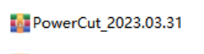after decompression can see the software installation all the file folder:

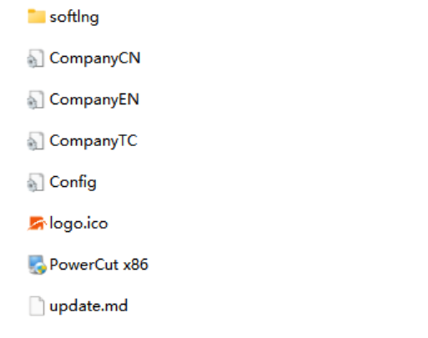

Softlng is a software install language pack, CompanyCN, CompanyEN, CompanyTC is a configuration file, Information update. The md is a software update, logo.ico file is decided to software installation exe executable file will be displayed after the completion of the icon, can be change according to the requirement of the user, as long as the name consistent. Powercut x86 is software installer, detailed below.

Double-click the Powercut x86 start after installation, install the welcome screen, click on the red arrows indicate the next step:

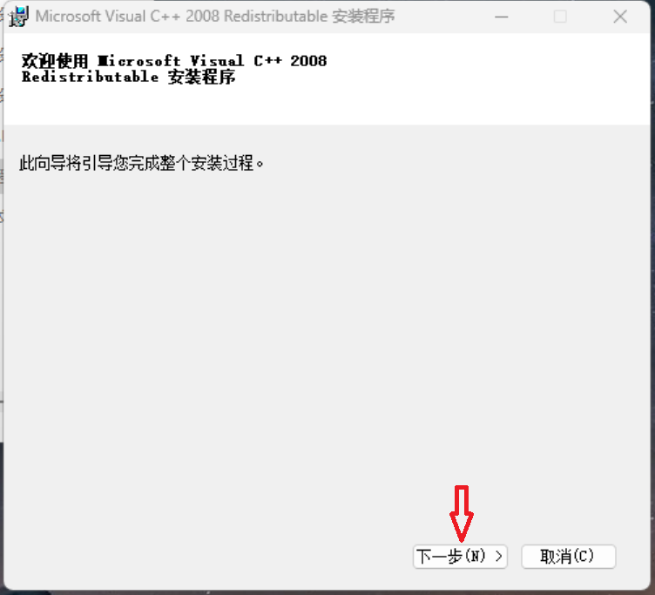

License terms, first click on the red arrow mark 1 "I have read and accept the license terms and conditions", then click on the red arrow mark 2 "install", then wait for the installation is complete:

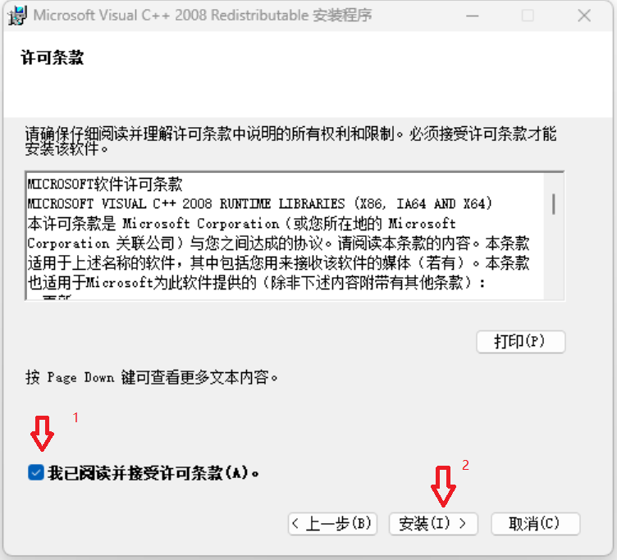

Click on the red arrows indicate the "finish" :

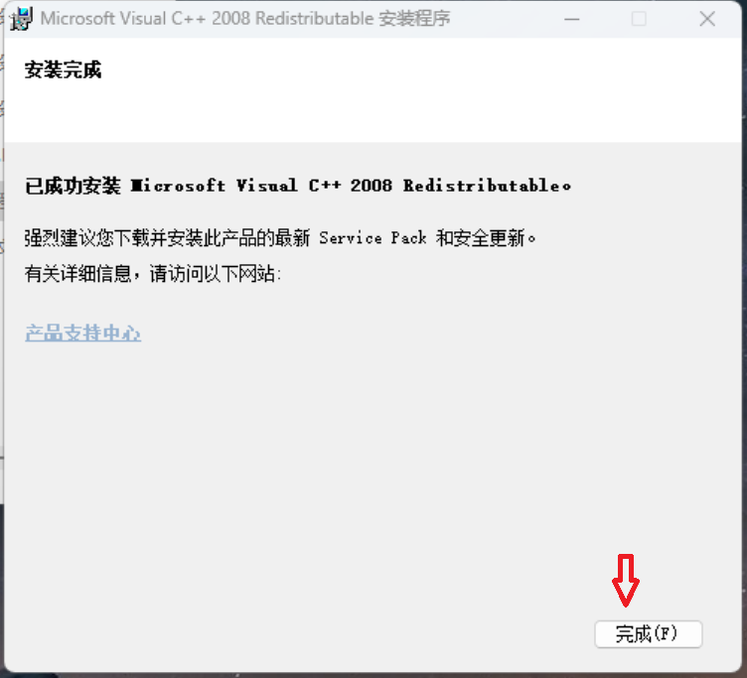

Can click on the red arrows indicate 1 first installation target path choice, then click on the red arrows indicate 2 into the "next" (or directly click on the red arrows indicate 2 into the "next")

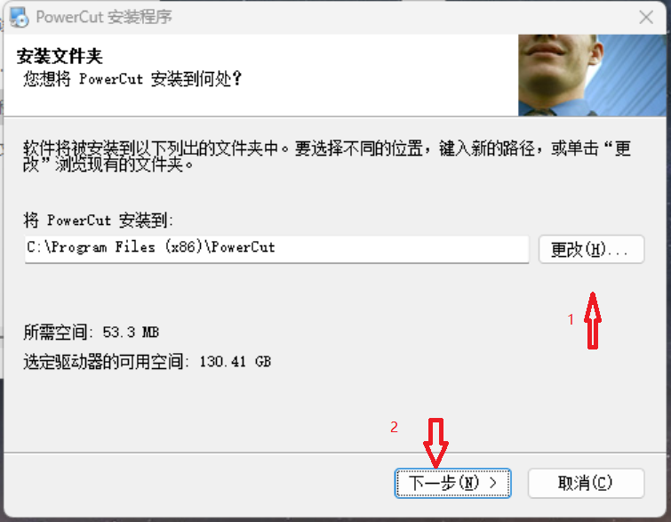

First click on the red arrow mark 1 "select language", then click on the red arrow mark 2 "finish" : (if enter the software or show Chinese, here is about how to back English mode)

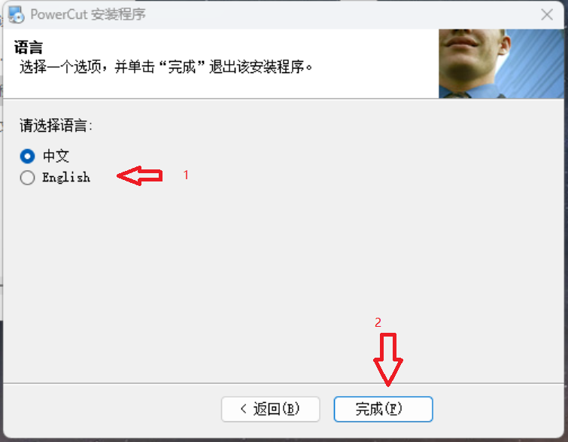

At this point, cutting engraving integrated control system software installation is complete. Create a desktop shortcut to complete at the same time.

（2）Set the network IP address

When using network communications, please manually changing IP address:

Open the network neighborhoodPoint to check the network connectionFind Ethernet, double click the mouse,

Property changes:

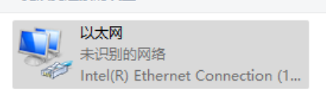

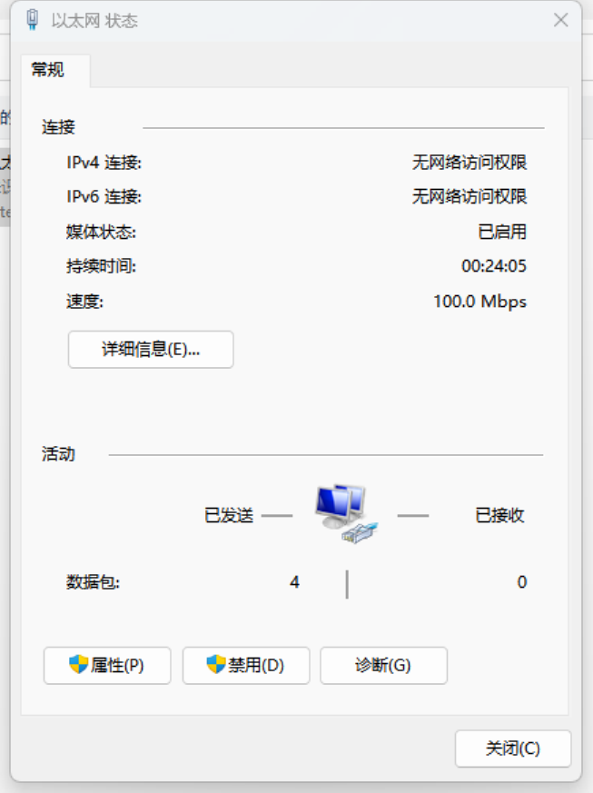

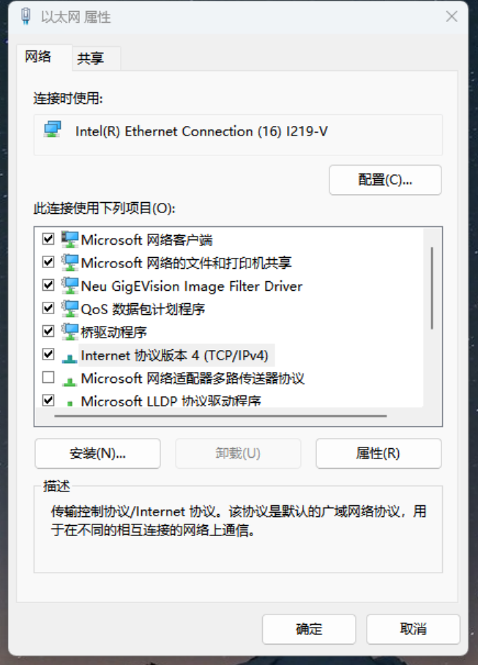

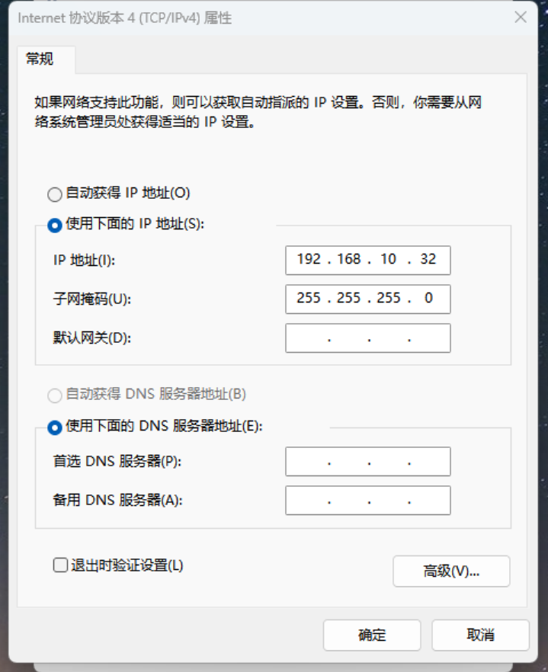

After the completion of the, change the point.

## Software installation is complete, and after the completion of the network Settings, software with the laser machine can realize communication with each other.

## 1.5 Software Features

* Friendly interface, easy to learn, easy to operate.
* Compatible with AI, BMP, PLT, DXF, DST, and other graphics data format.
* Can make simple graphics, text and to import the data editing and typesetting.
* Can, a multi-level hierarchical processing and define the output sequence.
* Personalized Settings, and the precision of laser trajectory simulation shows.
* A variety of path optimization function, suspension in the manufacturing process of function.
* Graphics and processing parameters of multiple preservation methods and use again.
* Processing time estimates and function of cost budget, intelligent typesetting input.
* Unique cutting a body system can well realize cutting and engraving intermittent motion trajectory and work independently and compensation control function.
* According to the different requirements of processing processing can set the starting point, dock work path, laser head position, etc.
* Compatible with a variety of communication methods, the user can according to the actual situation by using USB port communication or network communications.
* During processing, real-time control function.
* Power-off protection function, the power loss in the processing, the system can remember the breakpoints, restore power after can quickly find the breakpoint to continue processing.

## 1.6 Interface Description

Double-click the desktop shortcut to enter the main interface:

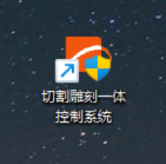

The main interface as shown in the figure below:

## 桌面

Graphics to create toolbars

Graphics editor,

Embedded typesetting tools

Layer tools,

alignment

The status bar

Control surface

Modify tools, graphics

The menu bar,

Standard tools

# Chapter 2 Menu Items

## 2.1 File menu items

Click on the menu barm1icon or press Alt + F keyboard shortcut to open the file menu. .

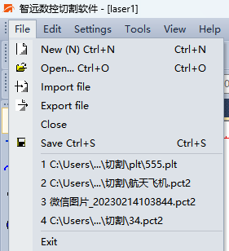

* New: create a new file processing, can press the keyboard shortcut Ctrl + N or the menu barThe new file.
* Open: opens the file at software support, software support file types include:

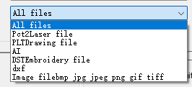

* Import: icon，· import file to edit graphics editing area, the software support DXF/PLT/AI/PCT/BMP/DST/JPG/JPEG file format.
* Export: the corresponding icon on the toolbar，this software can output DXF/PLT/BMP three file format, enter a file name and click the "save" button.
* Closed: delete file processing, can press Ctrl + c keyboard shortcuts.
* Save: to save the current graphics editing for PCT file, you can press Ctrl + s shortcut menu icon save the file.
* Exit: exit PowerCut software, can press Alt + X shortcut key to exit.

Tip: the difference between PCT and the CUT file, PCT is PowerCut software save file format, can open in the PowerCut software for editing. The CUT file is laser processing, PCT file through PowerCut software into the CUT, and then import the numerical control system. The CUT file can't open and edit in PowerCut software, PCT file have no direct import numerical control system.

## 2.2 Edit menu items

Click on the menu barm5icon or press Alt + E keyboard shortcut to open the edit menu.

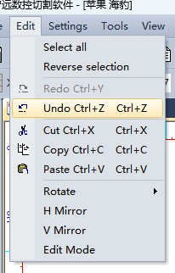

* Undo: undo the last operation, can undo continuously.
* Repeat: cancel the inverse operation, restore the last undo operations.
* Shear: shear the currently selected object, the currently selected object disappears, the shortcut Ctrl + X.
* Copy: copy the currently selected object, the currently selected object, the shortcut Ctrl + C.
* Paste: and cut or copy, paste the object, the shortcut Ctrl + V.
* Rotation: first is to use the mouse to rotate selected graphics then can rotate Angle has 90, 180,270.
* Edit mode: after the selected graphic, click on the icon, graphics edit points, mobile editing point can edit graphics, this feature is mainly used in the figure, such as processing and graphical interface:

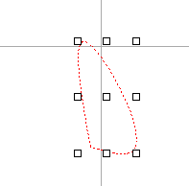 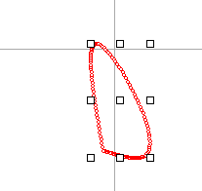 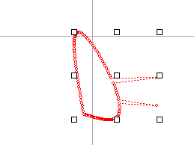

After selected graphics, Processing and Moving point with

click the edit button graphic appears the mouse

* Flip horizontal: flip horizontal on the selected graphic below:

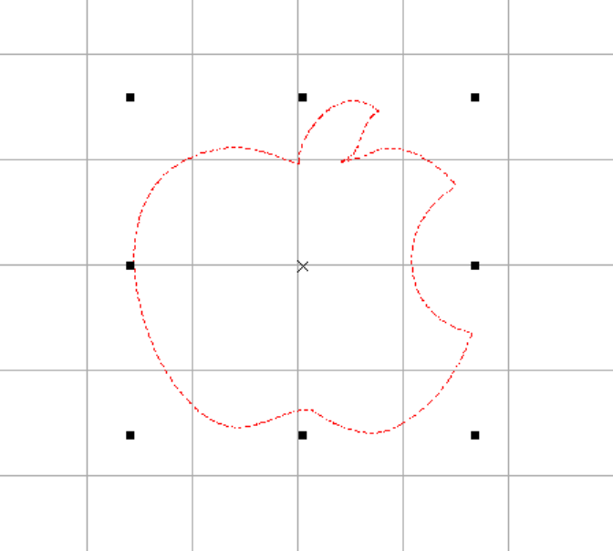

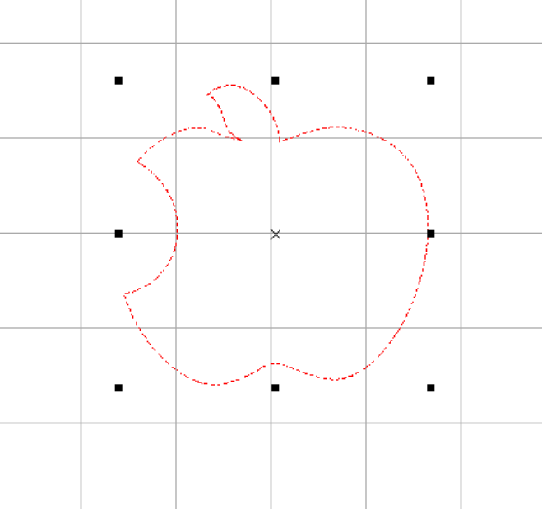

* Flip vertical: flip vertical on the selected graphic below:

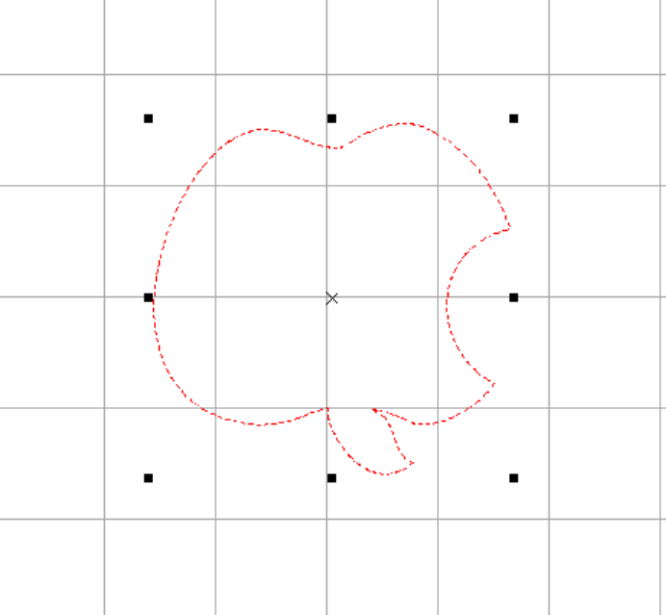

## 2.3 Set menu items

Click on the menu barm6icon to open the Settings menu:

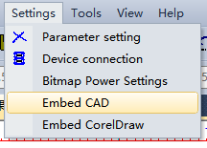

* Parameter Settings: details refer to chapter 3 standard toolbar.
* Equipment connection: details refer to the third chapter 3.18.
* Bitmap, power Settings: power map.
* Embedded CoreDraw: embedded point of the drawing software, after the success of the embedded in the drawing software generates a icon, after drawing software make graphical point the software can directly cut the graphics import.
* Embedded CAD: embedded point of the drawing software, after the success of the embedded in the drawing software generates a graph, mark, after drawing software ready graphics point the software can directly cut the graphics import and direct import control card.

## 2.4 See about menu items

Click on the menu barm9icon or press Alt + V keyboard shortcut to open the view menu.

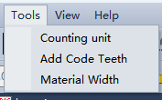

Counting unit:0

Overweight tooth:

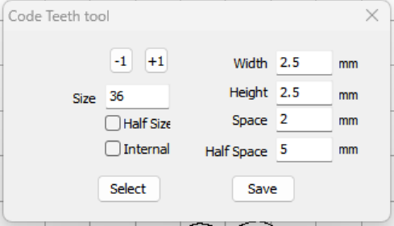

Overweight tooth:

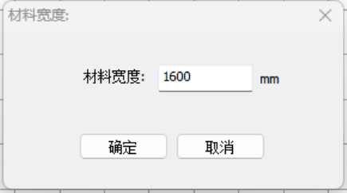

## 2.5 View menu items

Click on the menu barm14Icon to open the view drop-down menu.

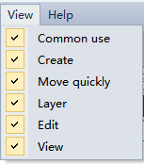

* Commonly used:m16
* Create：m19
* Fast moving：m20
* The layer:m21
* Edit：m18
* View：

## 2.6 Help Menu Item

Click on the menu barm15icon to open the help menu.

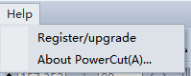

[select](javascript:;)，pop up registration/upgrade window, displays information registered/upgrades.

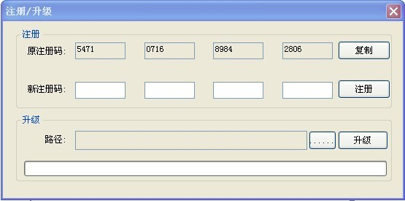

* After registration method: expires in the original registration code from the manufacturer to obtain a new registration code, after the new 16 registration code in the input box, click on the register.
* Upgrade method: get upgrade file from vendors, saved to the computer the location specified,click when upgrade path,found in specified location update file, and then click upgrade.

[select](javascript:;)，pop up on the window, show the related information.

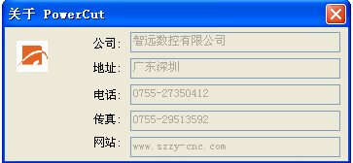

# Chapter 3 Standard Tools

Standard toolbar, realized the general file editing operations, as shown in the figure below:

m16

## 3.1 Create a file

The corresponding icon on the toolbar，used to create a new graphic editing area, shortcut Ctrl + N.

## 3.2 Open the file

The corresponding icon on the toolbar，H\have a DXF file format/PLT/AI/PCT/BMP/DST/JPG, JPEG, is the shortcut Ctrl + 0.

## 3.3 Save the file

The corresponding icon on the toolbar，to save the current edit graphics and processing parameters for extension. PCT file, is the shortcut Ctrl + S.

## 3.4 Import

The corresponding icon on the toolbar，import files to figure editing area for editing, the software supports DXF/PLT/AI/PCT/BMP/DST/JPG/JPEG file format, etc.

Tip: the difference between import and open, import file is the image file is inserted into the document is currently editing, open the file is to load a file.

## 3.5 Export

The corresponding icon on the toolbar，this software can output PLT, DXF, BMP three file format, enter a file name and click the "save" button.

## 3.6 Cutting

The corresponding icon on the toolbar，select graphics object and click on the icon, to modify selected graphics to shear, shortcut Ctrl + X.

## 3.7 Copy

The corresponding icon on the toolbar，click on the icon after selected graphics, copy the current graphics to the clipboard, the corresponding shortcut key Ctrl + C.

## 3.8 Paste

The corresponding icon on the toolbar，click on the icon is to copy or cut graphics paste in the current graphics editing area, the corresponding shortcut key Ctrl + V.

## 3.9 Undo

The corresponding icon on the toolbar，deregulation of the current file on one step operation, the shortcut Ctrl + Z.

## 3.10 Restore

The corresponding icon on the toolbar，on the recovery of the current file step operation, the shortcut Ctrl + R.

## 3.11 Shift

The corresponding icon on the toolbar ，The overall current graphics editing the mobile location.

## 3.12 Zoom in on all objects

The corresponding icon on the toolbar，in a graphical editor area all objects can be maximized.

3.13 Shrinking all objects

The corresponding icon on the toolbar, display all the objects in graphics editing area can be minimized

## 3.14 Displaying the Page

The corresponding icon on the toolbar，in a graphical editor area shows the entire page.

## 3.15 Local amplification

The corresponding icon on the toolbar，in a graphical editor area box to choose zoom in graphics.

## 3.16 Set parameters

The corresponding icon on the toolbar，in this setting system related parameters, the following details.

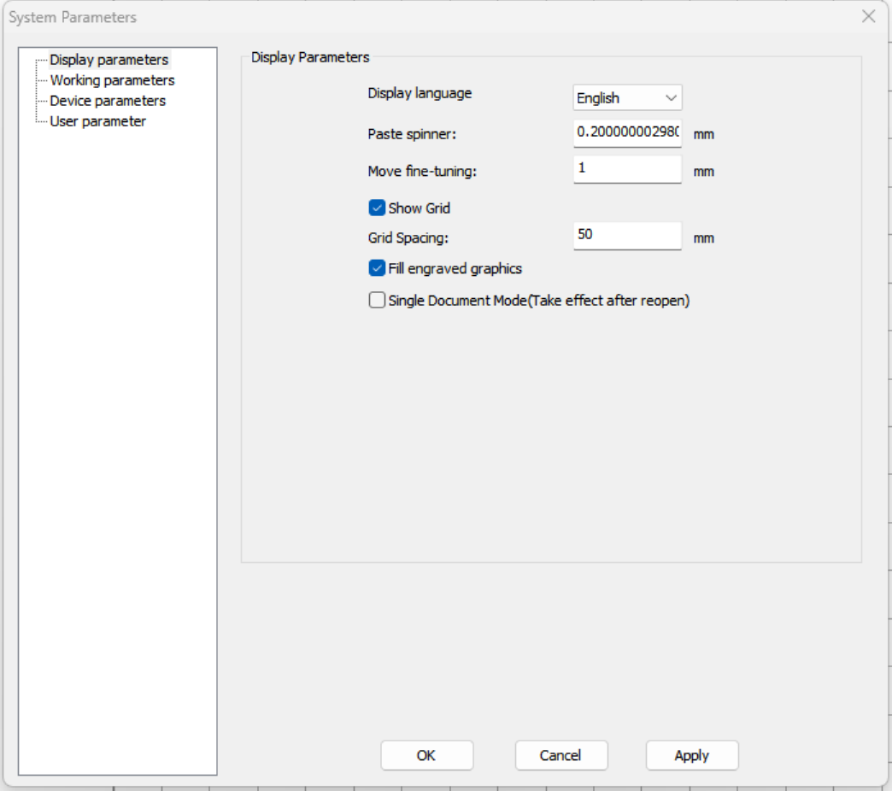

System parameter Settings page has four tabs: display parameters, process parameters, equipment parameters, user.

3.16.1 Display Parameters TAB：

* Display language:select language.
* Paste spinner: set the precise mobile distance size.
* Move fine-tuning: set and distance between the original image, and the original position in the original 45 degrees in direction.
* Shows the grid: selected graphics editor in the area to display the grid.
* The grid spacing: set the grid interval size.
* Fill engraving graphics: tick will fill the carving graphics, not tick not filled, the benefits is reduce the amount of data, load data is not too slow, below figure (2) (1) as the box to box:

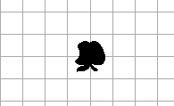

（1）

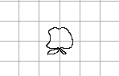

（2）

* Sure: save the parameter Settings.
* Application: application of the current set of parameters.
* Single Document Mode(take effect after reopen):A single document or multiple document work patterns.

### 3.16.2 Process Parameters TAB：

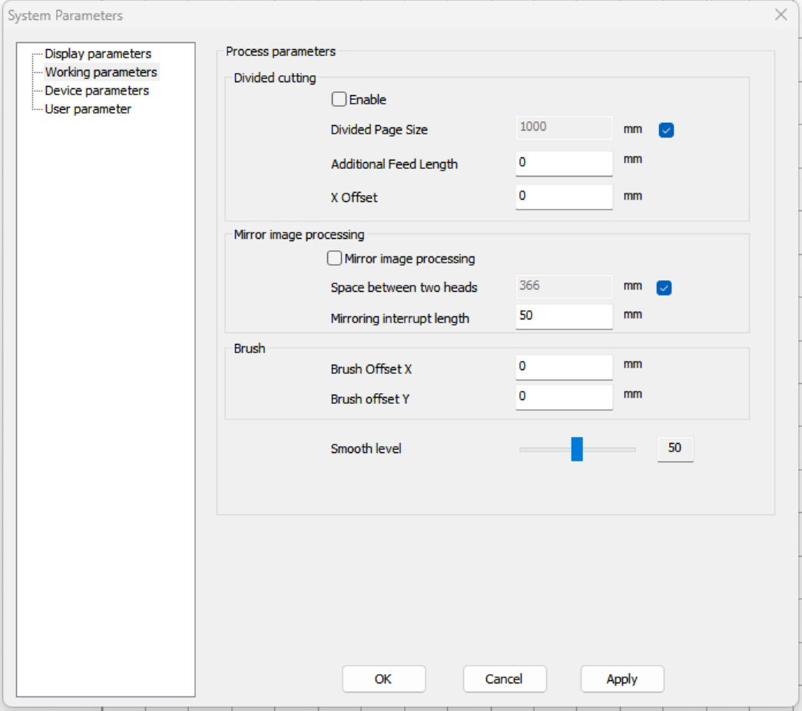

Divided cutting:

* Enable: when machining data beyond the wide, can joint conveying mechanism for continuous cutting. After cutting the current layout, feed cutting under the complete version.
* Divided Page Size: we set y height.
* Additional Feed Length:Clearance compensation.
* X Offset: complete next page after feeding, the two version of the spacing between the x direction will have a certain deviation, cut off by setting correction.

Mirror Image processing:

* Mirror Image processing: vertical and horizontal mirror mirror.
* Space between two heads: back to the origin, the distance between the double. Available to create a way of light dot measurement input again, this value is measured accurately, otherwise it will effect the precision of separately.
* Mirror interrupt length: After a mirror line interrupt length.

Brush: mainly used for marking speed.

* Brush brush offset X: offset X coordinate.
* Brush brush offset Y: offset Y coordinates.
* Smoothing level:Level 1-100.
* Sure: save the parameter Settings.
* Cancellation: save the original parameter set.
* Application: application of the current set of parameters.

### 3.16.3 Device Parameters TAB：

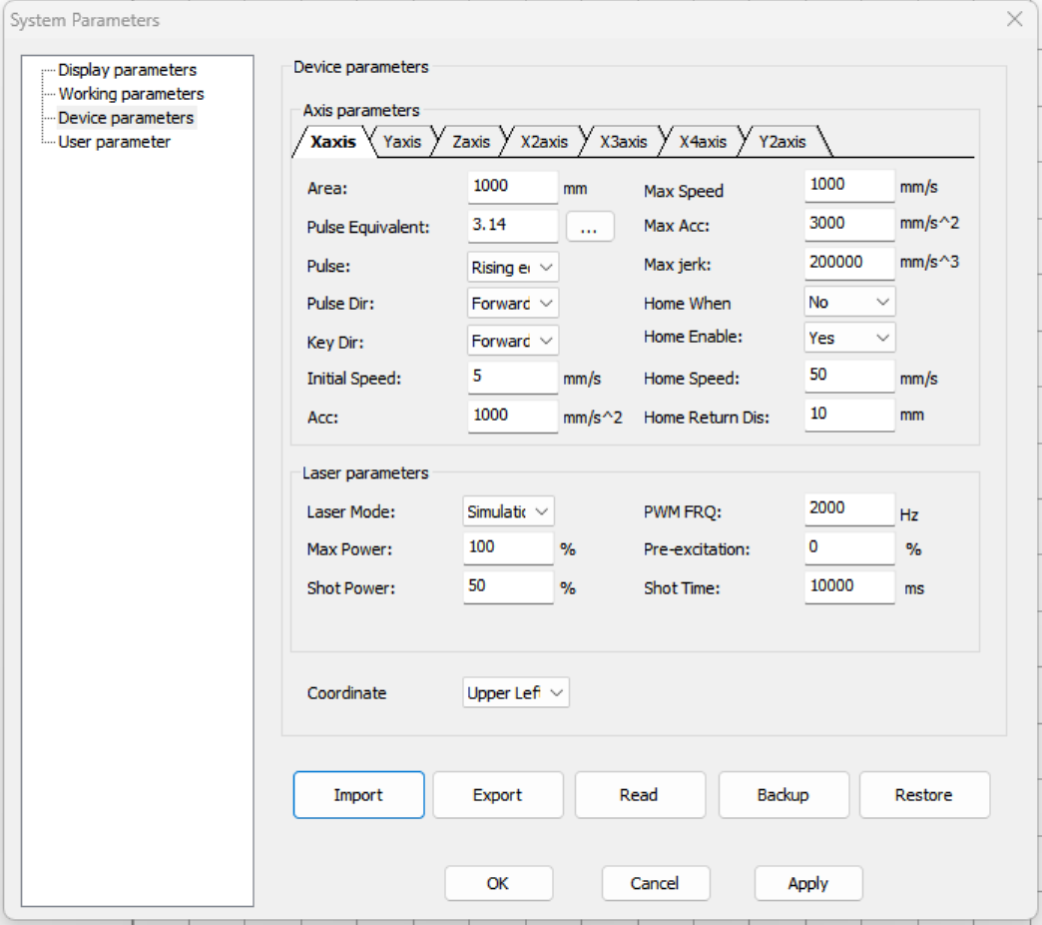

Device parameters:

X axis parameters: (the other axis parameters meaning with the X axis meaning, but the setting value is different)

* Area: set the axis motion stroke, according to the machine size adjustment.
* Pulse equivalent:relative to the displacement of each pulse signal of machine tool moving parts called pulse equivalent, also known as the minimum setting unit. Click Settings pulse equivalent, as shown in figure.

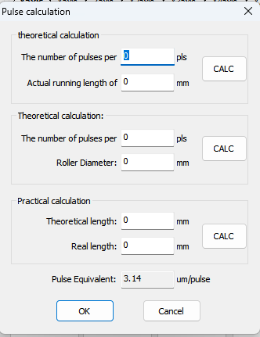

The theoretical calculation:

One motor pulse number: stepper motor; At 1.8 degrees, 32 subdivided driving machine, for example, one motor pulse number: 360/1.8 * 32-6400 (pulse). Servo motor. Panasonic servo A5, for example, PR008 parameter default PC sends ten thousand pulse motor turns a circle.

Motor real walk a circle length: this value when mechanical design have been confirmed, about mechanical design department.Click on calculate, automatically calculate the pulse equivalent, click ok button to set the value to X pulse equivalent.

Practical calculation:

Theoretical length: draw a 100 mm straight and level, theoretical length is 100 mm, to generate cutting processing documents.Actual length: the actual length of the measured by measuring tools and if 50 mm.Click on calculate, automatically calculate the pulse equivalent, click on button to set the value to X pulse equivalent.

* Pulse trigger edge: the rising and falling motor driver trigger along. Set this parameter is not correct, could lead to job cut dislocation.
* Pulse direction(dir): adjust the direction of axis.
* Key direction(dir): change the direction of the keys. If it is found that the up and down or so key direction inside out, and back to zero normal word, change the parameters, is normal.
* Initial speed: set the initial speed of the shaft began, usually set 10 mm/s. General scope for the 5 mm/s to 30 mm/s.
* Acceleration(acc): the acceleration of the shaft running. General step motor with 500 mm/s2 to 2000 mm/s2. Typical values for 1500 mm/s2. Servo motor using a wide range, in the 500 mm/s2 to 5000 mm/s2. Typical values for 2000 mm/s2.
* Maximum speed: set the speed of the shaft's largest can run.
* Maximum acceleration: the shaft maximum acceleration can run. Depending on the motor ability of the equipment. This parameter is used to specify the scope of the maximum speed of the shaft. Debugging good generally do not need to change.
* Max jerk: can set the shaft's largest run and acceleration. Depending on the motor ability of the equipment. This parameter is used to specify the scope of the maximum speed of the shaft. Debugging good generally do not need to change.
* Home when : : allows boot back to zero. No: boot back to zero.
* Home enabled: : then the axis allowed back to zero. No: the shaft back to zero.
* Home speed: back to zero.
* Home return distance: the X axis is set the distance between the origin and back to zero position.

The laser parameters:

* The laser mode: which related to the laser power supply interface connection. If the connection is simulated, the simulation, if the connection is the laser power supply PWM input port, select PWM mode. And according to the different laser Equipped with ultraviolet light, optical fiber, etc. Depending on the laser power supply is configured.
* The maximum power: set the maximum output power of the laser. Laser port maximum output power, such as setting up 50% and 50% of the system, the power of the laser tube, namely half. This is usually set up 100%. The limitation on the maximum power usually does not make the request.
* Shot power: set the preset percentage (some) power.
* PWM frequency(FRQ): set the PWM wave frequency, please according to the characteristics of laser Settings.
* Percentage pre-excitation syndrome: setting normal power output. Equivalent to the output power of the minimum or zero. Usually set 0%.
* Shot time: set the preset (some) light time.
* Coordinate:Upper left, lower left, upper right, lower right.
* Import equipment parameters: will U disk parameters into the software.
* Export equipment parameters: the parameter is exported to the U disk.
* Read the equipment parameters: read the controller parameter setting in.
* Save backup: backup set current good parameters to control system is mainly for the convenience of you here in the need to use the last time set good parameters.
* Restore: is the parameters restore to the previous backup control system.
* Sure: save the parameter Settings.
* Cancellation: save the original parameter set.
* Application: application of the current set of parameters.

3.16.4 User Parameters：

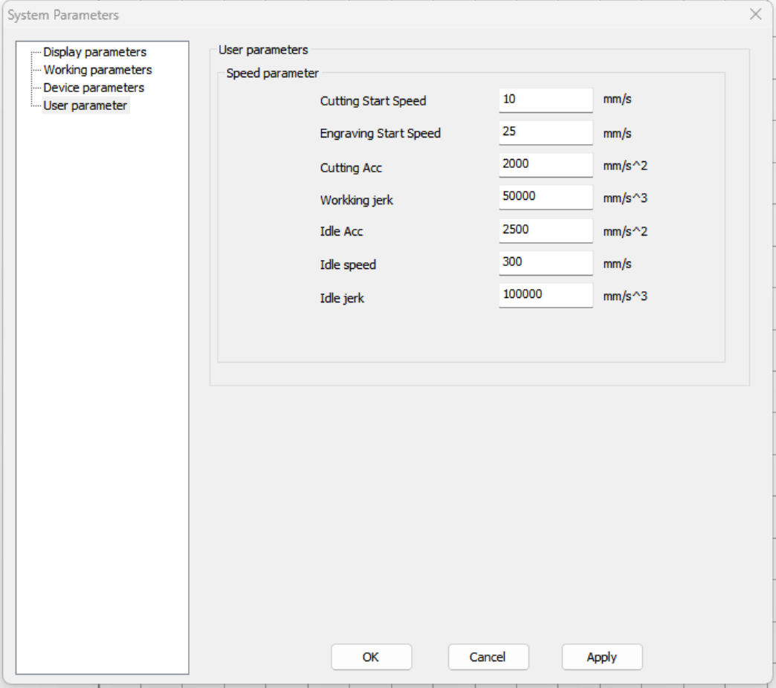

User parameters:

Speed parameters：

* Cutting Start speed: Settings when cutting speed motor start.
* Engraving started speed: set to start in sculpture at the time of the motor speed.
* Cutting acc: the processing of acceleration. Acceleration at the general processing to run the acceleration of than empty to smaller, more can ensure the cutting effect is mainly.
* Working jerk: the acceleration rate. This is usually with the default value for a smooth, the mm/s2 and acceleration in 60000 to 80000 mm/s2, requirement quickly and smoothly, is transferred to the 100000 mm/s. To 150000 mm/s.
* Idle speed: speed setting machine run path.
* Machine run idle acceleration: set path acceleration.
* Idle jerk: setting machine run path acceleration rate.
* Sure: save the parameter Settings.
* Cancellation: save the original parameter set.
* Application: application of the current set of parameters.

## 3.17 Connecting Devices

Click on thebutton，a device to connect dialog box, the diagram below:

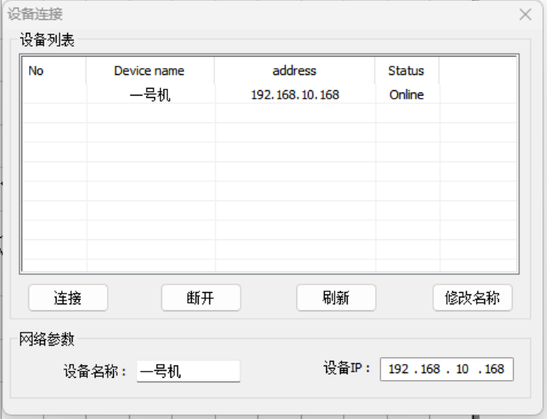

* Equipment list: list the devices can be connected, including types, equipment information such as name, address, state.

Article will highlight the moved to double-click, or click on the corresponding itembutton，Connect the device.

Article will highlight the moved to click on the corresponding itembutton，disconnect the device.

Click on thebutton，page refresh equipment connection.

* Network parameters: read the device name and IP address from controller parameters.Article highlighted will be moved to the corresponding item, fill in the device name field device name, click on the button，modify the device name.

# Chapter 4 Creating/Modifying the Graphical Toolbar

## 4.1　Creating a Toolbar

Graphics to create the toolbar is used to create the commonly used graphics, such as straight line, curve, circle, square, etc., if you choose the corresponding toolbar icon, the icon will be in the press state, as shown in the figure below:

m19

* Options:：The corresponding icon on the toolbar，Click on the icon, the mouse in a state of choice.
* Delete:The corresponding icon on the toolbar，Clear view.
* Editor:The corresponding icon on the toolbar，Some editors.
* The line:The corresponding icon on the toolbar，Draw more than any straight line line, click the left mouse button in a graphical editor area, by moving the mouse to refer to, location, and then click the left mouse button to complete a line edit any Angle, if you want to complete the end of the current editor, click the mouse right click.
* Round:The corresponding icon on the toolbar，Click on the icon, press the left mouse button and drag draw circle.
* A circular arc:The corresponding icon on the toolbar，Click on the icon, press the mouse left key to determine the center of the circle, drag the mouse to click ok arc at any positionDiameter, and then drag the mouse click to determine the arc. First draw arc radius.
* [ellipse](javascript:;):The corresponding icon on the toolbar，Click on the icon, press the mouse left key to determine the center of the circle, drag the mouse to click ok ellipse at any position X to the diameter, and then drag the mouse to click ok elliptic Y direction.
* Rectangular:The corresponding icon on the toolbar，Click the icon and drag the mouse to click at any position on the screen to draw a rectangle of any size.
* Text:The corresponding icon on the toolbar,This feature is mainly on the geometry to add text and the text editor. Click on this button will appear as shown in figure dialog:

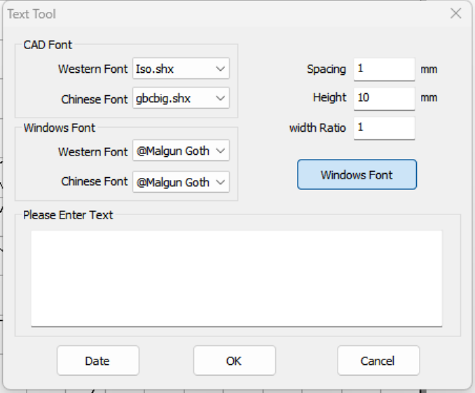

* Interrupted:The corresponding icon on the toolbar，Function keys to select it with the left mouse button click on the graphic to interrupt, interrupt mode is not closed their closed graph into graphics and then want to delete the line to delete broken and interrupt method is the line with the mouse click to change the function keys, and then under the first point with the mouse click to interrupt line, and then use the mouse to lay the adjacent line with him so that you can achieve interrupt.

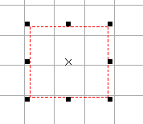

It had been before the interrupt

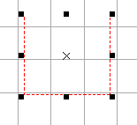

After the break

* Rotation:The corresponding icon on the toolbar，After selected, can manually adjust the rotation Angle.
* Layer selection:The corresponding icon on the toolbar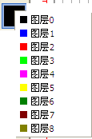,The default color, select the current use.
* Rod: The corresponding icon on the toolbar，Used for measuring dimension of graphics.
* Net:The corresponding icon on the toolbar，Its function is consistent with the view function (refer to 2.5 view menu bar).

## 4.2　Modifying the Toolbar

m18

* Set position:The corresponding icon on the toolbar，Click on the icon, the pop-up selection object reference point location dialog. As shown in figure 1

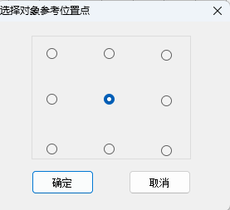

　　　 Select one or more objects, by selection around the object produces a consists of eight points and an x can edit box, put the mouse on the x by pressing the left mouse button, drag the mouse to drag the selected object, put the mouse to eight side with neither side in a point point, drag the mouse, press the left mouse button can be chosen from the larger/smaller objects.

Eight of the selected point and a corresponding above X nine circles, choose different location of the circle in the image above, the following coordinate values will change accordingly.

According to geometric properties of the object being selected, can directly input data in the edit box to modify geometric properties of objects.

* Ratio lock/unlock:The corresponding icon on the toolbar，Proportion of lock changes direction geometry size of the changes in proportion to the other direction. After proportion to unlock, modify the geometry size each other.
* Rotation:The corresponding icon on the toolbar，: input rotation Angle in the edit box, click the icon, the object with rotation Angle rotation Angle90, 180, 270
* X mirror

The corresponding icon on the toolbar,After the selected graphic, click the icon, the original graphics to the center of the vertical line graphic to shaft turn 180 degrees to the right, as shown in the figure below.

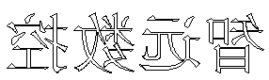

* Y mirror

The corresponding icon on the toolbar，After the selected graphic, click the icon, the original center of graphics in the graphics for horizontal axis downward turn 180 degrees, as shown in the figure below.

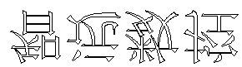

* Filter:The corresponding icon on the toolbar，For the import of graphics has to delete redundant overlapping segments

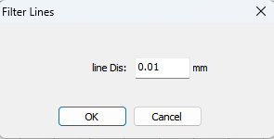

* Closed:The corresponding icon on the toolbar，For closed without closing graphics

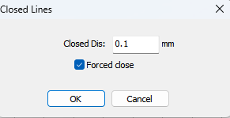

* Smoothing graphics:The corresponding icon on the toolbar,There will be below the pop-up dialog box, in the dialog box to drag the slider or the coefficient of numeric box enter the appropriate smoothCoefficient of point application, after to smooth import matte graphics was determined,If chose a recovery for the circle is not round graphics into round here is, of course, you need to get into a circle, graphics for modification, don't need to get into a round of graphics you don't need to be checked or will it be a circle, the biggest smooth coefficient is 1.

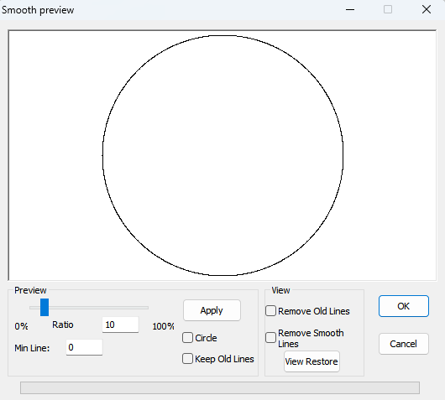

Before the fair

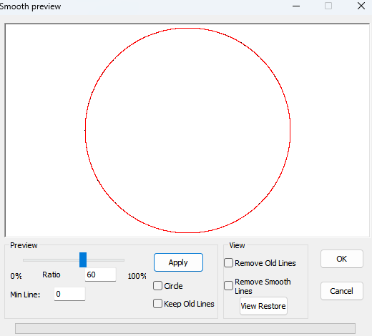

After the fair

Outside the building expansion:The corresponding icon on the toolbar，The selected need to enlarge or shrink the vector graphics, click on the icon appears below dialog:

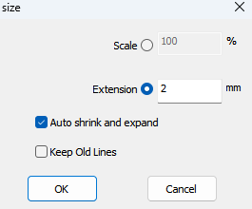

* Array:The corresponding icon on the toolbar，Click on the icon pop up the following dialog:

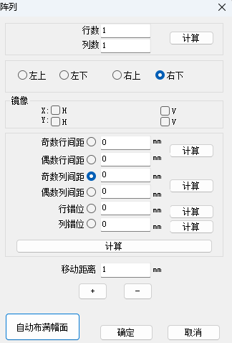

The number of columns: the number of columns on the array.

Number of lines: array rows.Column spacing: array column spacing.

Line spacing: array line spacing.

Array direction choice: in the original array upper left/right/left/right side.

Mirror, mirror: H is horizontal v is vertical mirror.

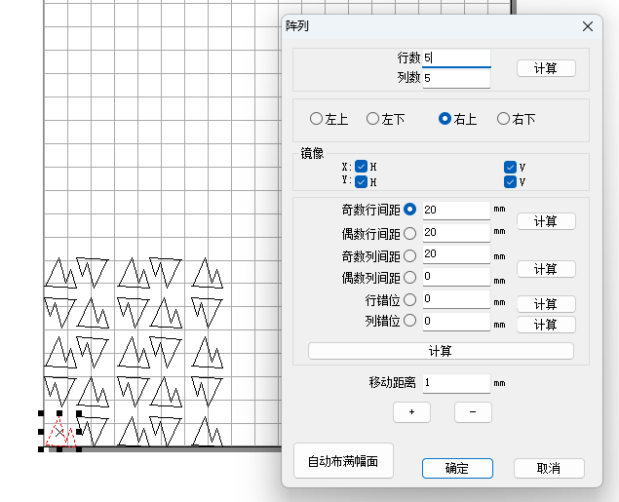

Odd column spacing: set longitudinal odd column spacing distance (such as 13579 odd)

even column spacing: longitudinal even set column spacing distance such as 246810 for an even number odd line spacing: setting transverse odd line spacing distance (such as 13579 odd)

as the even line spacing: setting transverse the even line spacing distance (such as 13579 is an even number)

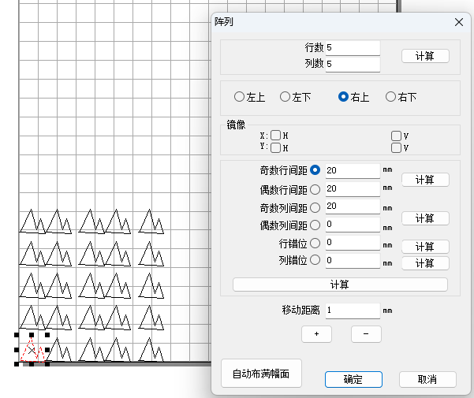

Dislocation: set it is between a column and column graph for dislocation arrangement.

Line dislocation: set it is carried out on the line and the line between the graphics dislocation arrangement.

Automatic is full: full automatic wide the whole machine.

Sure: determine the array.

Cancellation: cancel the array.

Tip: the array processing (virtual array) and array array (solid), the difference between a virtual array is only the mother is entity, other array of graphics just showed that had no substance, or modified matrix with maternal movement and change, the main advantage is that small amount of data. Real array is the array of objects are all entities, each entity can be edited separately.

* Layout:The corresponding icon on the toolbar，Is each other moving equipment layout tool operation.

Determined to generate typography. According to the instructions, in the full picture and can be specified for typesetting. After the layout directly by processing the data, don't go to translation, rotation, zooming, otherwise it will damage data individually, lead to Processing is not normal.

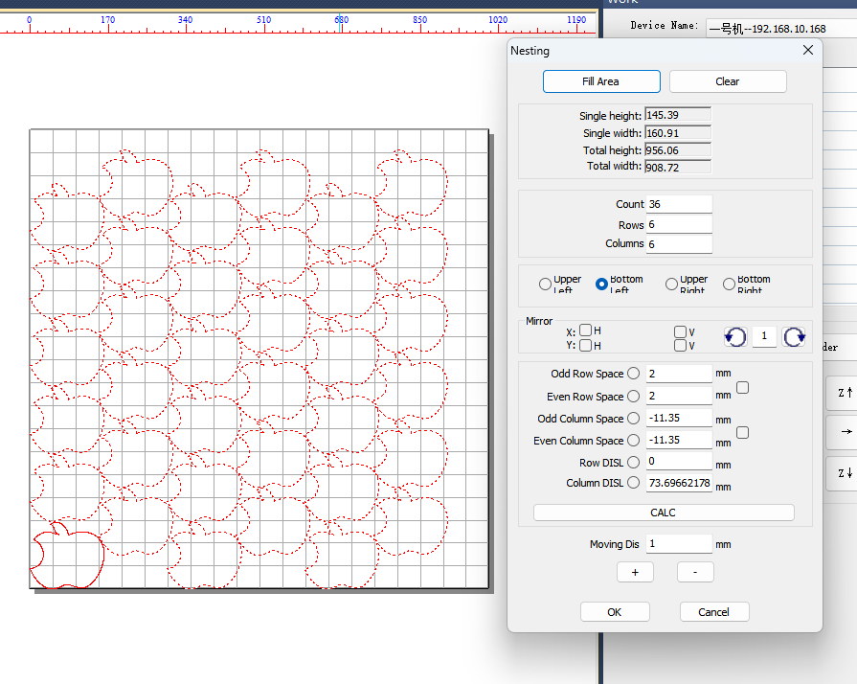

Full picture

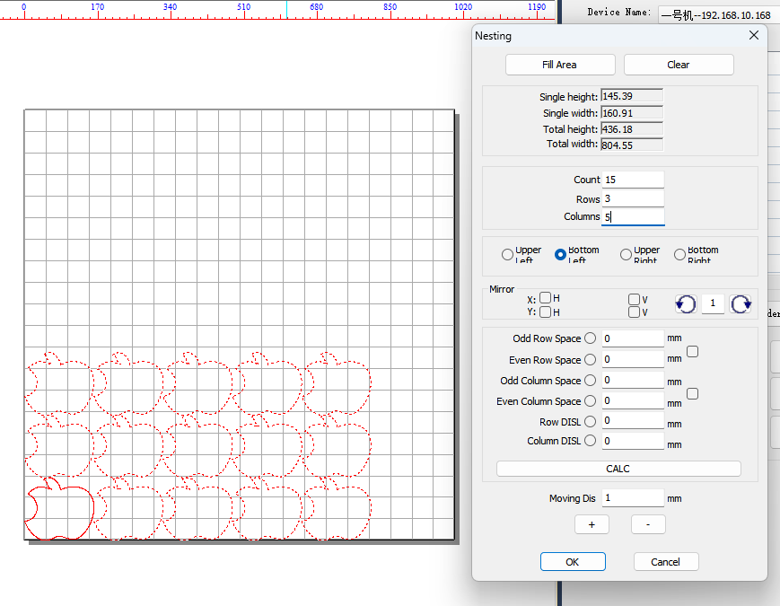

Specify the number of digits in typography

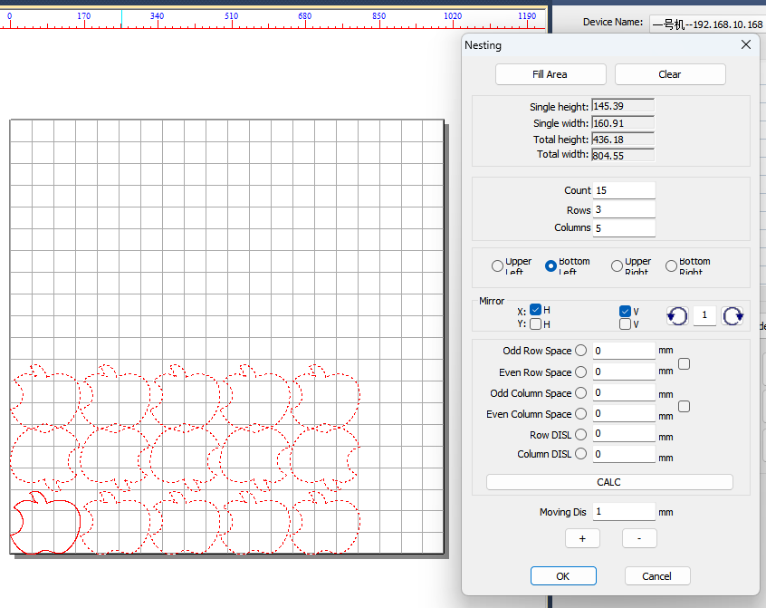

Image format

Here you can also manually accurate change the line spacing:

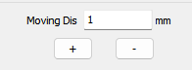

In the input you want to move the distance and then use the mouse to move up or down here is the line spacing can be modified, and then use the mouse to point column spacing in the mouse point shift to the left or the right end point "ok".

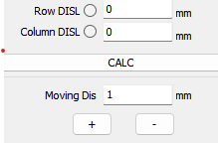

* Groups:The corresponding icon on the toolbar，Multiple graphics that make up a larger body.

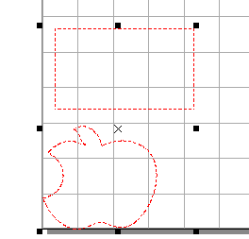

* Scattered groups:The corresponding icon on the toolbar, put a big whole into multiple small overall.

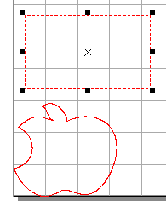

* Lead Settings:The corresponding icon on the toolbar，Click on the rebound out of the dialog box as follows according to need to be set.

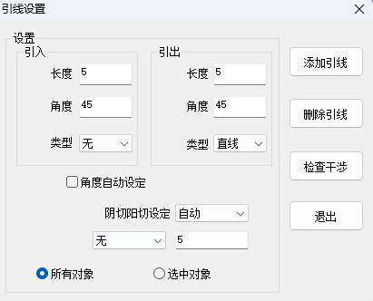

* Manual lead:The corresponding icon on the toolbar，Manually add lead.
* Material width:The corresponding icon on the toolbar，Click on the rebound out of the dialog box as follows according to need to be set.

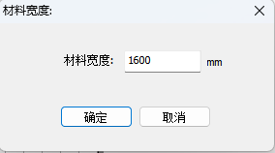

# Chapter 5 Layers/Alignment Toolbar

## 5.1　Layer Toolbar

Layer, the function of the toolbar is used to set the processing object layer, use different color to indicate different layers.

m21

Select graphics object, and then click on the layer color toolbar ICONS, the graphics object is stratified. The software supports 16 layer color Settings. Each layer object can be set separately different processing technology, detailed details later.

## 5.2　Align the Toolbar

Alignment aligned toolbar is used for single or multiple graphics object. Align the toolbar below:

m20

* Align center:The corresponding icon on the toolbar，The selected object as a whole wide center alignment.
* Upper left alignment:The corresponding icon on the toolbar，The selected object as a whole, wide left alignment.
* Lower left alignment:The corresponding icon on the toolbar，The selected object as a whole, wide bottom left alignment.
* Upper right alignment:The corresponding icon on the toolbar，The selected object as a whole, wide right alignment.
* The lower right alignment:The corresponding icon on the toolbar，Selected object as a whole to wide right alignment.
* Left alignment:The corresponding icon on the toolbar，, in the most on the left side of the object as a benchmark to align on the left.
* Right alignment:The corresponding icon on the toolbar，In the most the right side of the object as a benchmark aligned on the right.
* On the alignment:The corresponding icon on the toolbar, based on the upper object depend on alignment.
* The alignment:The corresponding icon on the toolbar，Based on the side of the object under lower alignment.
* Horizontal center alignment:The corresponding icon on the toolbarS，Based on all the selected object horizontal centerline center alignment.
* The vertical center alignment:The corresponding icon on the toolbar，With all of the selected object vertical centerline as a benchmark center alignment.
* Center alignment:The corresponding icon on the toolbar，The center of all the selected objects as a benchmark center alignment.

After the version directly by processing the data, don't go to translation, rotation, zooming, otherwise it will damage separately, data, guide to processing is not normal.

# Chapter 6 Work Panel

Panel, including the layer management, path optimization, equipment control and manual control, etc.

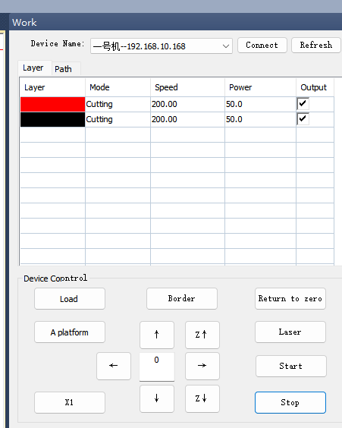

6.1 [Device attachment](javascript:;)



Device name: name and address of the connected device.

Status:

Connection: the connection to the device.

Refresh: refresh the address.

6.2 Layer Management

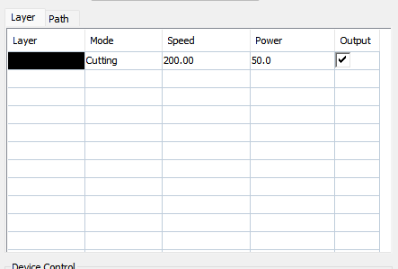

Including color layer, processing layer management mode, the information such as speed, power, whether the output and the layer move up, down, top, bottom, selected operations such as command buttons.

* Click on a color layer, the layer information is highlighted, click click the right mouse button, the following figure. Shown below:

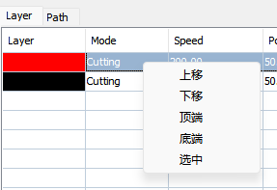

Click on theThe layer up a layer,Click on theThe layer down a layer,Click on theThe layer up to the top,Click on theThe layer down to the bottom,Click on theThe color layer object is selected.

Tip: file processing order based on the layer order, change the layer order is processing the order.

Output: check the output, the laser processing file output when the layer object. Don't check the output, the layer object don't output, machining process of the layer object does not.

* Double-click on a color layer, open the layer information box, the diagram below:

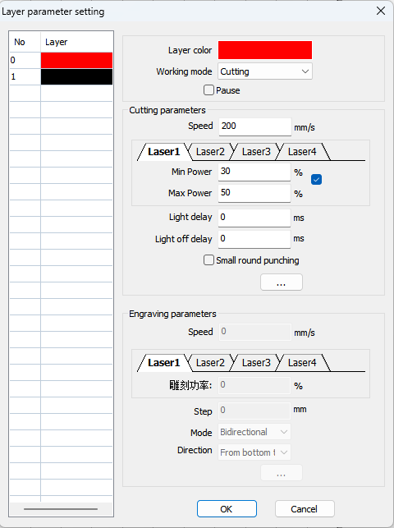

Layer information box on the left side of the show all layers and sequence, the right display the current layer information.

* Current layer color: displays the current selected color, the mouse click on the left side of the different layer, the layer change accordingly.
* Work mode: click the drop-down button on the right side, there are five working mode, as shown in the figure below:

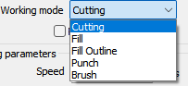

* Pause: check the pause, processing to the layer object machine stop, press the start key processing again.

Cutting parameter Settings:

* Speed: processing speed, not set is greater than the maximum speed of.
* Laser setup: there are laser1,laser2,laser3,laser 4.
* Minimum power: minimum operating power when processing.
* Maximum power: maximum operating power when processing.
* The light delay: a light ahead of time when processing, the material is difficult to cut through.
* The light off Delay: after the completion of processing.
* Small round punch: have the sealing length, delayed perforation graphic size, perforation, click in the diagram below:

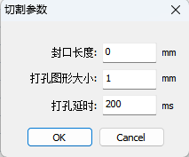

Engraving parameter Settings:

* Speed: processing speed, not set is greater than the maximum speed of.
* Laser setup: there are laser1,laser2,laser3,laser 4.
* Carving power: when processing a bitmap, percentage of laser power laser tube a carving speed.
* Carving interval(step): refers to the processing graph of the distance between line and line.
* Carving mode: a one-way scan, two-way scanning, as shown in figure:



* Carving direction: from top to bottom, from bottom to top, from left to right, from right to left, as shown:

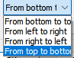

* Sure: save the parameter Settings.
* Cancel: save the original parameter set.

## 6.3 Path Optimization

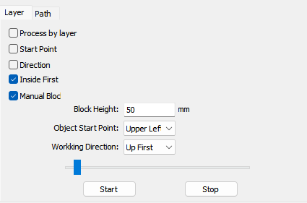

* Processing by layer:
* The Starting point:
* Direction:
* Inside first:
* Manual block:
* Block height: set when the set size and the width of the machining graphics, at the same time also need to be closed.
* Object Star point:starting point, relative to the graphics laser starting point, as shown in figure:

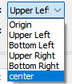

* Working direction: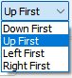
* Simulation:

6.4 Device Control

Equipment control including file processing (load), the processing/pause, stop, borders, back to zero, laser,As shown in the figure below:

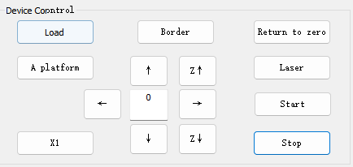

File processing (load) :click theButton,Card file processing dialog:

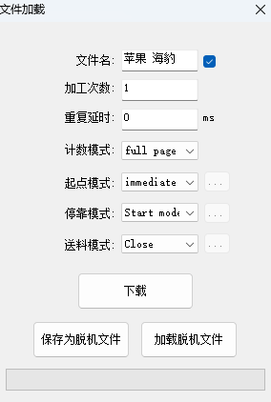

File list on the left side of the dialog box is equipment, display the current controller in the file, on the right side is pending file Settings.

* Under the file name: to stay under the file name.
* Processing times: Settings file repeated processing times.
* Counting mode: the whole and the individual count, as shown:



* Repeat delay: set the repetitive processing the processing to the end of the time interval between the start of the next process.
* Starting point mode: select processing starting point. Click the drop-down button on the right side, open the drop-down list box:

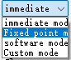

* Pattern: immediately to laser current location as a starting point of processing.
* Fixed point mode: to control the system Settings at the bottom of the X/Y coordinates do processing and the starting point.
* Software pattern: at the current processing object at the start of a PowerCut software graphics editing areaPoint coordinates as a starting point of processing.
* After custom mode: select the custom mode, followed by the coordinates of the set up button becomes available,Click on the button, the pop-up coordinates Settings dialog box, the diagram below:

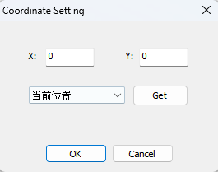

Can directly input X/Y coordinate values as a starting point, processing can also click on the button to get the coordinate values as a starting point.

* Docked mode: choose the docking stations. Click on the right side of the drop-down button to open the drop-down list box:



* Starting point mode: after completion of processing, laser head back to the starting point for docking stations.
* Origin pattern: after completion of processing, laser head back to the origin as a docking stations.
* Custom mode: select the custom mode, then the coordinates of the Settings button becomes available, click on the button, the pop-up coordinates Settings dialog box, see below:

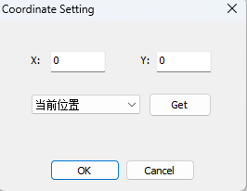

Can directly input X/Y coordinate values as docking sites, also can click the button to obtain the coordinate values as docking stations.

* Feeding mode:
* Close: no feeding mode.
* Feeding: select feeding mode, then feed Settings button becomes effective, click on the button, pop-up feed Settings dialog box, see below:

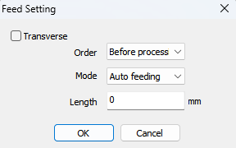

Feeding direction: check the option, transverse feeding, do not check this option, the longitudinal feed.

Selection of feeding order: there are two kinds of order, after machining before the feed or feed, the first processing to feed or feed processing again.

Feeding modes: there are two modes to choose from, automatic feeding mode or intelligent feeding mode.automatic feeding mode ，In the input feed length.intelligent feeding mode，The length of the system, intelligent computing each feed,

Only in the input feeding interval value.

clickbutton，Confirm the parameter is set,clickbutton，Cancel the parameter Settings.

Tip: feeding mode only in the direction of a feed.

* Push board: select push plate model, followed by feed Settings button becomes effective, click on the button, pop-up feed Settings dialog box, see below.



Feeding direction: check the option, transverse feeding, do not check this option, the longitudinal feed.

Selection of feeding order: there are two kinds of order, after machining before the feed or feed, the first processing to feed or feed processing again.

Feeding modes: there are two modes to choose from, automatic feeding mode or intelligent feeding mode.automatic feeding mode ，In the input feed length.intelligent feeding mode，The length of the system, intelligent computing each feed,

Only in the input feeding interval value.

clickbutton，Confirm the parameter is set,clickbutton，Cancel the parameter Settings.

* 。Material: select synchronous feeding mode, the following material Settings button becomes effective, click on the button, the pop-up material Settings dialog box, see below:

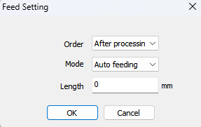

Selection of feeding order: there is an order, processing after feeding, the processing and feed first.

Feeding modes: there are two modes to choose from, automatic feeding mode or intelligent feeding mode.automatic feeding mode ，In the input feed length.intelligent feeding mode，The length of the system, intelligent computing each feed,

Only in the input feeding interval value.

clickbutton，Confirm the parameter is set,clickbutton，Cancel the parameter Settings.

* Processing/pause:click on thebutton，control equipment to start processing or pause.
* Stop:click on thebutton，stop processing.
* Walk borders:click on thebutton，equipment for processing documents cut rectangular boundaries.
* Back to zero:click on thebutton，device back to the origin of the operation, the X/Y axis to move the origin.
* Laser some:click on thebutton，Laser equipment to perform some action.

## 6.5 Manual Control

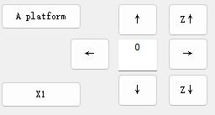

* 、：Click this button to control the X axis, moving, reverse.
* ：X1、X2、X3、X4 Switch button.
* 、：Click this button to control the Y axis moving, reverse.
* 、：Click this button to control the Z axis moving, reverse.
* 精确移动：Press the direction key, again in this input numerical laser accurate moving in this direction.

# 

# Chapter 7 Operation process

## 7.1 Step 1: Install the machine and its accessories

please according to the hardware hardware installation instructions in the installation manual, installation related machinery and equipment and accessories.

## 7.2 Step 2: Install the software

Who will be copied software from the CD to the computer, detailed installation method, please refer to the first chapter.

## 7.3 Step 3: Draw and process graphics

You can use this software graphing tools, such as CorelDraw. Photoshop AutoCAD draw your own graphics, and save them for the extension of PLT, DST, AI, DXF, PLT file. BMP file needs to be converted to the net and the format of the point (suggest using Photoshop).

## 7.4 Step 4: Set processing parameters

Click the icon in the software to design load you good graphics to working level. At this point you can to add, working parameters Settings, see the previous chapters set method in detail. , you can download the processing data to a machine or USB drive.

## 7.5 Step 5: Judge the focal length

Focal length is in the hardware installation to adjust good, here to judge, if not suitable to do.

## 7.6 Step 6: Start processing

When the above steps are completed, you can click the start button.