How to connect Manual Plasma Torch to Plasma Unit
Step 1 : Changing the default 2 pin Aviation connector to a 4 pin Aviation connector.
Out of the box the hand held torch comes with a 2 pin female connector that has to be changed to a 4 pin female connector.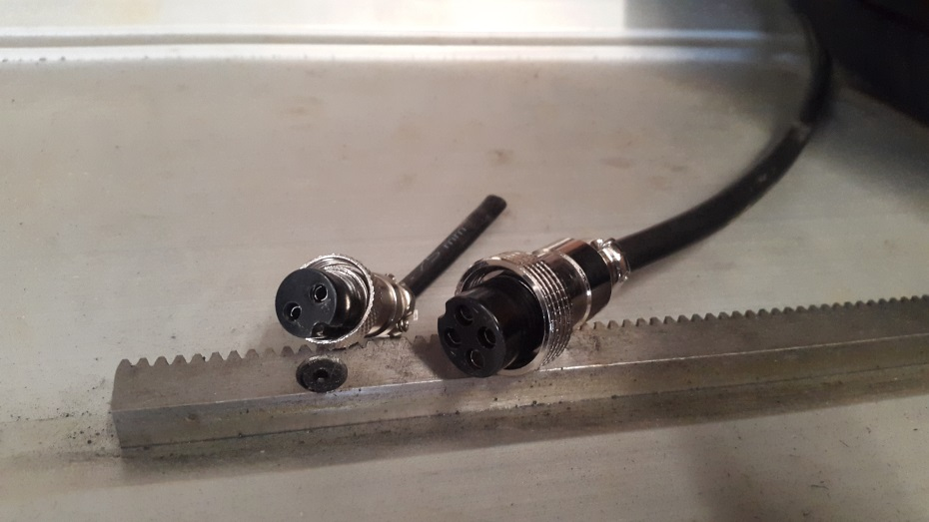
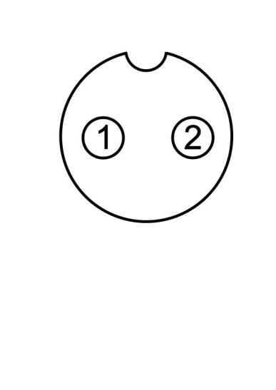 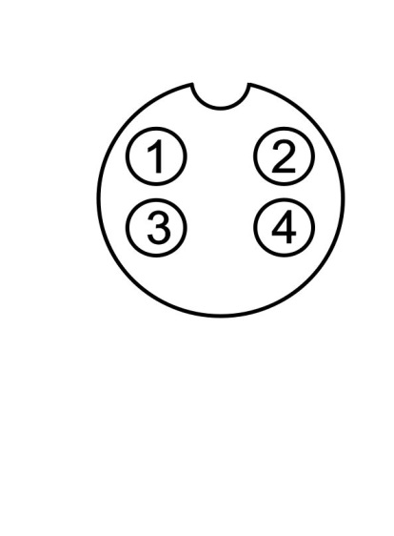
Step 2 : Connecting the Hand-held Torch to the Plasma Unit.
Move the wiring from pins 1 and 2 on the original connector A onto pins 1 and 2 (Control Signal) on connector B

B
A
Connect the 4 pin aviation connector to the Control/Feedback male plug at the back of the Plasma Unit.
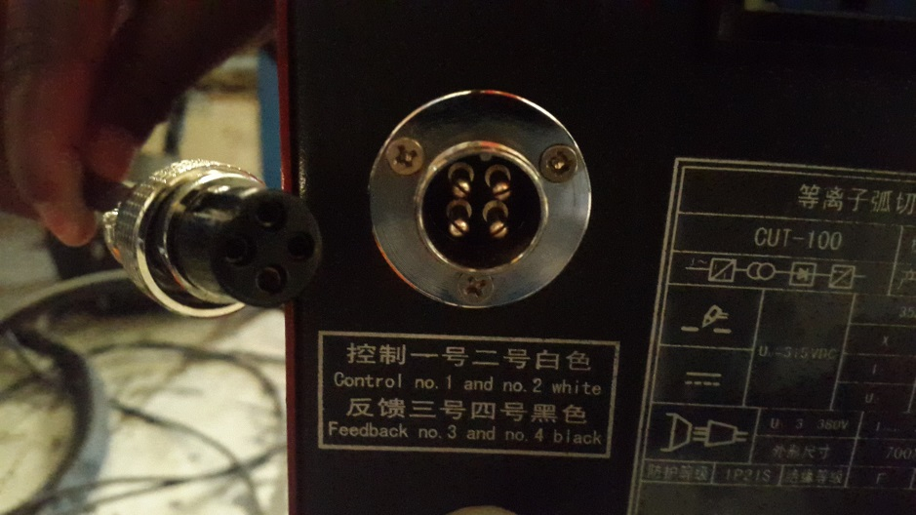
Connect the Red connector cable to the Arc Strike Interface and the Nut Connector to the Output Interface.
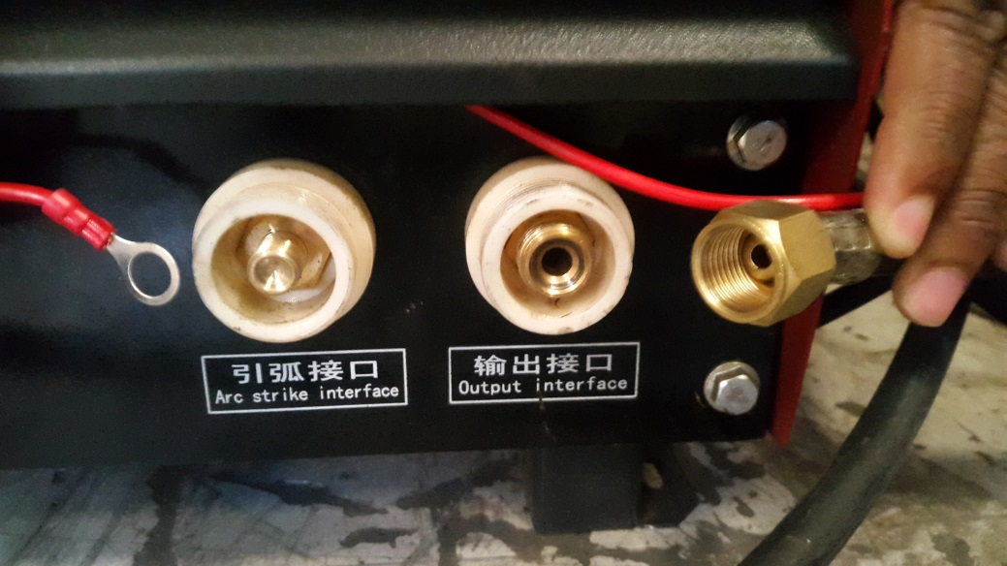
Please note that if the red wire is not connected you still will be able to cut, but only arcing when the torch touches the plate to create a circuit.

If connected, arcing can be achieved at a distance.

A rolling spacer can be used to maintain constant distance from torch to material during cutting.

