SKU Conversion LaserMaster RustOff System FWH20-DC30A Boxed Unit
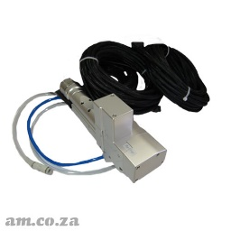 | LM-TORCH/DC30A | RustOff Dedicated Cleaning Torch with Dual-Galvo Lens for ≤3000W Fiber Laser LaserMaster RustOff System, FWH20-DC30A-V4-T
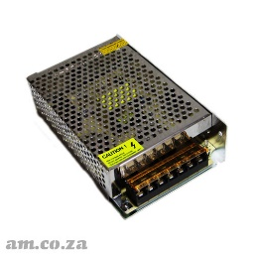 | AE-POWER/24/2 | Generic 220V Switched Power Supply Output DC 24V 2.5A, for LaserMaster Handheld System Controllers
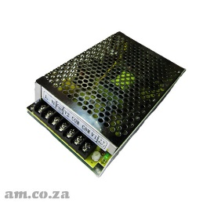 | AE-POWER/15/2 | Generic 220V Switched Power Supply Output DC +15V 2A and -15V 2A, for LabelMark Galvo Scanner, and LaserMaster Handheld System Controllers
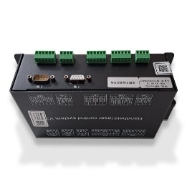 | LM-RUSTOFF.2026 | Motherboard of LaserMaster RustOff V4 Dual-Galvo Lens Control System (2026 Model) RDCleanV4-DWPro
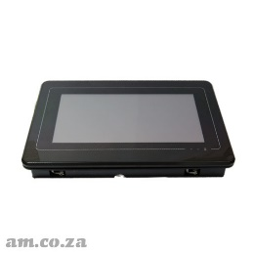 | LM-RUSTOFF/KEY.2026 | Touchscreen Interface of LaserMaster RustOff V4 Dual-Galvo Lens Control System (2026 Model) T7015WT, 6 PIN  There is a small bag of clips, go with the screen
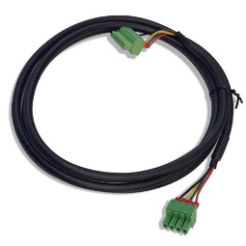 | LM-CABLE/V4 | V4 Data Cable from Touchscreen Interface to Motherboard (2026 Model, 6PIN - 6PIN) of LaserMaster RustOff control System
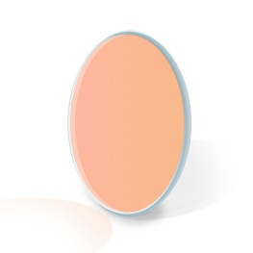 | L-LENS-QUARTZ/30/2 | Φ30mm Quartz Protection Windows 2mm Thickness Laser Collimator Lens for Fiber Laser with 650 1064AR Coating, for Welding/Cleaning Torch Protection  Total 4 Pieces

