打标机驱动安装
Marking machine driver installation

第一步 Ｆirst step：
将Ｕ盘的以下文件(Ｅzcad.2.12.2\win7 win8 win10 X64drive\winxp win7 32drive)拷贝到硬盘.
Will U disk of the following file (Ezcad.2.12.2 \ win7 win8 win10 winb win7 32drive) copy to the hard disk.
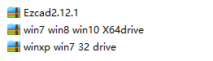
第二步The second step
将(Ｅzcad.2.12.2\win7 win8 win10 X64drive\winxp win7 32drive)３个压缩包文件解压．
Will be (Ezcad.2.12.2 win7 win8 win10 X64drive \ winxp win7 32drive) 3 compressed package file extract.
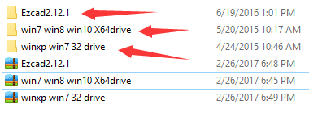
第三步Third step
检查电脑的windows系统为32位还是64位操作系统
Check the computer's Windows system for 32-bit or 64-bit operating system
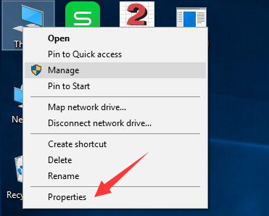
此台电脑为windows10 32位操作系统
This computer is windows10 32-bit operating system
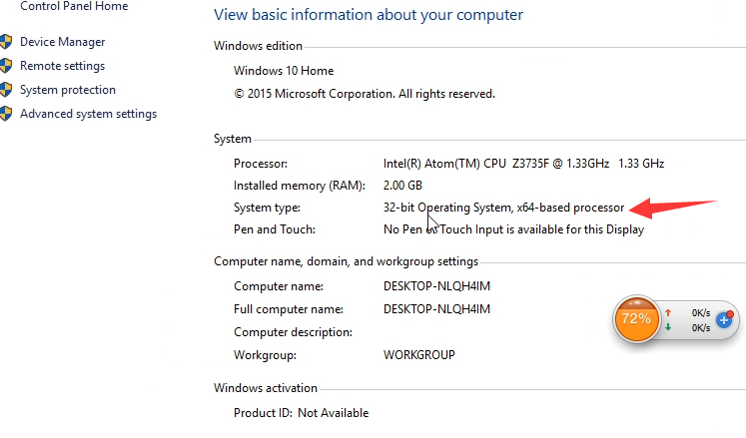
对应的驱动程序为硬盘里面的winxp win7 32 drive文件
Corresponding to the driver for the hard drive inside the winxp win7 32 drive
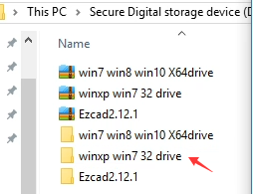
第四步The fourth step
安装驱动程序，点击This pc(我的电脑)右键，打开Ｍanage设备管理器
Install the driver, click This pc right, open Manage
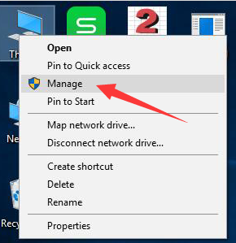
第五步 The fifth step
选择未加载驱动程序USBLMCV2
Select the driver USBLMCV2 not loaded

如果没有显示USBLMCV2,请将电脑与打标机用USB线连接，并打开打标机的钥匙开关及按钮
If USBLMCV2 is not displayed, connect the computer to the marking cable with the USB cable and turn on the key switch and button
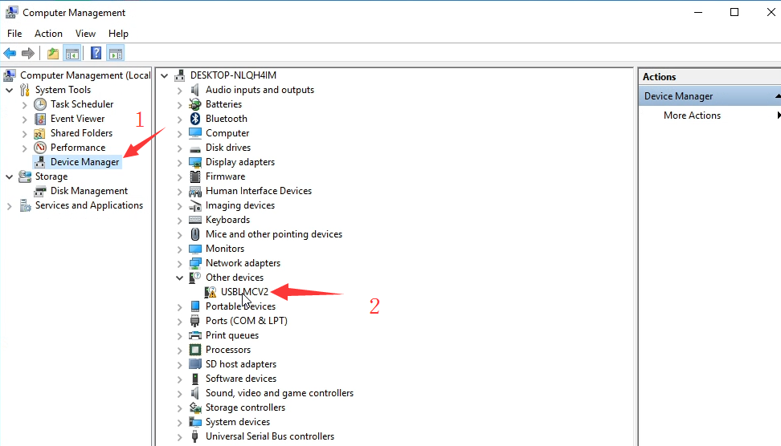
右键选择加载驱动程序
Right click to select Update Driver Software
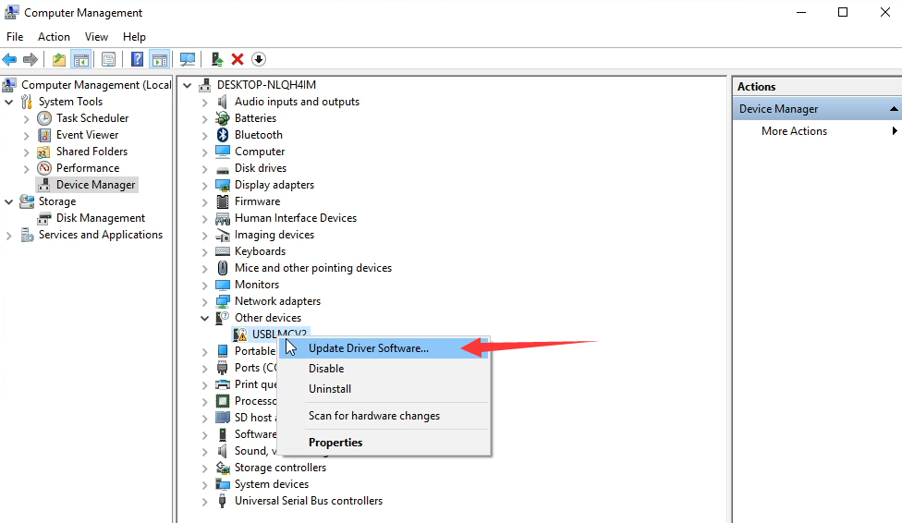

第六步Step 6
选择自定义文件夹选择驱动
选择Browse my computer for driver software
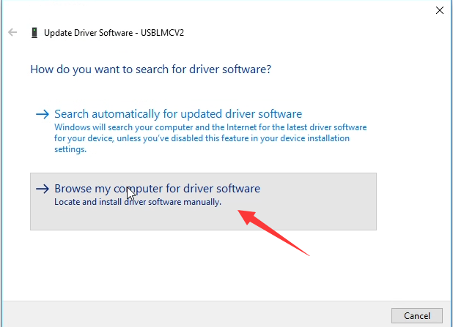
选择文件夹
Browse
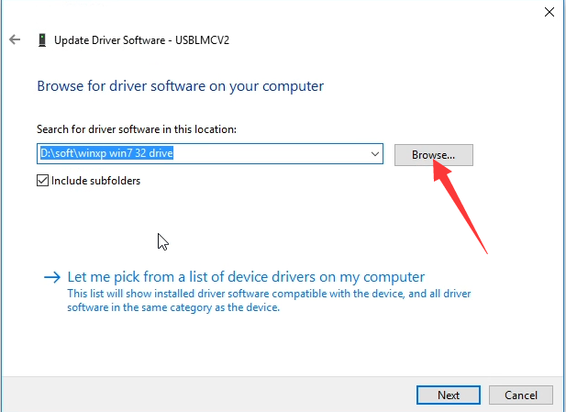
第七步Step 7
选择拷贝到硬盘里winxp win 32 driver文件夹
Choose to copy to the hard drive winxp win 32 driver folder
温馨提示：如果电脑是windows 64 位操作系统，请选择win7 win8 win10 X64driver
Tips: If the computer is windows 64-bit operating system, please select win7 win8 win10 X64driver
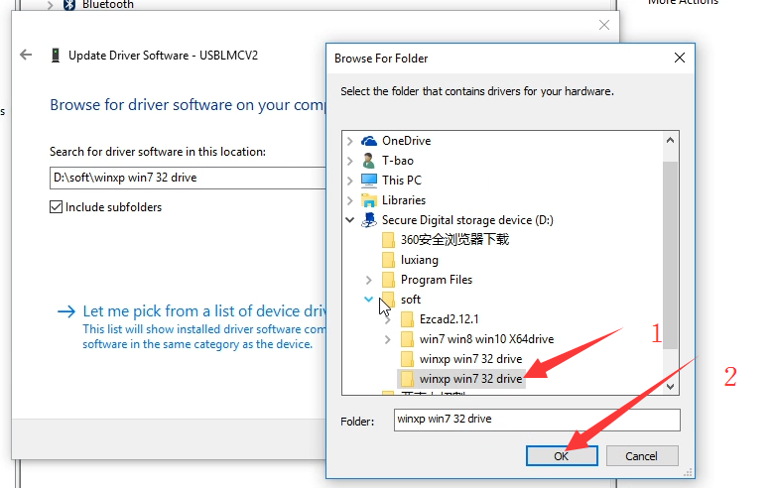
下一步Next
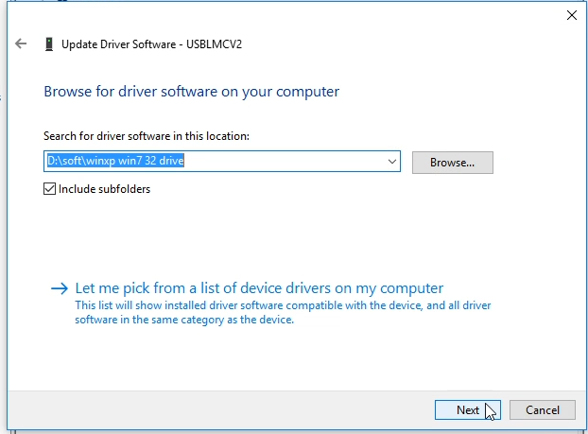
安装驱动程序中 lnstalling Driver Software…
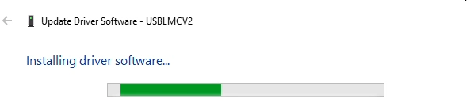
安装完成，点击Close
The installation is complete and click Close
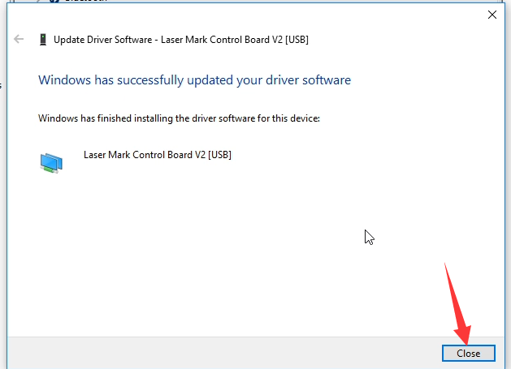
在设备管理器里面显示驱动名称为BJJCZ Device,说明安装驱动成功
The Device Manager displays the driver name BJJCZ Device, indicating that the installation driver was successful
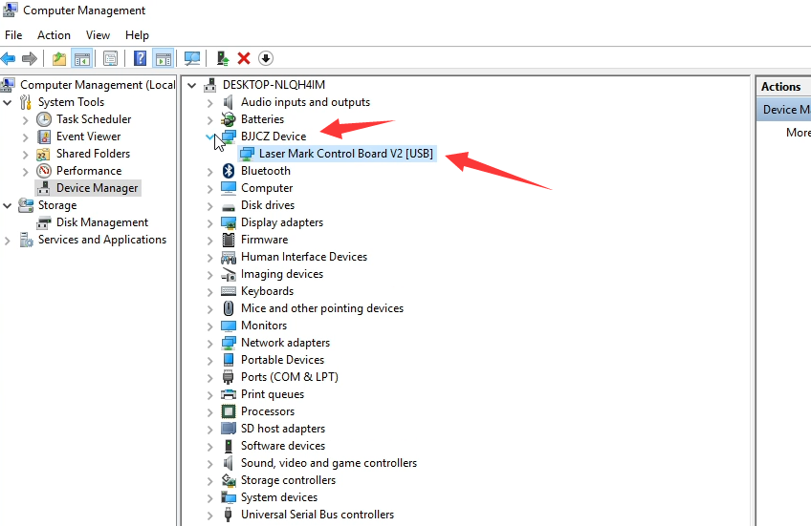

第八步Step 8
打开硬盘的Ezcad2.12.1
Open the hard disk of Ezcad2.12.1
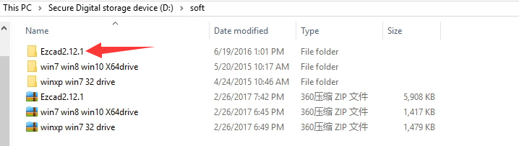
打开Ezcad2
Open Ezcad2
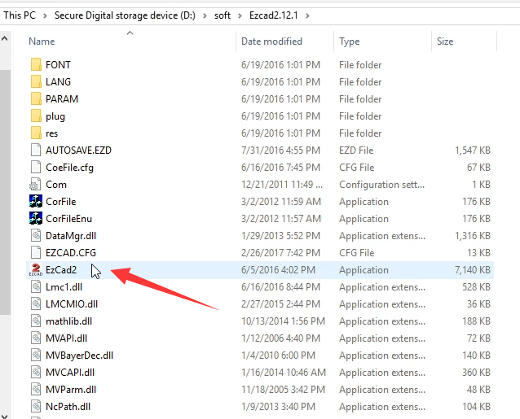
选择同意
Select l agree
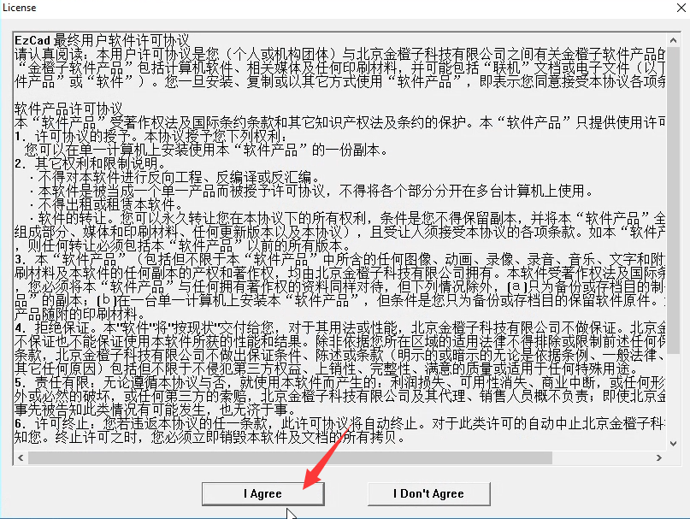
恭喜您顺利安装完成
Congratulations on your successful installation
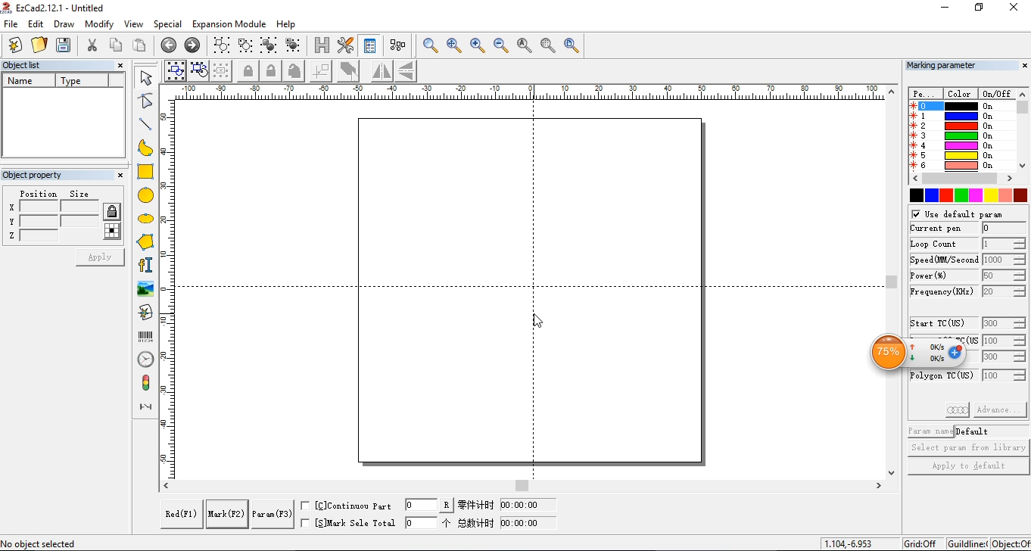

如果提示Can not find dongle! Software will work at demo state.说明您没有安装驱动或者打标机未打开，或者电脑与打标机用USB线没有连接．
If you can not find dongle! Software will work at demo state. Note that you have not installed the driver or the marking machine is not open, or the computer and the marking machine with USB cable is not connected.
