SKU Conversion H-ROLLER/1600/E6P to H-ROLLER/1600/E6
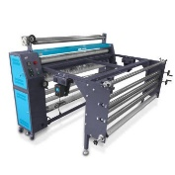 | H-ROLLER/1600/E6P | 1620mm Roller Heat Press (3x), 6.4kW 220V Electric Heating 3x Feeding & Take-up Rollers with Worktable (No Glass, 1760×800×10mm) in Crate Box, 32A 6mm² Cable Needed (Not Include) Suggest 32A Plug on 40A Breaker
Equal to all those products add together
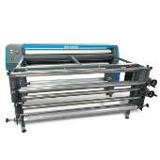 | H-ROLLER/1600/E6 | 1620mm Roller Heat Press (2x), 6.4kW 220V Electric Heating 2x Feeding & Take-up Rollers with Worktable (No Glass, 1760×800×10mm) in Crate Box, 32A 6mm² Cable Needed (Not Include) Suggest 32A Plug on 40A Breaker
+
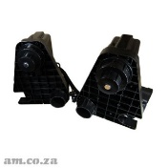 | F-ROLLER | Twin Drive Take-Up Rolling Collecting Device (on 50mm Poles, No Brackets), 220V, 25RPM, for All Large Format Printers and DTF Powder Shakers

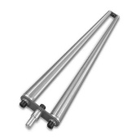 | H-PRESS/1600/STRETCH | Double Rolling Bar for Material/Paper Stretching to Increase Tension, ~1700mm Length
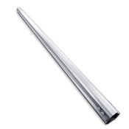 | H-PRESS/1600/UP | Paper Cone Fitting Bar with Friction Increasing Bands for Standard Take-up Roller, ~1600mm Length
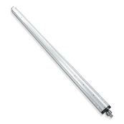 | H-PRESS/1600/FEED | Paper Cone Fitting Bar For Material/Paper Feeding with Friction Increasing Bands, ~1700mm Length with One Side Square Nut (ONLY ONE SIDE, there is a bar has both sides square nut. DO NOT Take Wrong One)
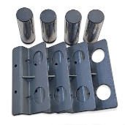 | H-PRESS/B/UP | Take-up Roller Brackets with Short Round Bars for 1600 Roller Heat Press Machine
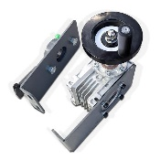 | H-PRESS/B/STRETCH | Rolling Stretching Bar Fitting Brackets for 1600 Roller Heat Press Machine  (There is a handle in box need to take out for this product)
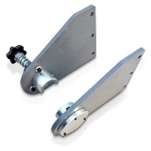 | H-PRESS/B/FEED | Feeding Bar Mounting Brackets with One Side Tension Adjustment Knob for 1600 Roller Heat Press Machine

