English version
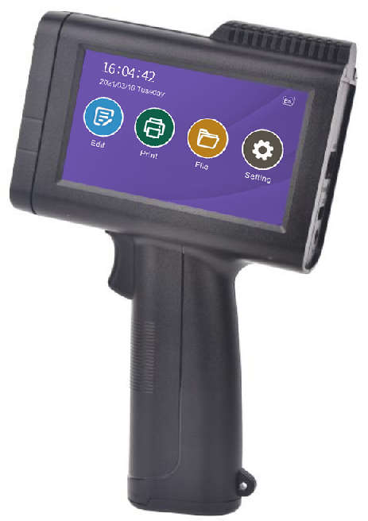
Please read the instruction manual carefully before using and keep it properly.
The picture related to this manual for reference only. All contents are checked and proofread. If there are any problems such as printing errors, please understand.
T-H series inkjet machine
instruction manual
- TH-1 (0.5inch)
- TH-2 (1.0inch)

Product warranty card
In the case of normal use and care, if any product quality problems are found, the company will repair or replace it for free.

Model： Dealer：
Number： |  |  | Date of Purchase：
Note：
Product  Warranty  Period | Product | Warranty Period
Product  Warranty  Period | Ink jet Printer | One year
Cause of Issue：
Tel：
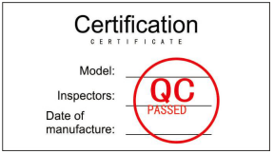

Disclaimer:
1. During the use of this product, if it is severely dropped, exposed to fire, water, unknown chemical corrosion, unauthorized disassembly and other man-made damage, it is not covered by the warranty.
2. If the machine fails, please back up the important information in the device in time before sending it for repair to prevent loss.
3. If the inkjet printer is abnormal, please call the maintenance engineer or call the manufacturer's service line as soon as possible.
4. It is strictly forbidden for untrained personnel to operate and use the inkjet printer.
5. It is strictly forbidden to disassemble the inkjet printer without the permission of the factory staff.
6. The operator of the inkjet printer must read the manual carefully before operating the machine.
7. The final interpretation right of this disclaimer belongs to the company
Precautions for use of
quick-drying ink cartridges

1.The power supply of the machine must be cut off before loading and unloading the ink cartridge
2.If you do not use the machine for more than 20 minutes, you must remove the cartridge from the machine.And clip it with the card.(Be sure to save the clip)
3.Specific requirements based on the nature of the ink cartridge, you are better to use ink cartridge out after opening ink cartridge.
4.Because the cartridge is quick dry nature, so the use of the process of a little drawing, missing line phenomenon, is a normal situation
5. If there is a phenomenon of a little drawing or missing line , you can use a soft paper towel to wipe the nozzle in one direction (Do not damage the nozzle with hard materials)
6.If it is fast dry white ink, shake it for 5-10 minutes before each use, otherwise the color will be lighter.(Be careful not to shake too hard）

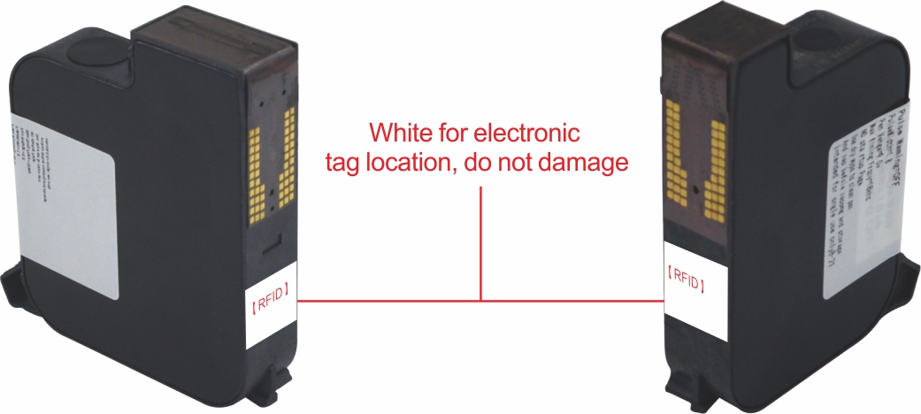

0.5inch ink cartridge（12.7mm）
1inch ink cartridge（25.4mm）
Technical parameter

Machine size： | 135*50*220mm (including handle)
Machine Material: | ABS Frame
Machine weight: | Approx. 425g (without ink cartridge)
Screen size： | 4.3 inch capacitive screen/480*272dpi
Save information： | unlimited storage
Printing accuracy： | 150DPI、300DPI、600DPI(Only for 1/2 inch )
Counting number： | 1-15 digits
Printing barcode： | Barcode, QR code, variable QR code
external interface： | Charging port, 3.5mm sensor interface, USB interface
Use environment： | Temperature 0-40C, Humidity 10-80%
Oily color： | Black, red, blue, green, yellow, invisible
Quick dry color: | Black, red, blue, green, yellow, orange, white, invisible
Cartridge capacity: | 42CC (half inch), 45CC (one inch)
Ink properties: | Fast dry, water, oily based Ink cartridge
Printing font: | Built-in national standard font library
Printing distance: | 2-5mm
Print height: | 2-12.7mm、2-25.4mm
Printing speed: | 40m/minute
Printing content: | Date, count, batch number, serial number, picture, etc.
Power parameters: | DC7.4V-0.8A lithium battery
Battery capacity: | 1500-2500mAh

T-H series inkjet machine
instruction manual
1.Appearance introduction

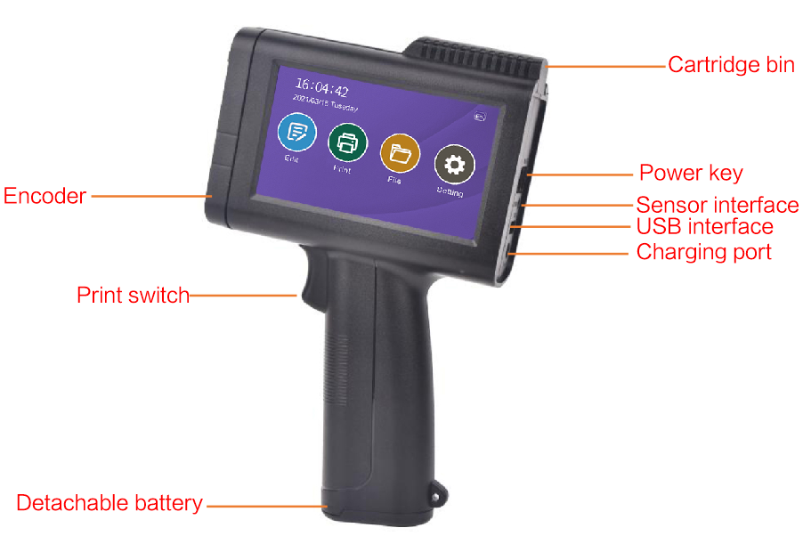

1. Encoder: Drive the inkjet printer to print out characters, so that the printed information is uniform and does not deform
2. Print switch: trigger the print command, press once to print once
3. Detachable battery; use detachable battery, the battery can be taken out after the cover is pushed open
4. Ink cartridge compartment: Push down along the direction of the indication pattern to open the ink compartment and install the ink cartridge
5. Switch button: This button can turn on or turn off the power
6. Sensor interface: can be connected to the sensor
7.USB interface: U disk can be connected to import data
8. Charging hole: used to charge the printer

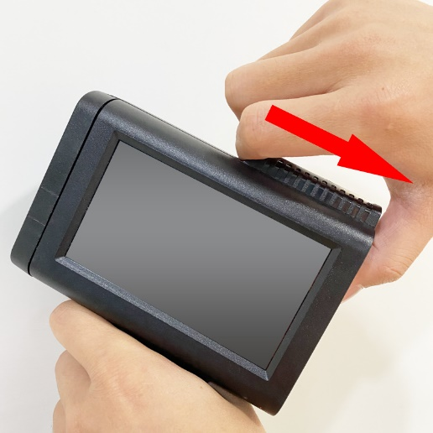
2.Installation introduction
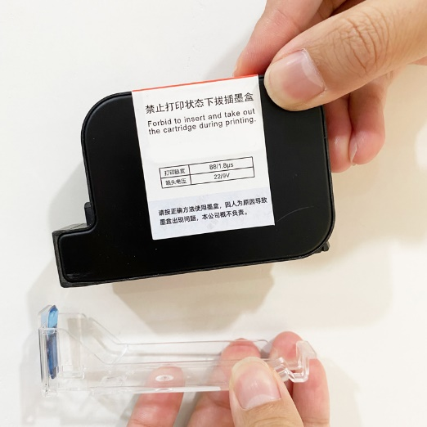

1.Open the ink tank cover, push it back in parallel to open
2.Open the transparent protective cover of the ink cartridge
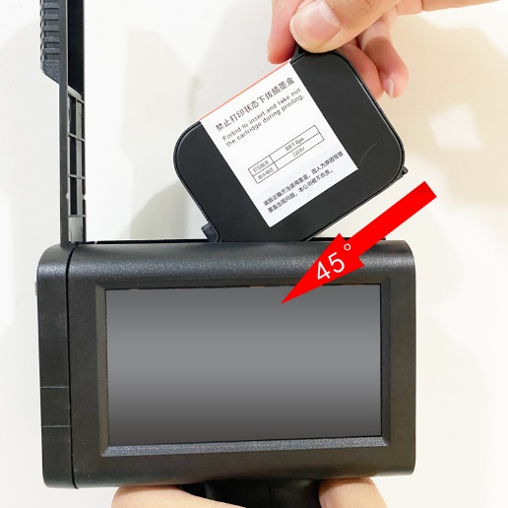
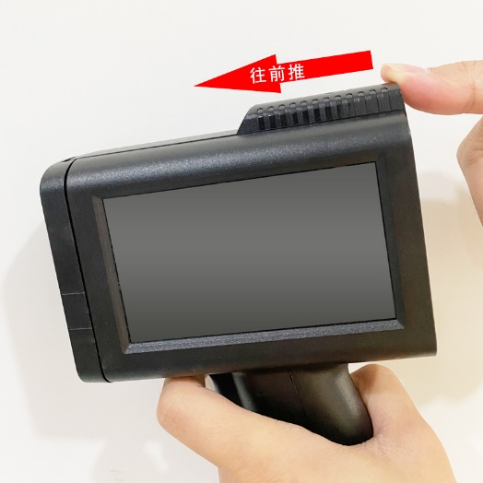

3. Put it into the ink tank at a 45° angle and press it down
4.Put the cover on and push it down to lock
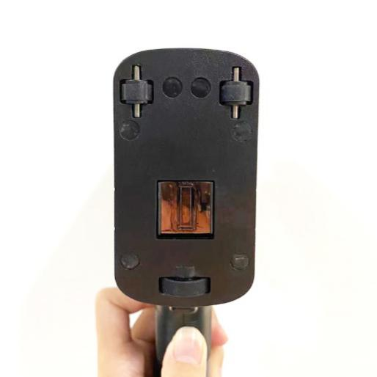
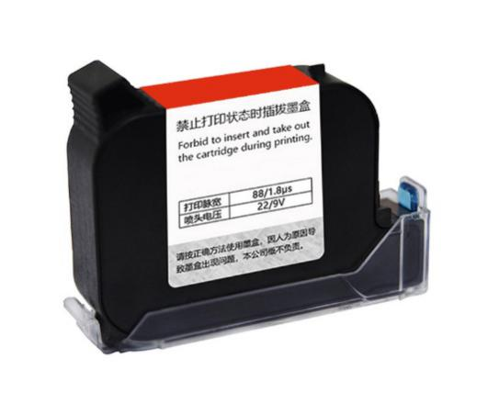

6.If not used for more than 20 minutes, remove the cover
5. If the nozzle is flush with the fuselage, the installation is correct
3.Main menu introduction
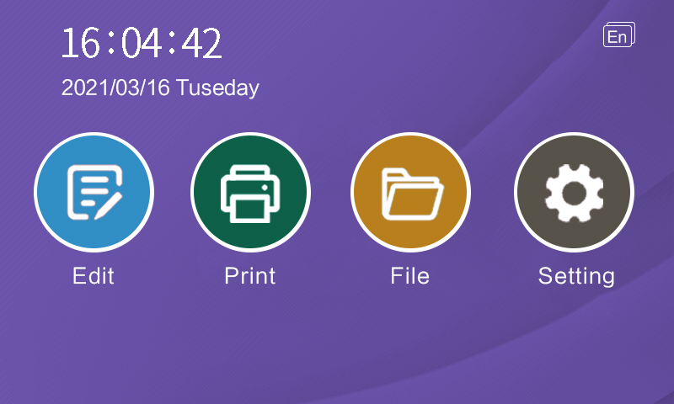
5
1
3
2
4

- 1.Edit: Click the button to enter the interface for editing and printing information
- 2. Print: click the button to enter the print interface
- 3.Files: Click the button to enter the file selection button, and you can choose the saved information
- 4.Setting: Click the button to enter the system parameter setting
- 5.EN:Click the button to enter the operation interface language switch button
4.Editing interface
14
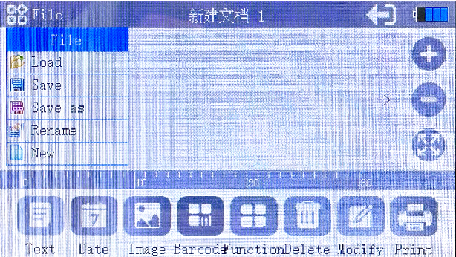
9
15
10
16
11
12
17
13
4
3
2
1
8
7
6
5

- 1. Text: Click this button to enter the input interface and enter text
- 2. Date: Click this button to enter the selected system date, which can be updated in real time
- 3. Pictures: Insert the U disk to import pictures and print
- 4. Graphic code: Insert U disk to edit QR code and bar code
- 5. Delete: delete the selected content
- 6. More functions: Click this button to select txt, table, segment, etc.
- 7. Modify: modify information, modify the selected content
- 8. Print: Click this button to start printing
- 9. Loading: recall saved information
- 10. Save: Click this button to save the edited content
- 11. Save as: Click this button to save the file as a message
- 12. Rename: Rename the saved information
- 13. New: Create a new text message
- 14. Return: return to the main interface
- 15.+: font enlargement
- 16.-: font size reduction
- 17. Enlarge the editing area, you can fine-tune the information

5.Print parameter introduction

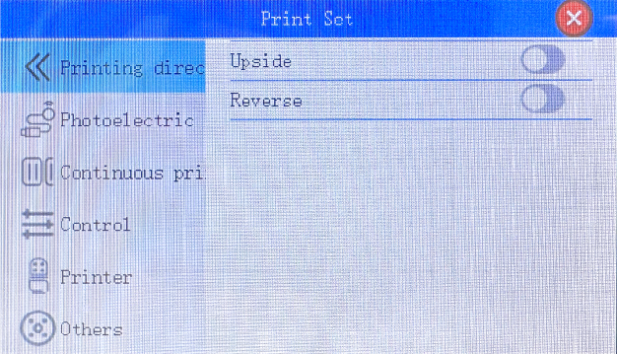
2
1
3

- 1. Printing direction: Click here to modify the direction of printing information
- 2. Flip up and down: After the switch is turned on, the printing information will be upside down
- 3. Reverse printing: After the switch is turned on, the printing information will be printed in reverse

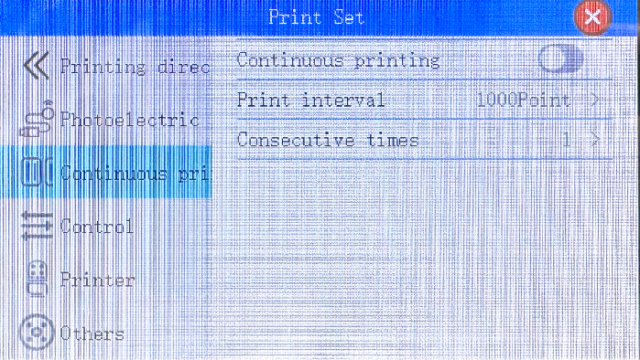
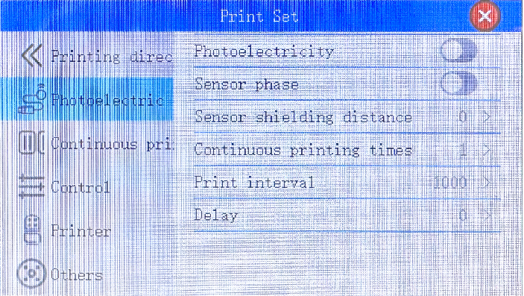
- 1. Photoelectric settings: Click here to set the parameters of the automatic printing of the assembly line
- 2. Photoelectric switch: After the photoelectric switch is turned on, it can be triggered by the sensor to transmit the printing signal
- 3. Printing delay: After the sensor detects the product, the position before and after printing is adjusted by delay
- 4. Photoelectric continuous printing interval: after detecting a signal, here you can set continuous printing multiple times
- Photoelectric signal unit: millisecond Pulse signal unit: point
- 5. Photoelectric continuous printing interval: here you can set the interval between two printing information
- 6. Photoelectric phase: Click here to turn on or off the phase
6
3
4
3
2
1
5
4
2
1
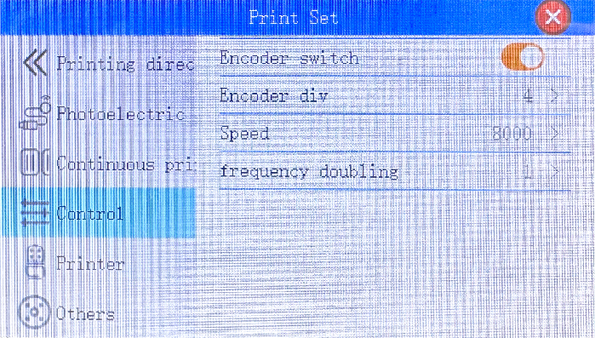
1
- 1. Synchronization mode: Click this button to set the encoder switch and coding speed, etc.
- 2. Encoder switch: This button is used to turn on or off the encoder
- 3. Encoder frequency division: subdivide the resolution of the encoder
- 4. Coding speed: refers to the printing speed of the inkjet printer. Generally, it does not need to be adjusted for handheld use, but it needs to be matched with the speed of the assembly line for online use. The speed of the assembly line is slow, and the coding speed also needs to be slow.
- 5. Synchronous multiplier: magnify the inkjet coefficient
5
4
3
2
- 1. Continuous printing: Click this button to set the inkjet printer to print continuously
- 2. Continuous printing control: This button is used to enable or disable continuous printing
- 3. Continuous printing interval: the interval between printing information, the greater the value, the greater the interval
- 4. Continuous printing times: set the number of continuous printing, the larger the value, the more printing times
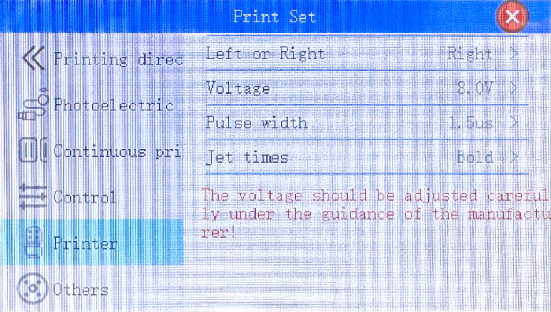
- Nozzle settings: Click this button to set the left and right selection of nozzles, nozzle parameters, voltage, etc.
- Voltage setting: 8.6-9.2V is recommended for quick-drying ink cartridges
- Water-based ink cartridges suggest 10.5-11.5V
- Pulse width setting: 1.6-2.2μs
- Ink jet density: It is recommended to use the normal option, bolding will increase ink consumption.

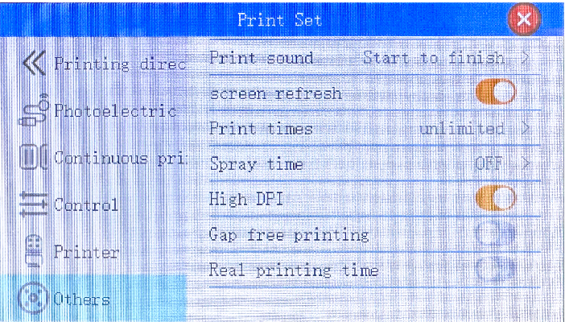
- 1. Other settings
- 2. Printing sound: off, start only, finish only, start & finish, etc.
- 3. Screen update: update the screen display content in real time
- 4. The number of printing times: the number indicates the number of times (do not change at will)
8
6
7
2
3
4
5
1
- 5. Flash spray setting: the value represents milliseconds
- 6. High DPI: open 300dpi; close 150dpi
- 7. Gapless printing mode: print the same content in a non-stop cycle
- 8. Printing real-time time: The printing time is refreshed in real time.

1
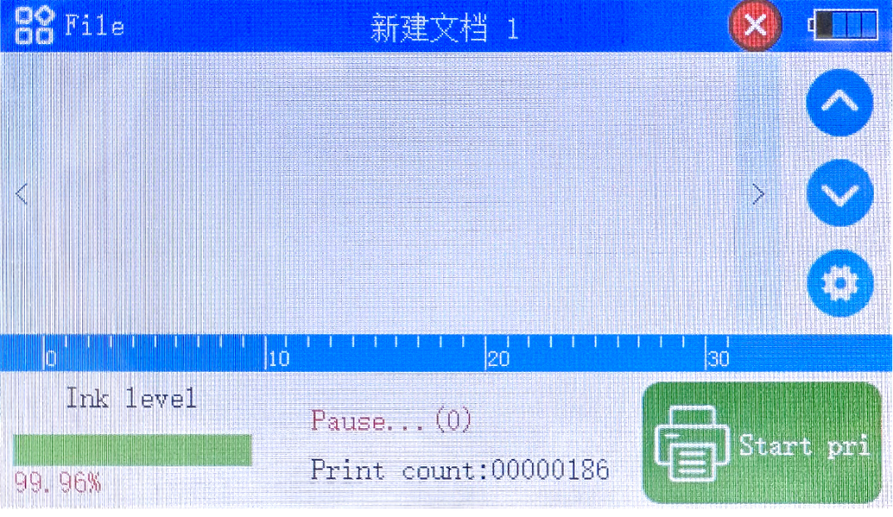
3
4
5

6
2

- 1. Return to the home page: Click this button to return to the previous interface
- 2. Main menu: This button pops up a drop-down box
- 3. Ink level: click the button to set the ink level
- 4. Turn up: If you print the serial number or import data from outside, if the printing is wrong, you need to reprint and you can turn up
- 5. Scroll down: If you print the serial number or import data from outside, you can choose to scroll down to find the content that needs to be printed
- 6. Settings: Click this button to enter the print settings and set the print parameters
- 7. Print: When the green button is clicked, it means stop printing, and the red color means the printing status

6.Introduction to file management
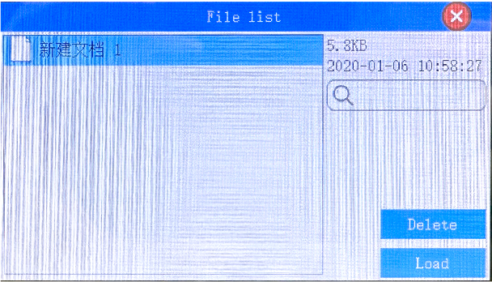
1
4

2
3
- 1.Displays the saved information
- 2.Delete the selected information
- 3.Loads the selected information
- 4.Find information

7.Introduction to system Settings
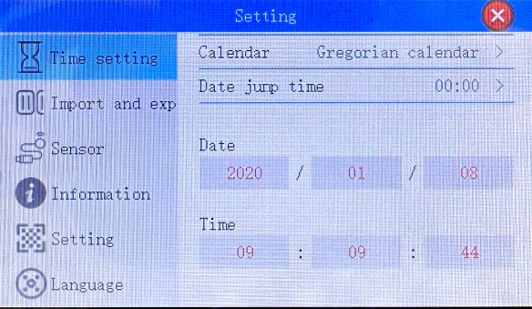
1
2
3

4
5
6

- 1. Time setting: Click this button to modify the system time
- 2. Record import and export: you can import or export the externally edited information to the U disk
- It must be ensured that machines with the same version number are imported or exported to each other, carefully check the version number
- 3. Sensor detection: Click this button to detect the encoder and sensor

- 4. System information: Click this button to upgrade the software, view the version number, etc.
- 5. System settings: Click this button to set button tone, restore factory settings, Bluetooth connection, etc.
- 6. Language selection: Click this button to switch the system language

*Bluetooth function introduction

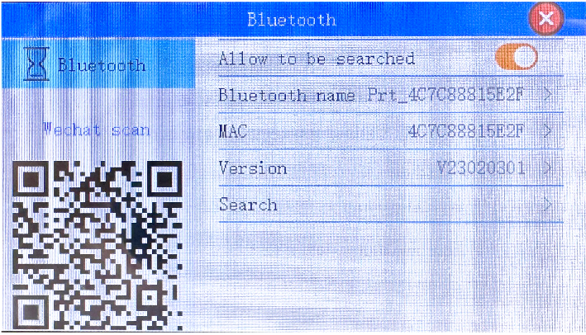
- 1. Allow to be searched: Click this button to open the QR code of the WeChat applet
- 2. Bluetooth name: You can see the Bluetooth name of the machine in the mobile phone applet
- 3. Search device: Click to search, it can be paired with the wireless code scanning gun to realize real-time scanning code printing function
- Scan the QR code to print the QR code or scan the QR code to print the variable data in the QR code; scan the bar code to print the bar code or number.
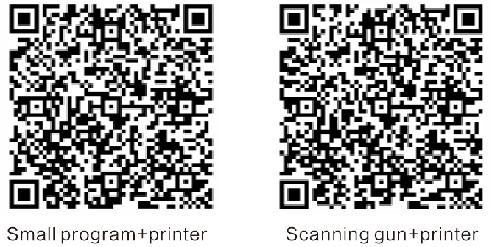
Packing list of InkJet Printer
S/N | Accessories | Qty | Photo
1 | Package  Box | 1 |  | ★
2 | Handheld printer | 1 | 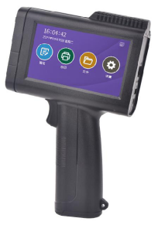 | ★
3 | Adaptor(17V 0.8A) | 1 | 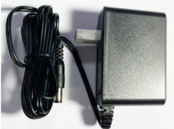 | ★
4 | Ink cartridge | 1 | 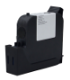 | ○
5 | Manual bool | 1 | 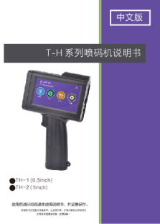 | ★
“★”为standard ，“○” pay extra fee

Certificate of approval
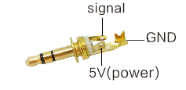

- 1. Thank you for purchasing the smart inkjet printer. In order to ensure the safety of the product and your legal rights, please read the manual carefully before using it.
- 2. This product is a precision instrument and equipment. If there is any abnormality and cannot be used, please perform detection and treatment according to the instructions in the manual, or contact the company after sales. Please do not handle it by yourself.
- 3. Except for vulnerable parts (such as ink cartridges, power cords, etc. are not covered by the warranty)
- 4. Repairs by non-designated maintenance departments of the company, or disassembly and maintenance by users themselves will not be guaranteed.
- 5. The use of non-company original accessories or consumables will not give warranty if damage is caused
- 6. No warranty will be given beyond the warranty period
- 7. During the use of this product, if there is a serious drop, open flame, water ingress, corrosion of unknown chemical substances, unauthorized disassembly and other man-made damage, it is not covered by the warranty.
- 8. If the machine encounters a fault, please back up the important information in the device in time before sending it for repair to prevent loss
- 9. This disclaimer, the final interpretation right belongs to our company.
Disclaimer

