H

a

n

g

z

h

o

u

A

I

L

Y

D

i

g

i

t

a

l

P

r

i

n

t

i

n

g

T

e

c

h

n

o

l

o

g

y

C

o

.

,

L

t

d

.

杭州艾利数码打印科技有限公司



**OMAJIC-UV6090 G5I**

**(**

**Model:6090G5I**

**)**

**U**

**ser's**

**M**

**anual**

Catalog

1. Products Instruction and Attentions--------------------------------------------------------------------------- 3
   1. Products Instruction -------------------------------------------------------------------------------------------- 3
   2. Attentions Before Installation--------------------------------------------------------------------------------- 3
   3. Requirement for PC Configuration ------------------------------------------------------------------------ 3
   4. Attentions During Installation--------------------------------------------------------------------------------- 3
2. Machine Diagram and Installation---------------------------------------------------------------------------- 4
   1. Machine Diagram----------------------------------------------------------------------------------------------- 4,5
   2. Installation Step------------------------------------------------------------------------------------------------- 6,7
3. Software Installation and Operation--------------------------------------------------------------------------8
   1. Ripprint Installation-------------------------------------------------------------------------------------------- 8
   2. Printexp Installation-------------------------------------------------------------------------------------------- 9
   3. Ripprint Operation Instruction--------------------------------------------------------------------------------10-12
   4. Printexp Operation--------------------------------------------------------------------------------------------- 13-19
4. Machine Maintenance and Errors Instruction-------------------------------------------------------------- 20
   1. Maintenance Manual------------------------------------------------------------------------------------------- 20-23
5. Attachment-------------------------------------------------------------------------------------------------------
   * 1. Trouble Shooting-----------------------------------------------------------------------------------------------
     2. How to make spot color channel in PhotoShop software-------------------------------------------------
     3. Consumable Spare Parts--------------------------------------------------------------------------------------

# Products Instruction and Attentions

（**Please Read this Manual Carefully before Installing the Printer)**

1.1 Product Instruction

OMAJIC-UV6090 printer is equipped with 3pcs G5I printheads, which can print color, white and varnish at the same time on both flat and rotary materials, such as: acrylic, glass, metal, wood, bottle, mug etc.

1.2 Attentions Before Installation

* Please power on the machine with single-phase 220V±5%, frequency 50-60Hz, peak power 3KW and pay attention to circuit requirements.
* The ground wire must be installed in advance，to prevent static . Please make computer and printer under same powder, to prevent voltage difference and static.
* Environment: Temperature:22℃-32℃. Humidity: 40% and 60%. Keep the room clean and little dust.

1.3 Computer configuration requirements:

* Intel i5 /AMD R5 or more advanced. MAC System is NOT WORKABLE
* 8G RAM or More
* 256G Storage or More (solid state disk is recommended)
* Gigabit Ethernet

1.4 Attentions During Installation

* Please strictly follow the manual and engineer’s instructions.
* Remove all the fixture before installation.
* Power on the machine and check initialization actions (There will be a beep sound, which is a normal to remind you put ink ).
* Install the software (See page for details)
* Make a printing job without printheads, to make sure the mechanic and electronic are in good condition.
* Turn off machine. Next to put ink and install the printheads. (Printhead is Fragile and expensive, pls strictly follow engineer’s instruction. Supplier will not be responsible for Human error)

# 2.Machine Diagram and Installation

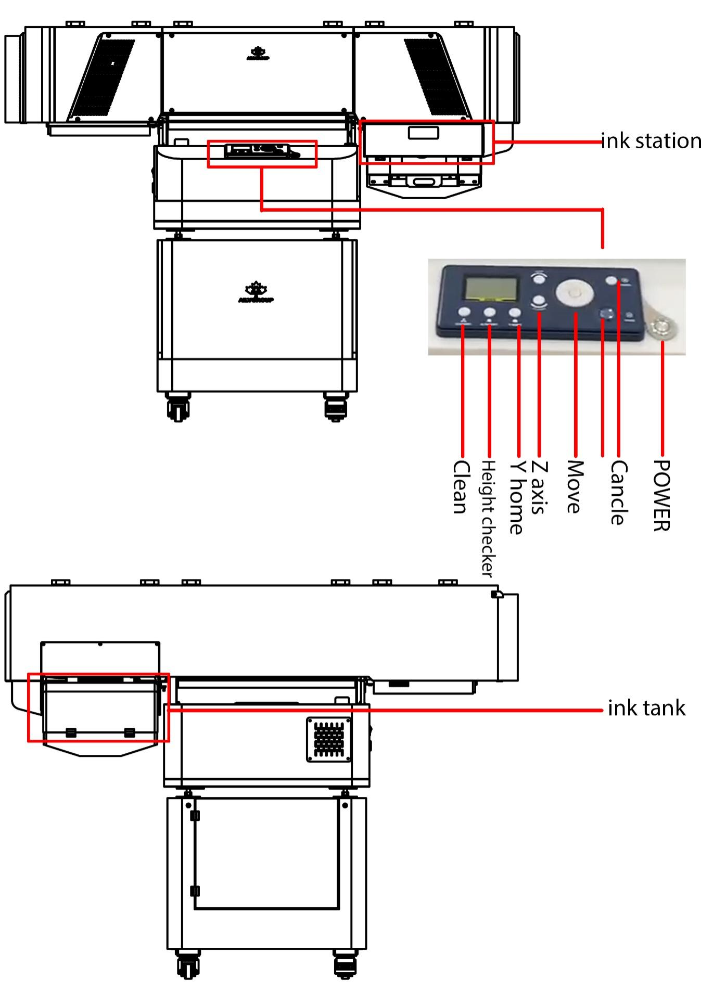

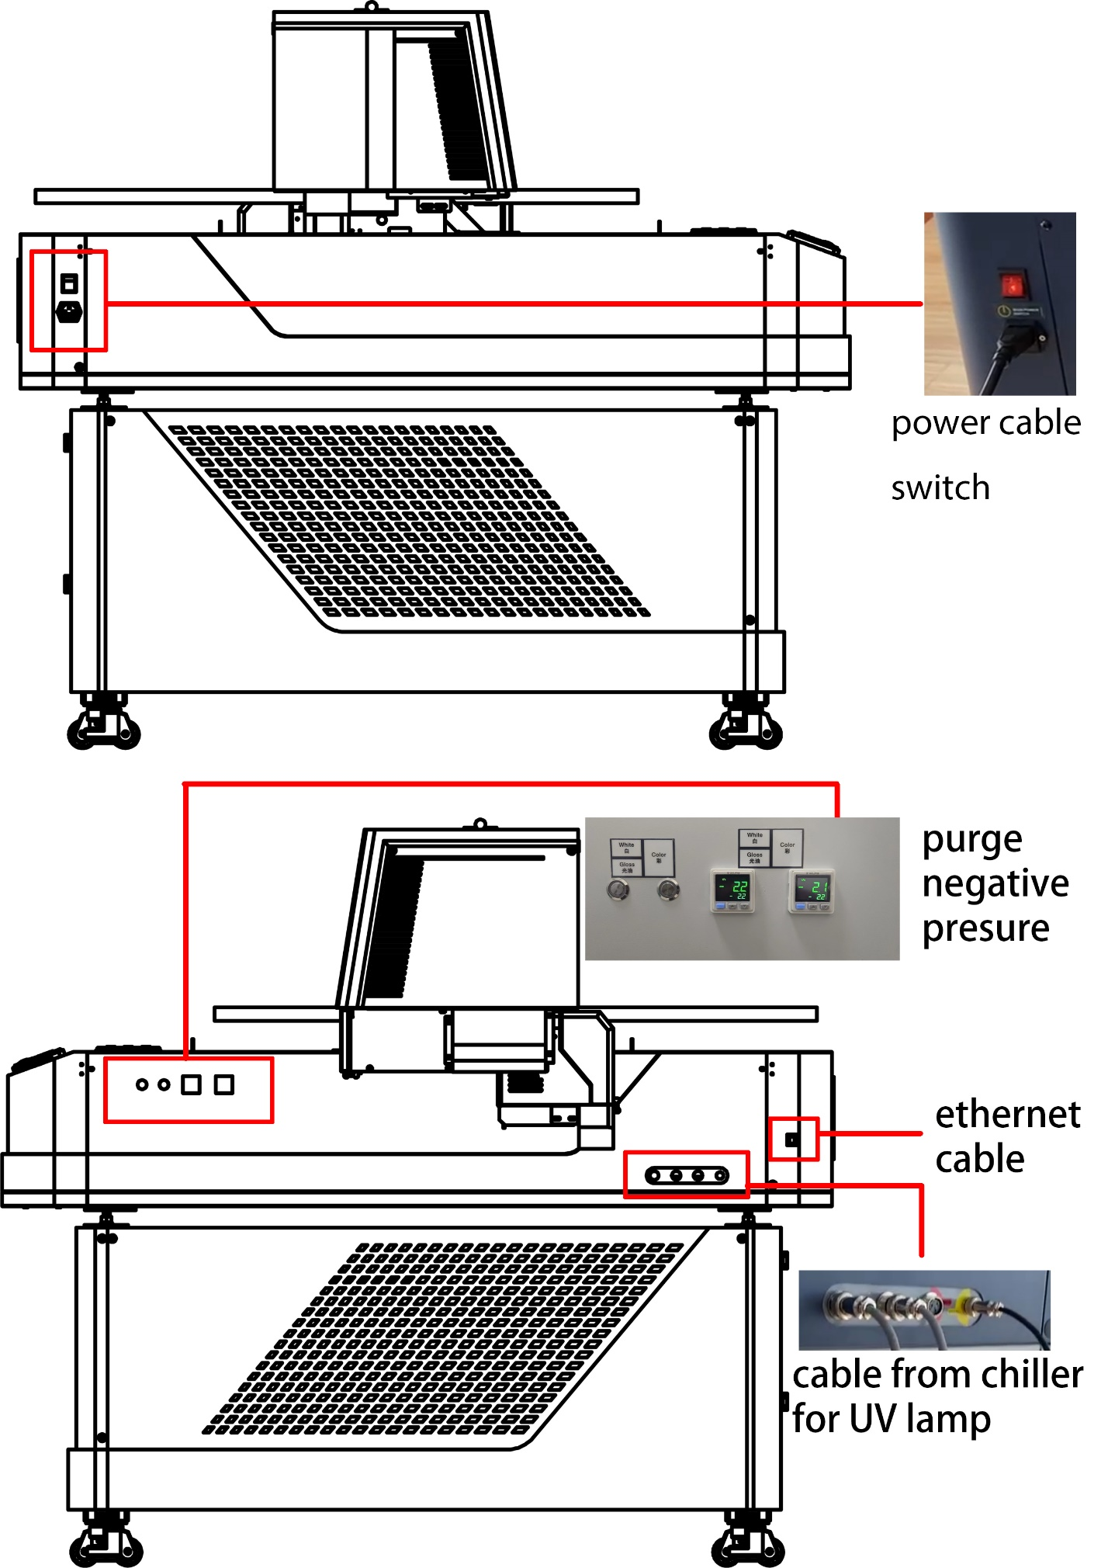

## Installation Instructions

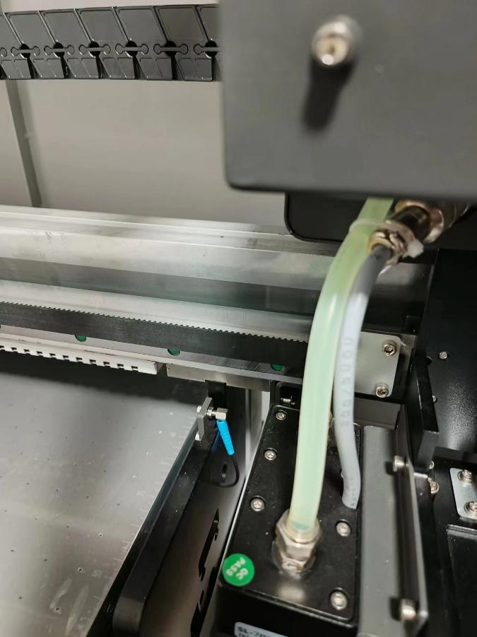

Printer front side sketch map

* Carriage fixed module (Remove it when you receive machine so that carriage belt can work.)  Turn on the printer and check initialization actions.
* Positions of print heads and print head cables.

Attention:

Before install print head need open the machine do the software test print. After confirm the mcahine work normally then power off the machine and install the print head and ink .

# 3.Software Installation and Operation

3.1. Ripprint Installation

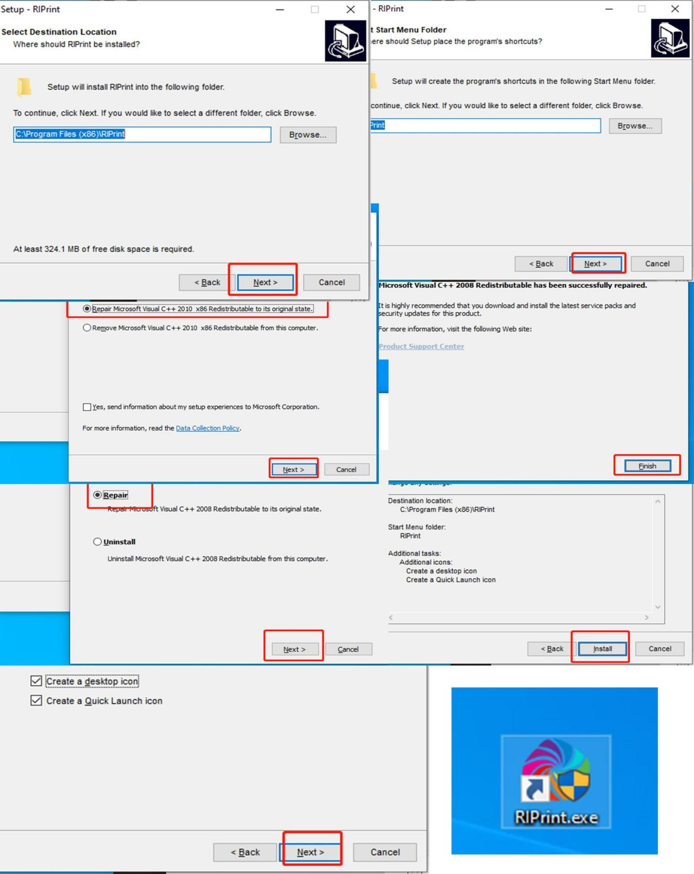

3.2. Exppirnt Printexp Installation

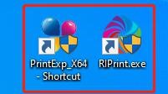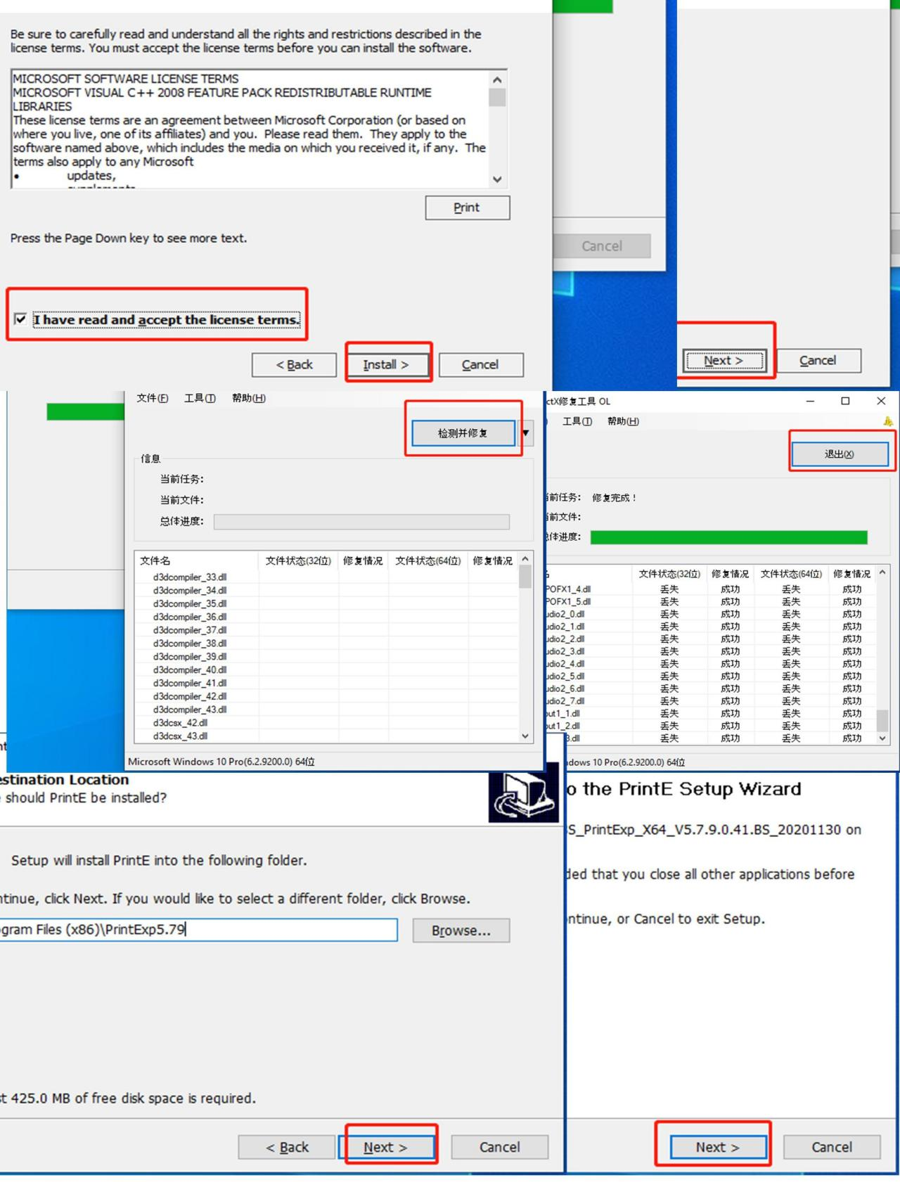

Need

to

choose

the

installation

directory

and

agree

to

the

system

plug-in

installation

After

finished

installation,there

will

be

two

software.

Note

that

the

installation

file

and

the

file

after

installation

must

be

run

as

an

administrator.

3.3. Ripprint Ripprint Operation Instruction

Setting printer, selecting the printer corresponding to the model and setting it as the default.

D:\Work\说明书\华印A3 dtf\英文\图片1.tif图片1

Import one picture,create a new working document and load picture.

Then adjust the size of picture suits to material what you are going to print.

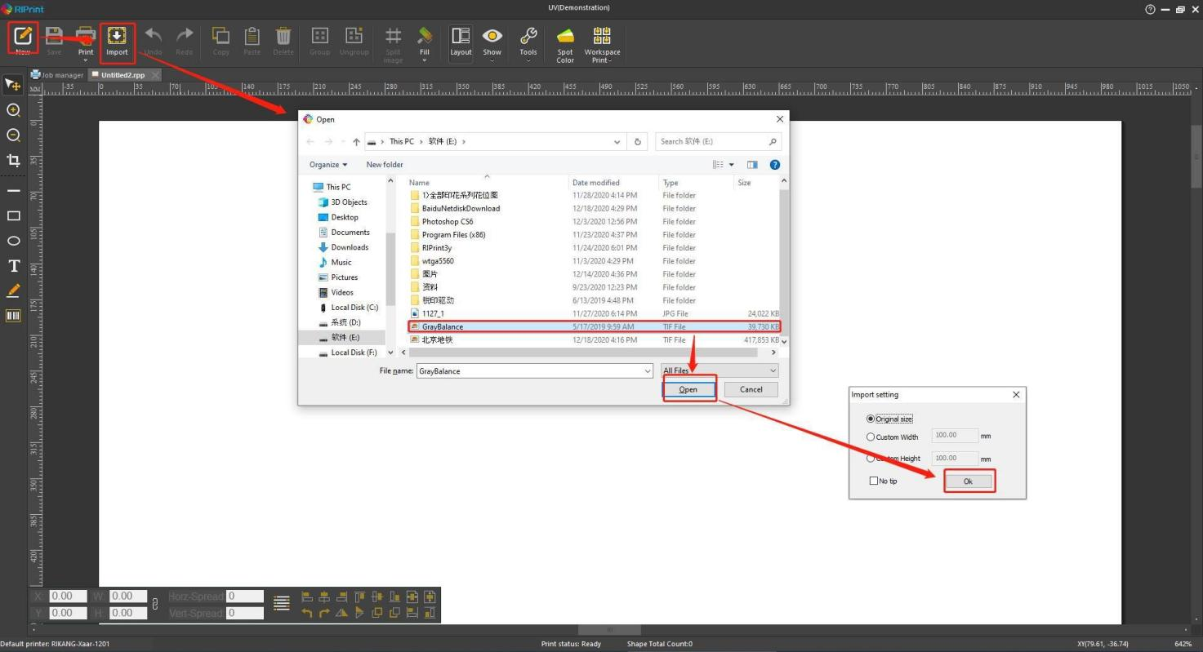

Further options for printing job

Different resolution/ Different height printing can be selected here.

Attention different options adhesive different performance follow engineer’s suggestions..

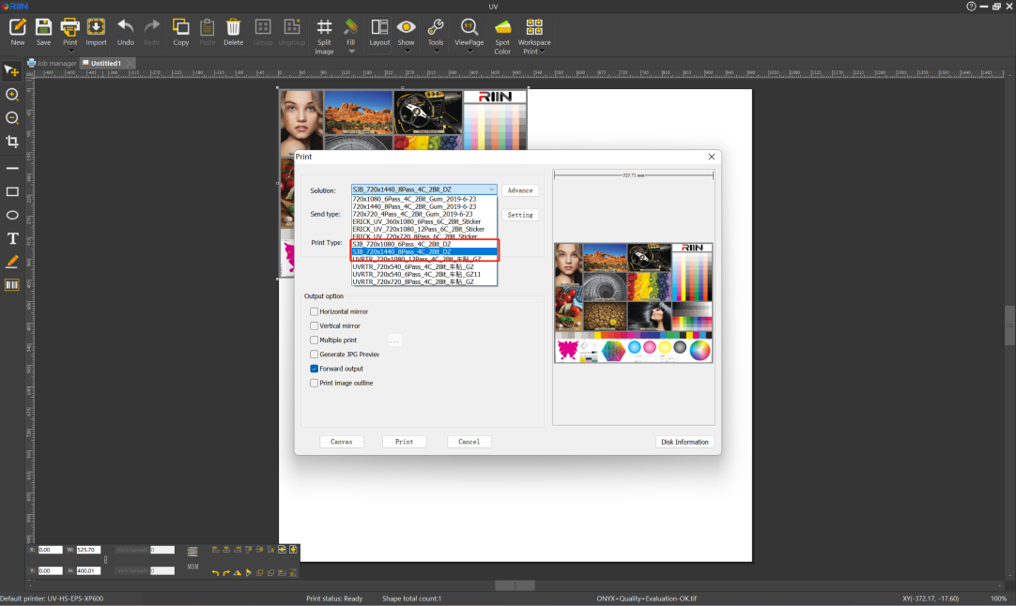

**After setting, just print it.**

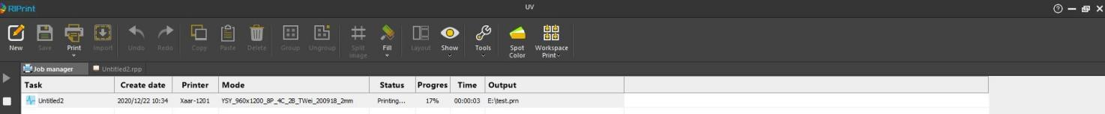

PS: Spot color option description

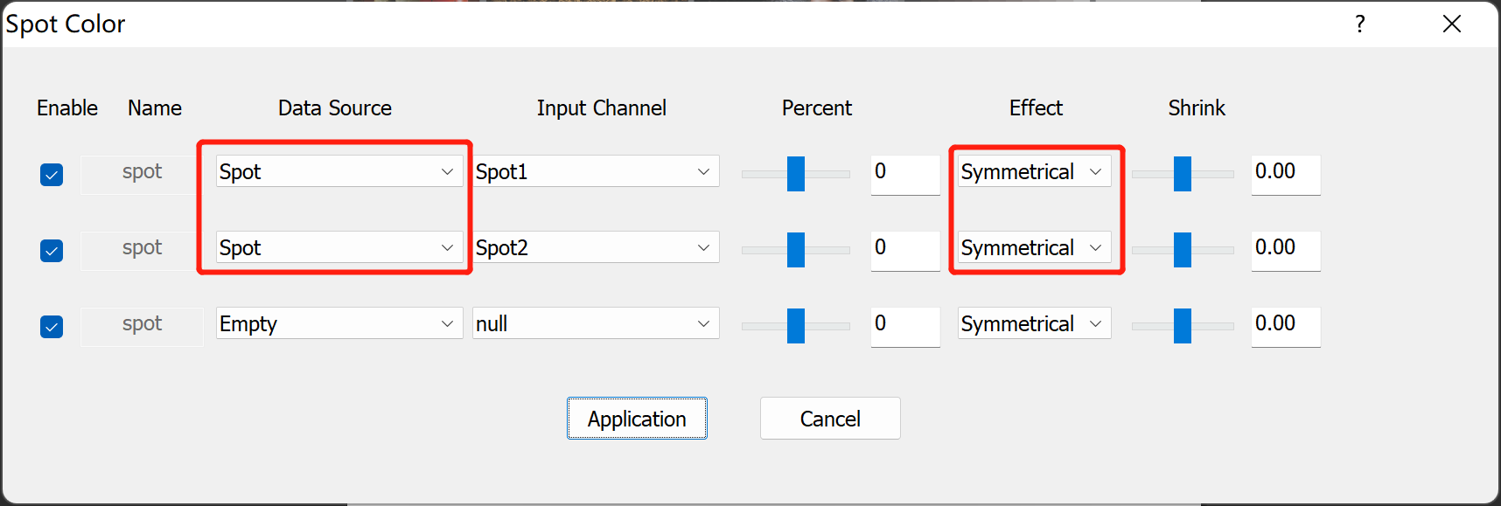

Data source type:

Image base (same density)

You can choose this option to print white background or varnish when you have not made spot colors.

Spot

You can select this option if you have made spot colors in PHOTOSHOP.

Halftoning type:

Single dot mode

High speed mode

Symmetrical mode

Ps: For spot color options, only SPOT or Image base (same density)is recommended.

For halftoning type,symmetrical mode is recommended.

BLeed: Negative value is contraction.

Positive value is expansion.

Normal setting value is -0.12.

3.4 Printexp Operation

Make sure the printer is connected to the computer network port with a network cable.

Change the computer IP address to connect to the printer.

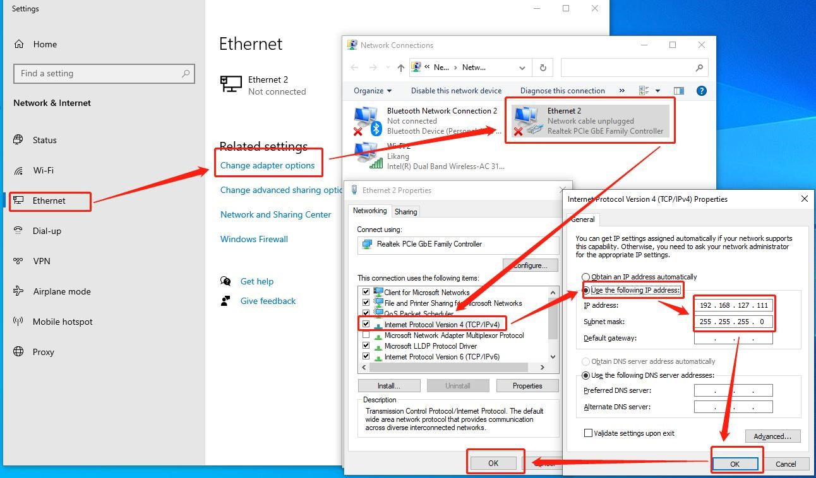

Software Interface

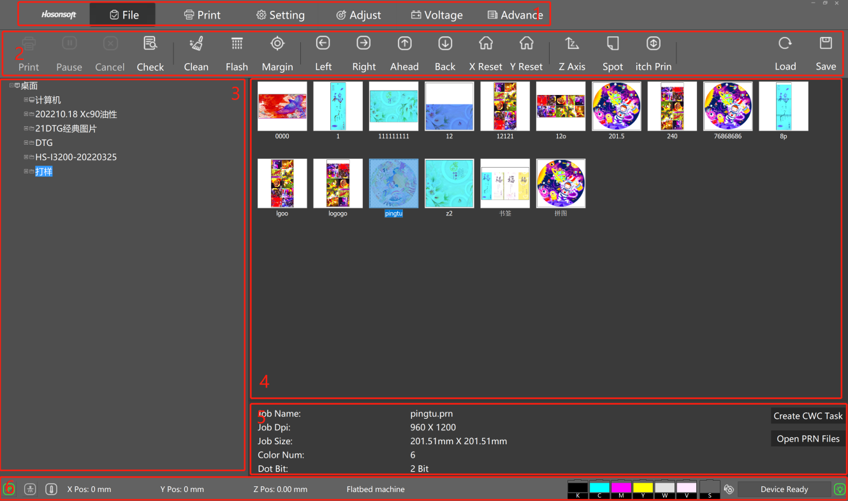

1. **Manu Bar**
2. T**ools Bar**
3. Files
4. Optional print file preview
5. File attributes
6. Status of parameter

The toolbar can be used to control the operation of the printer,including cleaning the print head status diagram,etc.

The status bar displays the current connection status, the position of the X Y axis, the status of the ink cartridge, etc.

**Print Bar**

1.Print

2.Task bar to be printed

3.Copy and print the current task

4.Cutting and printing of current task

5.Print information and print status display bar

6.Margin setting - print start position setting

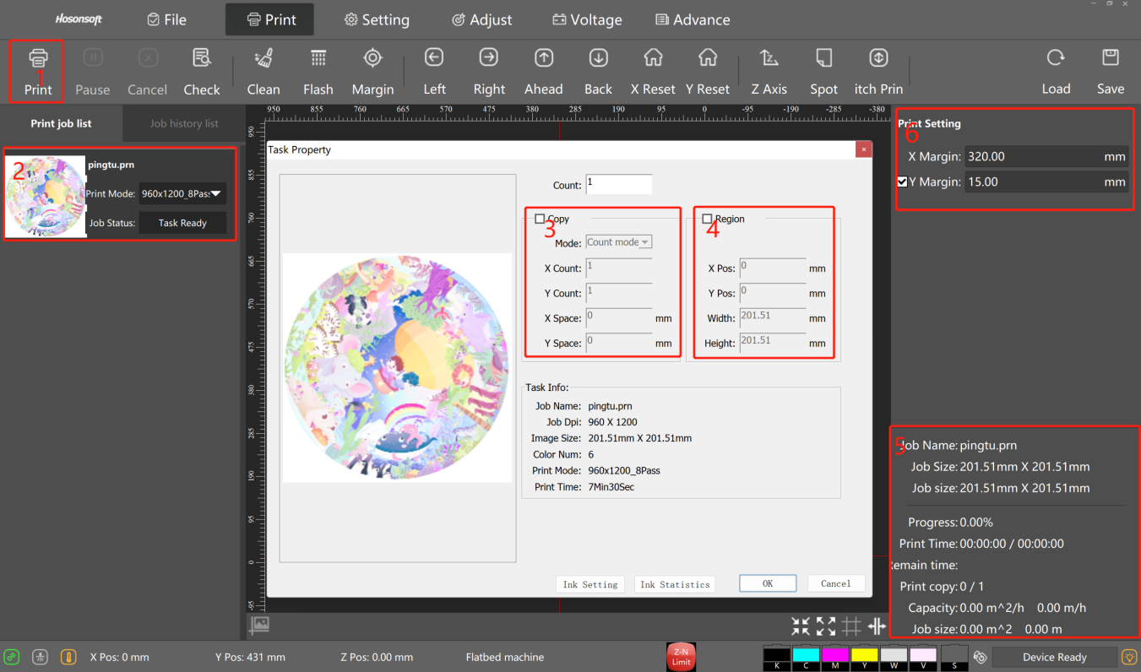

## “Setting”

1. Head select - for choosing different printing pattern such as 1H4C_4C_CWCV,
2. Common setting - printing speed and method setting (the speed and method need to be changed when printing irregular materials, and the printing direction need to be changed when printing mirror materials)
3. Color bar setting - used to observe the status of the print head and moisturizing function during printing
4. Eclosion setting - higher eclosion, can make the picture more
5. delicateAdvance Function - channel selection (can choose to print only color, white or varnish)
6. Load ink - manually pump ink for cleaning head if necessary
7. Print skip white setting
8. UV light - turn on/off

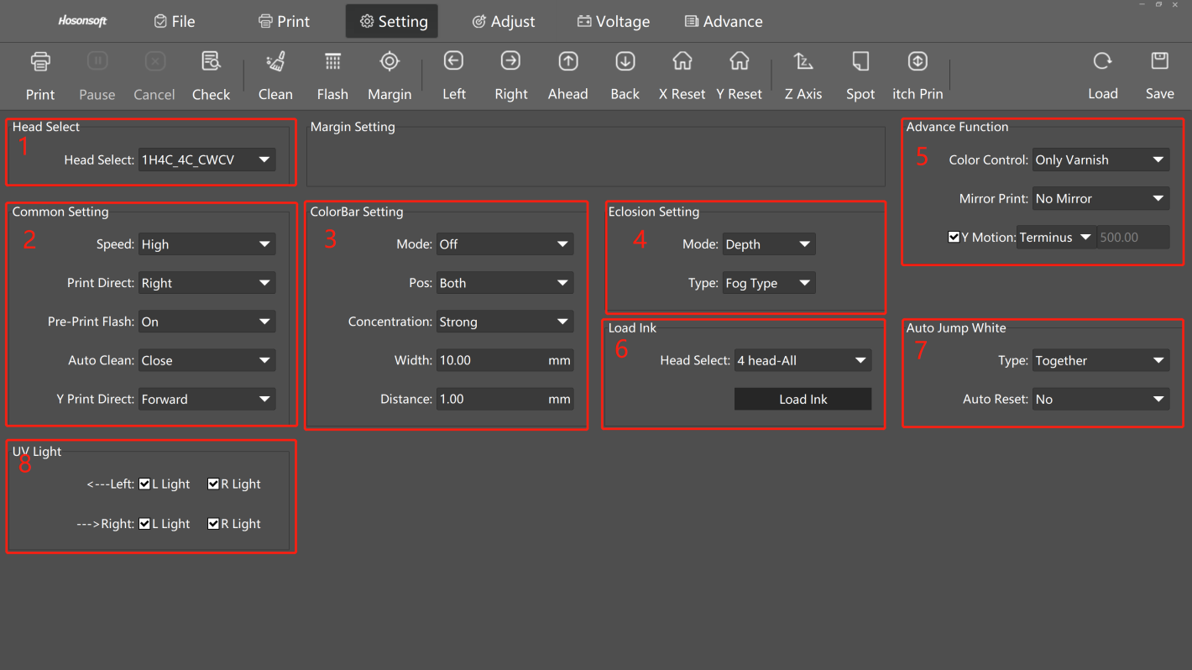

## “Head Install”

Used to check whether the print heads position is parallel to the printing surface.

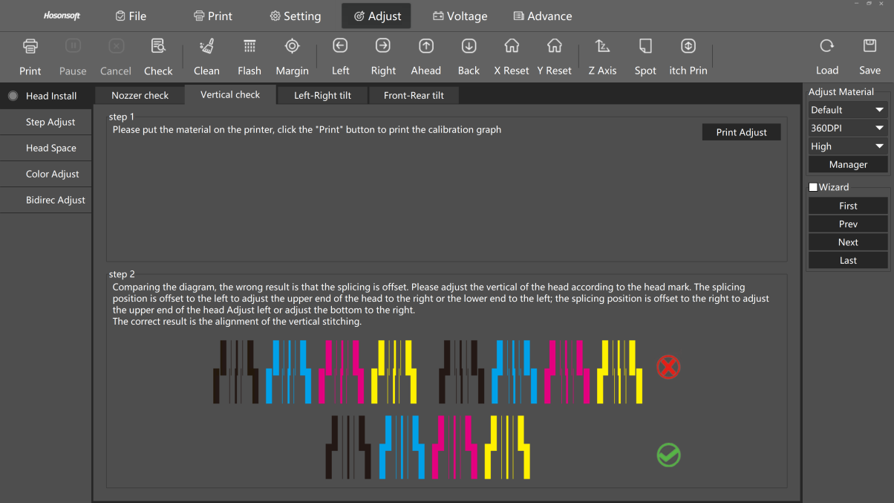

## “Step Adjust”

This affects the output resolution. Inaccuracy will cause ghosting in the Y-axis direction and different prints lengths.

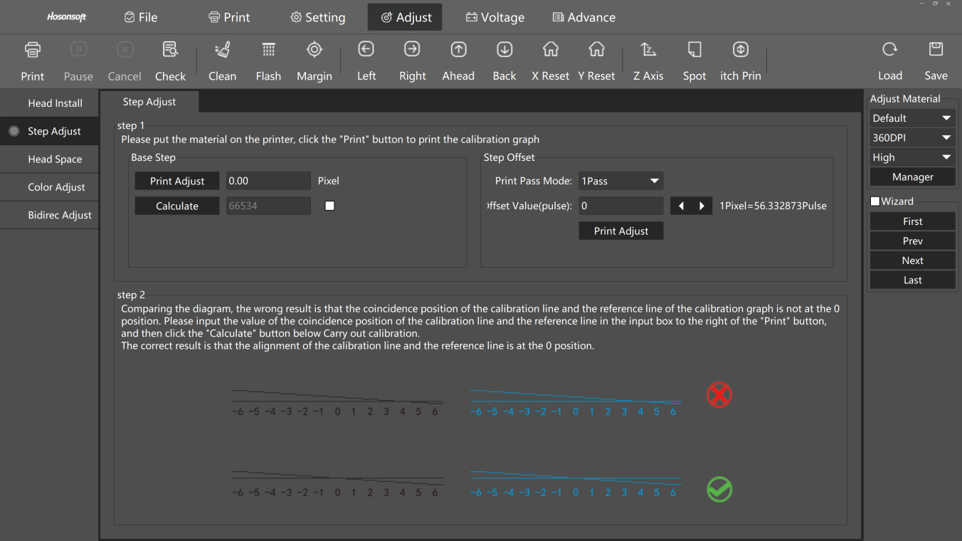

## “Head Space”

It is used to adjust the position parameters of the white, color and varnish heads to ensure that the print positions of the nozzles are the same without misalignment.

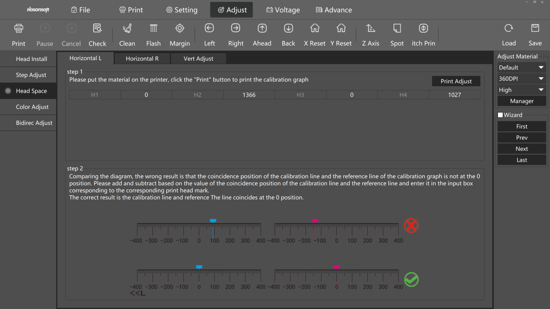

## “ColorAdjust”

The position calibration before different channels of the same head. Usually no need change.

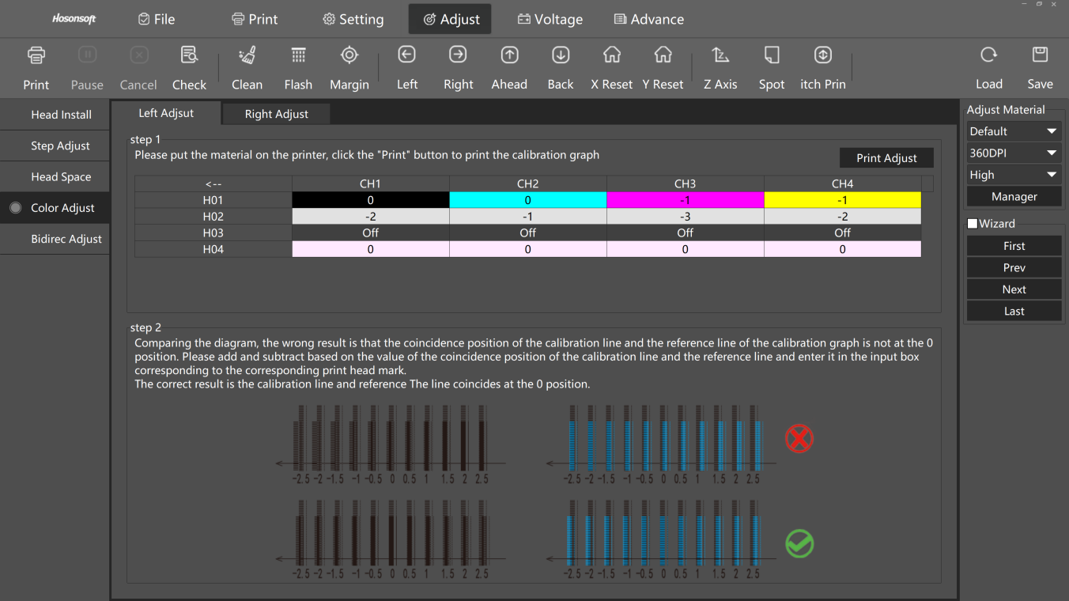

For correcting positioning of Bi-direct printing.

When the height drops between the head and the material are different, the difference needs to be compensated due to the difference in ink drop points for leftward and rightward printing.

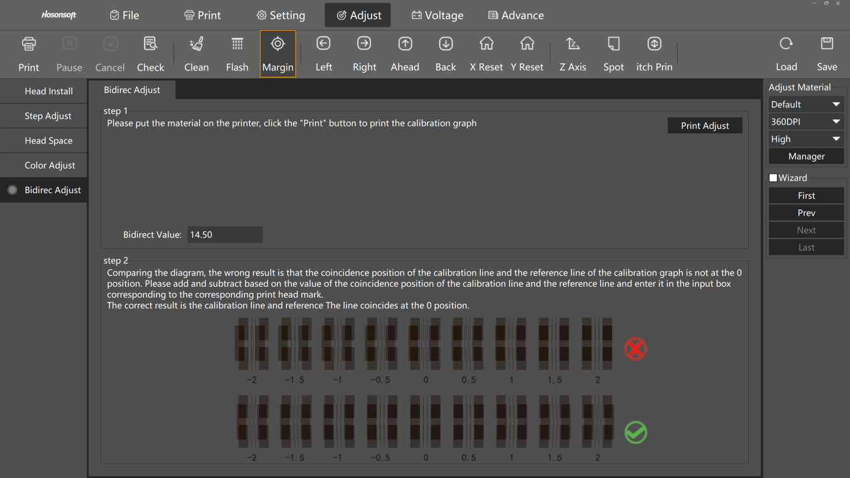

Factory version info RIP Print

Advance

## “Advance”

* “Factory”: Plant Engineering Parameter Setting.
* “Version info”: information of the hand ware and software which you are using currently.
* “RIP Print”: supported accuracy and transmission settings.
* “Advance”: additional function such as card decryption and language change.

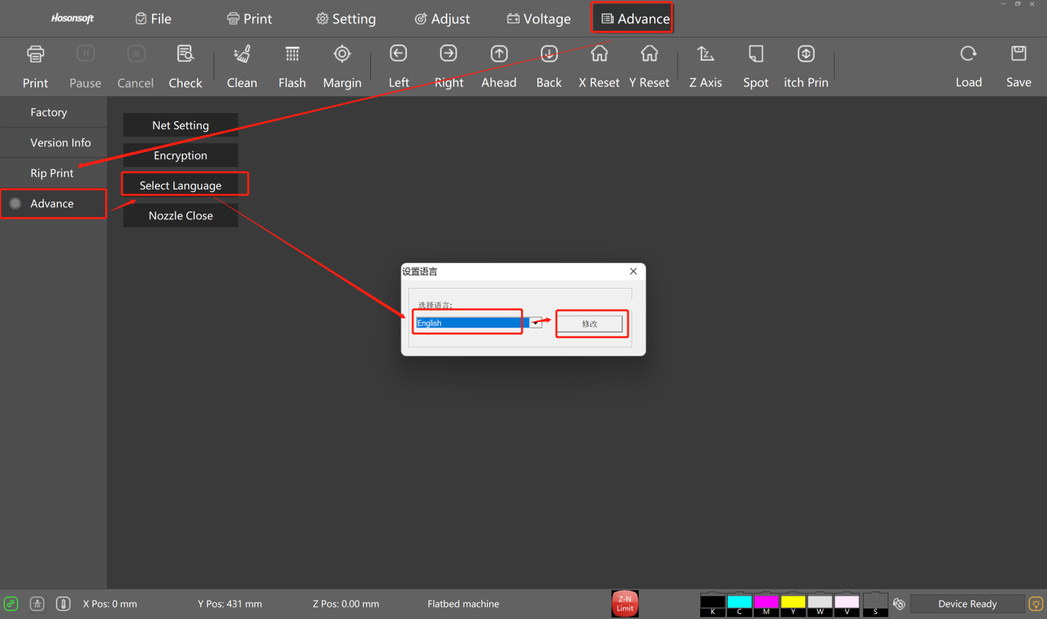

**“Log”** - - -displaying printer current running log.

When the printer has an error, can check the log information and find solution accordingly.

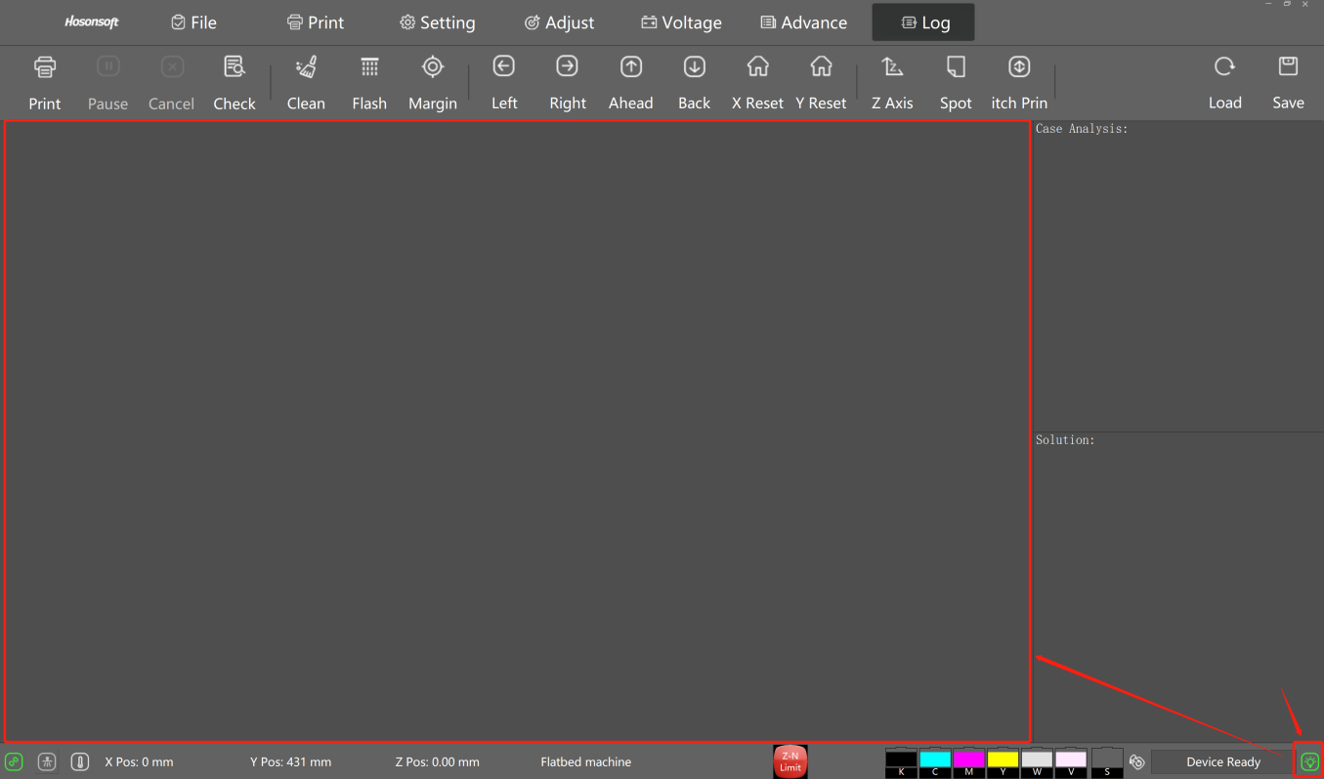

## Machine Maintenance and Errors Instruction

### Maintenance Manual

※ **Turn** on the machine and use machine every day, which is suggested.

※ **If** the machine will not be used for over 7 days, the print heads are suggested to disassemble and make a cleaning, and then keep wet.

※ **Before** printing, please adjust the print gap between print head and print object to be 2-3mm, and then start printing. Be cautious, if the print head is lower than print object surface, the print head will get scratched or clashed.

※do clean---do and check the nozzle test every day , compare with other day nozzle.

Note=Comparing the diagram, the wrong result is that the state has broken needles, oblique needles and color block drawing. Please clean the head according to the head markings. The correct result is that the state is all good and the block is even.

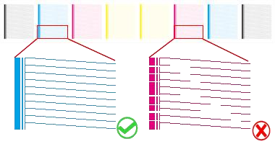

※**Reflective** materials, like stainless steel, mirror, Because their reflective surface will reflect UV light onto print head nozzles.

1: use alcohol clean the surface of material.

2: when print too much work, check the quality of printing picture, if not so good, click pause in the software, then click clean in the software, and continue printing.

3: when print transparent material, such as acrylic, glass ect.

should donot use make this out, or put black material on the platform,which will weaken the UV light reflection.

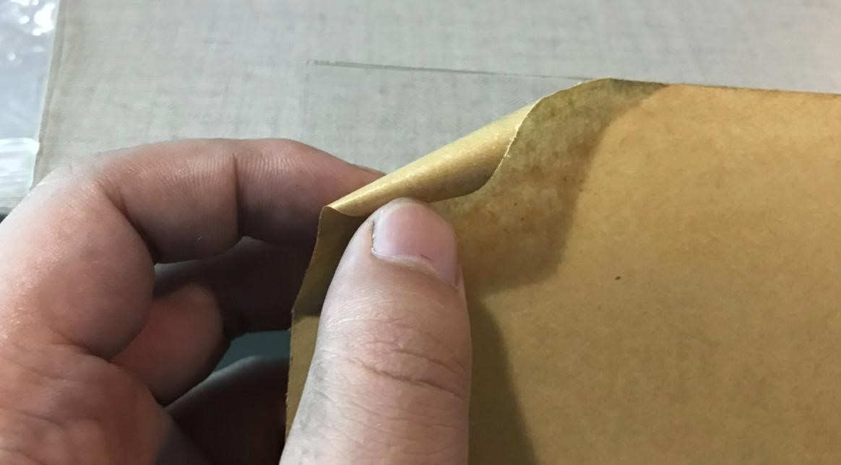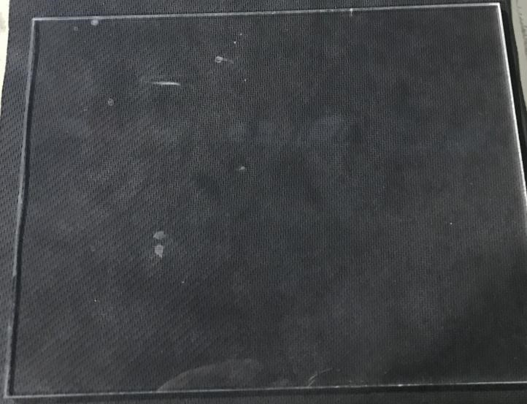

※ If the one bottle ink open, if use out it within 2 month.

And if the nozzle test have problem, change dampers one time each 2 month.

※ **1: It** should close the software first, then switch off the machine.

2: **Clean** the wiper every day before you off work

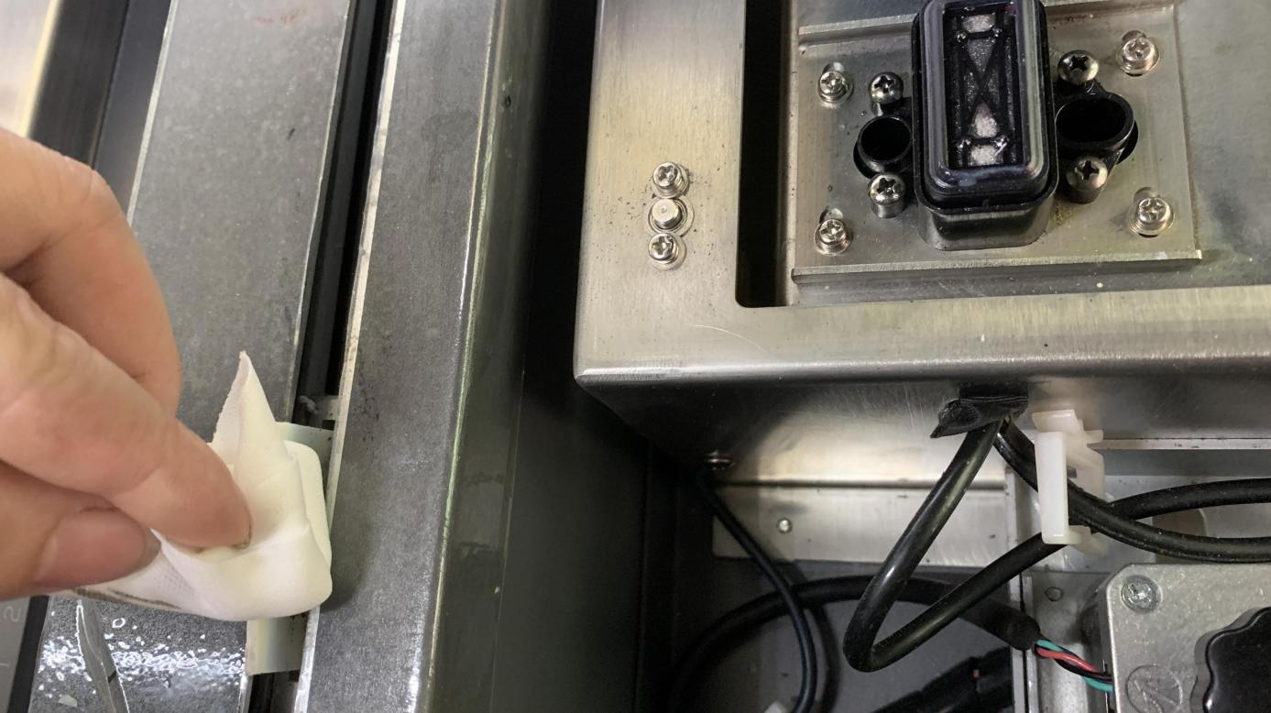

3: **Keep** the bottom clean

