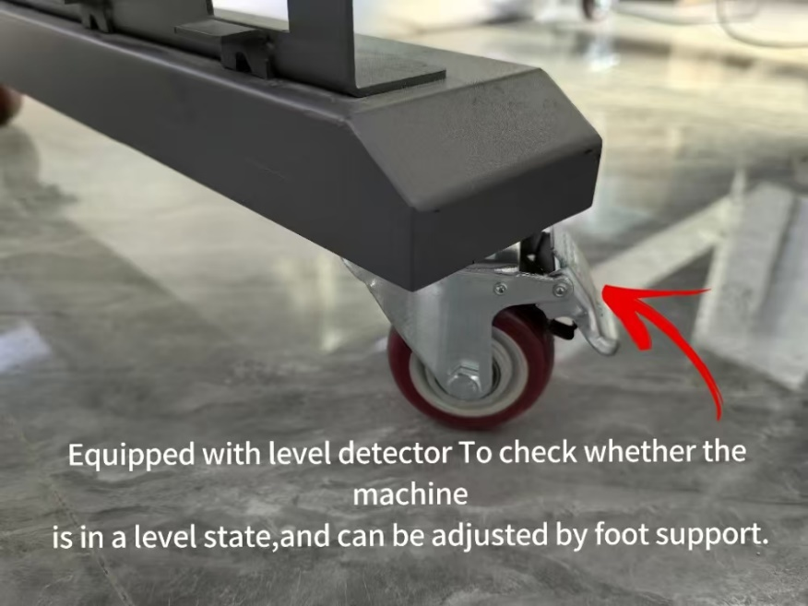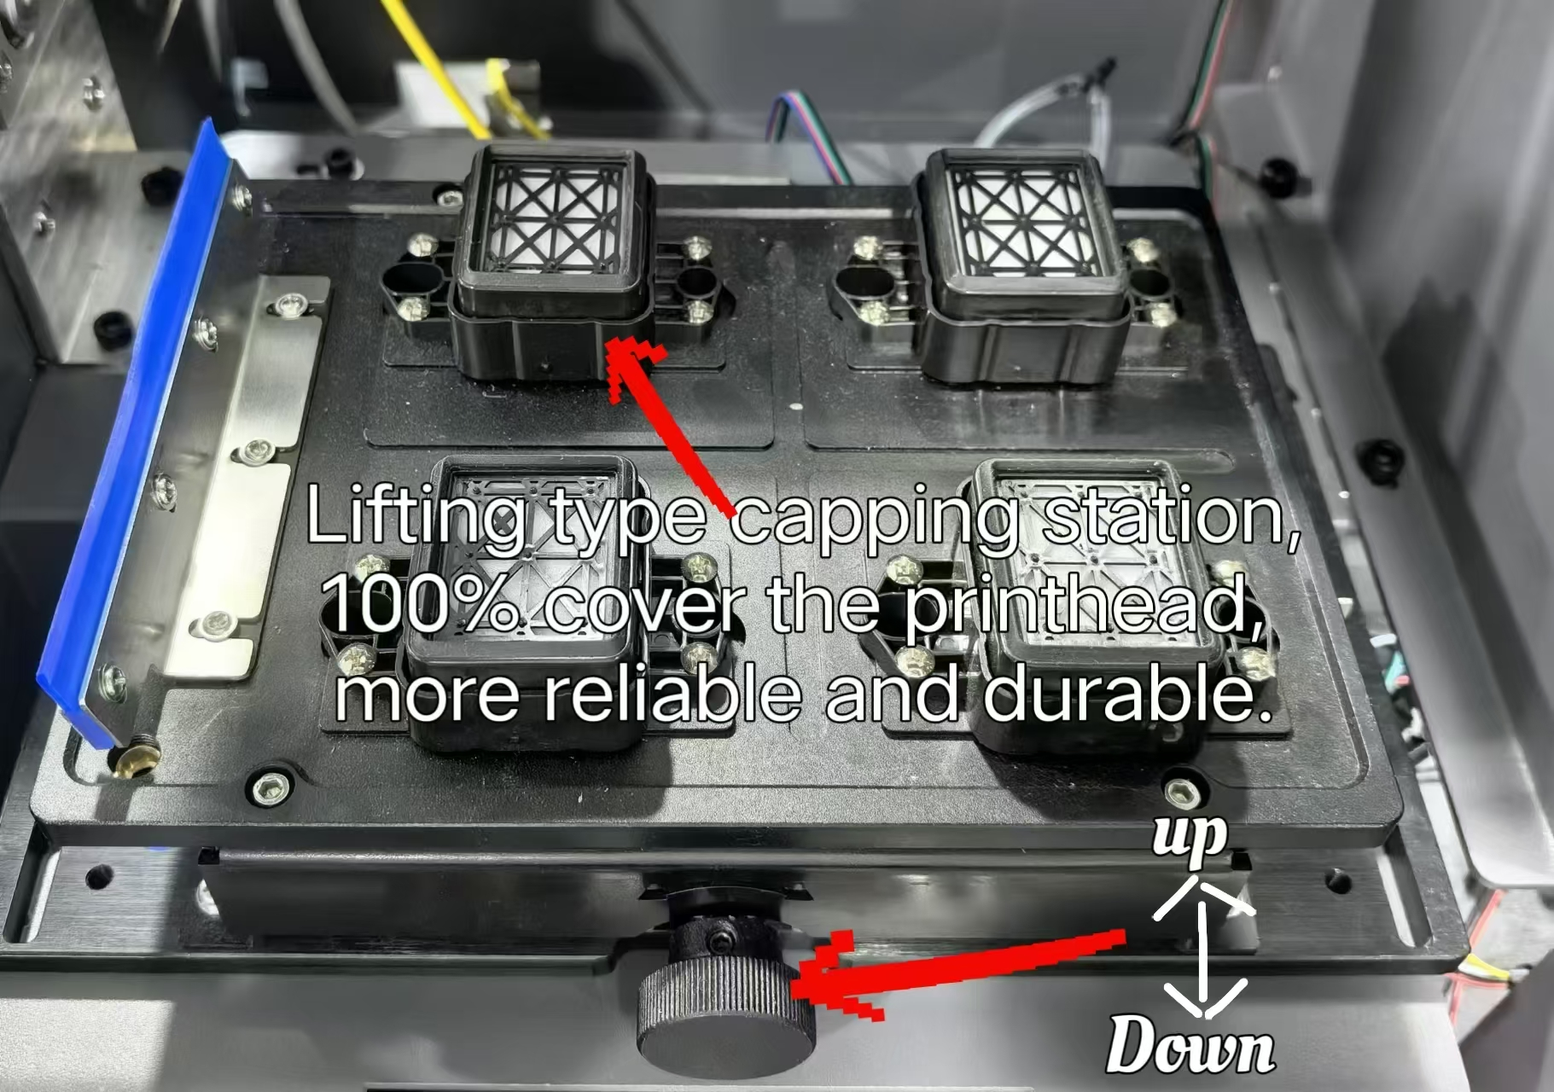
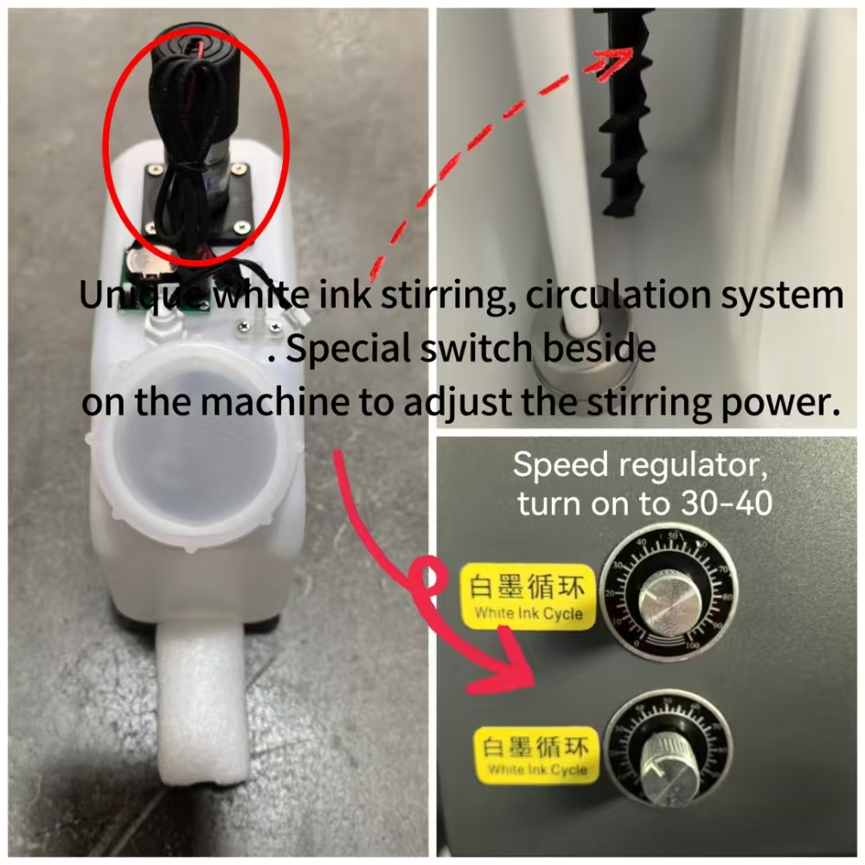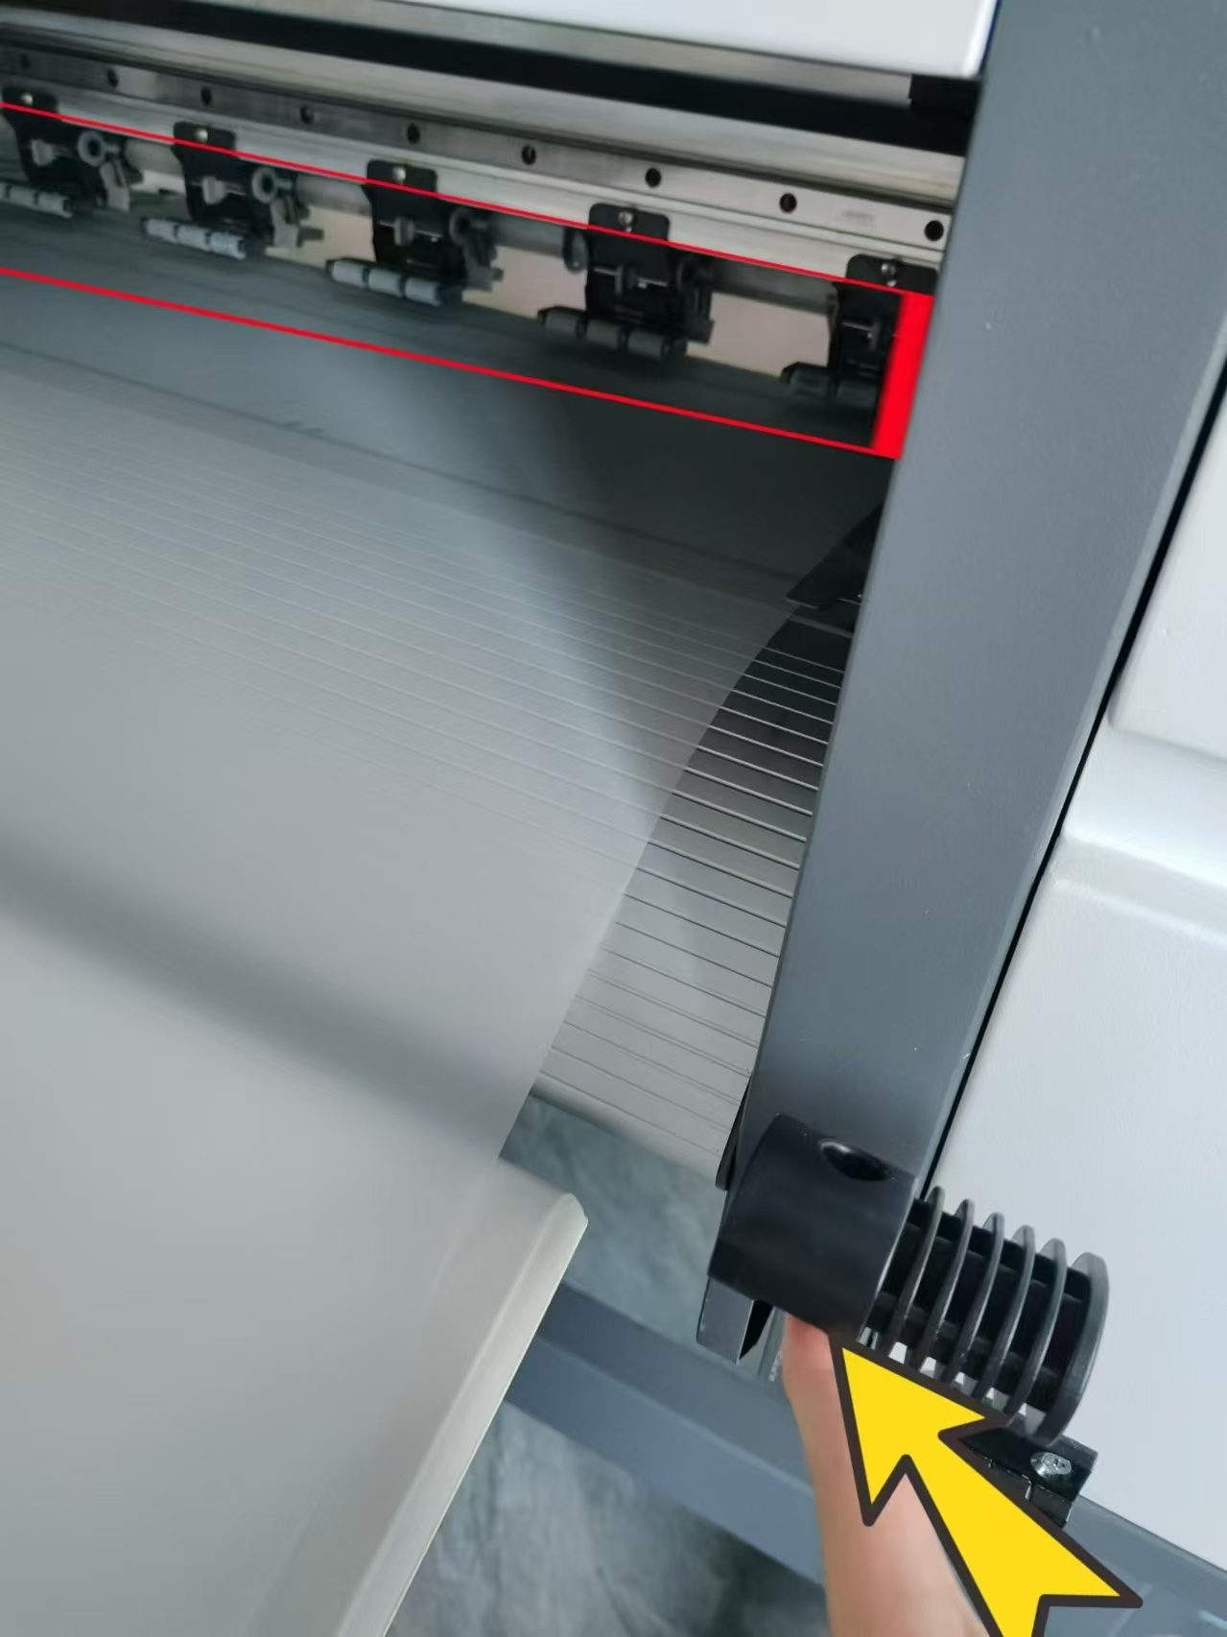
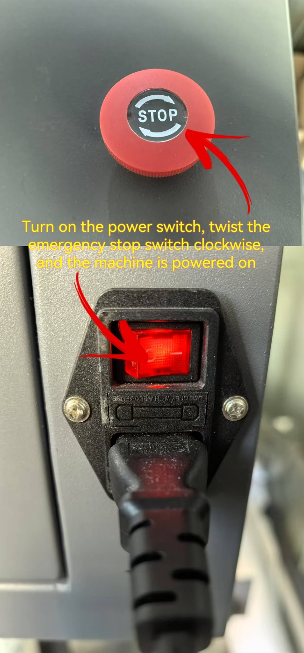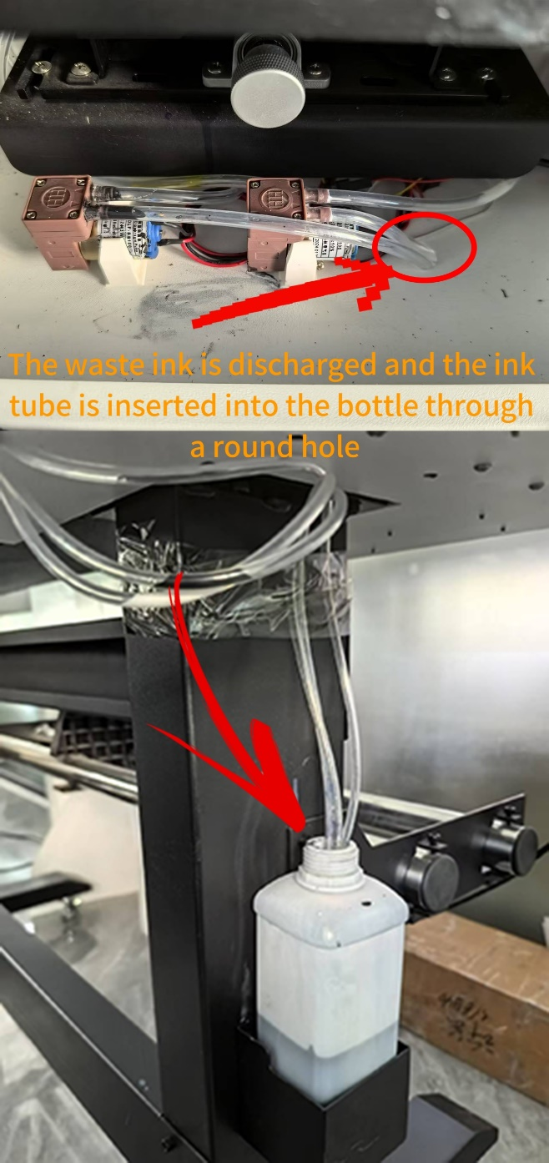
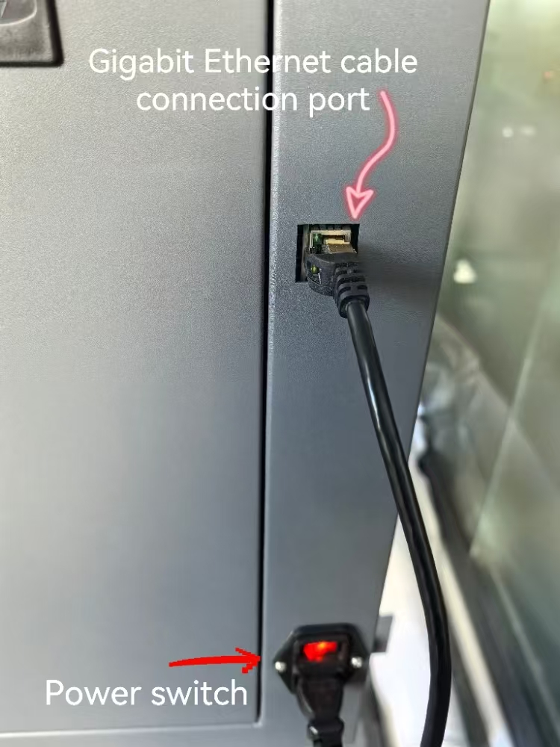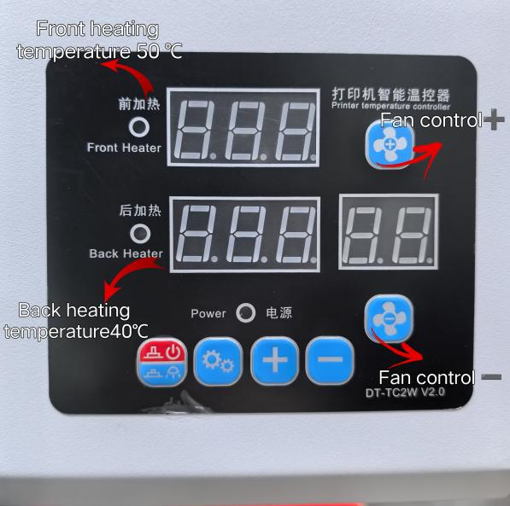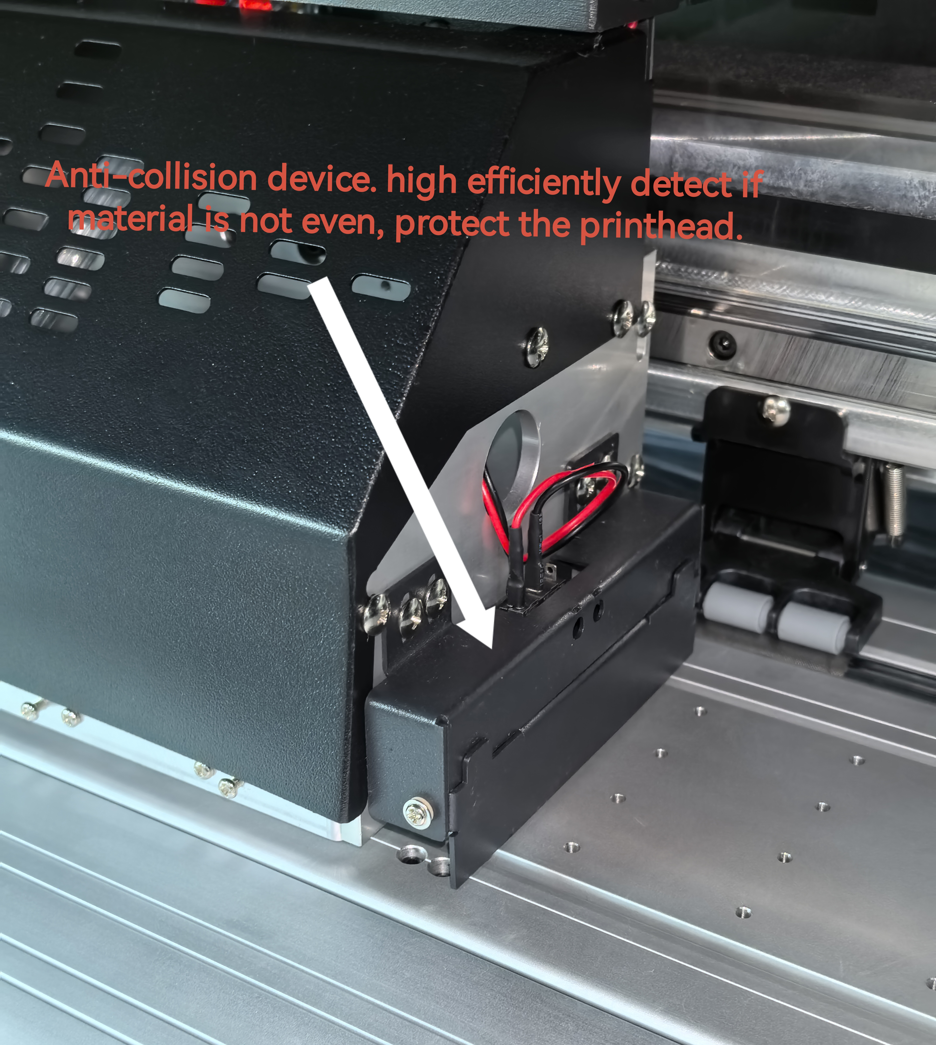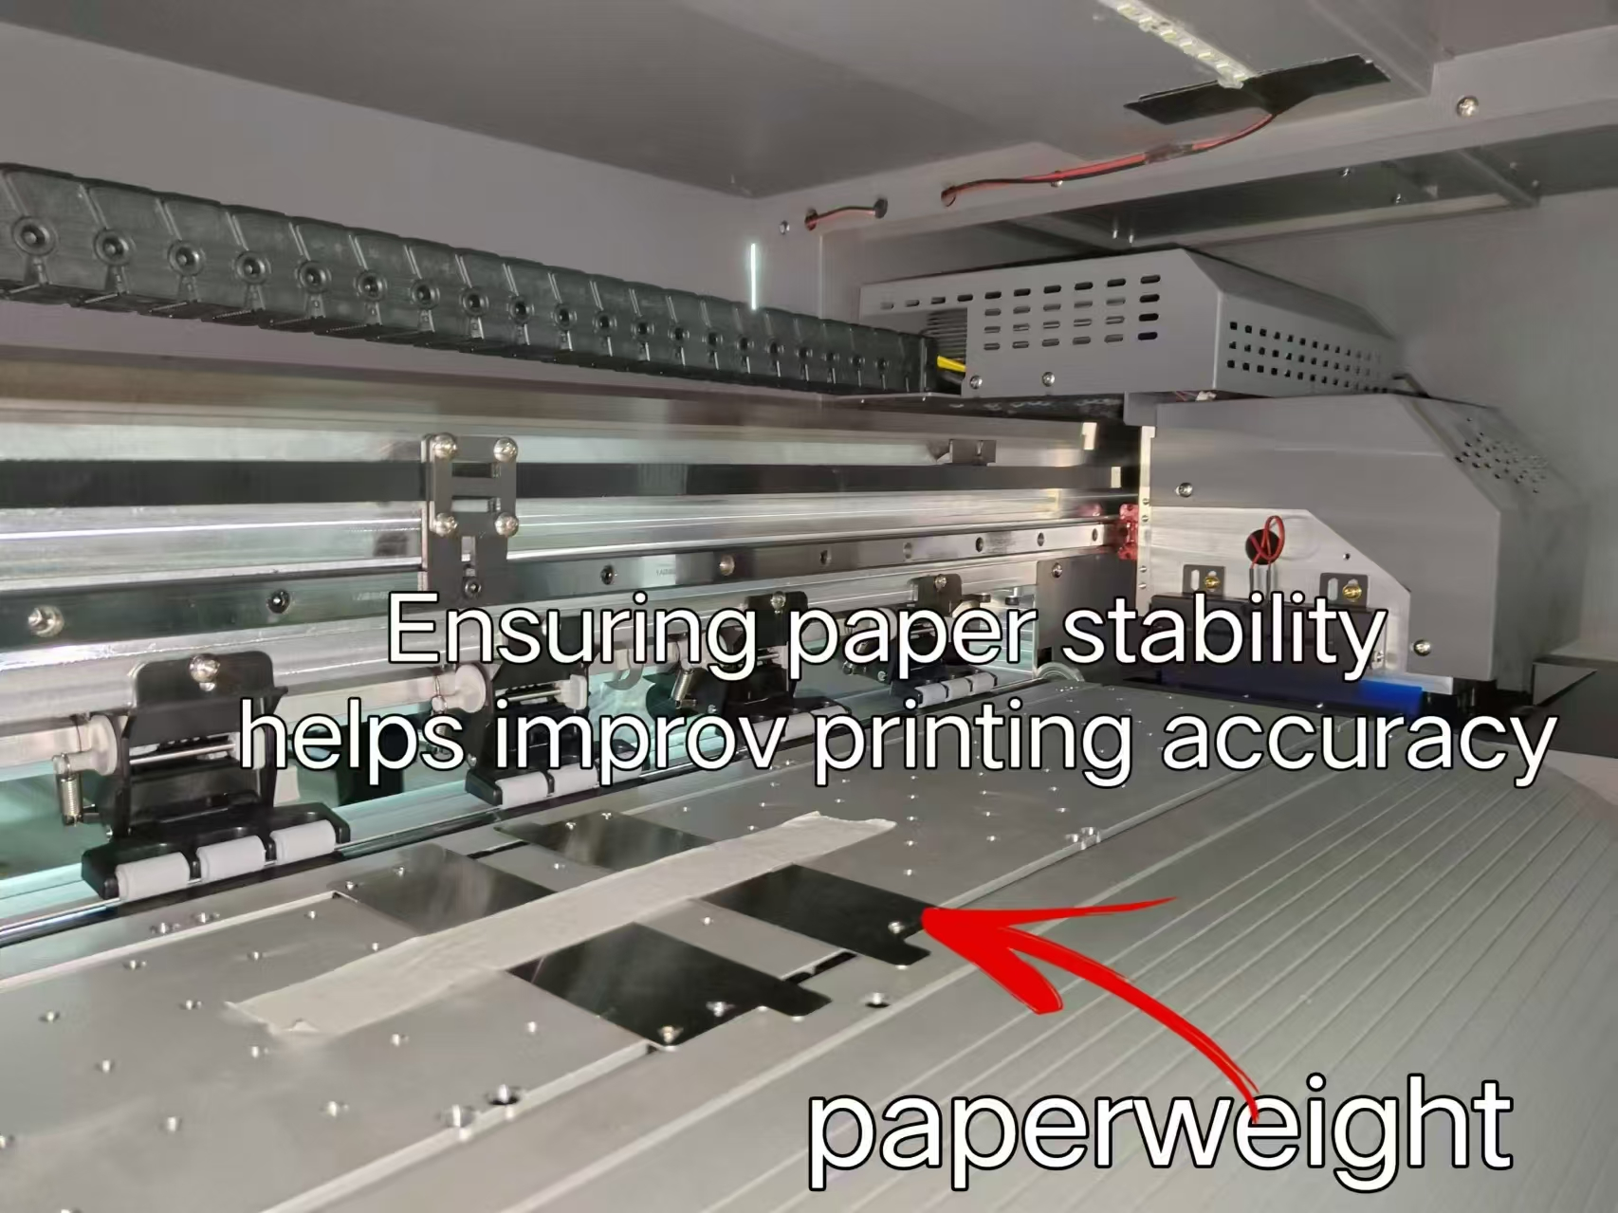
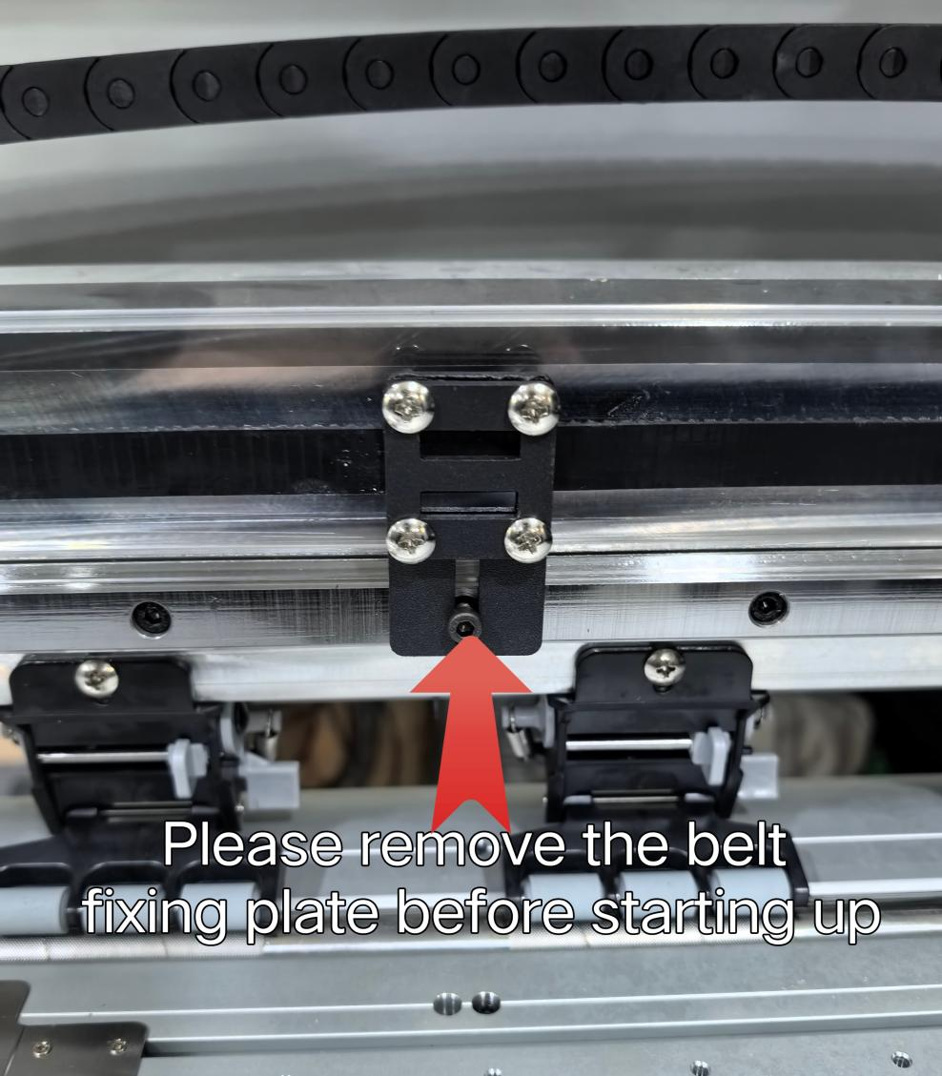

Revision Record
Date | Version | Revised sections | Revision description | Author
March 15, 2018 | First version |  |  | Liu Guangtao, Chenyan
April 17, 2018 |  |  | Add button description, operation steps of new version of card, network access method, judgment method of gigabit NIC, firmware import/export and so on. | Liu Guangtao

Table of Contents
I.Printing software overview 4
II. Software start and online 5
1.Start print control software 5
2.Software online settings 5
2.1 Gigabit NIC judgment 5
2.2 Network settings 5
III.Operation steps before the new board card is used 8
1Set the IP address 8
2 Motor gear ratio calibration 8
3 Clean print head 8
4 Calibration 9
5 Drawing printing settings 9
IV. Introduction of main interface window of the software 9
1 Main menu 9
2 Files 10
3 Print 12
3.1 Open the task list 13
3.2 Historical task list 14
3.3 Task attributes 15
4 Settings 16
5 Calibration 18
5.1 Introduction tonozzle detection function 19
5.2 Introduction to level detection function 20
5.3 Introduction to vertical detection function 21
5.4 Introduction tostepping calibration function 21
5.5 Introduction to print head horizontal spacing calibration 22
5.6 Introduction toprint head vertical spacing calibration 23
5.7 Introduction to bidirectional calibration function 24
5.8 Introduction to trapping printing calibration function 25
6Voltage window 26
7.Advanced 27
7.1 Version information 28
7.2 Upgrade 29
7.3 Sharpening over printing 30
7.4 Broken hole compensation 35
8Logs 37
9.Shortcut button 38
10 Status bar 39
V.Factory mode 40
2 Boot initialization 43
3X motor 43
4Y motor 45
5Ink stack 45
6 Blade 46
7 Print head combination 47
8 Print mode 48
9Reference trapping 49
10Automatic cleaning 49
11Manual cleaning 50
12.Automatic flash spray 51
13Running machine 51
14Paper feeding 52
15 Other 53
16Import / export firmware 54
16.1 Import firmware configuration 54
16.4 Exporting firmware parameters 57
VI.Button board operation instructions 57
1. Keyboard board button layout as shown below 57
2. Menu item description 59
3. Menu list 59

I. Printing software
Developed by Hosonsoft, PrintExp software is a kind of control software that works with printer. It features user-friendly interface, simple operation and meets the needs of end users and manufacturers. It is mainly used for printer control, printer calibration, program upgrade and update, import and export of parameters, saving of parameters to the board. In order to enable users to quickly and comprehensively understand the printing software, get familiar with the various functional operations, precautions and possible problems, the following is an introduction to the different kinds of printing software.

II. Software start and online

1. Start print control software
The PrintExp software can be used directly. First find the PrintExp software folder, open the folder, find the PrintExp.exe application, and double-click the program to start the PrintExp software.

2. Software online settings

2.1 Gigabit NIC judgment
Before network connection, first ensure that the computer's NIC is Gigabit NIC for normal connection. The difference between a 100M NIC and a Gigabit NIC is:
Gigabit NIC contains these characters: Gigabit, GBE, 10/100/1000M, RTL8169.
100M NIC contains these characters: Fast Ethernet, 10/100, FE.
Enter the computer device manager, check the network adapter to make a judgment. The picture shown below is the 100M NIC:

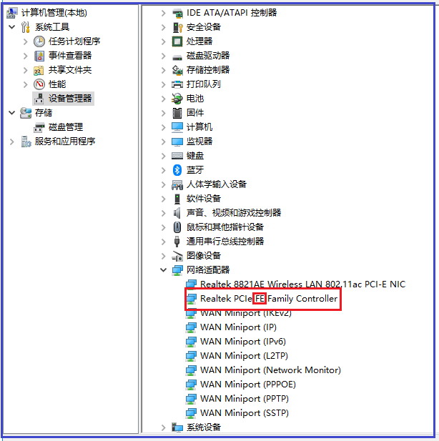

2.2 Network settings
For the first time, you must set the network connection parameters to connect to the network and connect TCP/IP network cable for network setup.
Network setting method: Advanced menu → Network settings, you can see the network settings window at this time, as shown below:

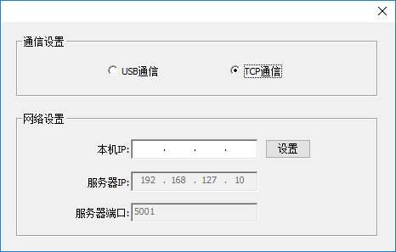

As the server IP and server port settings have been fixed, you only need to set the local IP.As shown above, enter 192.168.127.111 in the local IP address (note that the first three digits can be any number within 1-255 except for 10), click "settings" to complete the setting, check if the network is accessible. If it still cannot connect, you can address with the following methods:
Go to control panel → network and internet → view network status and tasks → change adapter settings → click Ethernet or local area connection → attributes to display the following window:

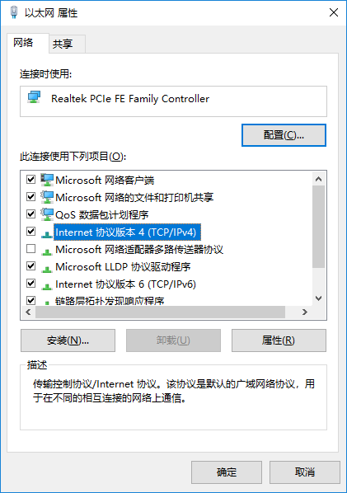
Double-click the highlight bar in the above image to enter the following window:

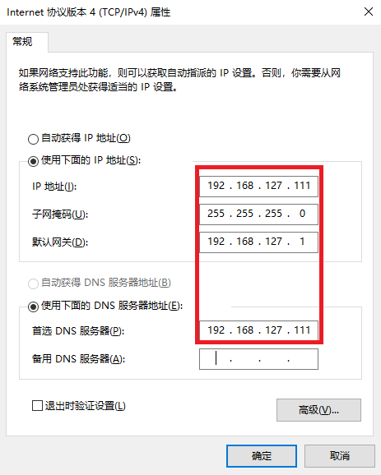

Enter the same address in the red box above and click OK to complete. Go back to the main interface window, check the first icon at the lower left corner of the main interface displayed in green to indicate that it is connected. If it is still red, it means that it is not online. You can unplug the network cable and try again to see if it is online. If you still cannot connect, check if the network cable is in good condition.

III. Operation steps before the new board card is used
For a new set of board cards and software, the steps before using:

1Set the IP address
The specific setting method can be seen in the "Software Online Settings" in "Software Online and Start" above.

2 Motor gear ratio calibration
It is described in the following section "Factory Settings" in detail

3 Clean print head
Ensure that all orifices of the print head can be inked normally

4 Calibration
In the following section, “Calibration" is described in detail

5 Drawing printing settings
In the following section, "sharpen and print" is described in detail.

IV. Introduction of main interface window of the software
The main interface of PrintExp software is as follows:

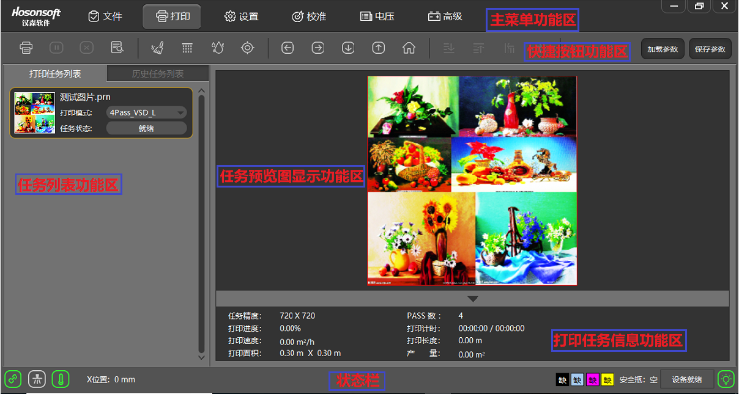

The main interface of PrintExp software mainly includes main menu function area, shortcut button function area, print list function area, task preview image display function area, print task information function area, status bar, etc., which are introduced in the following parts.

1 Main menu
The menu tree of the main menu is as follows:

2 Files
Click the file in the menu bar to enter the file interface. The interface mainly includes the file directory window, the image preview window, and the picture information display bar is shown below:

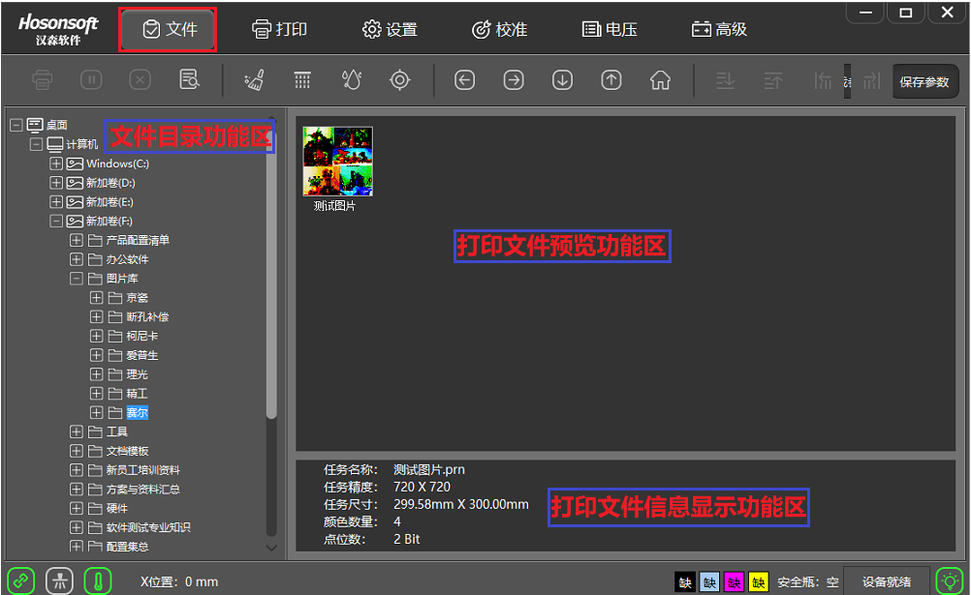
No. | Name | Function description
1 | File directory function area | Select the folder where the print files are stored
2 | Print file preview function area | Display all print files under the specified print file folder
3 | Print file information display function area | Display print information of the selected print file

If you select the preview image and right click, the menu list will pop up as shown below:

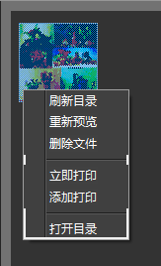

No. | Name | Function description
1 | Re-preview | Regenerate a preview of the currently specified print file
2 | Refresh the directory | Refresh all the print files in the specified print file folder
3 | Delete files | Delete print files
4 | Print now | Add the current print file to the print task list and print immediately
5 | Add to print | Add the selected print file to the print task list
6 | Open directory | Open the folder corresponding to the print file

3 Print
Click Print in the menu bar to enter the print interface, as shown below:

No. | Name | Function description
1 | Main menu function area | Display the area of the main function buttons of the system
2 | Shortcut button function area | Display the area of frequently used command buttons
3 | Task list function area | Display the current area of all tasks that are being printed or to be printed
4 | Task preview display function area | Display the area of preview of selected print task
5 | Print task information function area | Display the area of all print information for the current print task
6 | Status bar | Display the area of current working status or connection status of the system

The print interface includes a print task list window, a history task list window, a print task preview window, and a print information window; select a task in the print task list, right click topop up the drop-down menu as shown below:

3.1 Open the task list

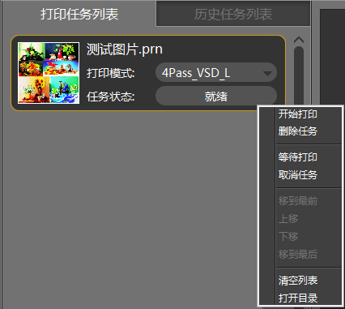
No. | Name | Function description
1 | Start printing | Perform printing
2 | Delete task | Delete from print task list
3 | Wait for printing | Add the current task to the queue to be printed
4 | Cancel task | Cancel the printing or cancel the waiting for printing status
5 | Move to the top | Move the selected task to the top of the task list
6 | Move up | Move the print task forward one bit
7 | Move down | Move the print task backward one bit
8 | Move to the last | Move the selected task to the end of the task list
9 | Clear list | Clear all tasks in the print task list
10 | Open directory | Open the folder where the print file is located

3.2 Historical task list

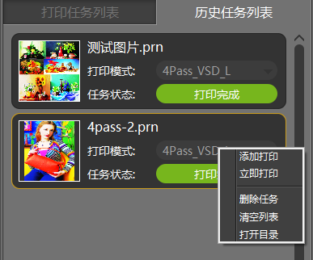
No. | Name | Function description
1 | Add to print | Add a task to the print task list
2 | Print now | Add a task to the print task list and print immediately
3 | Delete task | Delete task from history print list
4 | Clear list | Clear the tasks in the history print list
5 | Open directory | Open the folder where the print file is located

3.3 Task attributes
Double-click a task in the print task list to enter the task property window of the task, as shown below:

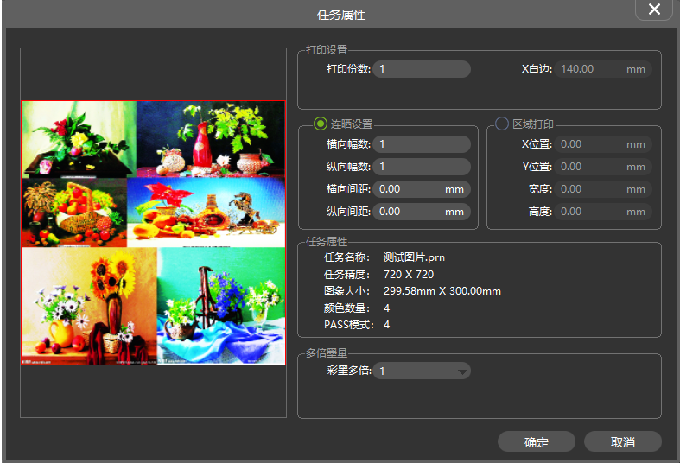
No. | Name |  | Function description
1 | Print settings | Number of copies | Set the number of times of repeated printing
2 | Photocomposing setting | Horizontal photo number | Horizontal photocomposing number
2 | Photocomposing setting | Vertical photo number | Vertical photocomposing number
2 | Photocomposing setting | Horizontal spacing | Horizontal photocomposing spacing(mm)
2 | Photocomposing setting | Vertical spacing | Vertical photocomposing spacing(mm)
3 | Regional printing | X position | Loading position in X direction in print files
3 | Regional printing | Y position | Loading position in Y direction in print files
3 | Regional printing | Width | Print width of selected area in print files
3 | Regional printing | Height | Print height of selected area in print files
4 | Task attribute |  | Include the name of the task, the print precision of the task, the size of the print job, the number of color of print tasks, and the number of pass of task.

4 Settings
Click settings in the menu bar to enter the settings interface, as shown below:

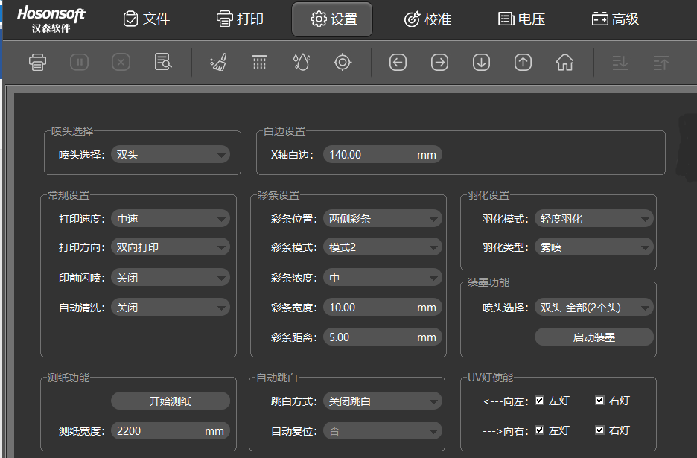
No. | Name |  | Function description
1 | Nozzle selection |  | Only specific model can have nozzle selection
2 | X white edge |  | Set loading position
3 | General setting | Print speed | Set the print speed to be low, medium and high speed
3 | General setting | Print direction | Set the print direction to be leftwards printing, rightwards printing and bi-directional printing
3 | General setting | Flash work before printing | Set flash work on or off before printing
3 | General setting | Automatic cleaning | Set automatic cleaning on or automatic cleaning off
4 | Color bar setting | Color bar setting | Set the color bar position to be left color bar, right color bar and color bars on both sides or color bar off
4 | Color bar setting | Color bar mode | Difference between two kinds of color bar modes
4 | Color bar setting | Color bar concentration | Set color bar concentration to be weak, medium and strong
4 | Color bar setting | Color bar width | Width of color bar
4 | Color bar setting | Color bar distance | Blank spacing between color bar and print picture
5 | Feather setting | Feather range | Feather range selection
5 | Feather setting | Feather type | Feather type selection
6 | Ink loading function |  | Put inking loading function on or off
7 | Test paper function |  | Click “start test” to test the width of printing paper
8 | White streak function | Stepping white streak | Enable white streak, follow PASS feeding in vertical white streak
8 | White streak function | Continuous white streak | Enable white streak, follow continuous feeding in vertical white streak
8 | White streak function | Close white streak | Close white streak function

5 Calibration
Click Calibration in the menu bar to enter the calibration interface, as shown below:

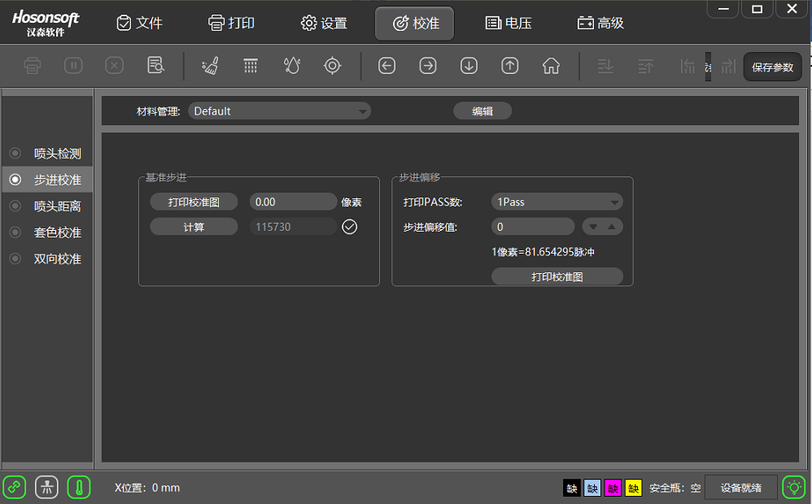

No. | Name |  | Function description
1 | print head detection | Nozzle detection | Check whether the ink jet of orifice of the print head are in good condition
1 | print head detection | Level detection | Check whether the entire nozzle plane of the print head is parallel to the horizontal plane.
1 | print head detection | Vertical detection | Check whether the print head is skewed.
2 | Stepping calibration |  | Calibrate stepping parameters and fine-tuning stepping parameters for different pass modes
3 | print head range | print head horizontal spacing calibration | Calibrate horizontal spacing between print heads
3 | print head range | print head vertical spacing calibration | Calibrate vertical spacing between print heads
4 | Trapping printing calibration |  | Calibrate the vertical and horizontal location of each passage of print head
5 | Bi-directional calibration |  | Calibrate bi-directional offset under different speed of bi-directional printing

5.1 Introduction to nozzle detection function
Click “nozzle detection”, the system will print the nozzle detection pattern, such as the print head state diagram of EPSON DX5 printer, as shown below:

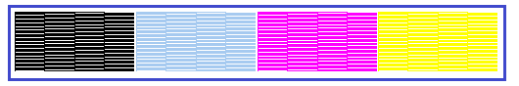

Partially enlarge the normal and abnormal conditions of the black state diagram, as shown below:

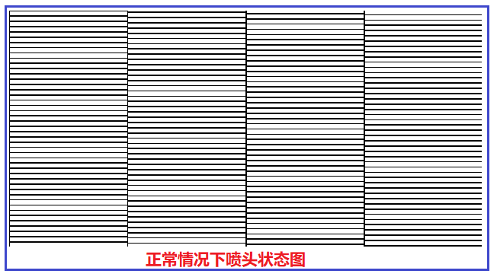
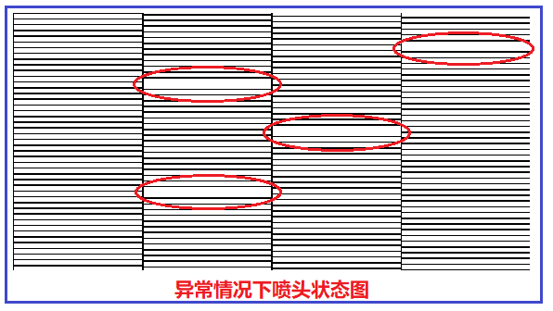

The state diagram in the above picture may be blocked and needs to be cleaned until the nozzle inkjet is optimal.

5.2 Introduction to level detection function
Click “level detection”, the system will print out the level detection pattern, such as the level detection pattern of EPSON DX5 printer, as shown below:

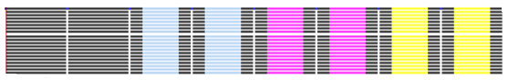

5.3 Introduction to vertical detection function
Click “vertical detection”. The system will print a vertical detection pattern, such as the vertical detection pattern of EPSON DX5 printer, as shown below:

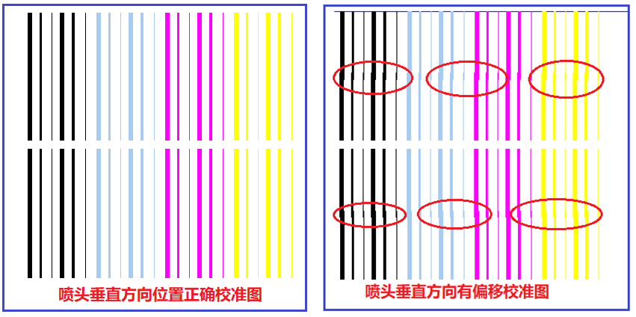

The calibration chart on the right side of the figure above needs to be adjusted vertically until the vertical calibration chart is in the correct state.

5.4 Introduction to stepping calibration function
Click “print calibration chart” under the reference stepping box. The system will print. For example, the stepping calibration chart of EPSON DX5 printer is as follows:

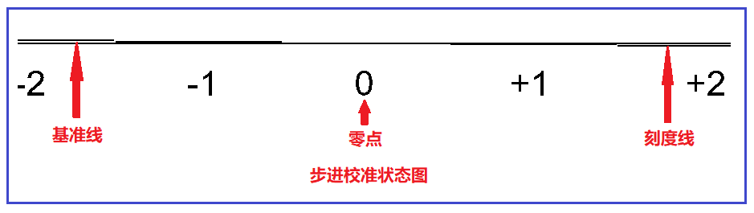
The above figure shows that the stepping is calibrated and the reference line and the tick mark are completely coincident at 0. If the stepping is not calibrated, the following situation will appear:

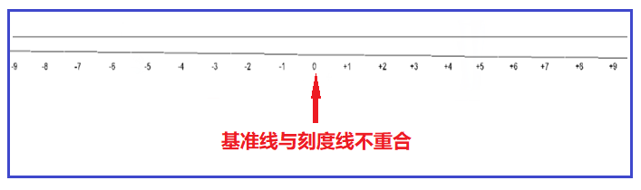
The above picture needs to be adjusted. Adjustment window is as shown below. Input the adjustment value, click calculation, and reprint the calibration chart until the baseline and the print line completely coincide at 0.

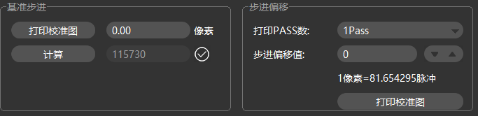

5.5 Introduction to print head horizontal spacing calibration
Click “Print left/right calibration chart” under the horizontal spacing calibration box of the print head. The system will print.

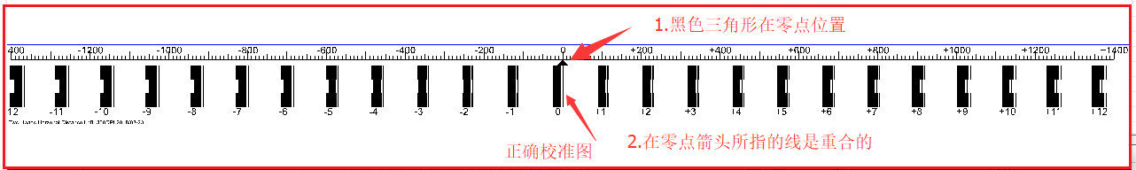
The above figure shows that the horizontal distance between the print heads is normal, and when the horizontal spacing of the print heads is not calibrated, the following picture will appear:

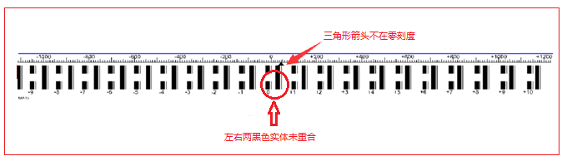
The above picture needs to be adjusted. The adjustment window is shown below. After inputting the adjustment value in the position H2 in the figure below, reprint the calibration chart until the mark of 0 is pointing to 0.

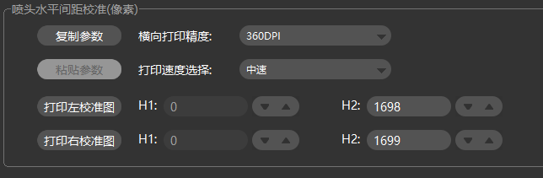

5.6 Introduction to print head vertical spacing calibration
Click “print calibration chart” under the vertical spacing calibration frame of print head. The system will print.

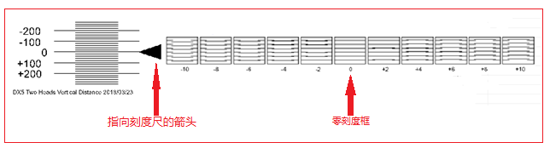
The figure above shows that the longitudinal distance between the print heads is normal. All the lines in the 0-point scale box are parallel, and the left arrow points to the 0-point scale mark. If the longitudinal distance is not calibrated, the following picture will appear:

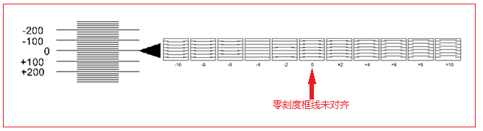
All the lines in the 0-point scale box are not parallel, but all the lines in the -4 scale box are parallel, so it needs to be adjusted. Subtract 4 from the original calibration value, and then re-calibrate until all the lines in the 0-point scale box are are parallel. The adjustment window is as follows:

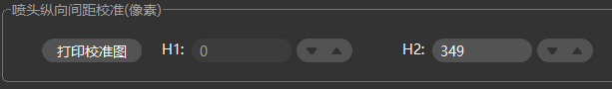

5.7 Introduction to bidirectional calibration function
Click “print calibration chart” under the bidirectional calibration interface, the system will print

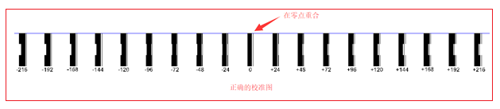

The figure above shows the calibration. The uncalibrated situation is as follows:

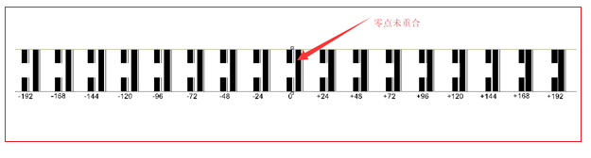

The calibration value must be filled in and recalibrated, as shown below:

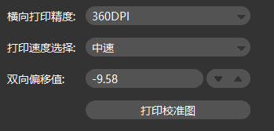

5.8 Introduction to trapping printing calibration function
Click “Print left/right calibration chart” under the color calibration interface, the system will print

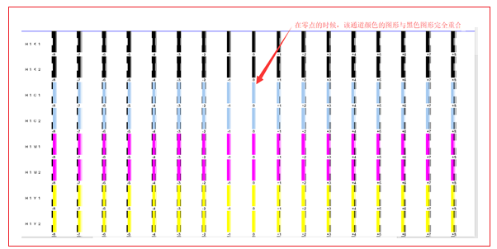
The figure above shows the calibration. The uncalibrated situation is as follows:

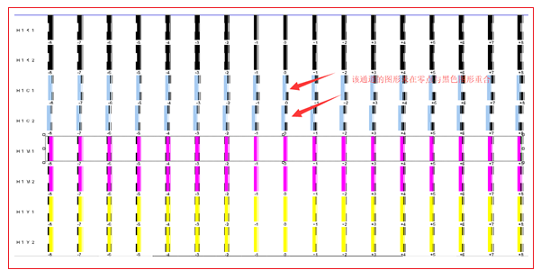

The calibration value must be filled in and recalibrated, as shown below:

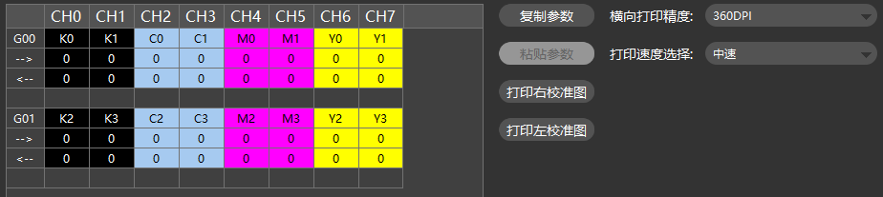

6Voltage window
Click the main menu voltage to enter the voltage window, as shown below:

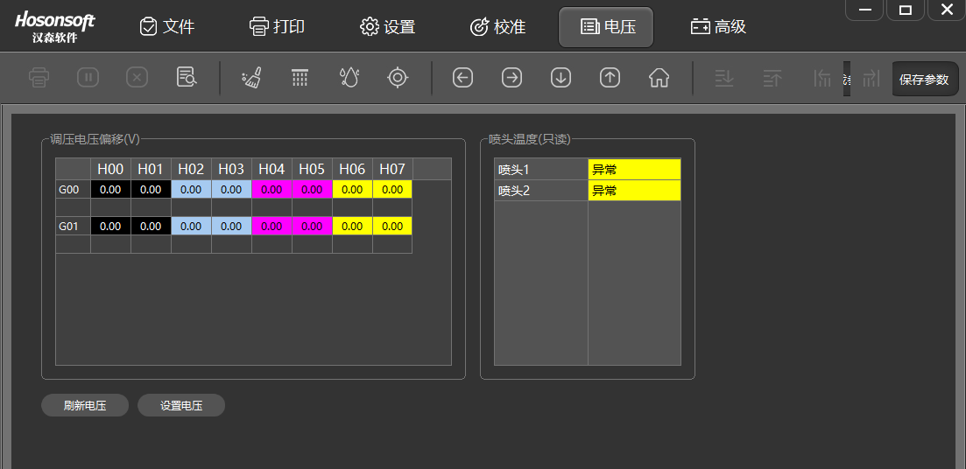
No. | Name | Function description
1 | Voltage regulation voltage offset | Set the offset voltage of the specified print head channel
2 | Refresh voltage | Update current print head channel voltage value
3 | Set the voltage | Save the current print head voltage offset value
4 | print head temperature (read only) | Display the specified print head temperature

7. Advanced
Click Advanced on the main menu to enter the advanced interface, as shown below:

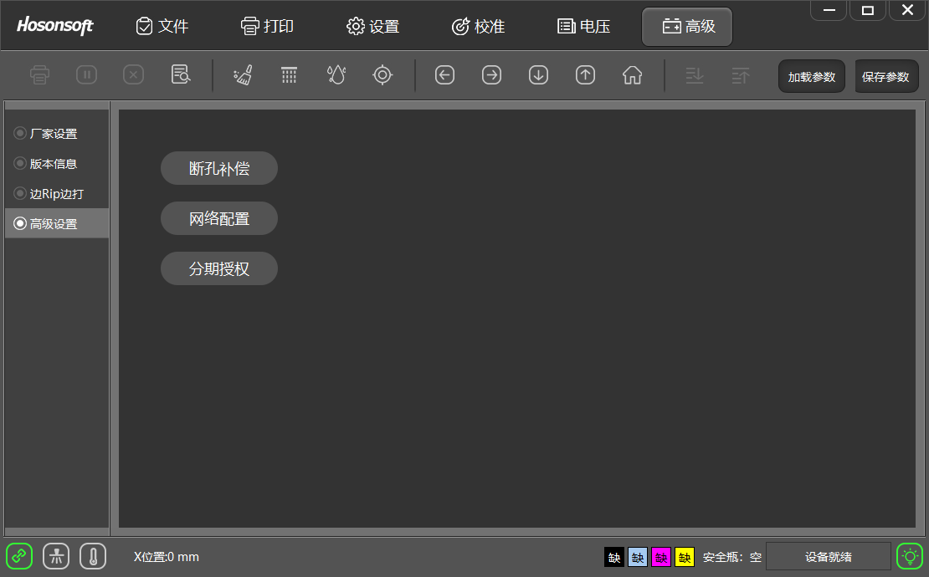
No. | Name | Function description
1 | Manufacturer setting | Enter the entrance of the manufacturer parameter setting interface
2 | Version Information | Display system board card related version information
3 | Rip over printing | Select the precision mode for rip over printing
4 | Advanced settings | Broken hole compensation, network configuration, installment authorization settings

7.1 Version information
Click the version information in the advanced interface and enter the following interface:

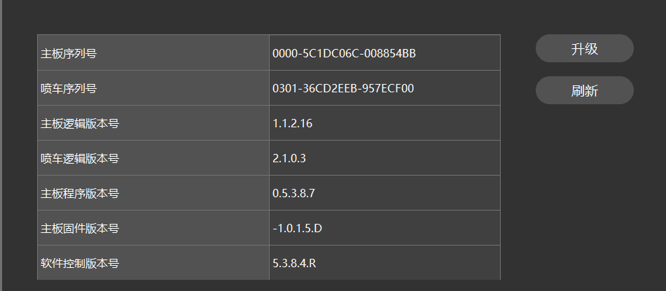

7.2 Upgrade
The mainboard logic, the sweep logic, the motherboard program, and the MCU program can be upgraded and updated separately. After the program is upgraded, the power must be turned off and then powered back on. Click refresh to check whether the newly upgraded program has been updated. The upgrade method is as follows:
Click the "Upgrade" button above to pop up the following window:

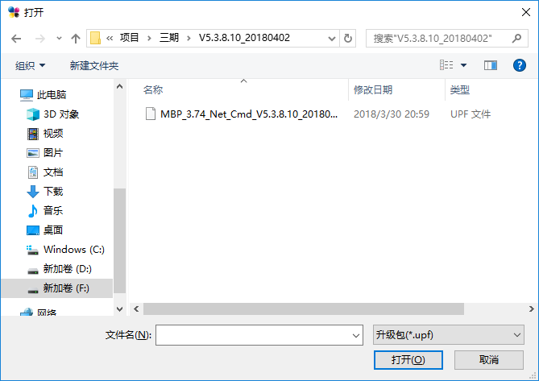
Select the program to be upgraded, and then click the "Open" button to enter the upgrade window. Click "OK" to enter the upgrade. The upgrade will prompt whether the upgrade is successful. After upgrade, power back on again, check the version information to confirm that it has been upgraded.

7.3 Sharpening over printing
In the advanced interface, click the sharpening over printing button to enter the following interface:

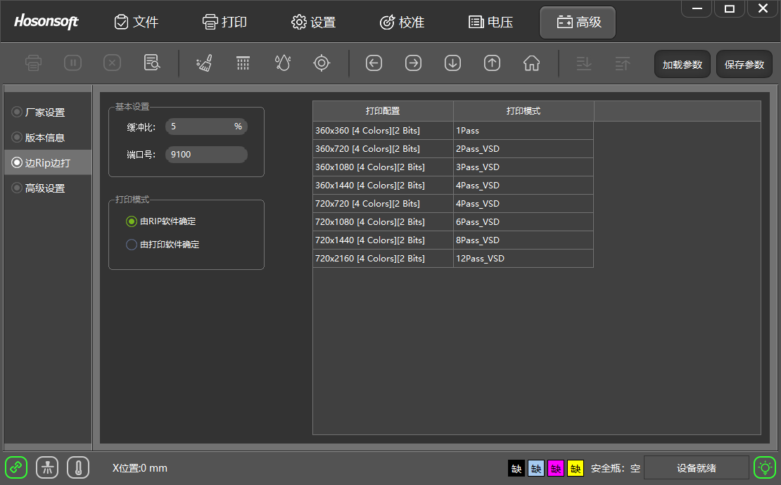
No. | Name |  | Function description
1 | Basic setting | Buffer ratio | Indicate that RIP reaches the set value and start printing
1 | Basic setting | Port number | Default value: 9100
2 | Printing mode | Determined by RIP software | RIP software determines the printing mode in the case of RIP over printing
2 | Printing mode | Determined by RIP software | Printing control software determines the printing mode in the case of RIP over printing
How does printing software set printing mode
Open the printing software, add the print task to the print list, click the print mode drop-down list of the print task, select different print modes, as shown below:

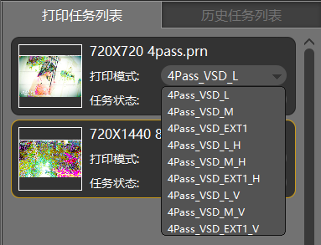
No. | Name | Function description
1 | VSD_L | For normal mode large dot printing, the effect is as shown in Figure 7-3-1
2 | VSD_M | Normal mode midpoint printing
3 | VSD_EXT1 | Normal mode extension point printing
4 | VSD_L_H | For horizontal connected large dot printing, the effect is as shown in Figure 7-3-2
5 | VSD_L_V | For longitudinal connected large dot printing, the effect is as shown in Figure 7-3-2

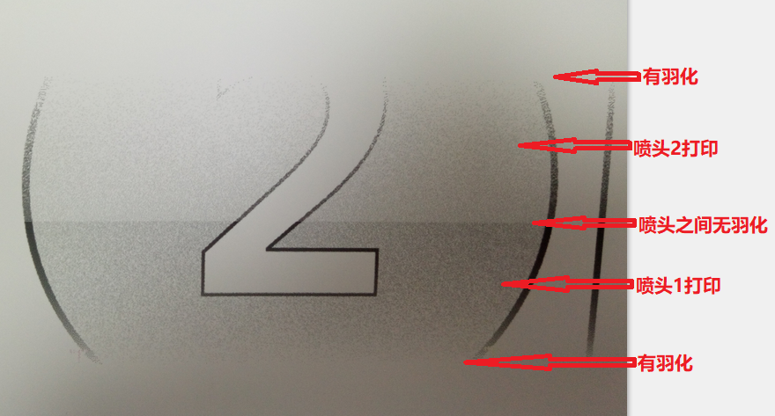
Normal mode Figure 7-3-1
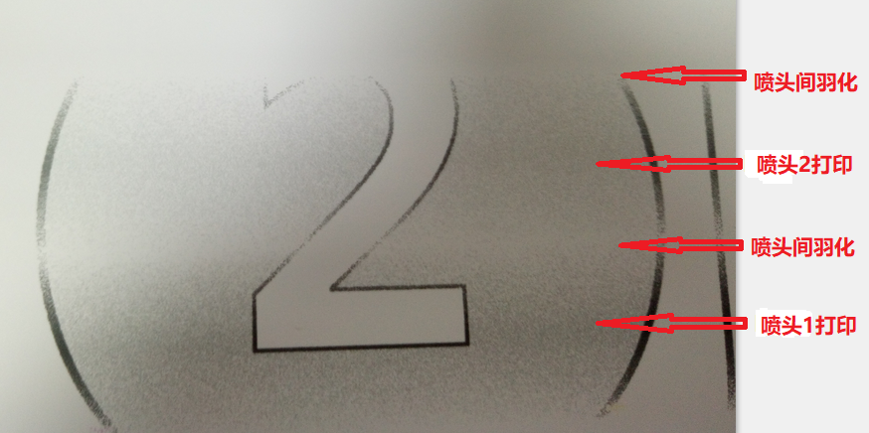
Horizontal connection Figure 7-3-2

How to set the print mode by Maintop Rip software
Open Maintop software maintop-file - create new file - load picture - print, pop up the following window

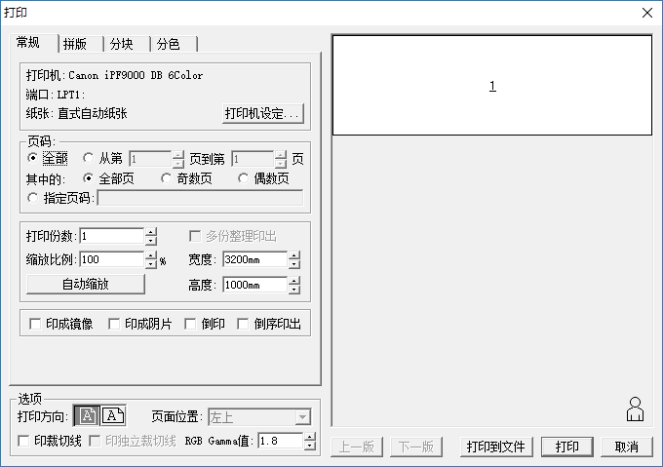
Click the "Printer Settings" button in the above figure to set the print mode and enter the red box as shown below.

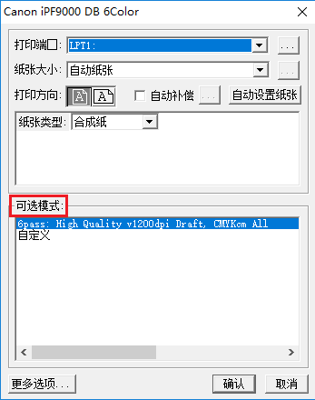
Click the “More Options” button in the above figure to set the printing precision, and select the printing precision from the precision drop-down list, as shown below.

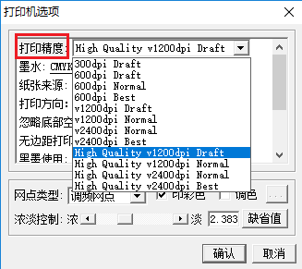

How to set the print mode by Honson Rip software
Open Honson Software UltraPrint - New Canvas - Place Image - Print Canvas, enter the settings interface, as shown below:

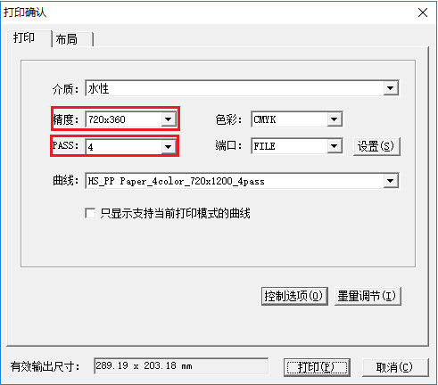
The red box in the figure is the setting for the precision and print mode.

7.4 Broken hole compensation
In the advanced settings menu, click the broken hole compensation button to enter the following interface:

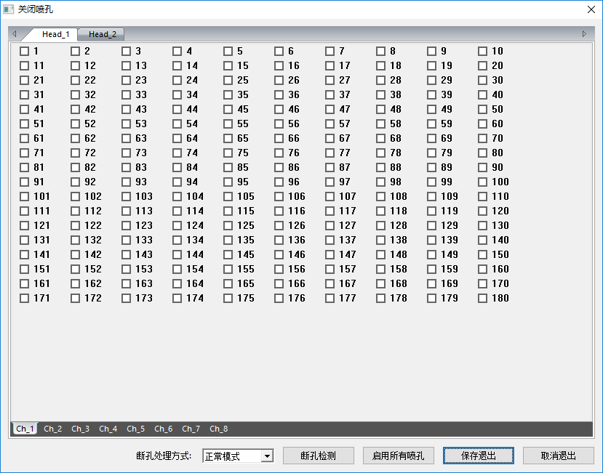

No. | Name | Function description
1 | Broken hole treatment method | Broken hole treatment method selection
2 | Broken hole detection | Check the broken hole status of each orifice of the print head
3 | Enable all orifices | All orifices opening/closing options
4 | Save and exit | Save the current settings and exit the broken hole settings.
5 | Cancel and exit | Don’t save the current setting and directly exit the broken hole setting state

Right click the orifice setting interface to pop up a drop-down menu, as shown below:

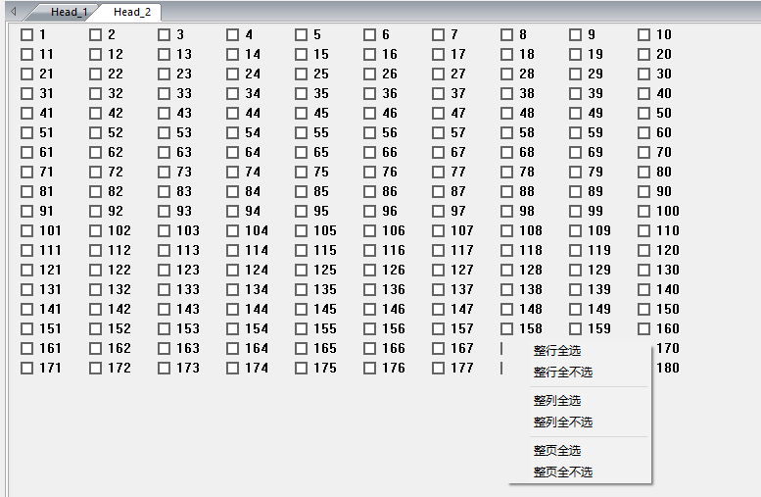
No. | Name | Function description
1 | Select whole row | Select the whole row at the same time
2 | Unselect the whole row | Unselect the whole row at the same time
3 | Select the whole line | Select the whole line at the same time
4 | Unselect the whole line | Unselect the whole line at the same time
5 | Select the whole page | Select the whole page at the same time
6 | Unselect the whole page | Unselect the whole page at the same time

8Logs
Click the log button in the lower right corner of the printing software to enter the log window, as shown below:

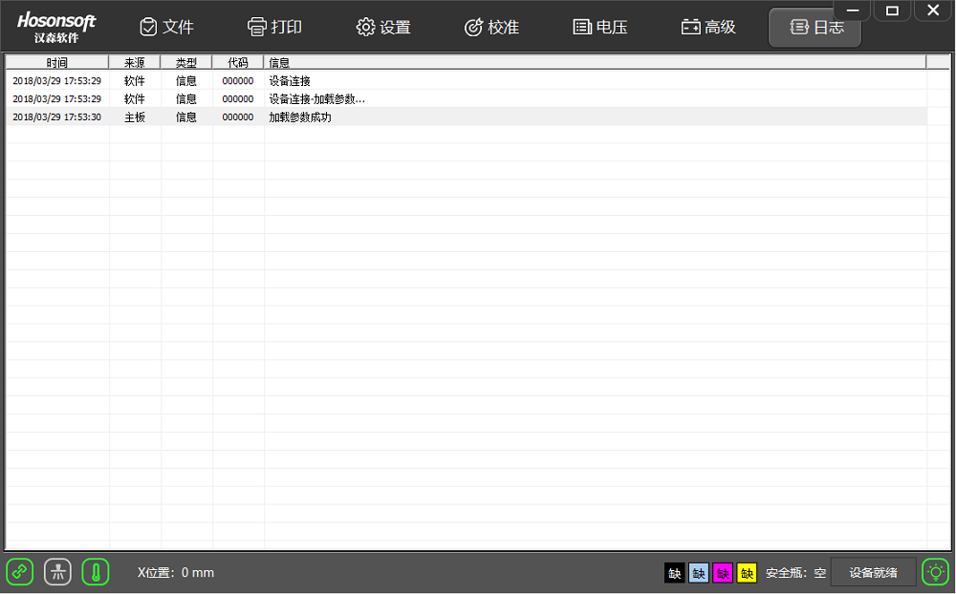
Through this window, you can see the current operation, especially when there is an error or a fault, you can know which type of error information is generated by viewing the debugging information, so that the error is solved in a targeted manner.

9. Shortcut button

Shortcut button | Function description
 | Printing start button to execute the print command
 | print head check button to execute print head printing state
 | Printing pause/resume button
 | Printing cancel button to execute the end printing command
 | print head cleaning button to execute print head cleaning command
 | Flash spray on/off button
 | White edge positioning button
 | Moisturizing off/on button
 | Reset button
 | X motor left shift button
 | X motor right shift button
 | Feed button
 | Return button
 | Stepping fine adjustment reduction button
 | Stepping fine adjustment increase button
 | Two-way fine adjustment reduction button
 | Two-way fine adjustment increase button
 | Entry into height measurement control panel button

10 Status bar
Status bar icon | Description
 | Network cable normal connection
 | Network cable disconnection
 | Offline
 | Turn on the flash spray
 | Turn off the flash spray
 | System functions normally
 | System error
 | System warning
 | Offline
 | Normal print head temperature
 | Abnormal print head temperature
 | print head temperature warning
 | Offline

V. Factory mode
Click the factory settings in the advanced interface, enter the password directly, enter the factory mode, as shown below:

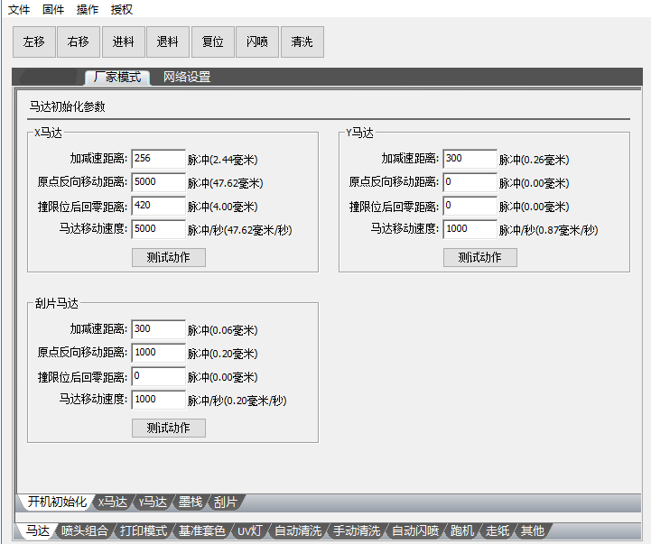
- Main content of factory mode
The main content of factory mode refers to the following menu tree

2 Boot initialization
Perform the motor's action parameters during power-on initialization, as shown below:

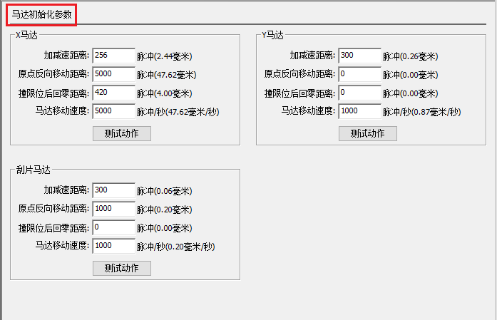
The parameters of the X motor, the Y motor, and the blade motor are the same. The X motor is taken as an example for explanation. See the following table:

No. | Name | Function description
1 | Acceleration and deceleration distance | Acceleration and deceleration distance
2 | Origin reverse movement distance | The distance the motor moves away from the origin
3 | Returning to the zero position after hitting the limit | After the motor moves to the origin direction, the distance of the reverse movement after hitting the limiter
4 | Motor moving speed | Motor moving speed

3X motor
The settings of the X motor parameters are as follows:

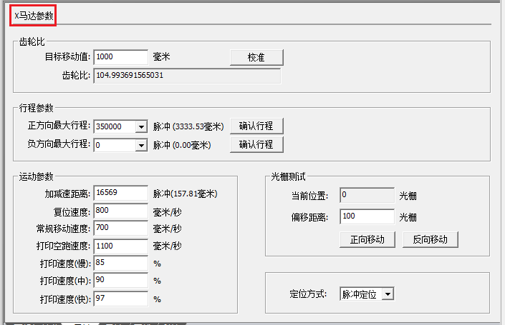
No. | Name | Function description
1 | Gear ratio calibration | Calibrate the gear ratio of the X motor
2 | Stroke parameters | The maximum range of motion of the X-direction trolley
3 | Acceleration and deceleration distance | Acceleration and deceleration distance
4 | Reset speed | The speed of the trolley movement during the reset
5 | Regular moving speed | The speed of trolley when moving to the left and right in manual mode
6 | Invalid running speed of printing | The back running speed of trolley in one-way printing
7 | Print speed | The ratio of the maximum spray frequency to the speed, the difference of the different speeds
8 | Raster test | Raster test has two main functions: First, it is confirmed whether the precision of the grating is accurate by comparing the set offset distance with the raster value reported in real time; in addition, determining whether the direction of the raster is correct
9 | Pulse positioning | Locate the current position of the trolley by pulse
10 | Raster positioning | Locate the current position of the trolley through the raster

4Y motor

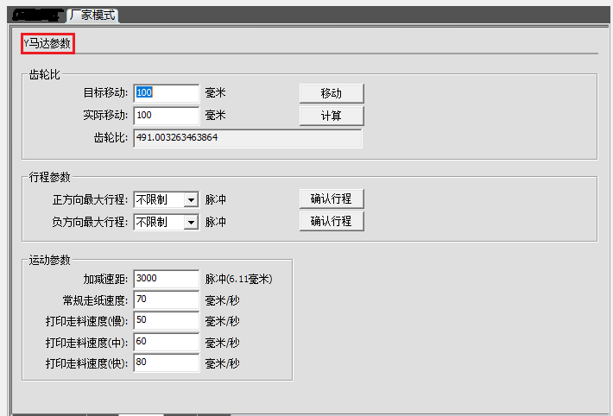
No. | Name | Function description
1 | Gear ratio calibration | Calibrate the gear ratio of the Y motor
2 | Stroke parameters | The maximum range of motion of the Y-direction motor
3 | Acceleration and deceleration distance | The motor accelerates from the stop state to the constant speed or decelerates from the constant speed to 0.
4 | Conventional feed speed | The speed of the Y motor at a constant speed during manual feed/return movement
5 | Printing speed | The ratio of the maximum jetting frequency to the speed, the ratio of the different speeds varies.

5Ink stack

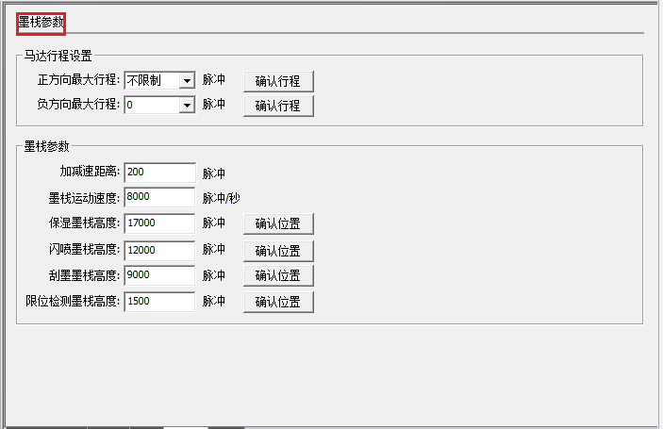
No. | Name | Function description
1 | Motor stroke setting | Maximum range of motion of the ink stack
2 | Acceleration and deceleration distance | Acceleration and deceleration distance
3 | Ink stack movement speed | Ink stack movement speed
4 | Moisturizing ink stack height | The height of the ink stack in a moisturizing state
5 | Flash inkjet stack height | The height of the ink stack in the flash spray state
6 | Scrape ink stack height | The height of the ink stack when it is moisturized
7 | Limit detection ink stack height | When entering the limit detection, the height of the ink stack (the height is as small as possible, but it must be out of the limit position)

6 Blade

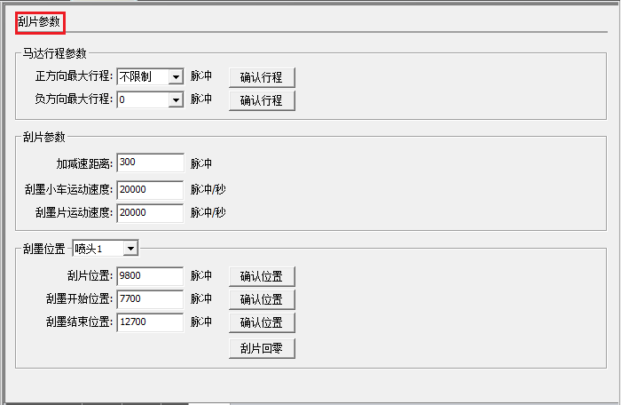
No. | Name | Function description
1 | Motor stroke parameters | Setting of the maximum stroke parameter of the blade motor
2 | Blade parameter setting | Blade motor acceleration/deceleration distance parameter and motion speed parameter setting
3 | Start position of ink scraping | The starting position of the trolley when the scraper is scraping the print head
4 | End position of ink scraping | The end position of the trolley when the scraper is scraping the print head

7 Print head combination

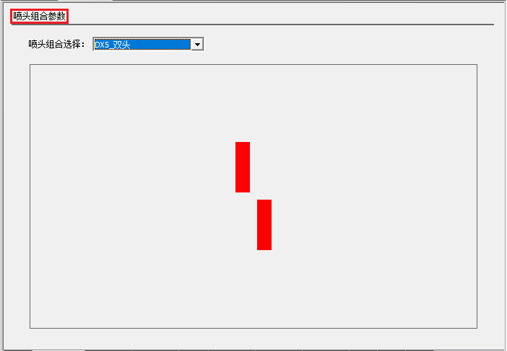
Show a variety of different arrangements of multiple print heads.

8 Print mode

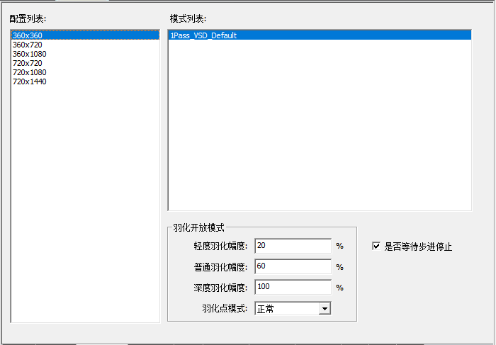
No. | Name | Function description
1 | Configuration list | Currently configured all precision list of the print head
2 | Mode list | List of print modes for each precision
3 | Feathering mode setting | Feathering amplitude setting and feathering point mode selection

9Reference trapping

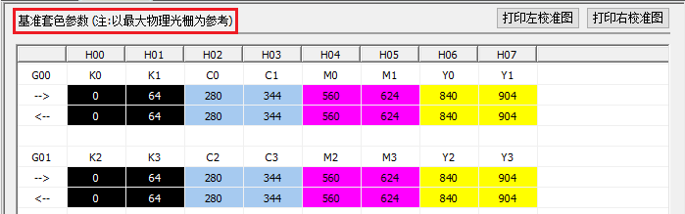
The trapping color value here is used to fill the internal trapping color shift of the print head.

10Automatic cleaning

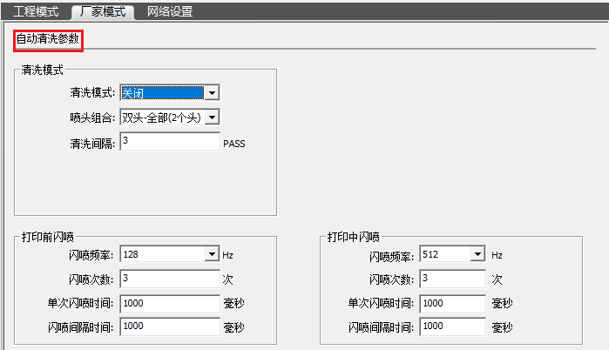
No. | Name | Function description
1 | Cleaning mode | Automatic cleaning on/off selection
2 | print head combination | Selection of combined cleaning between different print heads
3 | Cleaning interval | When the flash spraying printing is on, the flash spray is carried out after each set number of passes.
4 | Flash spray frequency | The number of times the print head ejects per second
5 | Flash spray times | Stop the flash spray after several flash spray cycles in succession
6 | Single flash spray time | One flash spray cycle, continuous flash spray time
7 | Flash spray interval time | Two flash spray intervals

11Manual cleaning

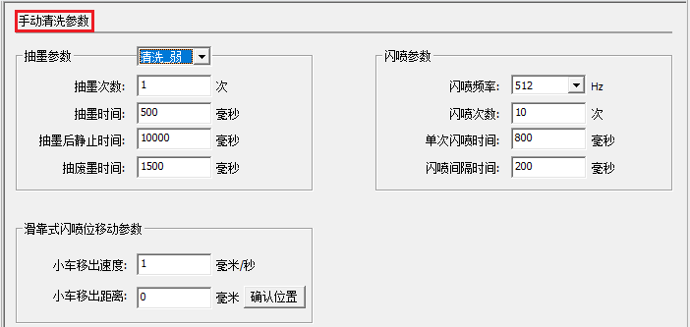
No. | Name | Function description
1 | Number of ink pumping | Number of ink pumping during manual cleaning
2 | Ink pumping time | The duration of each ink pumping
3 | Static time after ink pumping | After the ink pumping is completed, wait for the set time before proceeding to the next operation.
 | Waste ink pumping time | Start time to pump waste ink from motor
 | Trolley removal speed | In sliding flash spray, the speed of movement when the trolley moves to the specified position
 | Trolley removal distance | The flash spray position in sliding flash spray

12. Automatic flash spray

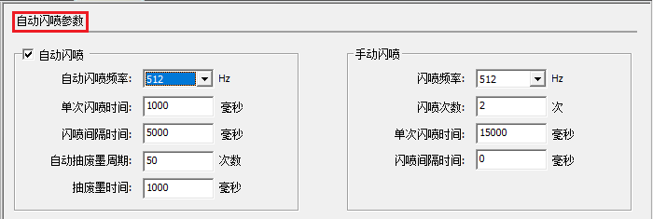
No. | Name | Function description
1 | Automatic flash spray frequency | The number of inkjet ejections per second during automatic flash spray
2 | Single flash spray time | One flash spray cycle, continuous flash spray time
3 | Flash spray interval time | Interval between two flash sprays
4 | Automatic waste ink pumping cycle | During the automatic flash spray process, carry out one waste ink pumping after setting flash spray times
5 | Waste ink pumping time | Start time to evacuate the waste ink motor

13Running machine

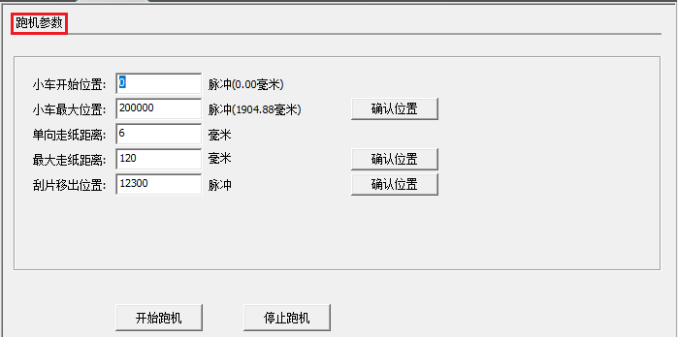
No. | Name | Function description
1 | The starting position of the trolley | The starting position of the trolley when running the machine
2 | The maximum position of the trolley | The end position of the trolley when running the machine
3 | One-way paper-feeding distance | The distance of paper feeding of one round of trolley movement in the Y direction
4 | Maximum paper-feeding distance | The total distance of the paper feeding in the Y direction in the machine running
5 | Blade removal position | The distance the blade is removed from the origin of the blade during the running

14Paper feeding

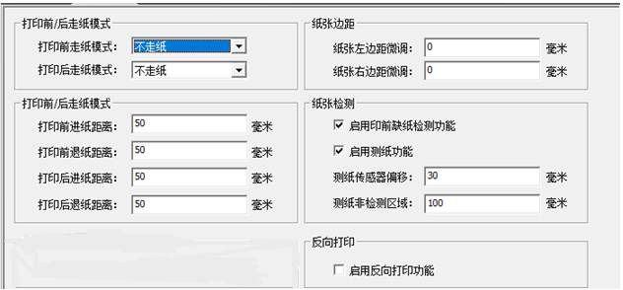
No. | Name | Function description
1 | Paper feed mode before printing | Paper feed mode selection before printing
2 | Paper feeding mode after printing | Paper feed mode selection after printing
3 | Paper feeding distance before printing | Set distance of paper feeding before printing
 | Paper return distance before printing | Set distance of paper return before printing
4 | Paper feeding distance after printing | Stop printing after the printing task is completed and paper feeding distance is set
 | Paper return distance after printing | Stop printing after the printing task is completed and paper return distance is set
8 | Fine adjustment of left margin and right margin of paper | Fine adjustment of the distance between the drawing to be printed and paper edge
9 | Paper detection | Turn on/turn off paper detection of paper shortage detection
10 | Test paper sensor offset | The horizontal distance between the test paper sensor probe and the raster decoder
11 | Test paper non-detection area | The distance of the test paper sensor detection probe to the paper start mark

15 Others

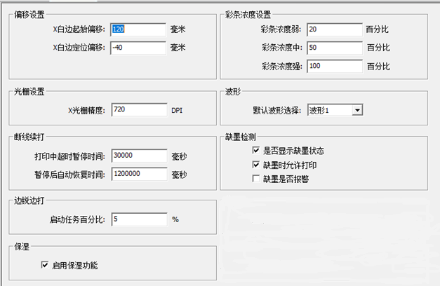
No. | Name | Function description
1 | X white edge start offset | The distance from the print head to the printed material
2 | X white edge positioning offset | White edge positioning error setting, its calculation formula: white edge positioning value - white edge positioning offset= white edge value + white edge starting offset
3 | Raster setting | Set the precision of the grating (precision after four-way frequency)
4 | Color bar concentration | The color bar concentration of different grades set different proportions
5 | Waveform | Waveform selection
6 | Timeout in printing | In the print, the dropout time reaches the set time and print pauses
7 | Automatic recovery time after pause | After the pause, the network cable is detected to be connected within the set time, and the printing resumes automatically.
8 | Ink shortage detection | Select the action to be taken when the ink is in shortage
9 | Moisturizing | Turns on/off moisturizing function

16Import / export firmware

16.1 Import firmware configuration
Click “Firmware Menu” to pop up the drop-down menu list and select “Import Firmware Configuration” to select the firmware configuration to be imported. Note the suffix is ..bsf, as shown below:

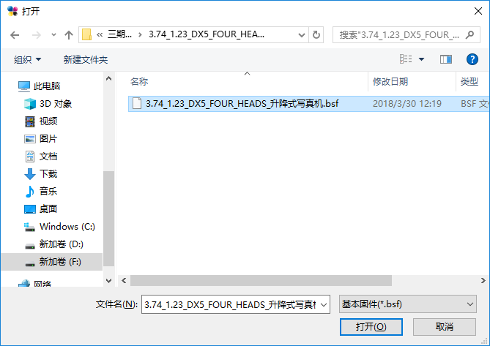
Click "Open" to enter the import firmware configuration state. At this time, you should not do anything. You will be prompted to "Import successfully" and view the debugging information. The message "Loading Flash successfully" indicates that the import is successful.
16.2 Import firmware parameters
Click “Firmware Menu” to pop up the drop-down menu list and select “Import Firmware Configuration” to select the firmware configuration to be imported. Note that the suffix is .xtf, as shown below:

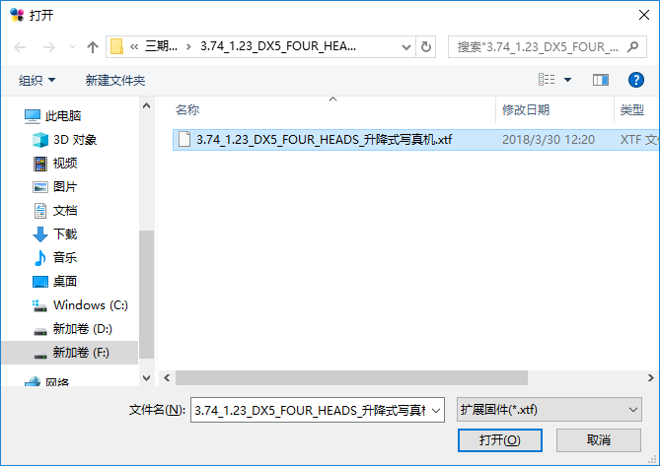
Click "Open" to enter the import firmware configuration state. At this time, you should not do anything. You will be prompted to "Import successfully" and check the debugging information. The message "Load parameter is successful" indicates that the import is successful.
16.3 Exporting firmware configuration
Click “Firmware Menu” to pop up the drop-down menu list, select “Export Firmware Configuration”, save it in the specified directory, note that the suffix is .bsf, as shown below:

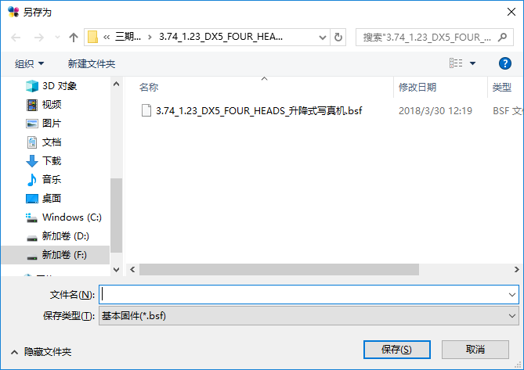
Click "Open" to enter the export firmware configuration state. At this time, you should not do anything. You will be prompted to "export successfully"

16.4 Exporting firmware parameters
Click “Firmware Menu” to pop up the drop-down menu list, select “Export Firmware Parameters”, save it in the specified directory, note the suffix is.xtf, click “Open” to enter the export firmware parameter status. No action should be done at this time and you will be prompted "export successful" later.

VI. Button board operation instructions

1. Keyboard board button layout as shown below

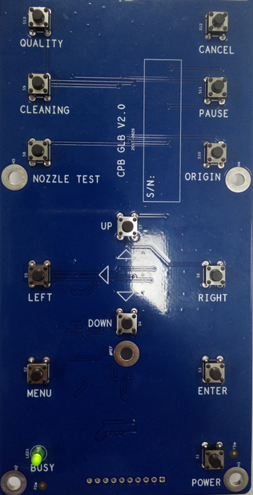
Button function list description

No. | Button name | Button function description
1 | QUALITY | Feathering settings
2 | CLEANING | Print cleaning
3 | CANCEL | Print cancel
4 | PAUSE | Print pause
5 | ORIGIN | Reset to original point
6 | NOZZLE TEST | Print head status
7 | UP | Return
8 | DOWN | Feed
9 | LEFT | Left shift
10 | RIGHT | Right shift
11 | MENU | Menu
12 | ENTER | Confirmation
13 | POWER

2. Menu item description
All the functions of the menu items have been introduced in the print software setting interface or the manufacturer mode, and will not be described here.

3. Menu list

