Cylindrical fixture mounting
The fixture consists of the following:
Fixture X1, long positioning iron sheet X2, short positioning iron sheet X2
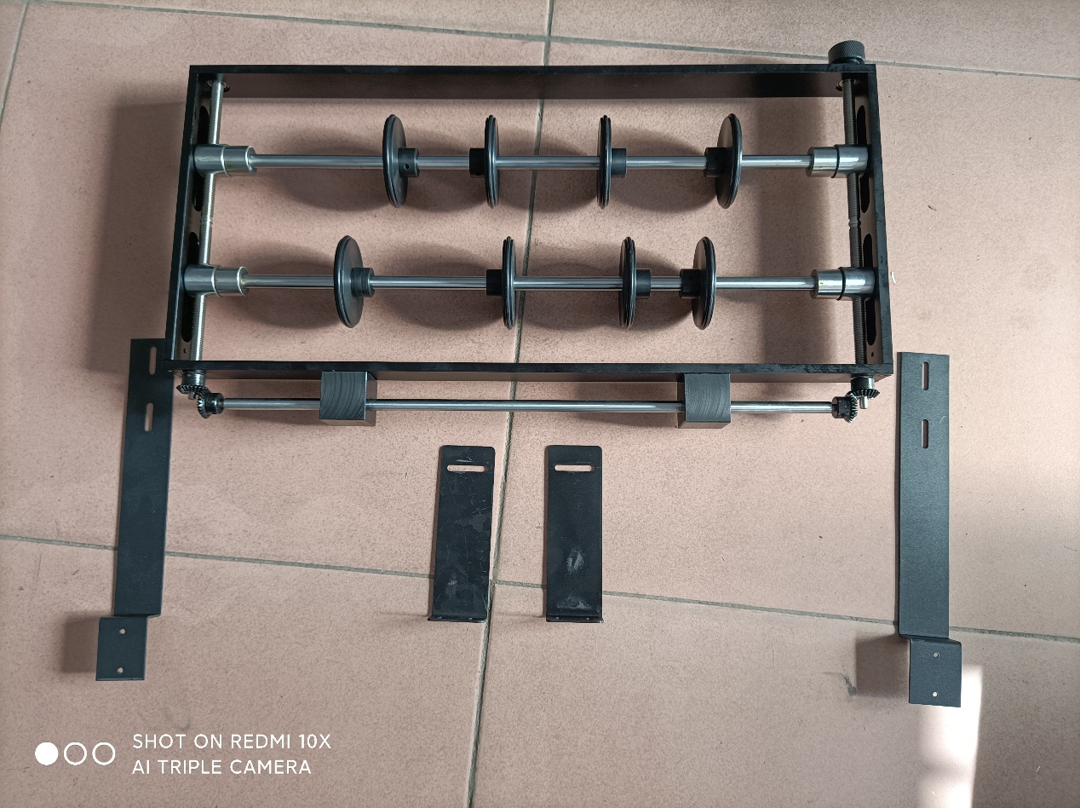

Install the long locating iron sheet to the clamp：
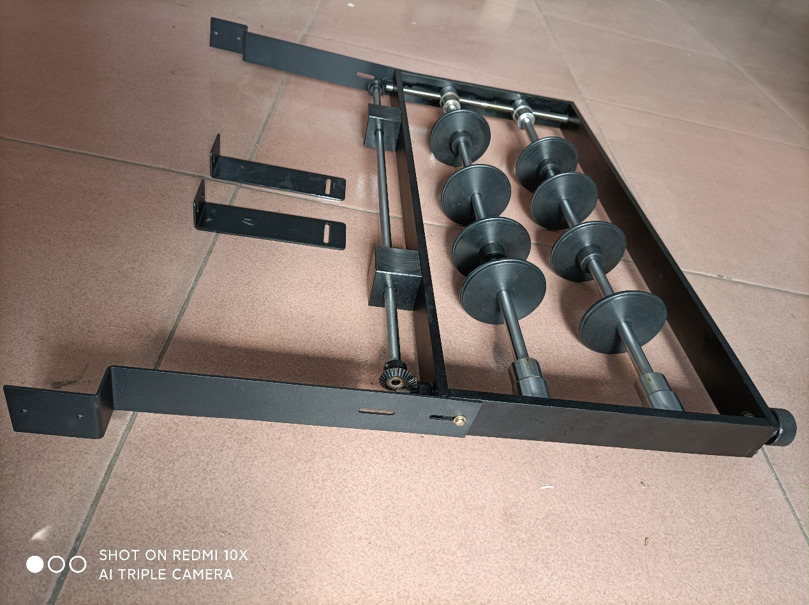
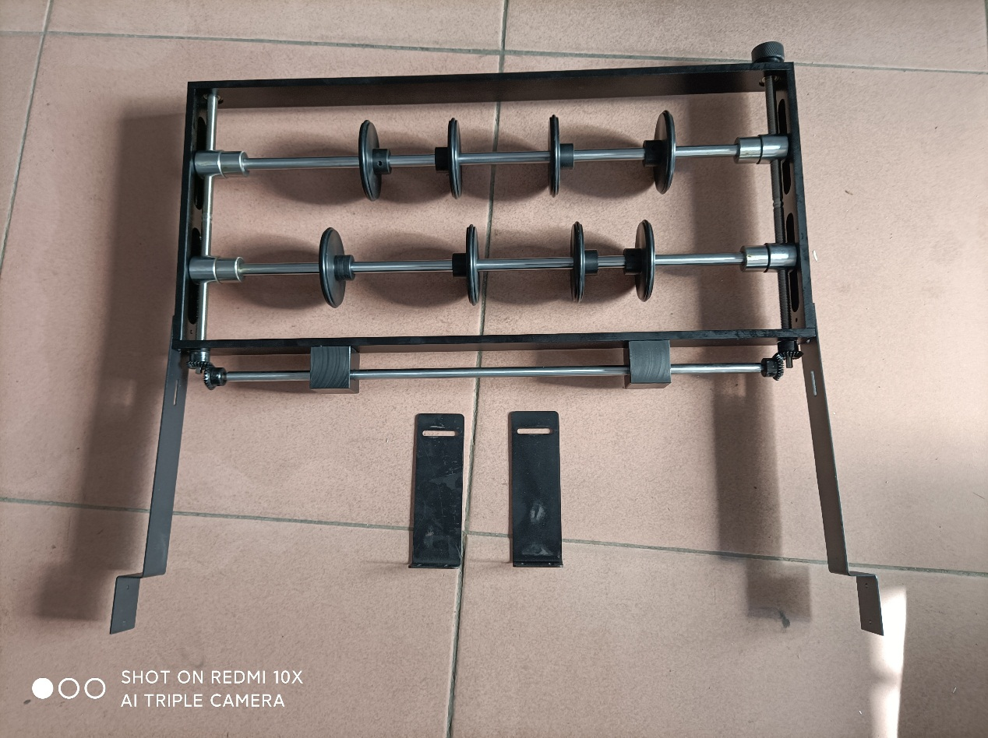

The short positioning iron sheet is installed on the machine, and the iron sheet is installed 19CM behind the aluminum part of the middle beam support:

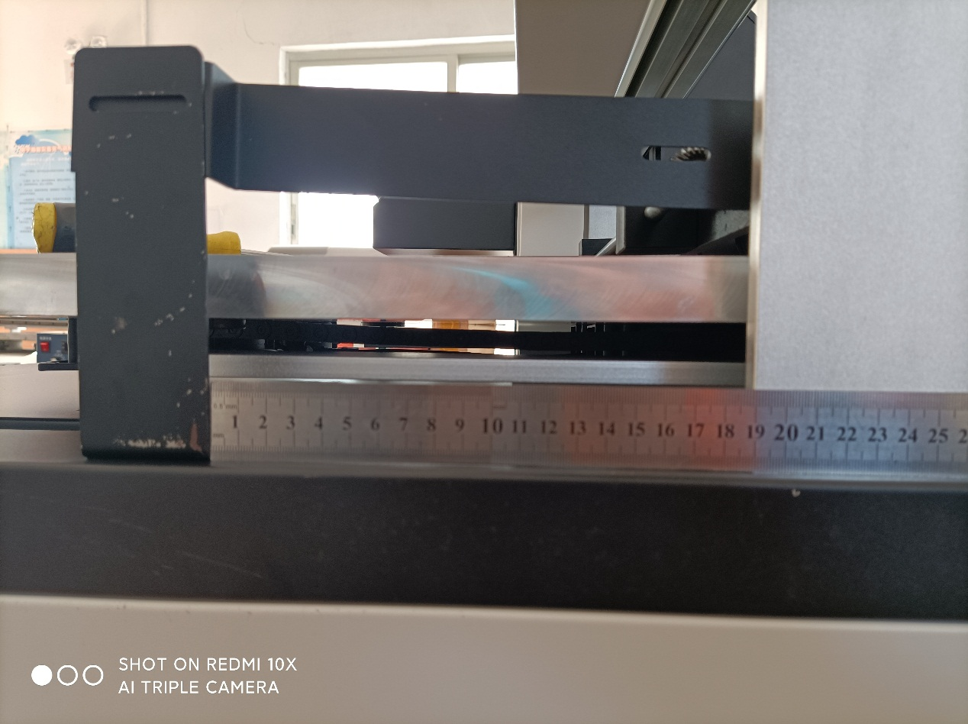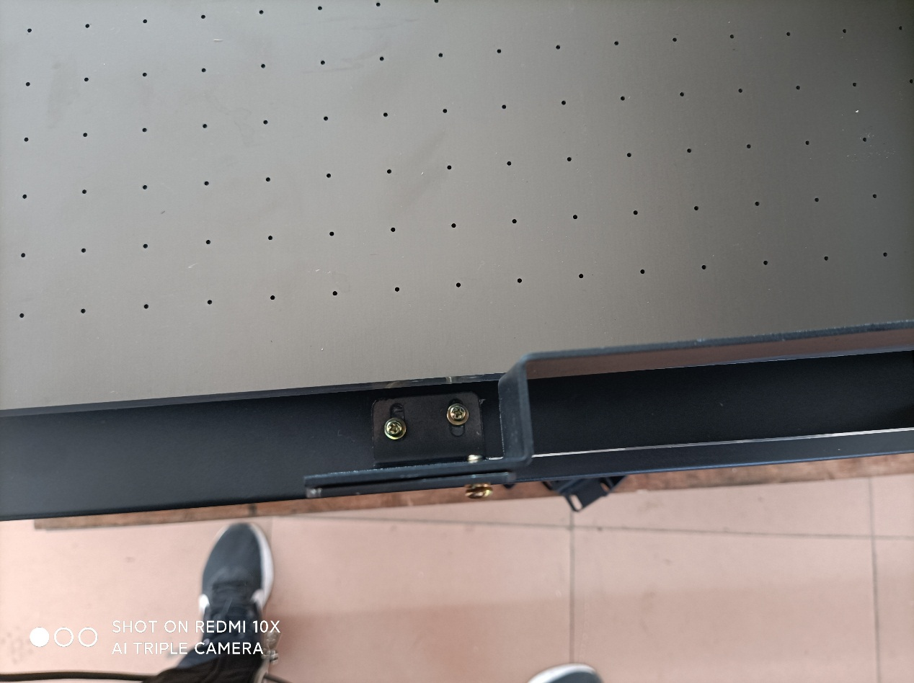

Open the software and change the printing mode to drum mode: System Menu - Drum Mode - Select Single Motor to manually switch the cylinder printing, and adjust the number of holes to 30%. Click "Hold and switch modes".

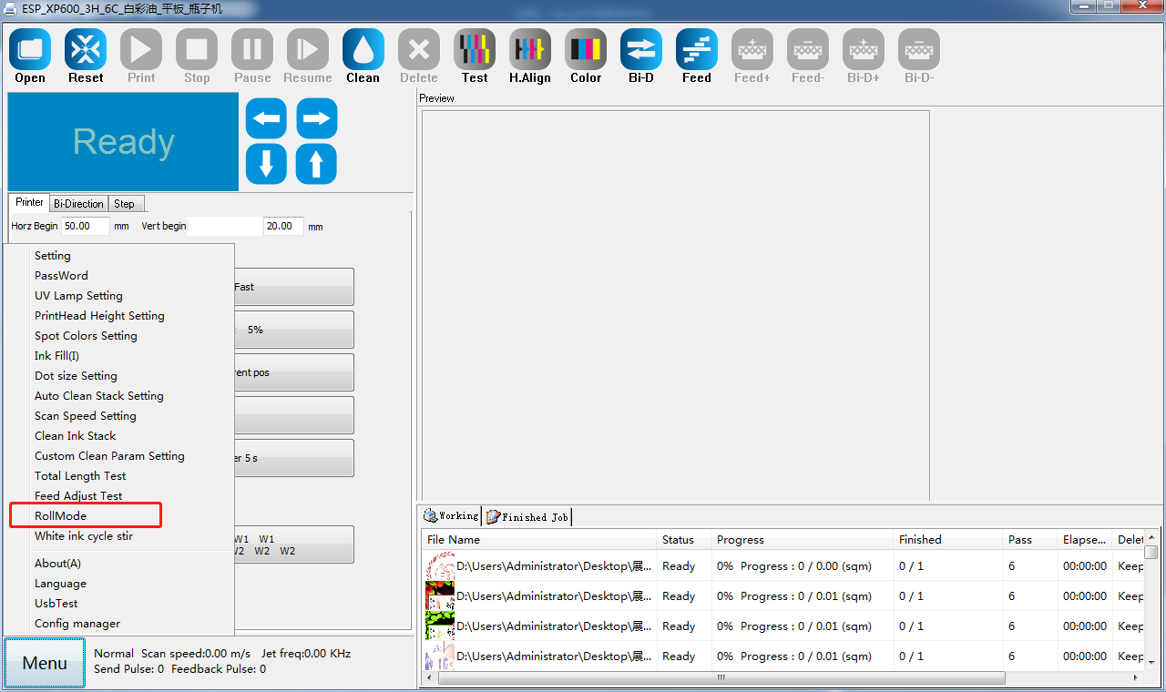
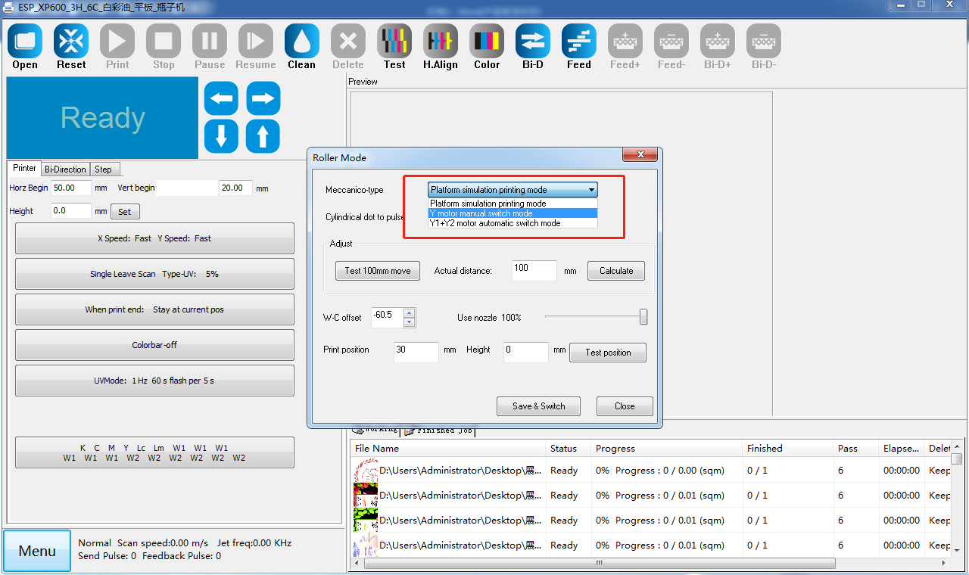

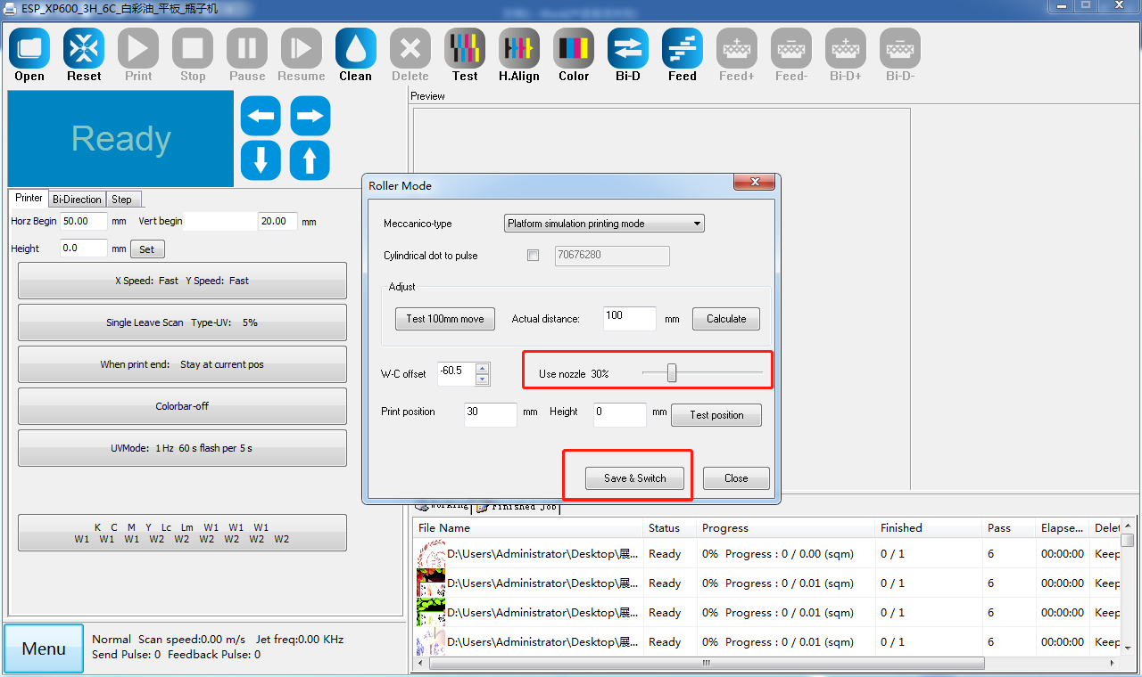

Then restart the software,
After restarting, raise the height to 120 and attach the clamp to the platform.
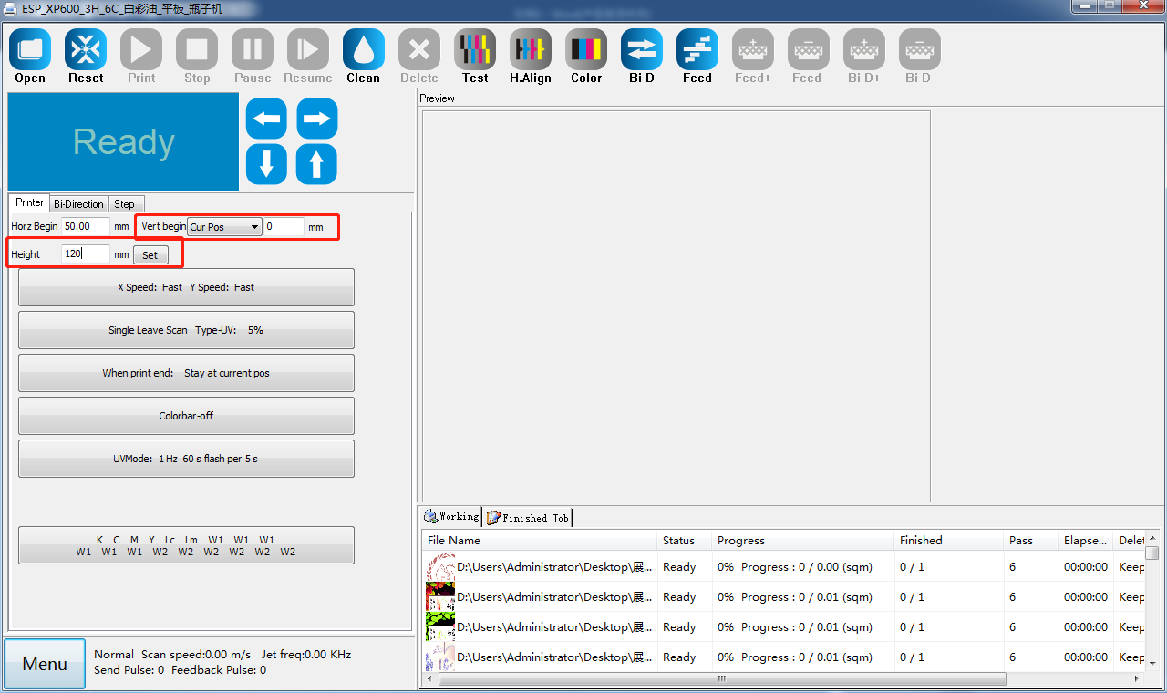

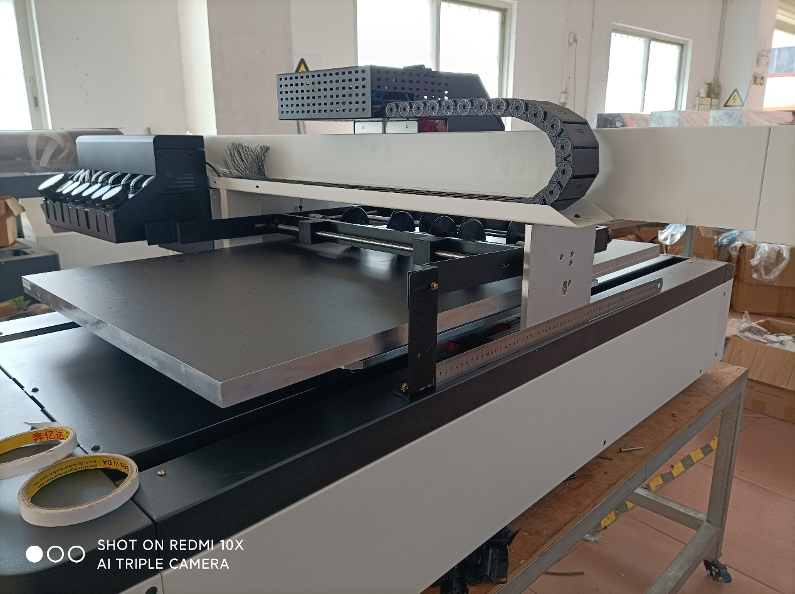
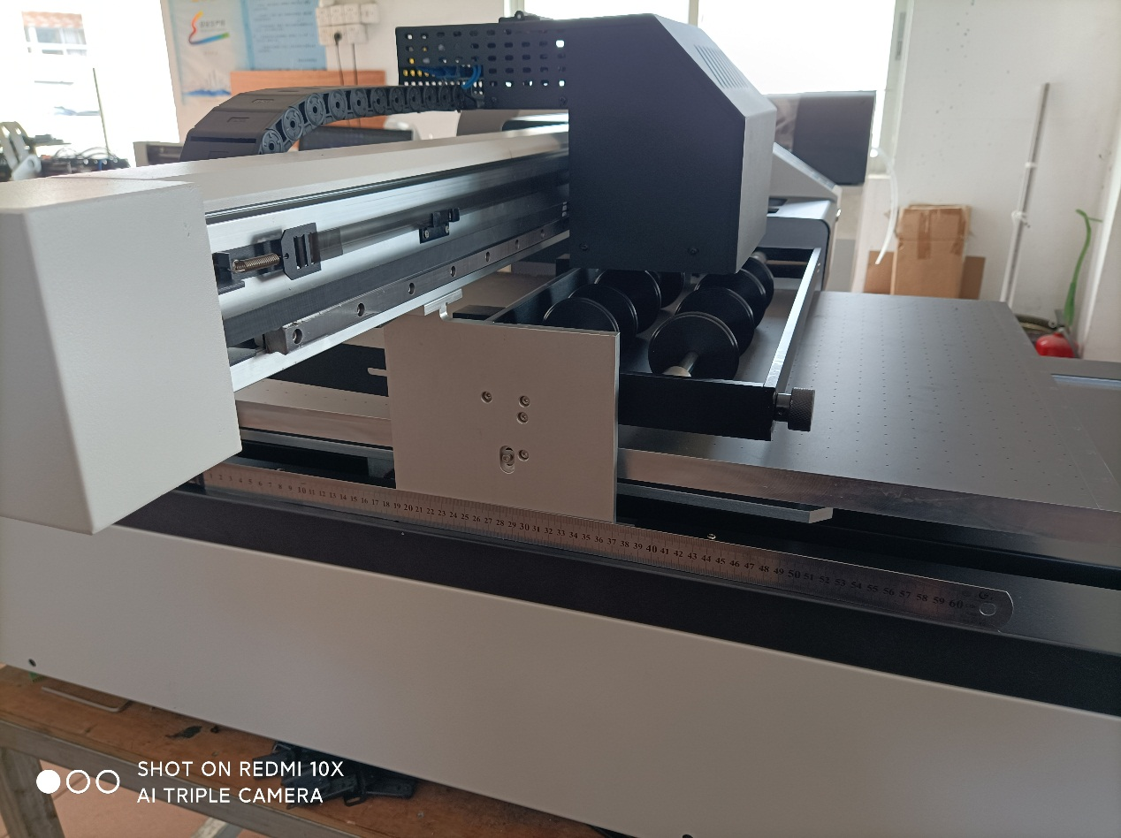

This will allow you to print.
Note: The fixture must be removed before the machine is turned off, otherwise the clamp may be crushed the next time the machine is turned on because the machine is going back to the original point.

