Xingduowei Icut high speed cutting machine
User Manual
Version 5.0.5

welcome
Welcome to use Xingduowei Icut flexible material cutting machine software.
[Improve Multi-Dimensional High-Speed Cutting Machine Control Software] (abbreviated as Icut) is a specialized control system designed for multi-industry cutting machines. This software excels in processing flexible materials such as textiles, advertising materials, and carbon fiber, while also supporting milling operations on rigid materials including acrylic, aluminum plates, copper sheets, and wood. Its core functionalities encompass graphic optimization, parameter configuration, customizable cutting pattern editing, intelligent material nesting, path planning optimization, machining simulation, and real-time process control.
The Icut software must be used with the corresponding hardware equipment to achieve processing operation control.
The Icut software supports offline demonstration operations. Without online, it supports non-processing control demonstration operations. You can experience the software without the device.
This manual is written based on version 5.0. Due to the continuous addition and update of software functions, there may be some differences between the Icut software you are using and the description in this manual. We hereby apologize for this.
If you have any questions or problems in the process of use, please contact us in time.
! The operation and cutting effect of the machine tool are directly related to the cutting material, machine configuration, the tool you use and the parameters you set. Please set the process parameters carefully according to your cutting process requirements.
Improper parameter Settings or incorrect operations may lead to reduced cutting performance, head or other parts of the machine tool and even personal injury. The Icut control system has made every effort to provide various protective measures, and equipment manufacturers and end customers should strictly follow the operation procedures to avoid accidents.

catalogue
Xingduowei Icut high speed cutting machine 1
welcome 2
1. Quick Start 7
1.1 Features 7
1.2 Obtain and install software 8
1.3 Start using 8
1.3.1 Desktop shortcut icon opening mode 8
1.3.2 User interface 9
in common use 11
1.3.3 Toolbar 14
1.3.4 File menu 15
1.4 Operation process 16
1.4.1 Import files 17
1.4.2 Optimization treatment 18
1.4.3 Process setup 19
1.4.4 Path optimization 22
1.4.5 Simulation inspection 22
1.4.6 Start processing 23
2. Graphic operation 25
2.1 Graphic display 25
2.2 Figure selection 27
2.3 Graphic editing 30
2.3.1 Size modification 30
2.3.2 Interactive graphical transformation 31
2.3.3 Quick translation, rotation and mirror 32
2.3.4 In-place replication 33
2.4 Capture tools 33
2.5 Draw graphics 34
2.5.1 Drawing basic graphics 34
2.5.2 Input commands to draw graphics 35
2.5.3 Text input 36
2.5.4 Create standard parts 37
2.6 Graphic optimization 38
2.6.1 Remove small graphics 39
2.6.2 Remove duplicate lines 39
2.6.3 Merge the connecting lines 39
2.6.4 smoothing 39
2.6.5 Interrupted merging 40
2.6.6 Detonation 41
3.Process tools and process parameters 43
3.1 Setting the starting point of the figure 43
3.1.1 Manual starting point 43
3.1.2 Automatic batch starting point 44
3.1.3 Longest straight line starting point 45
3.2 Graphic direction setting 46
3.3 Common borders 47
3.4 Graphic tool compensation 48
3.4.2 External contraction and internal expansion 50
3.4.3 Total contraction 51
3.4.4 All external expansion 51
3.4.5 Angle type 51
3.4.6 Compensation, same layer 52
3.5 Regional carving 54
3.5.1 Yang carving and Yin carving 54
3.5.2 Row cutting tool and ring cutting tool 55
3.5.3 Ring cutting and tool removal 56
3.6 Reverse cut compensation 57
3.7 Dispersal and grouping 60
3.7.1 Combined samples 60
3.8 Array 62
3.8.1 Rectangular array 62
3.8.2 Ring array 63
3.8.2 Interactive arrays 64
3.9 Sorting 65
3.9.1 Sequence Preview 65
3.9.2 Manual sorting 66
3.9.3 Automatic sorting 66
3.10 Chamfer 69
3.10.1 Round corners 69
3.10.2 Inverted concave Angle 70
3.10.3 Inverted chamfer 71
3.10.4 Inverted chamfer 72
3.11 Alignment tools 74
3.12 Closeness 75
3.13 Integration function 76
3.14 Circular fusion 77
3.15 Leads 77
3.16 Add the outer frame 78
3.17 Measuring tools 79
4. Processing control 80
4.1 Coordinate system 80
4.1.1 Original zero point 81
4.1.2 Workpiece zero point 82
4.1.2 Find the zero point after anomaly 82
4.2 Alarm 83
4.3 Soft limit 84
4.4 Manual testing 85
4.5 Blade cutting 85
4.5.1 Manual tool setting 86
4.5.2 Automatic tool cutting 86
4.5.3 Fine-tuning the blade depth 87
4.6 Walk the border 87
4.7 Processing, stopping, pausing and continuing 87
4.7.1 Processing 87
4.7.2 Stop 89
4.7.3 Suspension and continuation 89
4.7.4 Advanced Start 89
4.8 Partitioning 90
4.8.2 Application scenarios of partitioned adsorption mode 90
4.9 Pulling material 92
4.9.1 Multiple machining operations for general machining 93
4.9.1.1 Single page processing As shown in the following figure: 93
4.9.1.2 Single page cycle processing 94
4.9.1.3 Page processing 95
4.9.2 Various processing operations of border patrol 96
4.9.2.1 Add templates and visual interface introduction 96
4.9.2.2 Single page patrol processing 97
4.9.2.3 Single page patrol cycle processing 98
4.9.2.4 Page border processing 99
4.9.2.5 Cutting Mark mirror processing 101
4.9.2.6 Scanning code for border processing 103
5. System auxiliary functions 106
5.1 Board upgrade 106
5.2 Parameter export and parameter import 107
5.3 Table test 108
5.3.1 Configure the test IO signal on the console 109
5.3.2 Configuration of desktop data 109
5.3.3 Bench test 111
5.3.4 View the surface data 112
5.3.5 Export/import of console data 113
5.3.6 Enable surface compensation 113
5.4 Language modification 114
5.5 Diagnosis and log viewing 114
5.7 Shortcuts 116
6.Common problems and treatment 117
6.1 Tool debugging 117
6.1.1 Angle offset 117
6.1.2 Blade tip offset 120
6.2 Offset test 124
6.2.1 Tool holder offset 125
6.2.2 Camera offset test 125
6.2.3 Dual head offset test 126
6.3 Tool compensation 127
6.3.1 Blade lifting and blade falling compensation 127
6.3.2 Blade compensation 129
6.3.3 Blade radius compensation 130
6.4 The device is not connected 130

1. Quick Start

1.1 Features
Xing multidimensional cutting machine control software is a comprehensive cutting control software specially developed for clothing, advertising and other flexible material cutting. Its main features are as follows:
- Supports parsing of various formats such as dwg, dxf, txt, nc, ai, eps, pdf, plt, xdw, jpg, tif, bmp, png, etc., providing convenience for users to make files;
- When opening or importing a file, the file will be optimized automatically, including deleting small graphics, removing repeated lines, automatically merging connected lines, smoothing processing, setting starting points automatically, sorting and adjusting cutting direction automatically;
- Optimized functions such as automatic compensation can be manually executed, turned on or turned off;
- Supports common functions of CAD, including size modification, translation, mirror, rotation, alignment, copy, array, etc.;
- In the WYSIWYG mode, parameters such as lead-in and lead-out lines, tool compensation, micro connection, bridge and so on can be easily set;
- Support curve segmentation and merging, curve smoothing processing, as well as part merging and breaking operations;
- It has the function of automatic sampling which saves time and effort, can realize automatic common edge and generate surplus material;
- Through a variety of array methods, it can easily complete the layout of the plate;
- Flexible and diverse automatic sorting and manual sorting functions, support through group lock the processing order of graphics within the group;
- Supports viewing the processing order and previewing the cutting order through simulated processing;
- The cutting depth of the graphic file can be set, and the layered cutting and the adjustment of the amount of each cut can be supported;
- Supports breakpoint processing, which records the line number when the processing stops or pauses, so as to facilitate the subsequent return to that position to complete the remaining processing tasks;
- Support power failure continuation processing. If there is an unexpected power failure during processing, you can choose the power failure continuation mode after power supply is restored to continue processing from the position before power failure;
- Support CCD camera vision calibration; support printing inkjet, labeling, automatic feeding and pushing, projection, sorting, large vision, layout of materials and many other extended functions.

1.2 Obtain and install software
You can contact your supplier or customer service personnel to obtain the software installation program, or you can download the installation program from Xingduowei's official website. Before installing the software, please check whether your computer meets the following installation requirements:
- Win7 or above operating system
- I4 or higher CPU
- At least 4GB of memory
- 15 VGA display above 1 inch, resolution above 1280*1024, recommended 32-bit true color above
- If you are using a Vista-based computer system, run it as an administrator to avoid errors.
After the check, run the installer directly. For Vista, right-click and run the installer as an administrator.
To prevent program modifications during installation and ensure proper installation, please disable Security Guard and antivirus software before proceeding. Antivirus software cannot guarantee a completely virus-free computer. If your device is already infected with viruses while the antivirus is active, it may mistakenly flag Icut as a virus, potentially causing Icut to be incorrectly identified as malicious.

1.3 Start using

1.3.1 Desktop shortcut icon opening mode
After the installation of the software is successful, the icon shown in the figure on the right will appear on the desktop. Double-click to run the Icut cutting machine system.

1.3.2 User interface
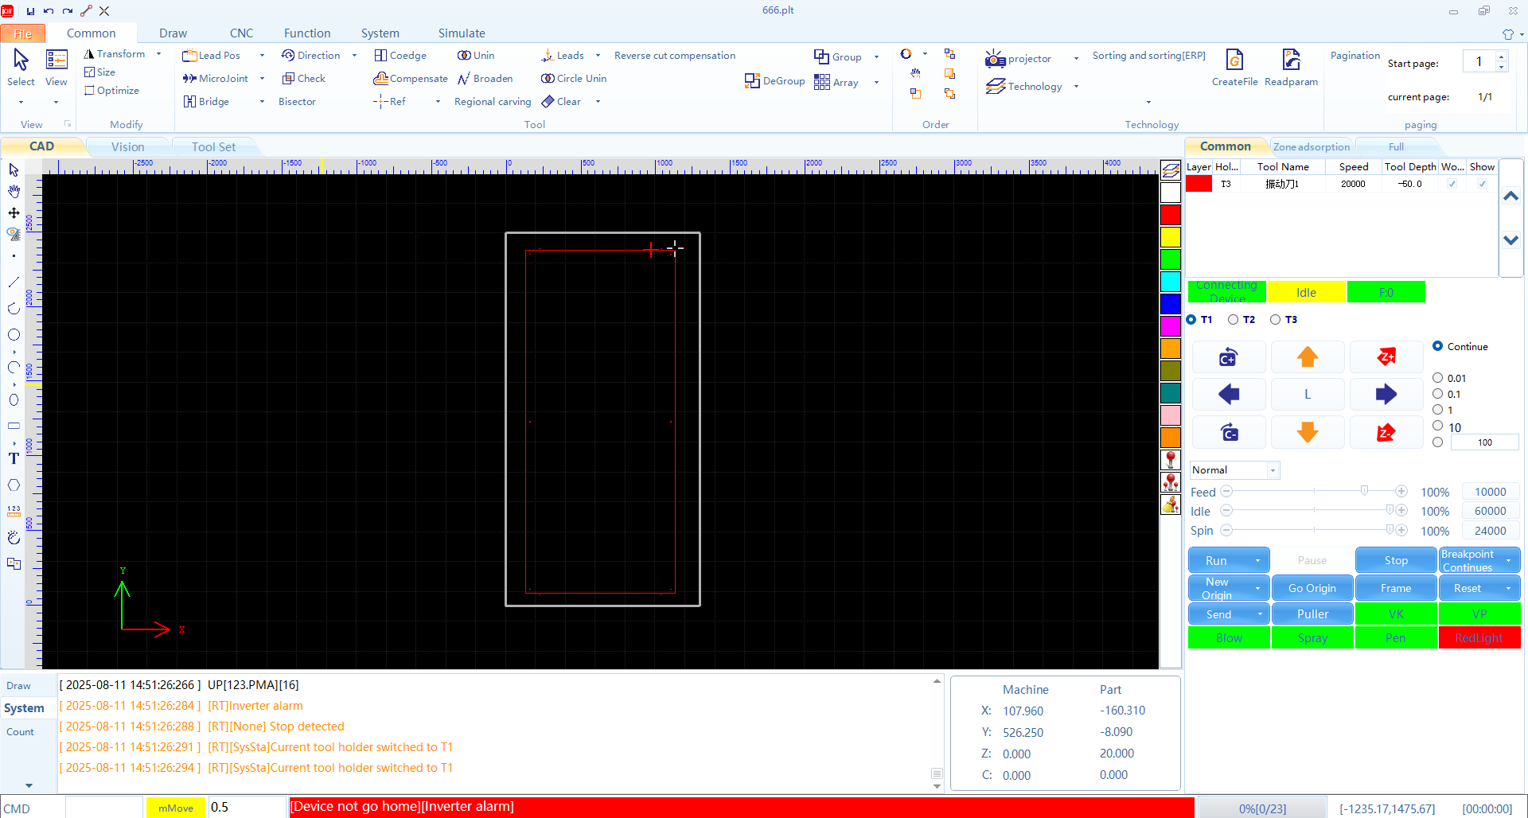
In the center of the interface, the black background plate is the drawing board. The white square in the drawing board is the drawing plane, and there are grid displays. The grid and the scale bar on the top and left of the working plane will change with the zooming of the view, which provides convenience for drawing.
At the top of the interface, from top to bottom are the title bar, menu bar, and toolbar. The toolbar features prominently grouped with large icons, where users can access common tools. The menu bar includes a [File] menu and seven toolbar menus: [Common], [Graphics], [CNC], [System], [Simulate], [Large View], and [Functions]. These menu options can be switched between. To the left of the title bar is a [Quick Access Bar] that provides quick access to save, undo, redo, endpoint capture, and intersection capture functions.
The left side of the drawing panel features a shortcut toolbar, which we refer to as the "navigation bar" in subsequent explanations. This section provides quick access to essential drawing functions. From top to bottom, the first four tools are [Select], [Pan], [Main View], and [Quick Hover Toolbar]. Below these are corresponding drawing tool options that can be selected by clicking. At the bottom is the measurement tool.
The right side of the drawing panel features a layer toolbar, arranged from top to bottom: The first button is [Open Process Settings] , followed by [Layer Selection] (buttons 2-13) – a total of 12 color layer buttons corresponding to each layer. After selecting a graphic, clicking the corresponding layer color will automatically apply that layer's color to the selected shape. Mark points can be created for selected shapes. A one-click command marks all selected points. Clearing all marked points can be done by clicking the corresponding button.
The interface features three vertically arranged display windows. The top window serves as the drawing information display area, where all drawing command prompts and input data are shown. The middle window displays system information (excluding drawing-related details), including system logs with timestamp markers and color-coded alerts (operation, warning, alarm). The bottom window shows processing statistics. The right side displays coordinate positions (machine coordinates and workpiece coordinates) for real-time monitoring of the machine's current physical location and relative positioning.
The interface's bottom section contains the [Command Prompt Bar], [Fine-Tuning], [Status Bar], [Progress Bar], [Mouse Position Display], and [Timing Display]. Command Prompt Bar: Displays real-time input information during drawing. Fine-Tuning: Click the fine-tuning button to switch between zooming in/out and rotating tools, allowing users to input adjustment steps, zoom distance, and rotation angle values. Status Bar: Shows real-time device connection status, zero-reset status, and file loading progress. Progress Bar: Displays the current processing progress. Timing Display: Shows the processing time of the current file.
The top panel features a function module navigation bar, including interface switches for CAD, 3D, Visual, Tool Adjustment, and Large View. The CAD interface serves as the drawing board for creating and editing graphics. The 3D interface displays G-code parameters. The Visual interface enables CCD edge detection operations. The Tool Adjustment interface handles tool holder configuration, tool debugging, parameter modification, and depth settings. The Large View section provides a comprehensive display interface with advanced visualization capabilities.
The upper-right corner of the drawing panel features an interface navigation bar containing four sections: Common, Zone Adsorption, Material Cladding, and Layout. The Common section provides essential display and operational functions, arranged from top to bottom as follows: Layer Display, Status, Tool Holder Switch, Manual Operation, Process Selection Graphics, G-code Programming, Processing/Blanking, Spindle Speed Scaling, and On/off Buttons.

in common use
1) Layer display includes: Layers 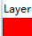(current layers used in the graphic), Blade Holder (blade holder used for cutting in the graphic), Tool 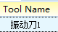 (tool used for cutting in the graphic), Speed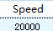 (cutting speed used in the graphic), Blade Depth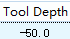 (cutting depth of the blade holder and tool), Processing (whether processing is active), Display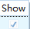 (whether graphics on the drawing board are visible). Layer order toggle button (after selecting a layer, click the up/down arrow icon to switch layer order).
2) The status bar includes: green indicates that the equipment is connected, red indicates that the equipment is not connected. Display the machine status, standby or processing. Display the speed, the current moving speed and processing speed. Display the current spindle tool number.
3) Tool holder switching: Click to select the tool holder to switch between different tool holders. When switching the tool holder, if the Z-axis of the previous tool holder is not at the 0 point position, the Z-axis of the previous tool holder will be moved to the 0 point position.
4) Manual operation: The machine can be rotated forward, backward, left and right by manually moving the button. Select and click the following quick button
.This shortcut enables mobile position adjustment. The L and H buttons represent low-speed and high-speed modes respectively. On the right side, you can select the movement step size (customizable). Click the "100" position to open a dialog box where you can input the desired distance. Click "OK" to confirm.
5) Select graphic processing:  After checking, only the selected graphics in the drawing board will be processed. If the graphics are not selected, a dialog box will pop up to prompt you to check whether the graphics are selected or cancel the check.
6) Code processing: Check and execute G code instructions.
7) Ratio adjustment: including feed, empty stroke and spindle adjustment speed. The speed ratio can be adjusted by dragging the progress bar. Click the red box to open the setting speed window, input the correct value and confirm.
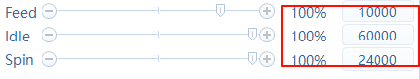
8) Quick button: Blue represents the default button, which is displayed by default after installing new software. Green represents the custom button, which can be selected in the window of system-switch setting-function switch. The required quick button of the device can be selected, and the unnecessary one can be blocked.
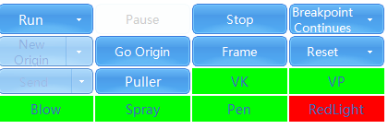
process | Execution of processing, equipment begins processing
suspend | Execution is suspended, the equipment is suspended, and then click Continue, the equipment continues to process
cease | Execution stops and the equipment stops working
The breakpoint continues | Execution of the breakpoint continues, and the equipment is processed at the breakpoint where it stopped
Set a starting point | Set the starting point and determine the XY coordinate of the workpiece origin
Back to the starting point | Execution starts at the XY coordinate position of the workpiece origin
Walk the perimeter | Execution of the border walk, the device performs the border walk function
Back to zero | Zero return is performed, and all shafts of the equipment return to zero point
transmit by radio | Execute the send and download the file to the controller
9) Zone Adsorption: Click each zone to enable or disable adsorption in the current area. Green indicates disabled adsorption, while red signifies active adsorption. The left-side drop-down arrow allows selection of four modes: Manual, Adaptive, Auto-follow, and Manual Memory. Full On/Off options enable complete activation or deactivation of zones. Adsorption refers to activating the vacuum pump.
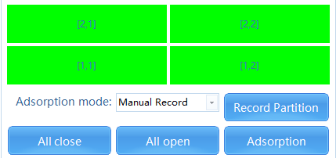
10) Batching: This process organizes graphics for processing into structured sequences to optimize material usage. (Note: Batching requires a digital signature to activate). Parts: Contains additional graphics with specified quantities. Material Library: Stores approved materials. Completed Batches: Files containing finalized processed graphics.
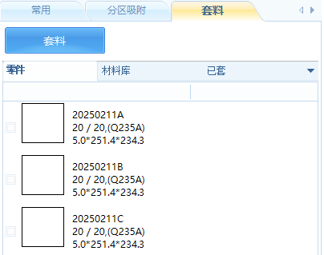
11) Fill: The fill function is used to reasonably fill the specified graphics on the board with the highest utilization rate. Icut supports one-click fill. It also provides a number of parameters for local adjustment, such as part spacing, material edge, rotation, common edge, quantity, etc.

1.3.3 Toolbar
The Icut toolbar uses a style called Ribbon (the ribbon), which places the most commonly used functions in columns and partitions, and uses some large buttons for easy operation. The following figure shows you:
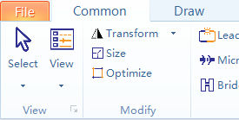
There are several large ribbon toolbars under each menu bar. You can open the corresponding window through the menu bar, find the corresponding partition toolbar, and select the tools to use.
Each page's toolbar organizes functions into multiple "tabbed sections" such as "View", "Edit", and "Tools". Some sections contain "Expand Buttons" (marked with an icon), which open corresponding function dialog boxes. Additionally, some tool buttons feature small triangle icons below them – these are called "Drop-down Buttons". When clicked, they reveal the corresponding "Expand Menu" that provides more detailed operation options.
When the mouse moves to the position of a large size tool (such as the "Select" tool), the tool button changes color and shows as a rectangle. At this time, click to use the tool to perform the corresponding editing operation on the selected graphics; if you click the small triangle below the button, you can open the extended menu of the tool.
Whether you have used software with similar interface or not, you can quickly get familiar with and master the operation of this software

1.3.4 File menu
In the upper left corner of the menu bar, there is a special menu that appears in a drop-down style called the "File Menu". It includes some tools related to files. Click on File to open the file menu to display the tools, as shown below:
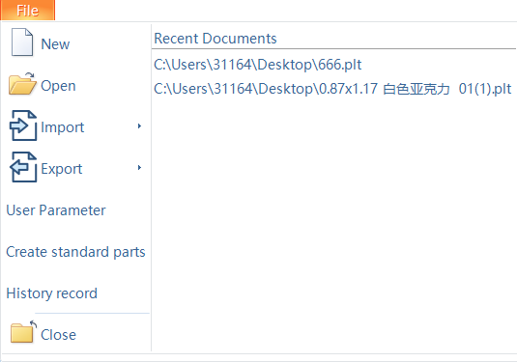
Please note that the right side is the recently opened file, which is to facilitate your finding of the last designed file.
Create: Create a new file in Icut.
Open: Open a new file in Icut.
Import: Import a file to the drawing board without removing existing graphics from the drawing board. If you want to open an external file, use Open instead.
Export: Icut can export "XDW", "XDWL" and "PLT" files.
User parameters: You can set some common parameters, including the automatic optimization parameters for imported graphics.
Create standard parts: Icut contains some libraries for you to choose from. If suitable, you can directly call and open them, and modify the size to cut and use them.
History: You can view recently processed files.

1.4 Operation process
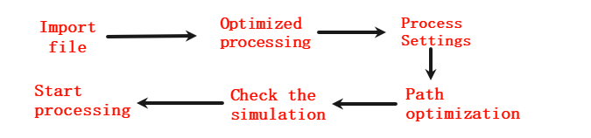

1.4.1 Import files
To open a file, click the "" button in the "Open" menu of the Quick Start bar at the top-left corner of the interface. Navigate to the target directory and select the desired file. Click "Open" next to the filename. (The "File Explorer" dialog provides a preview window where you can instantly view processed files by clicking on any filename, helping you quickly locate files needing processing.)
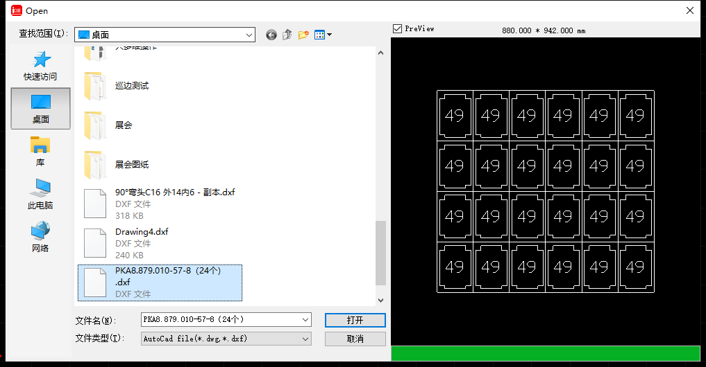
If you want to draw graphics by yourself in the CAD interface, you can draw graphics through the drawing tool under the "Drawing" tool. You can also pick the drawing tool by using the quick navigation bar on the left side of the CAD interface.
The Icut system supports simultaneous import of multiple files. Click the "Open File" button in the top-left corner of the interface's shortcut bar, then select "Import" from the drop-down menu (supporting file formats like DXF, PLT, AI, images, XDW, etc.). Importing other graphics is possible even when CAD has existing graphics in the current session.

1.4.2 Optimization treatment
When importing graphics, Icut automatically applies a series of optimization processes, including "eliminating minor graphics", "removing duplicate lines", "merging connected lines", "automatic smoothing", "sorting", "setting starting points", "selecting sections", "common edges", "automatic M-point generation", "angle adjustment", "automatic compensation", and "layer mapping". Typically, after automatic optimization, you can proceed directly to the next step of process parameter settings without additional manual adjustments. If the automatically optimized graphics do not meet your requirements, you can manually configure them through two methods: First, click the "File" menu drop-down and adjust optimization settings in "User Parameters"; Second, select the target graphic and find the "Optimize" tool in the toolbar of the "Common Tools" menu to configure specific parameters.
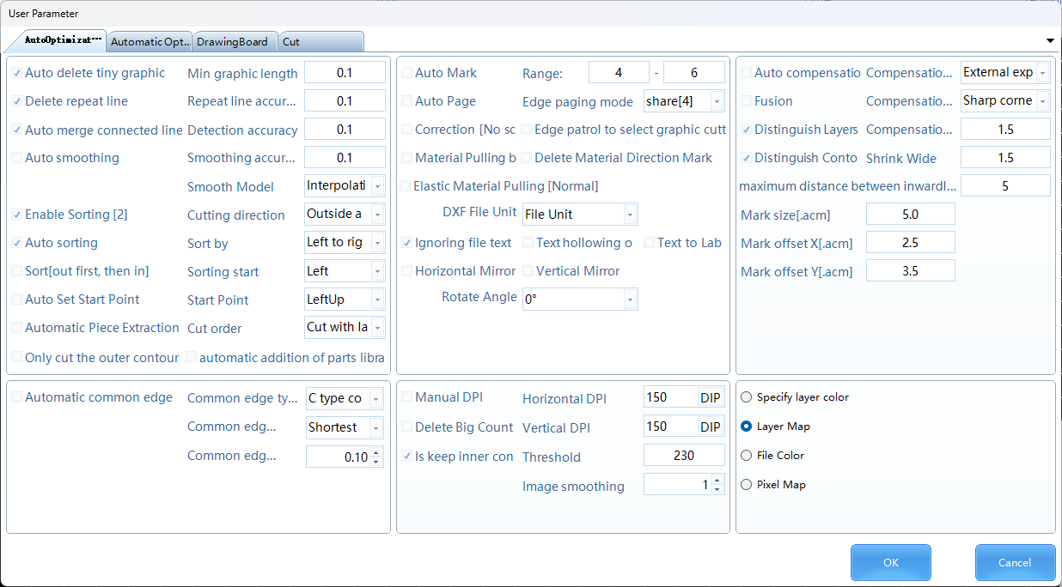
When using the "Layer Mapping" tool for the first time, it's essential to establish a mapping relationship with the processing file beforehand. The process is as follows: After opening the file, select the target document. In the top menu bar, navigate to "Common Tools", then click on "Process" in the drop-down menu and choose "Layer Mapping". Within the pop-up window, click "Import Current File Layer Mapping". Next, select the layer number you want to modify. Through the "Color" drop-down menu, choose the target color corresponding to the graphic in that layer. Once selected, click "Modify" to complete the configuration.
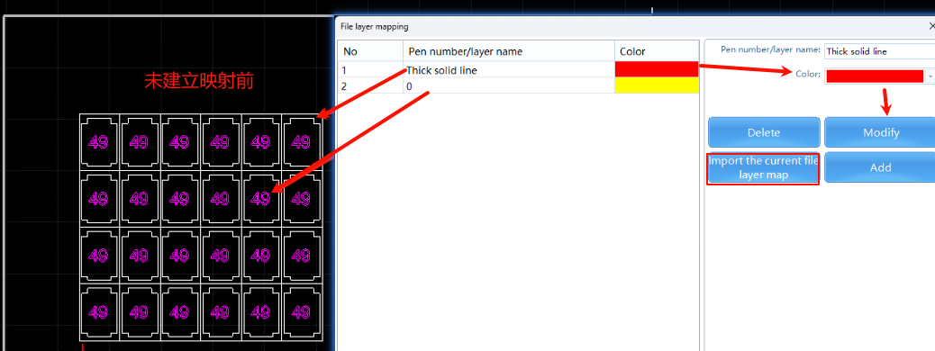
After the modification is successful, exit the layer mapping dialog. You will find that the current graphic is as shown in the figure below, and different graphics correspond to different colors.
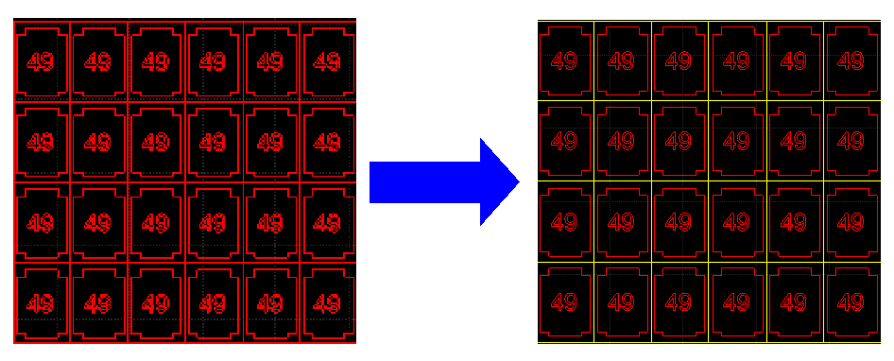
When creating graphics in other software, it's recommended to assign specific colors to each graphic and confirm adjustments before exporting. This way, when importing files into Icut software, simply check the "Layer Mapping" option in the "User Parameters" section beforehand. The imported graphics will automatically retain their original color properties without manual color reassignment. Different colors correspond to various tool holders and tool settings within the software.
Note! Icut mapping supports two modes: PLT and DXF files are supported respectively. PLT uses layer mapping, and DXF uses element mapping function.

1.4.3 Process setup
To complete this step, we need to configure the layer parameters in the CAD interface. Click the "Open Layer Process Settings" panel in the top-right corner of the CAD window. As shown below: The "Layer Process" interface includes parameters such as speed settings, tool lift height, tool lift angle, layering configuration, and tool drop compensation settings. These parameters determine both machining efficiency and cutting quality during production. Please configure them according to the specifications provided in the manufacturer's training materials.
The layer order can be modified by pressing the "up and down" button. Select a layer and click up or down to change the layer order.
The "Is processed" property can be used to modify whether the current layer is processed.
Through the "Knife seat" option, you can choose which knife seat is needed for cutting the current figure.
Refers to the current tool cutting speed and sets different values according to the actual cutting material.
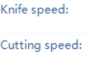Refers to the vertical processing speed of Z axis, and different values are set according to the actual cutting material.
Refers to the height of the Z+ blade lifting relative to the Z depth when the Z axis is empty. Generally, the lifting height must be greater than the material thickness
Refers to whether the Z-axis lifts the blade at the clamping angle position during cutting. According to the first quadrant of the four-quadrant coordinate system, determine whether the lifting angle range is within the set range. Generally, a larger value means fewer blade lifts. A value of 0 indicates no blade lift.
Icut supports layered cutting. This feature enables multi-depth material processing, allowing you to meet diverse order requirements. To activate layered cutting, configure three key parameters: "Material Thickness" (the actual thickness of the workpiece), "Cutting Depth" (the depth the tool cuts into the material surface), and "Cutting Layers" (the number of layers to be cut or the number of cuts required to reach the desired depth).
Change the tool spindle. Which number of tools is needed for cutting at present? Select the corresponding tool number.
Current tool spindle speed
Tool compensation, after opening, the graphics automatically compensate.
Check advanced to select different ways of milling cutter cutting, including: "Carving mode" includes path carving and drilling carving. "Landing mode" includes "slanted downward cutting" and "vertical downward cutting".
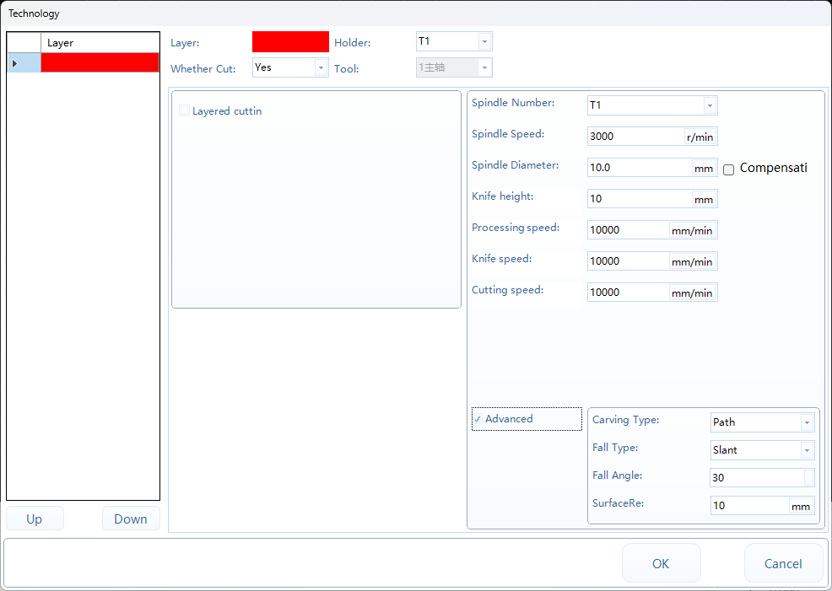

1.4.4 Path optimization
When importing graphics and encountering paths that don't meet expectations, further optimization is required. You can select the graphics and use quick tools for refinement. Common optimization methods include: shape adjustments, starting point settings, path direction optimization, shared edge handling, group processing, and sorting enhancements. For detailed instructions, refer to Chapters 2 and 3.
After selecting the graphic, you can zoom, rotate, mirror and other operations on the selected graphic through the drop-down arrow.
After selecting the graphic, you can edit the starting point of the selected graphic through the drop-down shortcut arrow. Manual editing of the starting point is supported, and one-click editing of the starting point is supported.
After selecting the graphic, you can edit the direction of the selected graphic and path by dragging the arrow.
After selecting the figure, the common edge processing of the figure can be realized by modifying the interface parameters of the common edge, so as to improve the processing efficiency.
After selecting the graphics, you can process the selected graphics group, or you can take a sample of the selected graphics through the drop-down shortcut button. The system supports sample order processing.
After selecting the graphics, you can optimize the path order of the selected graphics to improve processing efficiency. The system supports a variety of automatic sorting modes. Please select the path order mode suitable for your own materials to optimize.

1.4.5 Simulation inspection
Before actual cutting, the depth of the knife and processing trajectory should be checked.
Knife depth confirmation check: Open the "adjust knife" interface, click the "drop knife" button, the current tool holder tool will automatically drop to the Z set depth position, check whether the tool is in the specified position. If the depth of the tool is not in the cutting position, please reset the depth.
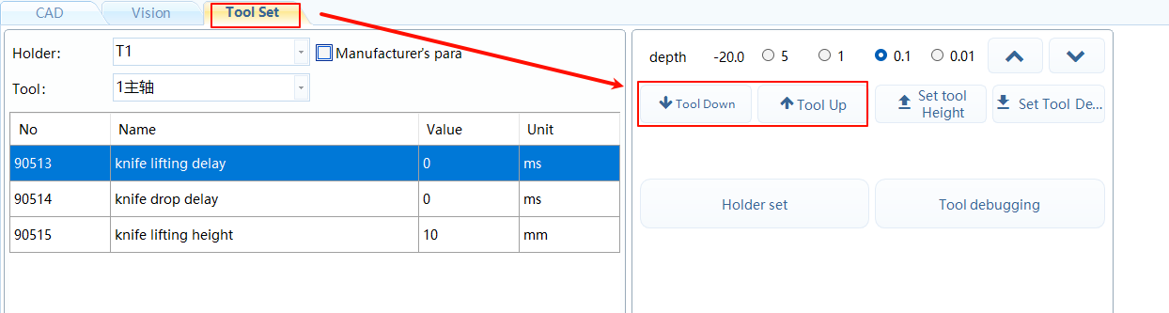
Path Simulation: First switch to the CAD interface. Open the "Simulation" option in the menu bar (as shown below). Adjust the simulation speed by dragging the progress bar next to "Speed". Click the button to start simulating the path by cutting shapes in the CAD interface. The simulated path will be displayed in yellow color, allowing you to visually observe its starting point and direction. During simulation, click the pause button to stop. You can then hover over the CAD interface to zoom in/out, resume simulation, or click again to continue. To end the simulation, click the button to terminate the process.
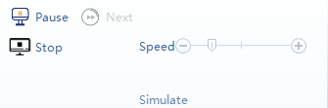
The simulated path trajectory does not meet the cutting requirements. Please select the graphic for further optimization.

1.4.6 Start processing
The white area represents the workbench, the red light indicates the current position of the machine, and the white cross marks the mechanical zero point. Before processing, we need to check whether the processed graphic exceeds the workbench range. If any graphic oversteps the workbench boundaries, modify it accordingly. Ensure that the processed graphic does not exceed the workbench limits.
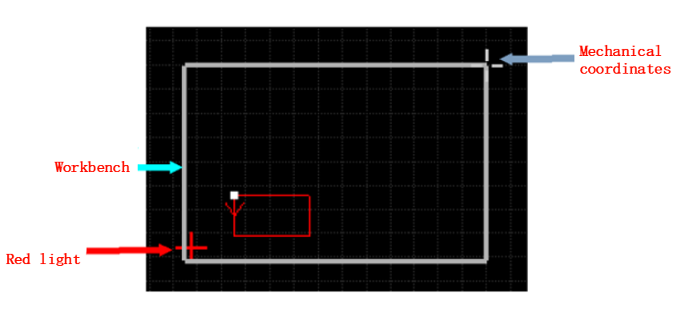
Selecting the starting point: Navigate to Menu> Common> Docking Buttons, then choose your docking position. Based on the structure of your purchased machine and operational habits, use the docking tool to set the starting point. Typically, this is positioned at either the lower left or lower right corner. For devices with red light positioning functionality, the starting point can be determined by tracking the mechanical position indicated by the red light.
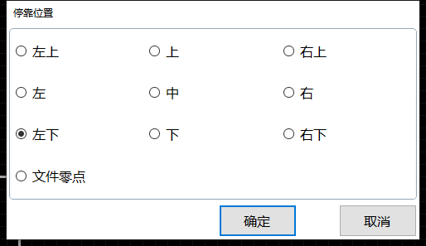
After setting the graphic docking position, move the machine to the material's designated docking location (e.g., the lower-left corner). Align the red light with the "lower-left corner" of the cutting plate. Click the shortcut button in the lower-left corner of the Icut interface to set the starting point and confirm the workpiece coordinates. Then execute the border-following command by clicking the button. As the machine begins tracing the border, check if the red light's path stays within the material processing area. If any deviation occurs, reset the starting point or adjust the cutting plate position before repeating the border-following process. Ensure the red light's movement stays within the machine's operational range.
Finally, click the button to start processing. Click the button to pause processing, and you can move the machine during the pause. Click the button to continue processing.
Click the button to stop the processing. After stopping, the equipment can go back to the starting point, reset the depth of cut, modify the speed and other operations. As long as you do not change the graphics or move the cutting plate, you can click the button to achieve the continuation of the cut.
If you encounter a sudden power failure during the use, you can re-import the file and click the button to continue cutting from the last power failure position. Currently, it does not support continuing from the edge of the circuit breaker.

2. Graphic operation

2.1 Graphic display
The first "View" column in the common menu provides a number of quick buttons to help control the display effect, as shown below:
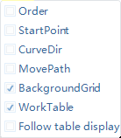
Processing number: After checking, the number is displayed at the starting point of the figure to show the processing order of the figure element
Path start: After checking, the white square center point is the starting point of the figure
Outline direction: After checking, the arrow direction shows the processing direction
Flight path: When checked, the trajectory of the flight path is displayed
Background grid: Check to display the grid in the CAD drawing interface
Workbench: Check to display the workbench, which is open by default.
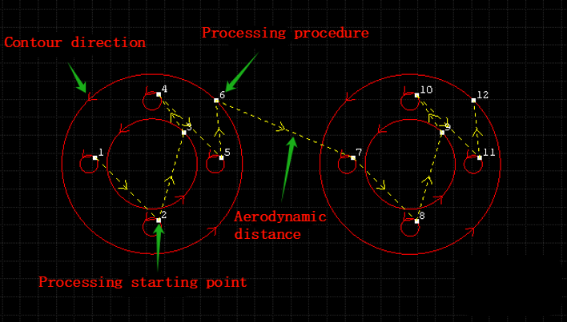
On the right side of the CAD interface, click the mouse right on the color layer navigation bar, as shown in the following figure:
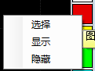
You can select the current color layer, you can hide the selected graphics, and you can display the currently hidden color graphics.
Click the "View" icon in the lower-right corner of the tab to open the User Parameters and Drawing Board dialog box. Here you can customize detailed settings for graphics displayed in the CAD interface, as shown below: Modify workspace dimensions including background color, cursor color, drawing pen color, sequence number color, starting point color, compensated original line, left frame selection color, and right frame selection color. All display colors can be customized here.
In the CAD drawing interface, the middle mouse wheel can zoom in and out of the view for easy viewing. Right-click opens a shortcut navigation bar, including hidden graphics operations. There is also a one-click switch to the main view for quick viewing of all graphics
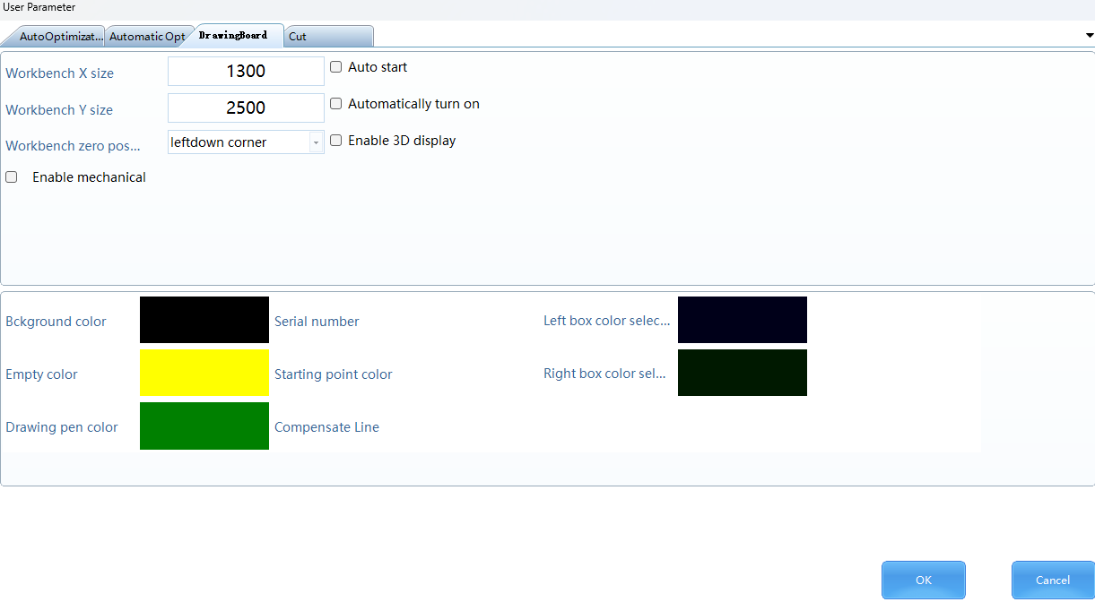

2.2 Figure selection
Icut provides a rich selection of graphical options.
The most fundamental selection method is "point-and-click" — simply hover over a graphic and click to select it. Another common approach is "box selection": hold down the left mouse button while moving to create a semi-transparent box around the target shape in the CAD interface. There are two variations: The first method involves dragging from the top-left corner to the bottom-right corner (as shown in the green box) — only shapes fully within this green rectangle get selected. The second method works in reverse — drag from the bottom-right corner to the top-left (as shown in the blue box) — any part of the shape inside the blue box gets selected.
The selection diagram is as follows: The green area on the left from top to bottom will select items 2 and 3. The blue area on the right from bottom to top will select items 1, 2, 3, and 4. Flexibly using these two selection methods can help you more easily choose the graphics you need.
Whether it is "click" or "box", if you press the "ctrl" key while selecting, you can select multiple graphics without removing the original selected graphics. Of course, the selected graphics can be removed from the selection status.
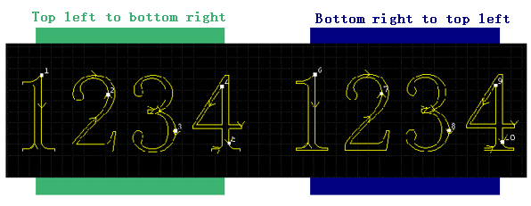
The Icut system provides you with a more convenient way to select graphics by selecting the "View" column under the common menu.
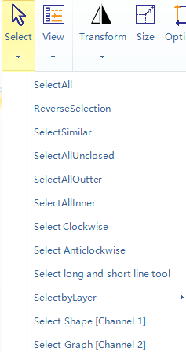
Basic selection: Select all (Ctrl+A), invert.
Shape selection: Select similar contours, select all unclosed ones, select all outer or inner shapes, and select all clockwise or counterclockwise.
Select short or long: The "Selection Type" contains: line length, shape length, and shape width. The "Short or Long" input size. The "Four Methods" contain: Select short, select long, select all, and inverse.
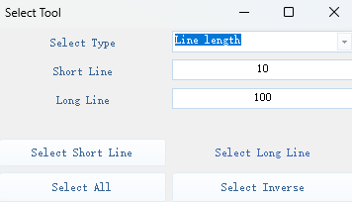
Layer selection: Selects all graphics with the same layer color. You can also select the corresponding color by right-clicking it under the "Process Navigation Bar".
Among them, "Select Similar Shapes" can select shapes of the same size. For example: I first select a 10MM circle, and then click "Select Similar Shapes" to select all circles of the same size of 10MM.

2.3 Graphic editing
The "Modify" tab in the menu bar offers comprehensive graphic editing features. Before using any tools, select the target graphic. Most transformations can be completed by clicking the drop-down shortcut menu under the "Transform" icon (e.g., translation, rotation, mirroring). The tab also includes size modification functions. As shown in the figure below:
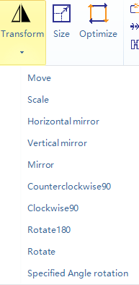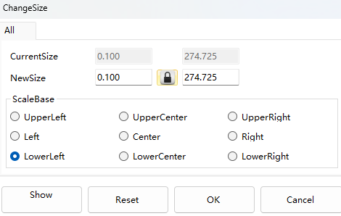

2.3.1 Size modification
Icut provides a variety of convenient ways to modify the size. You can enter the modification window through the column size modification tool in the common menu "Modify", or you can right-click anywhere in the CAD interface to quickly access the "Size" column and enter the modification window. As shown in the figure above:
Current size: The default gray cannot be edited. It shows the current selected graphic size for reference.
New dimension settings: Enter precise values to modify graphic dimensions. When the interface lock is active, length and width are proportionally locked according to the original drawing scale. Adjusting dimensions in any direction will proportionally adjust the other dimension. When the interface lock is inactive, length and width scales remain unlocked. Modifying dimensions in one direction will not affect the corresponding dimension in the opposite direction.
Zoom center: You can specify the positional relationship between the new shape and the original shape after zooming. For example, select "upper left" to indicate that the new shape and the original shape are transformed based on the upper left corner of the shape after zooming.
    - Interactive graphical transformation
Icut offers three interactive graphic transformations: zoom, rotate, and mirror at any angle, enabling precise adjustments to graphics. To perform these operations, first select the target graphic, then click the corresponding tool (as shown in the diagram above). Follow these steps: For example, to rotate a rectangle 45 degrees using its lower-left corner as the pivot point, follow these instructions:
- First, select the shape to rotate.
- Then click the small triangle below "Graphic Transformation" to open the drop-down menu, and select "Rotate". At this time, the drawing prompt bar below the CAD interface prompts: Please specify the starting point of rotation.
- Move the mouse to the lower left corner of the graph, and the mouse will be automatically adsorbed to the lower left corner to capture the endpoint.
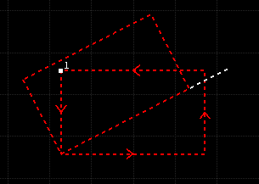
- Click the mouse, and the drawing prompt bar below the CAD interface prompts: Please specify the rotation Angle.
- At this time, directly enter "45" in the "command bar" below the system, and click the Enter key to complete the rotation.
Interactive zoom and mirror operations are the same as above, so I won't repeat them here!
Note! Interactive zoom, the command bar input instructions indicate the number of times the graph is zoomed!
To retrieve the interactive zoom, interactive rotation, and arbitrary Angle mirror tool, you can pick the tool by right-clicking on the quick access bar in the CAD interface.

2.3.3 Quick translation, rotation and mirror
The Icut system offers a user-friendly graphic transformation tool. Under the "Modify" menu in the common menu, there's a drop-down menu with a small triangle next to the graphic transformation section, providing options like horizontal mirror, vertical mirror, 90-degree counterclockwise/clockwise rotation, 180-degree rotation, and translation. Simply select the graphic you want to transform and click the grab tool to start editing.
You can also use the function in the shortcut bar at the bottom of the interface to quickly shift and rotate the value input by switching and fine-tuning.
Fine-tuning: Select the graphic and move the keyboard arrow keys to move the graphic according to the set step distance
Rotate: Select the shape and click the arrow key or press the "R" key to rotate the shape

2.3.4 In-place replication
We sometimes need to duplicate shapes at identical positions within a graphic, as shown below: Two identical rectangles exist in the same layer at the same location. First, select the shape and right-click to open the shortcut menu. In the dialog box that appears, choose the target layer (you can select either the original or another layer). Click OK to create two fully overlapping rectangles.
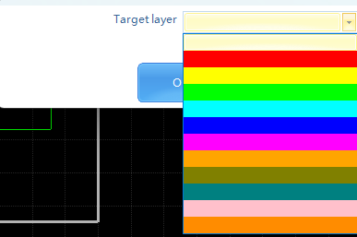

2.4 Capture tools
During graphic drafting, we need tools to precisely capture special feature points like endpoints and intersection points for accurate selection. The Icut interface provides two feature point capture tools in the top-left corner. As shown in the figure below, when drawing graphics that intersect with existing shapes, simply activate these tools. Move your mouse over the endpoint of the existing shape, and it will automatically hover over the endpoint. Click here to confirm the reference point position for your new drawing.
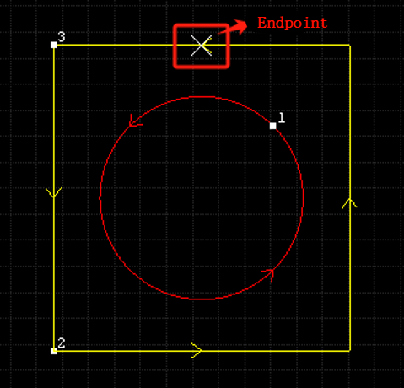
There are three special shortcuts in the top left corner of Icut, from left to right: software icon, save, undo (Ctrl+Z), and restore shortcut.

2.5 Draw graphics
Icut provides graphic drawing functions. In the middle section of the left navigation toolbar, from top to bottom are: Isolated Point, Line, Multiline, Circle, Arc, Ellipse, Rectangle, Text, Polygon, and Measurement. This layout is also present in the drawing module of the top menu bar. Except for Text and Measurement, the first seven functions are standard graphic drawing tools similar to those in CAD systems.

2.5.1 Drawing basic graphics
Drawing isolated points, straight lines, polylines, circles, arcs, ellipses, rectangles, text, and polygons is remarkably straightforward. Here's the step-by-step guide: Select the drawing tool in the CAD interface, click to select the first corner or center point. Release the mouse and drag to set the rectangle's or circle's dimensions. Finally, click again to confirm the end corner position – and there you have it!
During the drawing process, if you want to cancel the current drawing command, right-click and cancel in the shortcut bar. Alternatively, press the ESC key to cancel the drawing command.
In the left navigation bar drawing tools, circles, rectangles, and arcs each feature distinct drawing modes. By clicking the small triangular icons below these shapes, users can quickly access various drawing methods for their preferred options. For example, the circle dropdown menu includes: center-radius circles, center-diameter circles, two-point circles, and three-point circles.

2.5.2 Input commands to draw graphics
Icut works like a CAD drawing program by typing commands to draw graphics with precise positioning and dimensions. The specific format (X coordinate ****/comma, /Y coordinate ****) is as simple as entering 100,100 and pressing Enter.
Most drawing operations can be performed either by mouse or by inputting coordinates. The following example uses a 100 by 100 rectangle with rounded corners of 10MM:
- Select the rounded rectangle tool in the drawing navigation bar. The drawing log bar prompts you to specify the first corner point
- Enter the first corner point position: -2500, -1600. Enter to specify another corner point
- Enter the second corner point position: -2400, -1500. Enter to specify the radius of the circle
- Press Enter 10 times. The operation is complete. As shown in the figure below:
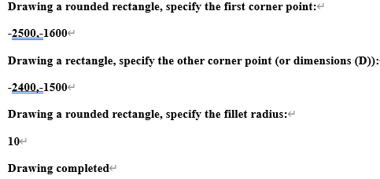

2.5.3 Text input
Icut supports text input. Click the tool icon on the left drawing navigation bar and type text directly at the "Text" location.
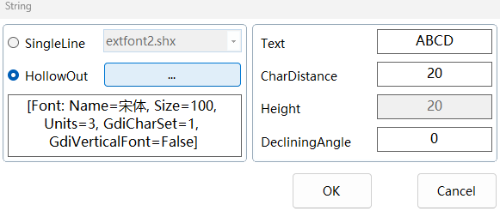
Select "Luo Kong" on the right to open the font editing interface
Font: Configure the common font. You can select the font you need here
Font: You can choose the form of the font, including regular, italic, bold, and bold skewed.
Size: Can set the size of the font
Effect: Whether to delete the line or add an underline.
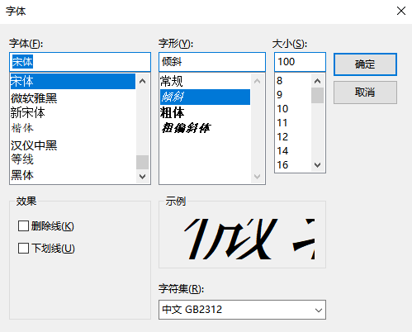

2.5.4 Create standard parts
Icut provides the drawing of standard parts, menu bar, "File" drop-down menu, open the window to create standard parts: as shown in the figure below: you can open the graphics you need, open it directly, select the parts, and confirm.
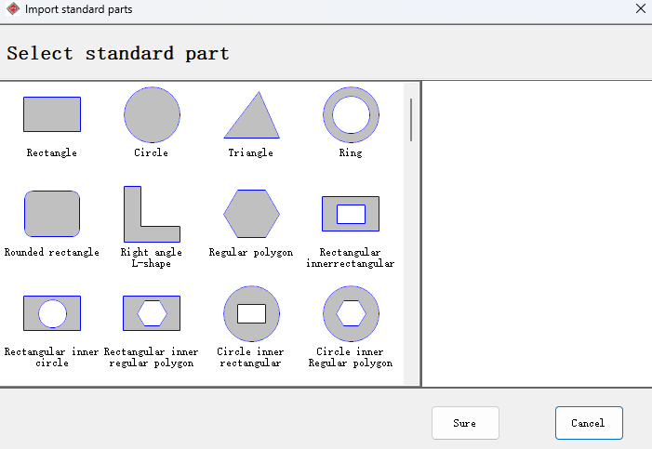
After opening the part, a window to modify the size of the part will be opened, as shown in the figure below: Finally click OK and place the part anywhere in the CAD interface.
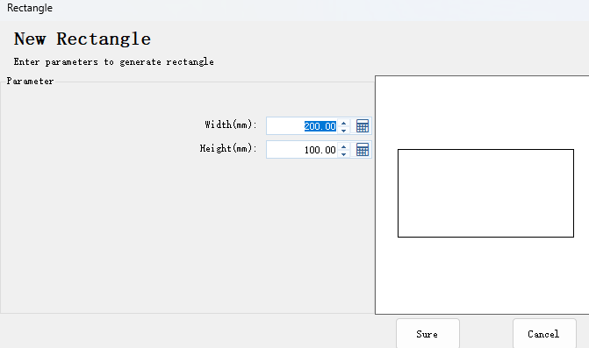

2.6 Graphic optimization
When importing a external graphic, Icut will automatically optimize the graphic. If you need to manually optimize the graphic, you can open the "Optimize" window in the "Modify" column of the common menu, as shown in the figure below:
Effective between layers: When checked, graphic optimization is effective for graphics on the same layer
Optimize the selected shape: When checked, only the selected shape is optimized
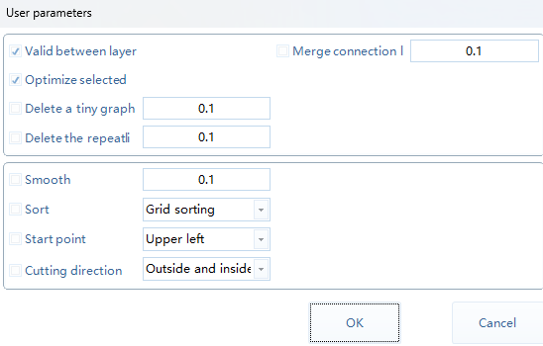
Select the graphics that need optimization, check the options that need optimization, configure the optimization parameters, and confirm.

2.6.1 Remove small graphics
Imported graphics may sometimes contain visually inconspicuous elements that result in small display sizes or unintended positioning during processing. To resolve this, use the "Delete Minor Graphics" feature: Under the optimization tool, select "Delete Minor Graphics", adjust the size range of minor graphics, then confirm. This process will remove graphics smaller than the specified dimensions while preserving others.

2.6.2 Remove duplicate lines
This function is used to remove overlapping graphics until only one remains. Under the optimization tool, check "Delete duplicate lines" and modify the parameter range of duplicate lines, then confirm. It will search and clean all graphics. If two lines are smaller than the parameter range, one line will be automatically deleted.

2.6.3 Merge the connecting lines
Graphics created with other software like AutoCAD often contain visually connected but actually separate shapes. These can be merged by selecting the shapes to combine, checking the "Merge Linked Lines" option in the optimization tool, adjusting the parameter range, and confirming the changes.
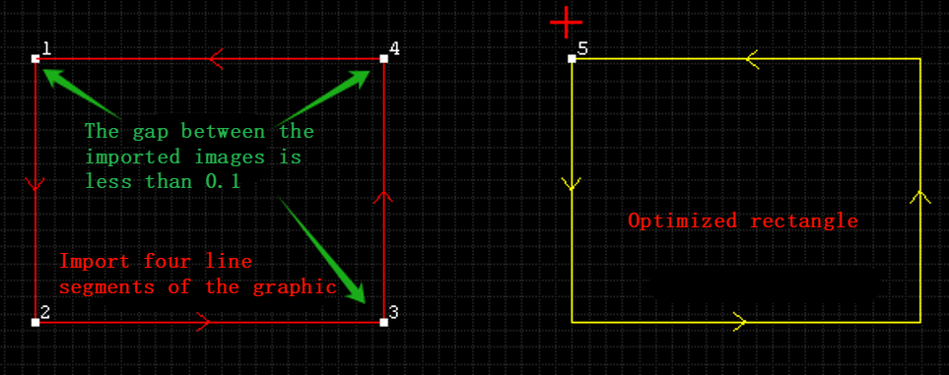

2.6.4 smoothing
Imported graphics from other drawing software often exhibit irregular curves and excessive nodes, resulting in choppy cutting motions or frequent tool lifting, which significantly reduces processing efficiency. To resolve this, apply smoothing optimization to imported graphics: Select "Smooth" in the tool settings, input precision parameters, then click OK to complete the enhancement. The comparison below shows the original curve versus the smoothed version. For clarity, we've applied a higher smoothing precision here. In practical applications, users should adjust the fitting values according to specific machining requirements.
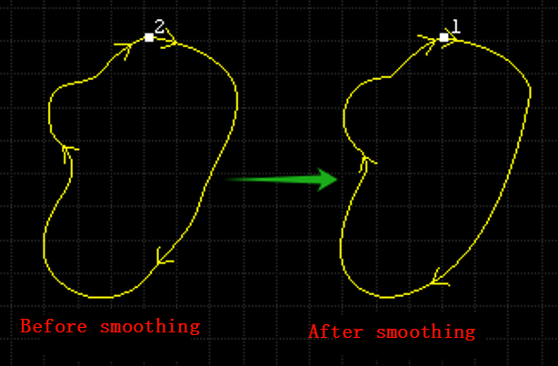
The Icut system offers two smoothing modes: fitting and interpolation. Each mode represents a distinct algorithm, allowing users to select based on their specific requirements. For fitting mode, the precision value should be set between 0.1 and 0.3. The interpolation mode typically requires values between 5 and 6. Please ensure you correctly select the smoothing mode and input appropriate precision values accordingly.
Note! The "User Parameters" section in the menu bar already provides smoothing optimization. Before importing files, check the smoothing option to enable automatic smoothing once during import. If this option is not selected in "User Parameters", manual optimization can be performed by checking the "Modify" tab in the menu and opening the optimization window for manual adjustments.

2.6.5 Interrupted merging
To interrupt a shape, first select the target shape. In the menu, navigate to the "Operation" tab and click the "Break" tool. Position your cursor over the target location (as shown in the red box at position 3). Click to cut the shape. Once interrupted, the shape becomes open and loses access to certain functions.
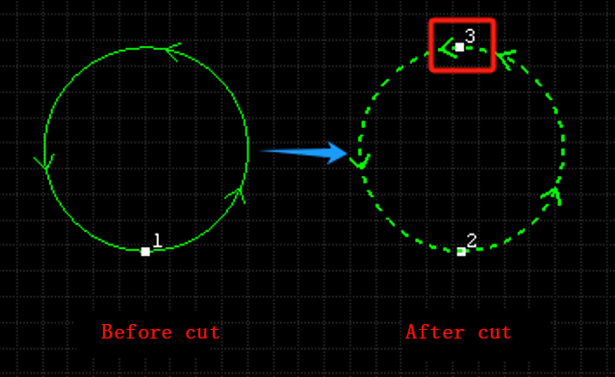
The merge tool is the opposite of the break function. The prerequisite for using the merge tool is that two nodes of two graphics must completely overlap. Select the graphics, click the tool in the "Operation" column of the menu. Both graphics to be merged must be selected.
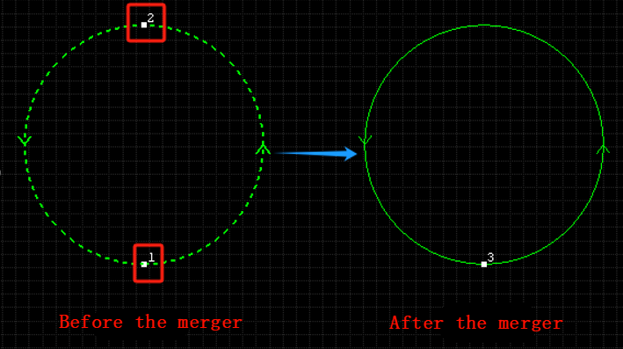

2.6.6 Detonation
Select the "Operation" column of the graphical menu and click the tool. As shown in the figure below, it will automatically break at the endpoints.
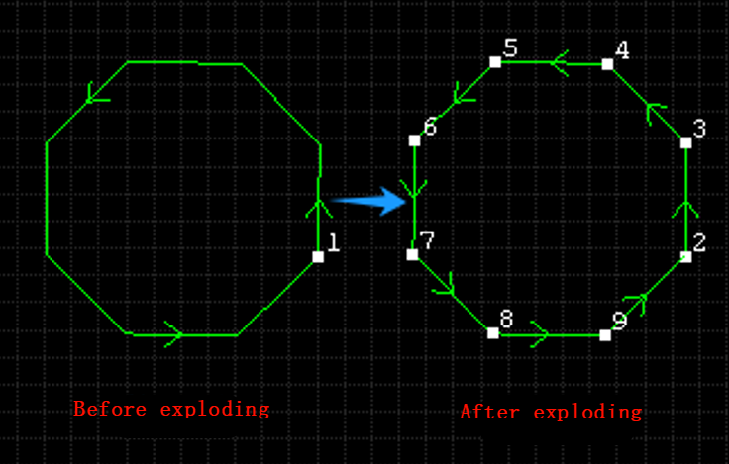

3.Process tools and process parameters
This chapter details the process setup features provided by Icut. As most process parameters are directly linked to the materials being cut, tool holders, and cutting tools, please configure them according to actual production requirements. All parameters mentioned here—including those shown in the images—are for reference purposes only and should not be considered as definitive specifications.
Note! Improper or wrong parameters may lead to poor cutting effect or even damage the machine tool, please set carefully.

3.1 Setting the starting point of the figure
Icut offers three optimized starting point methods: Manual Start, Automatic Batch Start, and Longest Straight Line Start. These intuitive options are detailed below. To configure your starting position, first select the graphic you want to work on, then navigate to the "Tools" menu in the toolbar section where you can choose between these preset settings.

3.1.1 Manual starting point
After selecting the figure, click the button， as shown in the following figure: Before modifying the starting point position at "1", move the mouse to "2", the mouse automatically adsorbs a cross shape, and then click the mouse to complete the modification of the starting point position. Starting point position 1 to 2.
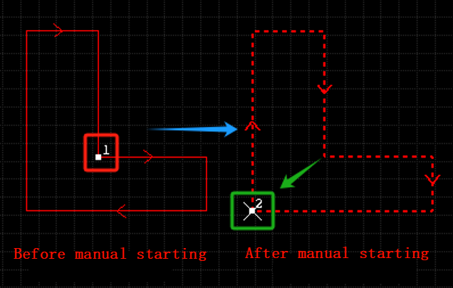

3.1.2 Automatic batch starting point
Icut supports automatic batch starting point configuration. When processing multiple individual graphics in a file, we utilize batch starting points to optimize workflow efficiency. First, select the desired graphics by clicking buttons under the "Tools" menu section and selecting "Automatic Batch Starting Points" from the drop-down menu. This activates the starting position window (as shown below), offering 10 positioning options: top-left, bottom-left, top-right, bottom-right, left, right, top, bottom, center point 1, and center point 2. The first eight positions are standard starting points, while the last two feature specialized starting point methods.
In the "starting point" window, select the desired starting point. For example, select "upper left corner" and click OK. The selected graphic starting point will be set to the upper left corner.
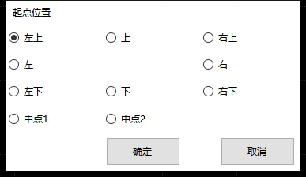
The usage of Point 1 and Point 2: These two methods are respectively applied in environments where a file contains right angles and rounded corners. For Point 1, the starting point of the fingertip angle pattern is located at the angle intersection, while the starting point of the rounded corner pattern is at the midpoint. Point 2 refers to situations where both right-angle and rounded-corner patterns share the same midpoint origin. As shown in the figure below
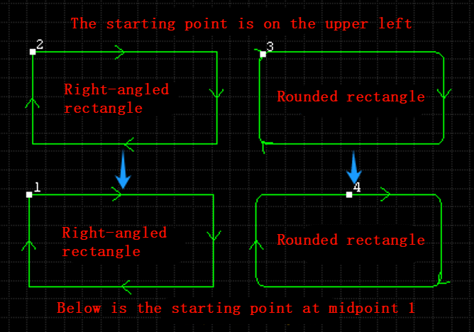
Point 1 effect
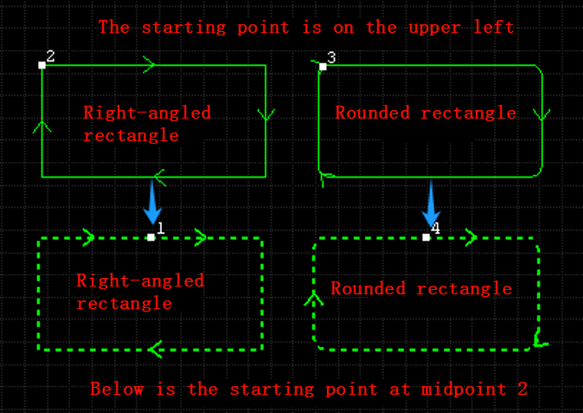
Point 2 effect

3.1.3 Longest straight line starting point
Under the "Tools" tab in the menu bar, the "Longest Line" dropdown menu offers three options: longest starting point, longest center point, and longest endpoint. As shown in the diagram below: The red area represents the graphic, the yellow arrow indicates the cutting direction, and the yellow box marks the starting position. From left to right, these correspond to the original image, longest line starting point, longest line center point, and longest line endpoint, respectively.
As shown in the diagram below, we first identify the longest side of the triangle. It's evident that the base segment is the longest. Next, we need to determine the cutting direction. Examining this base segment individually, its extension runs from right to left, meaning it starts at the right end and ends at the left end.
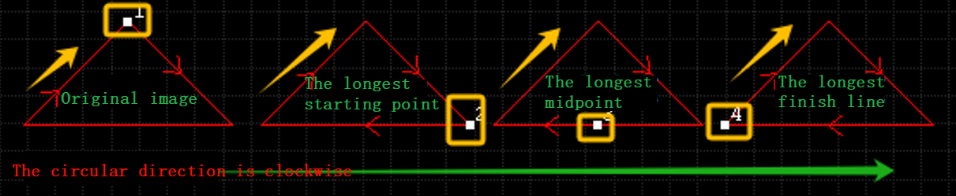

3.2 Graphic direction setting
During material cutting processes, precise control of cutting direction is crucial. Icut offers a comprehensive and detailed tool for optimizing cutting orientation: Simply select the target shape, navigate to the "Tools" menu section, click the "Direction" button to open the drop-down menu, then choose the appropriate function to modify the cutting path direction, achieving optimal cutting results.
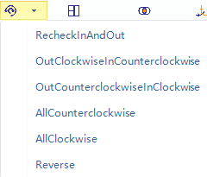
Re-distinguish inner and outer contours: The default cutting order of the system is "inner first, then outer". When a closed shape contains other shapes, but the actual cutting order is "outer first, then inner", you need to click the "direction" drop-down menu to re-distinguish inner and outer contours.
External clockwise and internal counterclockwise: As shown in the figure, Figure 1 represents "external clockwise and internal counterclockwise" (clockwise outside, counterclockwise inside), while Figure 2 demonstrates "external counterclockwise and internal clockwise" (counterclockwise outside, clockwise inside). To use this function, two prerequisites must be satisfied:
1. The figure must be a closed figure;
2. The internal and external graphics should be two independent graphics. If there is a group state, the graphics should be split first with the scattering tool and then the direction should be modified.
Counterclockwise and clockwise: As shown in the figure, Figure 3 is the counterclockwise cutting direction, and Figure 4 is the counterclockwise cutting direction. You can directly choose the corresponding direction for modification according to actual requirements.
Reverse: This function can directly reverse the cutting direction of the current graphic.
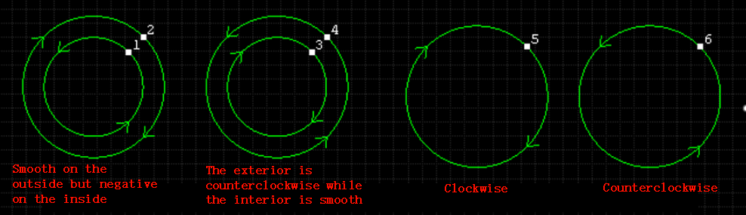

3.3 Common borders
In cutting and processing, we often encounter graphics with the same boundary. In order to save the processing length and improve the processing efficiency, it is necessary to merge these graphics with the same boundary and realize the common use of boundaries.
Icut also supports the optimization of common edge effect by modifying the "common edge spacing" parameter: For graphics that are not completely coincident and have a certain edge spacing, the common edge function can be enabled by adjusting this parameter to automatically merge the graphics, so that the boundary can be shared without manual alignment.
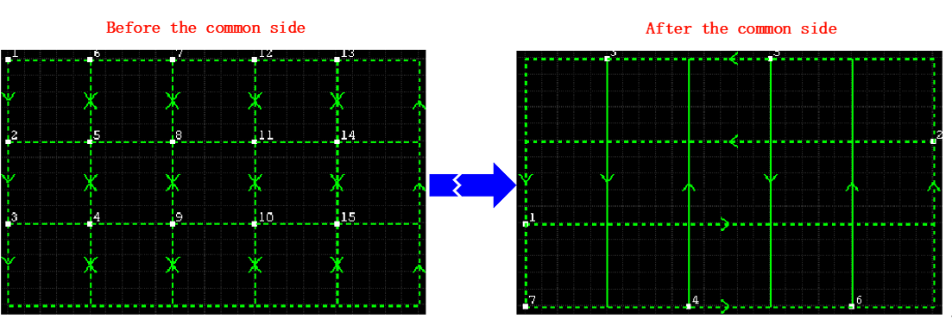
- Select the "Tool" column under the menu, select the common edge, and open the common edge window
- Select "common edge type" includes regular common edge, C-shaped common edge. The figure above shows the regular common edge
- Select "Common edge sorting" Common edge sorting automatically, including the shortest distance, horizontal U-shaped, horizontal Z-shaped, vertical U-shaped, vertical Z-shaped.
- Modify the precision of "common edge spacing". It refers to the spacing between graphics, and is default 0.1.
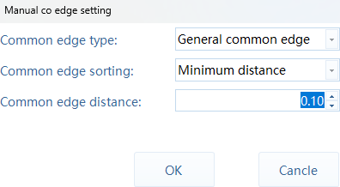

3.4 Graphic tool compensation
Icut offers multiple graphic compensation functions. Since standard cutting paths follow the original graphic trajectory, we sometimes need to expand or contract the cut area. This is particularly important when using spindle milling cutters. For example, with a 3.17mm diameter tool cutting 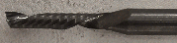a 50×50 rectangle without compensation, the actual cut size would be 3.17mm smaller. Therefore, we must expand the rectangle by half the tool's diameter (1.58mm), ensuring the final material meets the 50×50 dimensions. This method significantly improves cutting accuracy. However, when using G code files for machining, no external expansion or contraction is required, as these paths are automatically processed during creation.
Under the "Tools" column in the menu bar, open the window as shown below:
Input of compensation precision, including external expansion distance and internal contraction distance
The compensation methods include external expansion and internal contraction, external contraction and internal expansion, full internal contraction and full external expansion
The corner types include flat corner, rounded corner and sharp corner selection
Reoptimize the function of separating inside and outside contours
Use expand and shrink on the same layer to determine the layer when expanding and shrinking.
The above features will be introduced below in text and pictures.
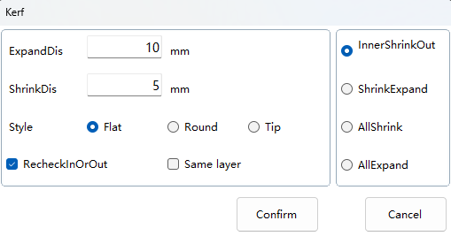
3.4.1 Expanding and contracting
The figure below shows: the original figure on the left and the compensated figure on the right. Red represents the cutting trajectory and white represents the original line. The distance between expansion and contraction is half of the tool diameter.
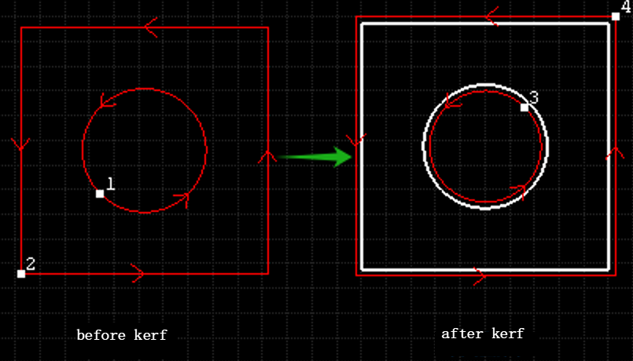
The demonstration is a closed shape. If it is a non-closed shape, both the outer and inner shapes will be expanded.

3.4.2 External contraction and internal expansion
The figure below shows: the original figure on the left and the compensated figure on the right. Red represents the cutting trajectory, and color change represents the original line. The distance between external contraction and internal expansion is half of the tool diameter.
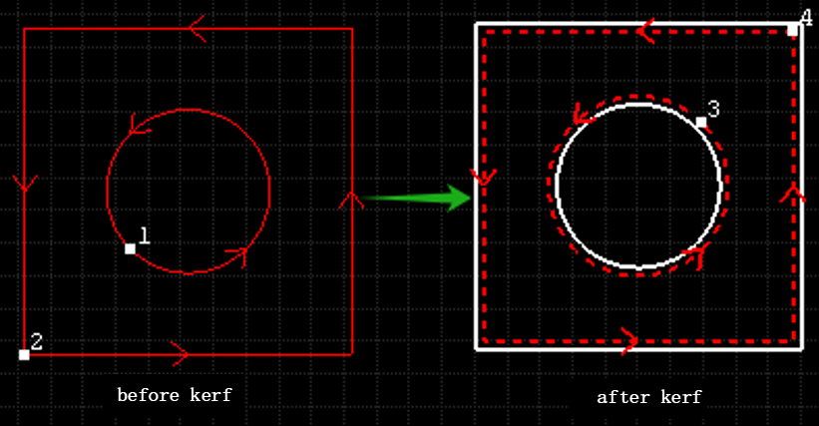
The demonstration is a closed shape. If it is an open shape, both the outer and inner shapes will be contracted.

3.4.3 Total contraction
The figure below shows: the original figure on the left and the compensated figure on the right. Red represents the cutting trajectory, and color change represents the original line. The total retraction distance is half of the tool diameter.
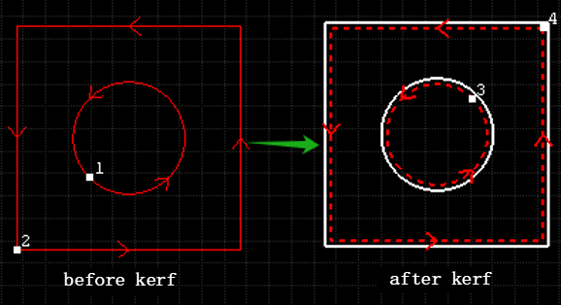

3.4.4 All external expansion
The figure below shows: the original figure on the left and the compensated figure on the right. Red represents the cutting trajectory, and color change represents the original line. The entire external expansion distance is half of the tool diameter.
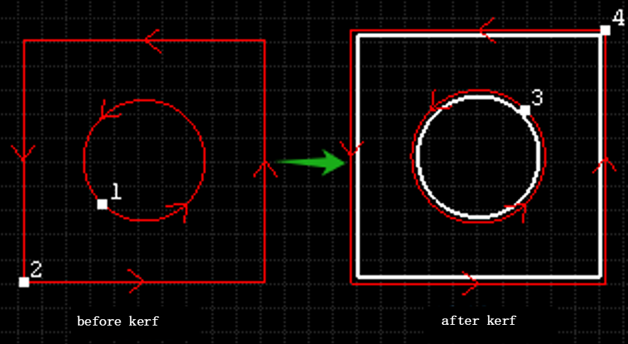

3.4.5 Angle type
As shown in the figure below, three types of corners are displayed here together, instead of being separated. According to the needs, different corner types are selected, and the compensated sharp corner position will optimize different corner features.
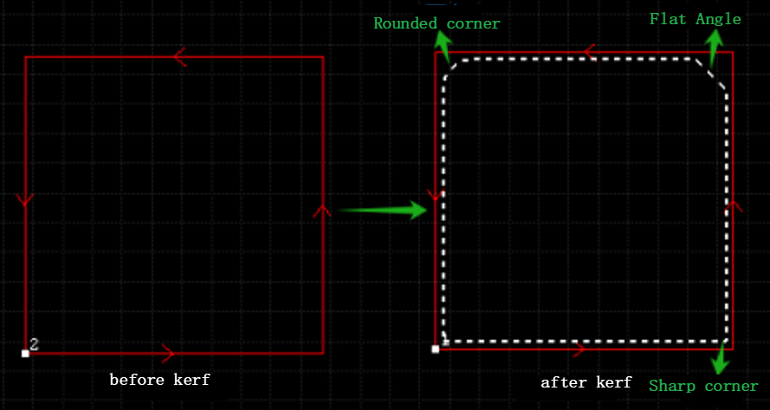
The corner precision after compensation can be modified in the chamfer parameter window under the drop-down menu of "Operation" column in the menu bar

3.4.6 Compensation, same layer
The following figure shows: No.2 is compensated without selecting "same layer", and the compensation is expanded and contracted according to the same layer. No.3 is compensated by selecting "same layer", and the compensation is made independently for the outer and inner layers, and all layers are expanded.
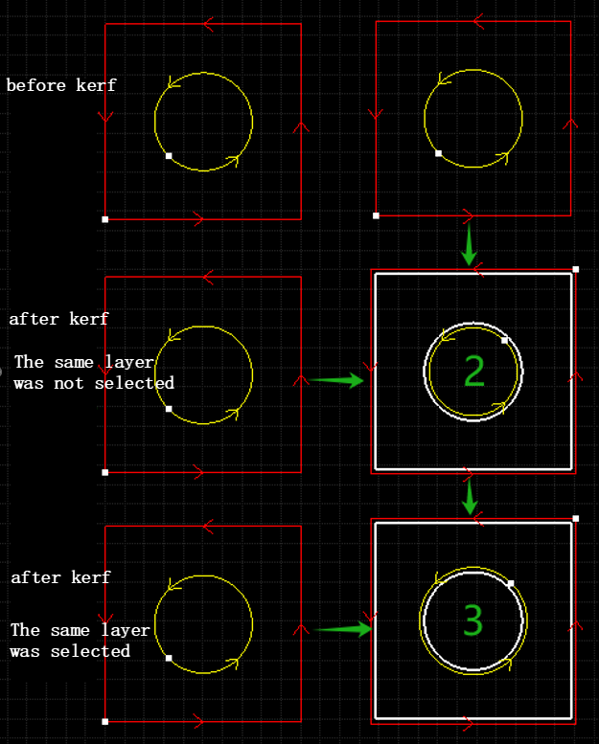
As shown in the figure below: Sometimes we encounter the following graphics, there are multiple graphics in the closed graphics, separated into different layers, and want to use the expand or contract function, you can check the same layer for compensation. The inner and outer contours of the same layer are distinguished.
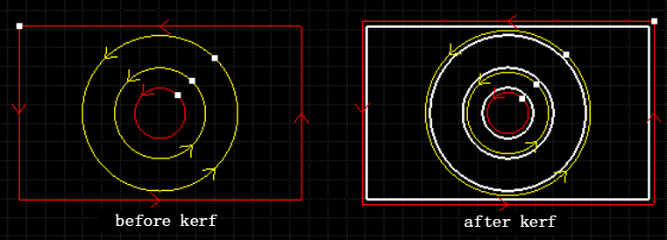

3.5 Regional carving
Icut supports the "area engraving" function, which refers to the process of local engraving within a specific area. It can directly generate concave and convex milling effects through vector graphics. This is widely used for engraving planes, EVA foam, and other irregular slotting. It saves the time we spend writing G code.
In the common menu, go to the "Tools" section, open the Window and parameters can be set as shown in the figure below:
Tool radius: refers to half of the diameter of the milling tool used, r
Path spacing: Refers to the distance between regional engraving paths, also known as overlap distance. Generally, the value should be set smaller than the tool radius. A smaller value increases the overlap rate, prolongs processing time, but improves engraving and milling quality. Conversely, a larger value reduces overlap rate, shortens processing time, but decreases engraving and milling effectiveness
Target layer: Select which layer color is used to generate the area carving path.
Cutting methods: including row cutting and ring cutting
Whether to delete the original image: Check to delete the original outer contour graphics, only retaining the generated area carving path
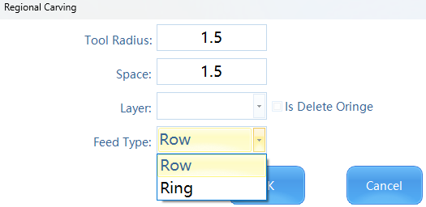

3.5.1 Yang carving and Yin carving
Icut supports milling operations for positive and negative relief effects, as shown in the figure below:
Ingot carving: Select the text Icut, click the "Tool" column in the common menu, click the "Area carving" button, open the area carving parameter window, set the parameters, and click OK.
Yang carving: Select the text Icut and the outer contour rectangle. Click the "Area carving" button in the column of the common menu, open the area carving parameter window, set the parameters and click OK.
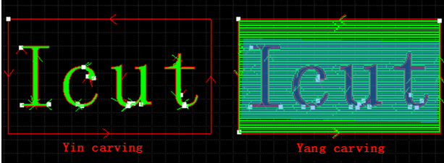
Important: When carving areas, select the tool based on your design's minimum dimensions. Using oversized tools may result in insufficient path spacing, potentially leaving narrow sections without complete paths. Conversely, choosing undersized tools could reduce processing efficiency. Always measure the design's minimum dimensions beforehand to choose an appropriate tool size.

3.5.2 Row cutting tool and ring cutting tool
The diagram below illustrates two milling approaches: the left image shows linear cutting with tool removal, while the right demonstrates circular cutting with tool removal. Linear cutting involves horizontal X-axis reciprocation with tool insertion starting from a specific corner point and lifting at the same position. Circular cutting follows the contour path, typically initiating cuts either within the graphic pattern or at intersections between straight lines and arcs. You can select appropriate cutting methods based on material characteristics, tool specifications, and design features. Choosing the optimal cutting method significantly enhances milling efficiency.
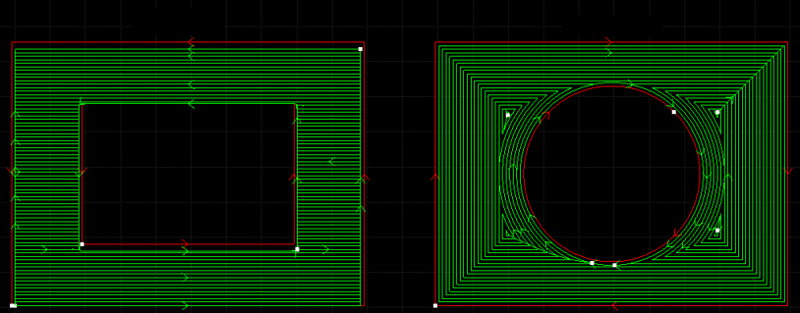
Suggestion! Hard materials are selected for ring walking.

3.5.3 Ring cutting and tool removal
When performing circular cutting operations in area engraving, we offer two rotation options: clockwise and counterclockwise. Since certain materials have strict requirements for cutting direction, incorrect orientation may cause burrs during milling, leading to time-consuming manual polishing. Icut effectively resolves these issues by allowing users to customize rotation parameters for both clockwise and counterclockwise operations.
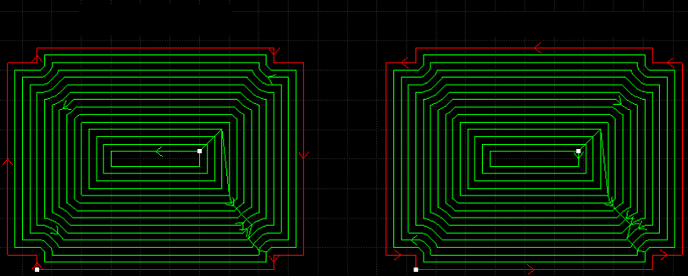
Most importantly, Icut can also modify the tool starting point without changing the milling direction of the path by using the "direction" tool. Some flexible materials need to be milled from outside to inside.
The default system setting is to cut from inside to outside. To modify the starting point of the cutting tool, please refer to the following steps: For example, for milling from outside to inside, the path direction is clockwise
- To select the graphic, open the "Area Carving" window under "Tools" in the common menu and modify the parameters
- Select "counterclockwise" for the loop cut tool. OK
- As shown in the figure below, the left side is the carving path of the current area, with the starting point inside.
- Select the area of the carving path. Click the "Tool" column, click the "Direction" tool button, and click "Reverse" in the drop-down menu
- As shown in the figure below, the final effect is on the right. The starting point is outside and milled clockwise.
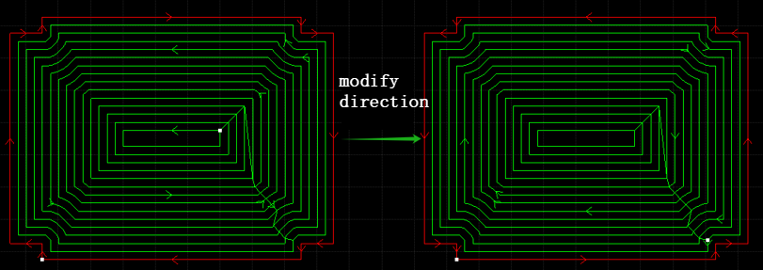

3.6 Reverse cut compensation
The tools used in the cutting machine are angled tools, unlike the milling tool which is completely vertical and wide at the top and narrow at the bottom. Cutting thick materials will produce "overcut", that is, the bottom is cut and part of the material is cut into the upper part.
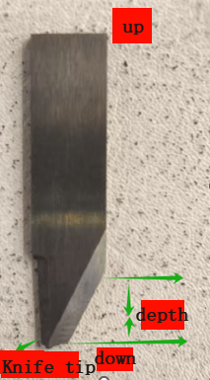
Therefore, we added the parameter "anti-cut compensation". When cutting along the processing trajectory direction, the cutting is reversed near the lifting position. The end point of cutting is consistent with the starting point of reverse cutting, and the tip of the blade and the rod are on a vertical line.
The menu is usually located in the "Tools" column. Open the window as shown below:
Overcut length: refers to the length of the material surface cut after the bottom surface is cut
Knife lifting Angle: refers to the exterior angle of two straight lines at the cutting point of the figure. If the exterior angle is less than the knife lifting Angle, the current line segment will open reverse cut.
Select shape: When checked, the selected shape is cut off
Anti-cut layer: When checked, you can specify which layer to use for anti-cut. Anti-cut can be used with different layers and different tools.
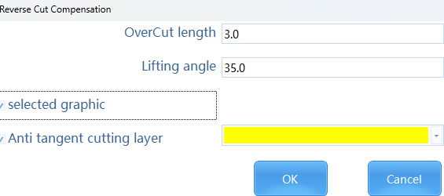
Operation steps: Select the graphic, click the "Tool" column in the menu bar, click the "Anti-cut compensation" button, and modify the parameters. Click OK to confirm, as shown in the figure below: Red is the source path, green is the anti-cut path.
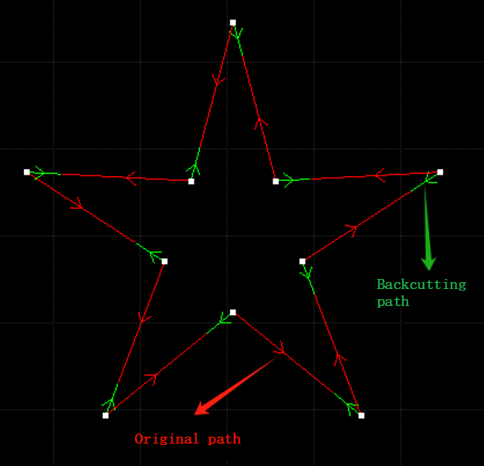
Knife lifting angle: As shown in the figure below: Red represents the cutting path, green represents the reverse cutting path. The two red cutting paths have an angle of 30° and an outer angle of 150 degrees. When the knife lifting angle is ≥150°, there is no reverse cutting. When the knife lifting angle <150°, there is reverse cutting
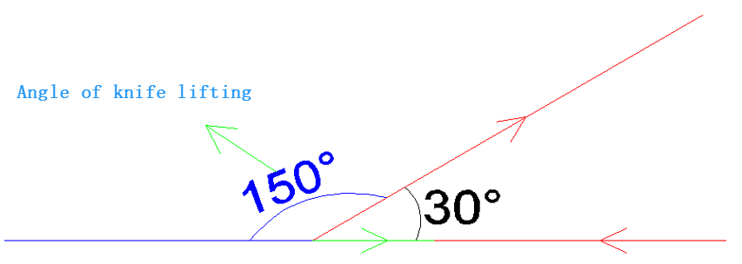

3.7 Dispersal and grouping
In Icut, a "group" refers to the combination of multiple graphics, even multiple "groups", forming a "group". The entire "group" will be viewed as a whole. The order within the "group", the positional relationship between graphics, and the layers are fixed. The internal order will not be affected when sorting, dragging, etc.
To create a group of graphics, click the "Tools" tab in the menu bar. Select the desired graphics and click the button to combine them into a group. To "break up" graphics, select the grouped graphics in the menu bar and click the button. Note that "breaking up" doesn't split individual curves but only breaks the group itself, whereas "splitting" will break the graphics into separate line segments.

3.7.1 Combined samples
A composite sample refers to automatically grouping individual page samples that share common features, including both internal and external graphics. As shown in the diagram: The left side illustrates the pre-selection state where rectangles and hexagons remain independent graphics that can be individually selected and edited. The right side demonstrates the post-selection effect where these shapes merge into a unified group, allowing simultaneous selection and editing.
Specific operation: Select the graphics that need to be taken (as shown in the figure below, select the rectangle and hexagon). Click the small triangle on the right side of the "Group" column under the "Tool" menu, and click the button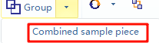. At this time, the rectangle and hexagon become a whole, and other identical graphics are grouped together.
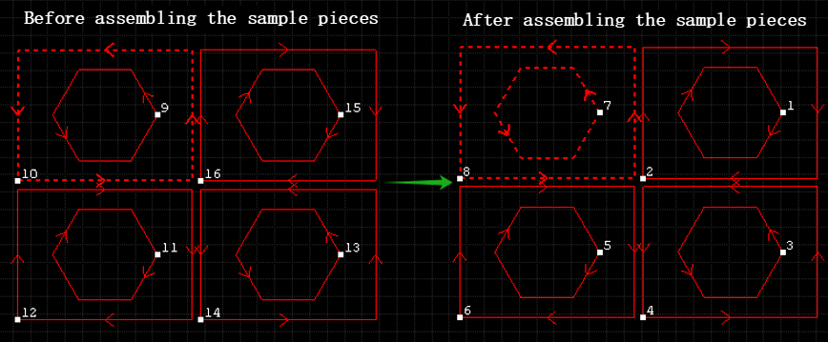
After using the photo-taking function, Icut has two cutting modes for you to choose from: "Cut by sample" and "Cut by layer order". The "User Parameters" window can be opened in the drop-down menu of "File" in the upper left corner of the menu bar.
Check "Automatic photo retrieval" to select the cutting order. Click the button, and select the cutting order mode from the drop-down menu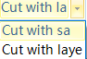:
Cut by layer order: as shown in the figure below, the yellow layer is in front and the red layer is behind. First process two yellow hexagons, then process two red rectangles. The layer in front is processed first.
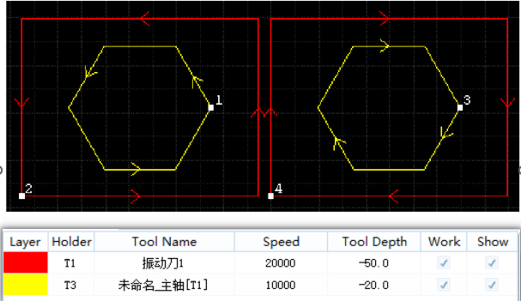
Process according to the order of sample pieces: As shown in the figure above, take a single sample piece as the benchmark, process the No.1 hexagonal figure first, switch the tool holder, then process the No.2 rectangular figure, and so on. Process the next sample piece after processing one sample piece.

3.8 Array
Using arrays can quickly and accurately obtain multiple objects. Icut provides three array modes, including rectangular array, circular array, and interactive array.

3.8.1 Rectangular array
To select the graphics that need the array, click the button in the "Tools" column of the common menu, and select "Rectangular Array" in the drop-down menu. Open the rectangular array setting parameter window, as shown in the following figure:
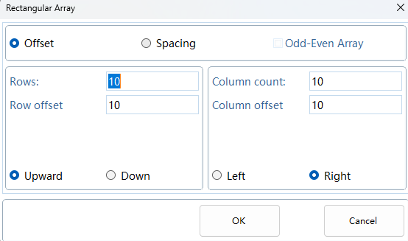
Set the number of rows and columns, spacing distance, array direction, click OK, you can complete the rapid array of graphics, as shown in the figure below:
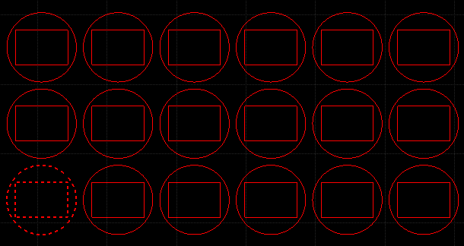

3.8.2 Ring array
To select the graphics that need the array, click the button in the "Tools" column under the common menu, and select "Ring Array" in the drop-down menu. Select the center position of the array points, and open the ring array setting parameter window, as shown in the figure below:
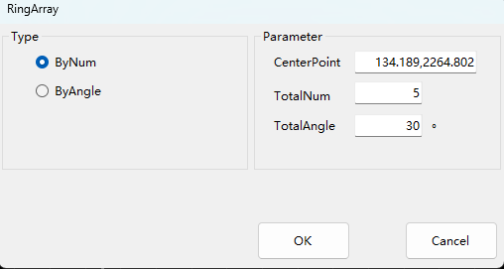
Set the array mode (by quantity, by interval), array, center point position, interval Angle, array Angle, click OK to complete the ring quick array, as shown below:
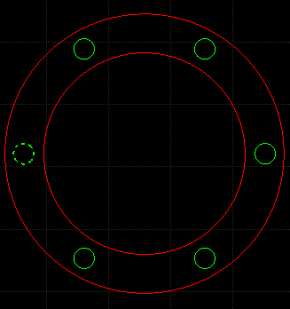

3.8.2 Interactive arrays
To select the graphics that need the array, click the button in the "Tools" column under the common menu, and select "Interactive Array" in the drop-down menu to open the interactive array setting parameter window, as shown in the figure below:
Set the parameters, row and column spacing, click OK, in the CAD drawing interface, hold down the left mouse button, drag the mouse, drag a region, it will be quickly array completed.
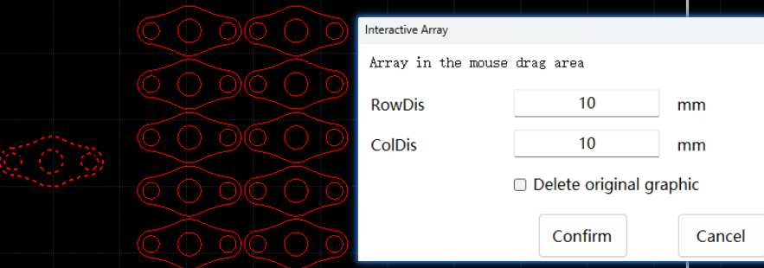

3.9 Sorting
You can use the "Order" column under the common menu, which lists all the functions in order, as shown below:
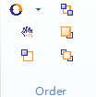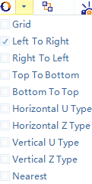

3.9.1 Sequence Preview
You can access the "View" tab in the menu bar to enable the "Processing Sequence" display by selecting the button drop-down menu, which makes it easier to track production stages. As shown in the diagram below: From bottom to top and left to right, the processing sequence is: 1, 3, 4, 2, 5, 8, 7, 6. Alternatively, you can preview simulations using the "Simulate" tool in the menu bar.
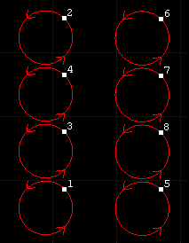

3.9.2 Manual sorting
If you want to fine-tune the results of auto-sort, you can use manual sorting. First, select the graph you want to adjust, and then click the button、、The function buttons work as follows:
Move the selected graphic processing order one step back
Move the selected graphic processing order to the last processing
Move the selected graphic one position forward in the processing order
Move the selected graphic processing order to the previous one
Select the "Manual Sort" button and click the graphics you want to sort in order, starting with the first one by default
Note! The "layer cut" is cut in the order. The order does not affect the layer cut. The layer order is the cut.

3.9.3 Automatic sorting
You can click the small triangle button on the left side under "Order" in the common menu, and select the appropriate sorting method through the drop-down menu. See the following effects of various sorting methods: Yellow dotted line indicates the empty path, and white numbers indicate the processing sequence number.
Grid sorting
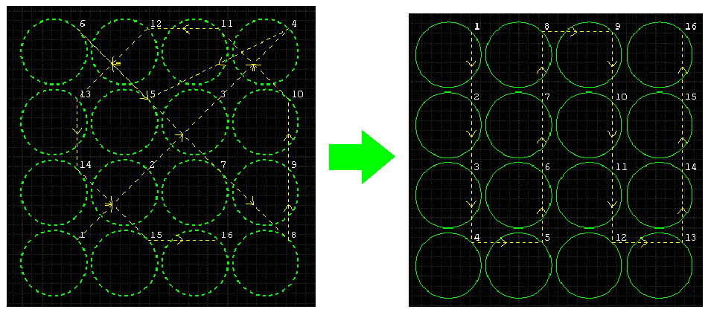
from left to right
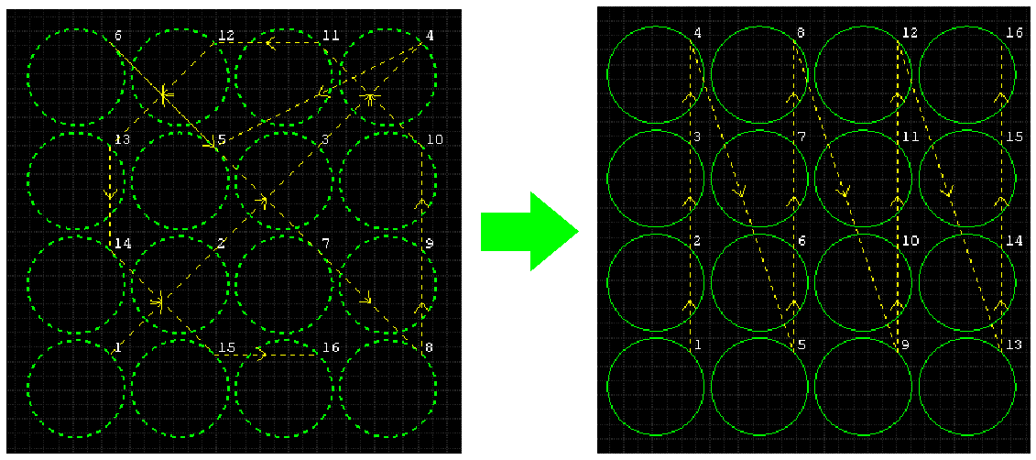
R-L
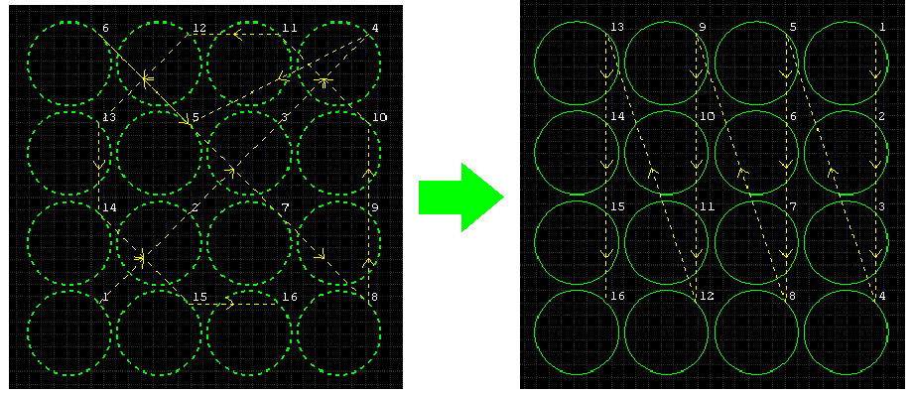
from top to bottom
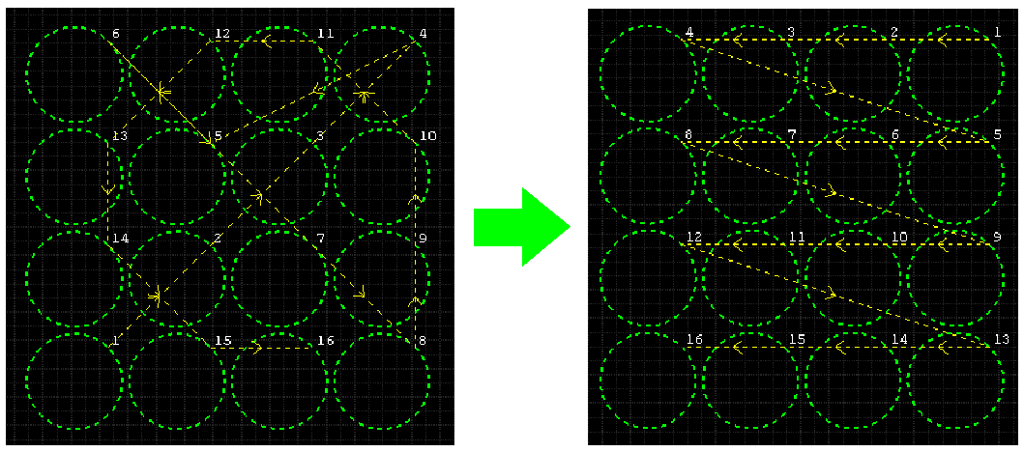
from the bottom up
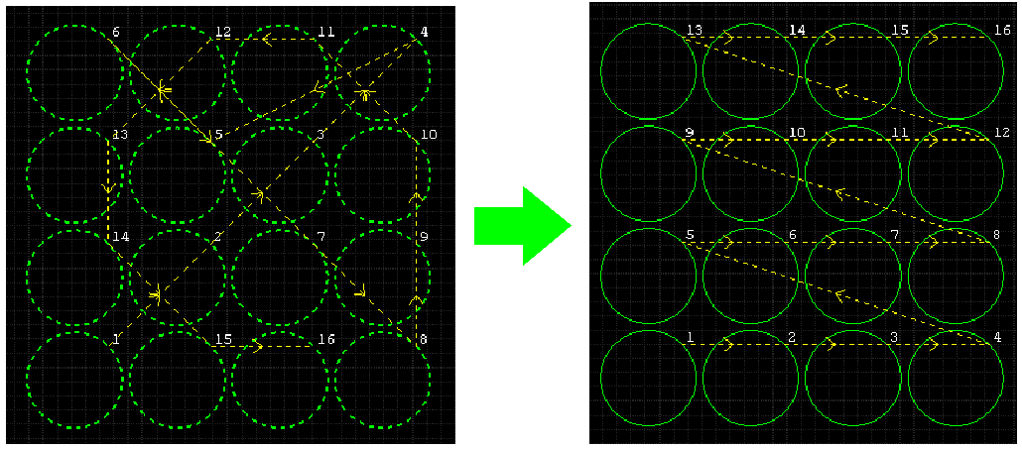
Horizontal U-shaped
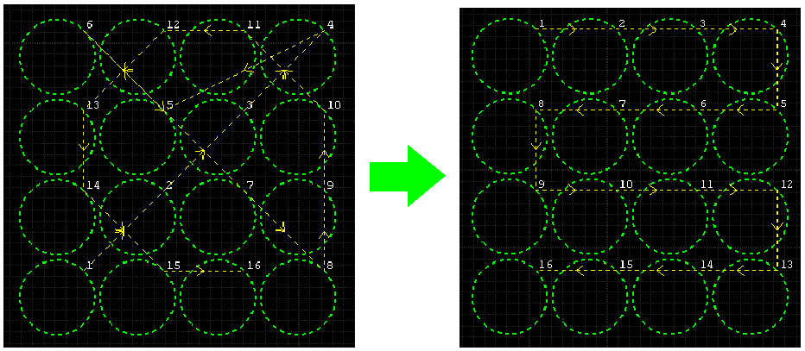
Horizontal Z-type
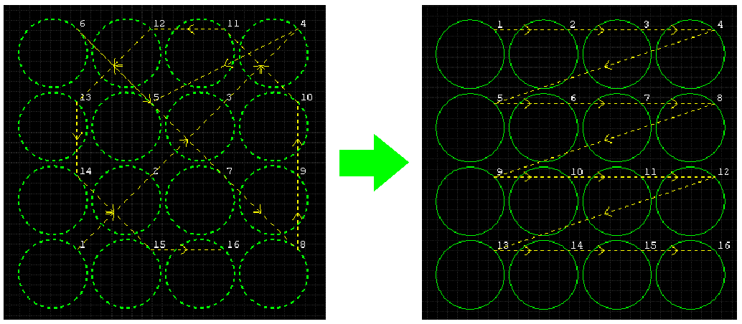
Vertical U-shaped
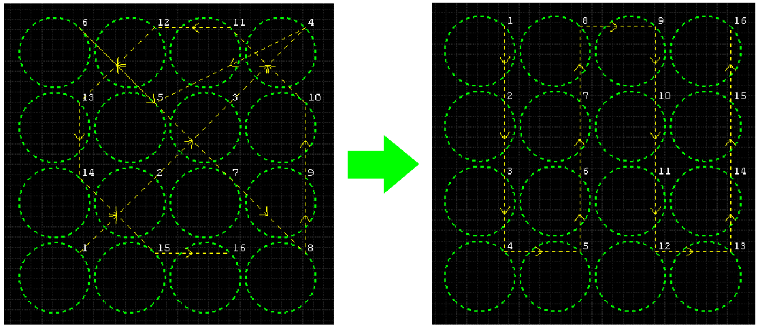
Vertical Z type
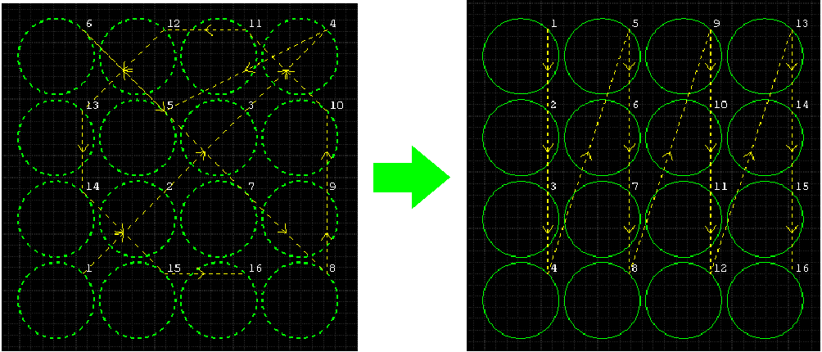

3.10 Chamfer
Under the drawing "operations" column in the menu bar, open the "bevel" drop-down menu and select the bevel mode. You can convert sharp corners at the corner of the graphic into various types of bevels, including rounded bevel, concave bevel, and chamfered bevel.

3.10.1 Round corners
Select the graphic, click the button, and open a window with a drop-down menu. Select the fillet tool, modify the R value, and click the mouse over the sharp corner you want to fillet.
Select the shape and use the pickup tool to achieve one-click rounded corners. Select the shape and round off all the sharp corners.
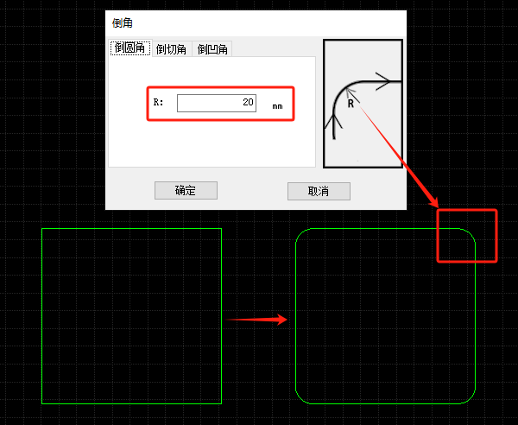
To flip the corner, you need to open the capture tool. In the upper left corner of the system, click endpoint capture and intersection point capture.

3.10.2 Inverted concave Angle
Select the shape, click the button, and the drop-down menu will open a window. Select the chamfer, modify the L1/L2 values. Pick up the chamfer tool. Move the mouse to the sharp corner position that needs chamfer, and click it.
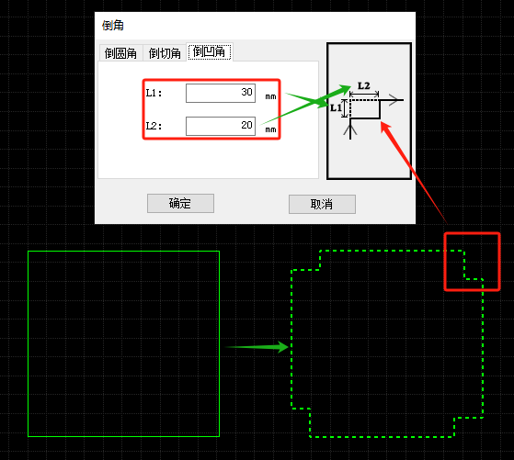
To flip the corner, you need to open the capture tool. In the upper left corner of the system, click endpoint capture and intersection point capture.

3.10.3 Inverted chamfer
Select the shape, click the button, and the drop-down menu will open a window. Select the chamfer tool, modify the L1/L2 values. Move the mouse to the sharp corner position that needs chamfering, and click it.
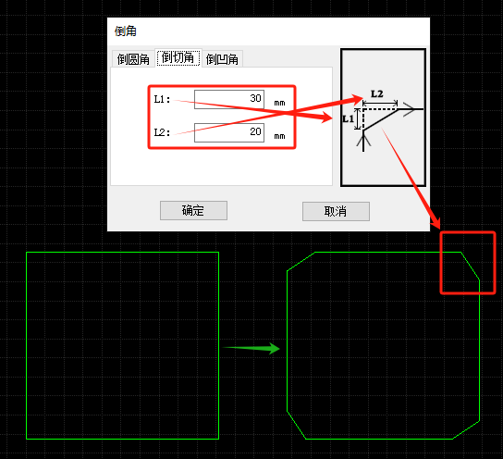
To flip the corner, you need to open the capture tool. In the upper left corner of the system, click endpoint capture and intersection point capture.

3.10.4 Inverted chamfer
Icut has specifically enhanced its chamfering capabilities for the garment industry. Designed for patterns with "cut edges", this tool allows seamless V-groove processing through chamfering, eliminating the need to lift the cutting blade and boosting production efficiency. Before using this tool, it's essential to understand two critical parameters: "cut point distance" and "chamfer angle". As illustrated in the diagram below:
Cut point distance: The distance between the red figure's Angle position and the yellow figure's arc cut point is the cut point distance.
Apex Angle: The outer angle of the red figure's apex. The blue auxiliary line in the figure below is marked as the outer angle.
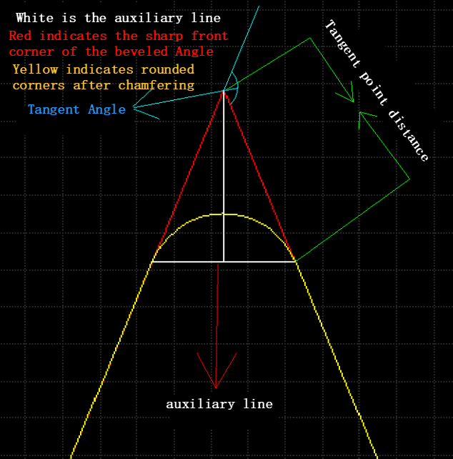
To distinguish between the inside and outside angles, as shown in the figure below, the red box is selected for the outside angle and the green box is selected for the inside angle. If the "Distinguish inside and outside angles" parameter is checked, the inside and outside angles are inverted by default. If not checked, the inside and outside angles are inverted.
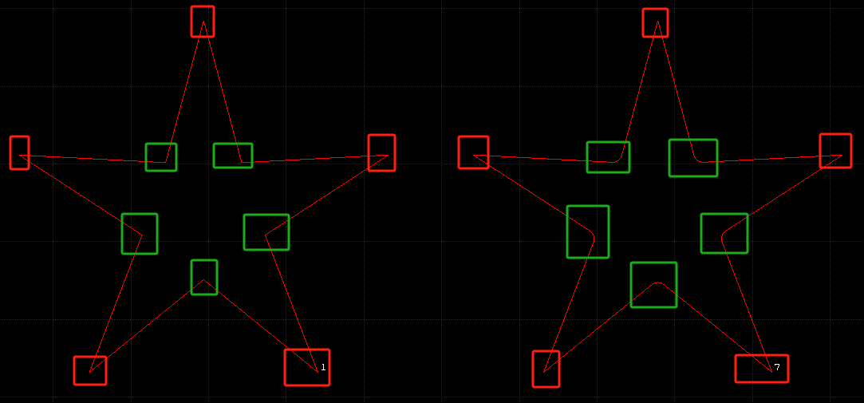
In the drawing menu, click the "Operation" column to open the "reverse corner cutting" window as shown in the figure below:
In the parameter window, modify the Angle range, cut point distance, and selected graphics。After modifying the parameters, click OK.
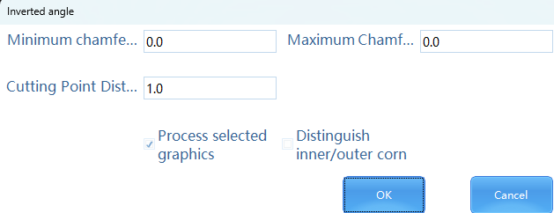

3.11 Alignment tools
Under the "Operation" section of the drawing menu bar, you can find our alignment tools. First, select the graphic you want to align and use the grab tool. The alignment tools include left align, right align, bottom align, top align, vertical align, horizontal align, and center align.
The alignment tool determines graphic positioning by using the nearest shape along the alignment direction as a reference. As shown in the diagram: When using the left align tool, select a rectangle on the left and a circle on the right. When selecting the left align tool, it aligns with the left side of the rectangle as the reference point.
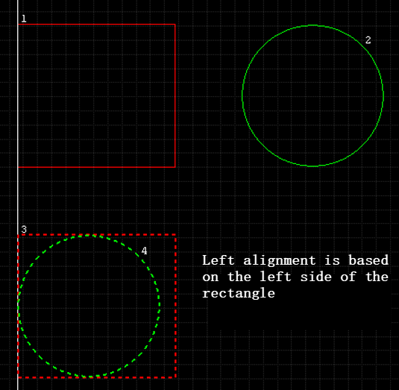

Left aligned, as shown below:


3.12 Closeness
Under the "Operation" column of the drawing toolbar, we can use the close function, including: left close, right close, top close, bottom close.
Left-right tightness refers to graphics that are on the same horizontal level, while top-bottom tightness refers to graphics in the vertical direction. Tightness is based on the graphics in the tightness direction. The tightness distance can be modified below the CAD interface.
as illustrated in following figure ：
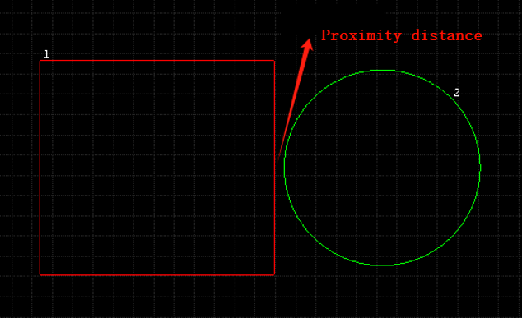

3.13 Integration function
In the common menu, the "Tool" column can be selected to pick up the fusion function. Select the two graphics that need to be fused and click "Fusion" as shown in the figure below: The fusion function takes the union area of the two graphics and retains it
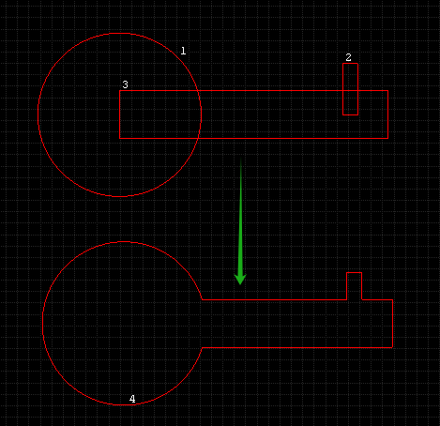

3.14 Circular fusion
Under the "Tools" section in the menu bar, you can select the "Circular Fusion" tool.Circular fusion refers to connecting adjacent circular shapes to create 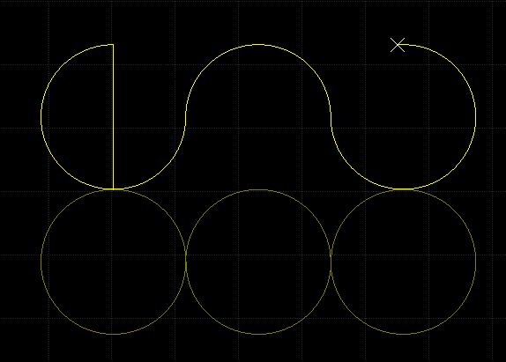
S-shaped trajectories, as shown in the figure below: This significantly improves cutting efficiency. The default spacing between circles is <=1MM.
Circular fusion includes bidirectional, horizontal and vertical circular fusion.
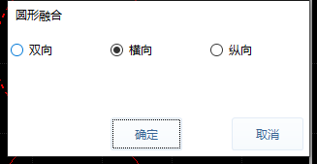

3.15 Leads
Open the lead function from the "Tools" column in the common menu. Add leads to selected graphics by modifying the import and export parameters.
Type of lead: straight line, arc
Length: The length of the lead
Radius: Modify the radius of an arc lead when using an arc lead
Angle: lead Angle
Starting point introduction: Add a lead to the starting point
Long line introduction: Add a lead to the long line break
Only applies to closed shapes: Selected only adds leads to closed shapes
Redefine the inner and outer contours: Selected to make the outer lead of the outer mold and the inner lead of the inner membrane.
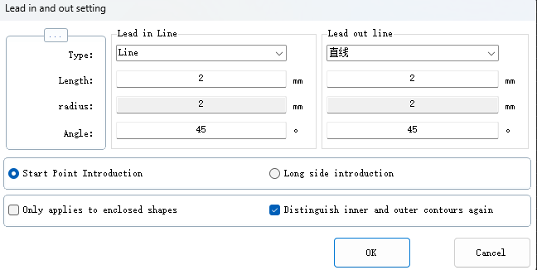

3.16 Add the outer frame
Icut supports adding an outer frame to the current graphic, which can add M points to the current graphic. In the "Operation" column of the drawing menu, click the button as shown in the figure below: After modifying the parameters, confirm to complete the function of adding outer frame and M points to the edited graphic.
Add a border: When checked, all graphics are given a border
Select a shape and add a border: When checked, the selected shape is added to the border
Add mark: Check to add M point
X/Y offset: The maximum range of the edited graphics and the offset value
Circular Angle: Circular Angle at point M
Radius: the size of the radius at point M
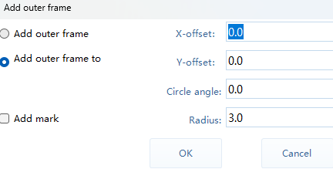
The figure below shows: white is the added outer frame, M1-M4 is the added M point.
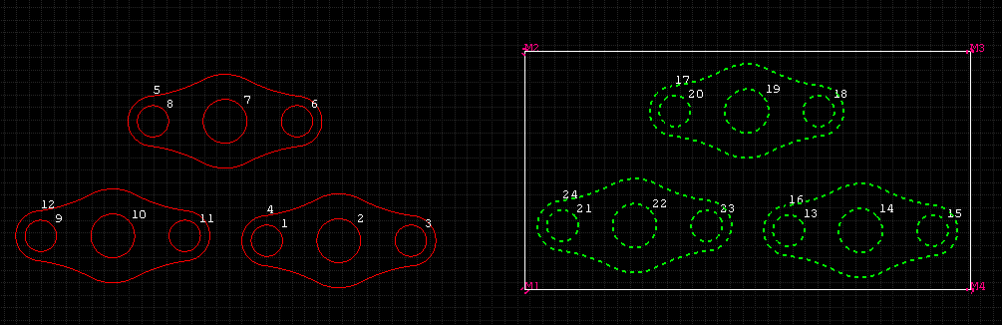

3.17 Measuring tools
Under the drawing menu, select the "Operation" column to pick up the tool, which can measure the size of the graphics. The measurement data is viewed in the drawing display column below the software.
The figure below shows: The white dotted line is the measurement trajectory. Select the "measurement" tool, click the starting point of the measurement, move the mouse to the end point of the measurement, and click to confirm to complete the measurement
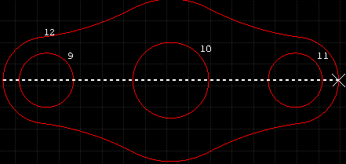

4. Processing control
Icut is a set of design and processing control software. All the graphics and parameters mentioned above can be prepared off the machine tool. After all the design is completed, the file can be saved and then opened on the machine tool for processing.

4.1 Coordinate system
Coordinates include zero point and origin. The zero point refers to the mechanical zero point, the machine's reset position. The origin represents the workpiece coordinate, existing relative to the mechanical coordinate, marking the starting position of machining. Using the red light as the starting point as the reference, the red light indicates the origin coordinate position. The white cross marks the mechanical coordinate position.
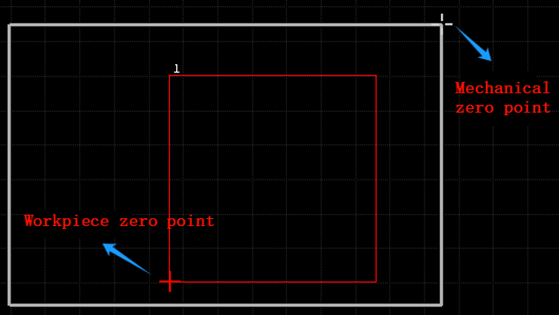

4.1.1 Original zero point
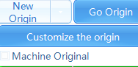The original starting point is fixed mechanically and does not move with the workpiece's starting position. This represents the coordinate of the graphic relative to the mechanical zero point within the worktable. When using functions like "Projection" or "Large View", select "Original Starting Point" from the drop-down menu to temporarily activate calibration files. There are two methods for setting the original starting point: custom origin or machine current position. Selecting "Machine Current Position" allows entering X/Y coordinates, after which clicking "Set Point" will automatically align the graphic with the coordinates. Choosing "Machine Current Position" makes the machine's current location the starting point, and clicking "Set Point" will automatically align the graphic with the machine's current position.
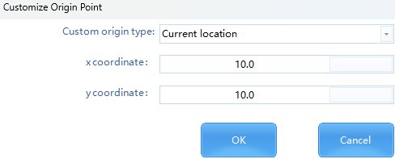
Imported graphics can be automatically parked at the custom position or the current position of the machine. This can be achieved by checking "User Parameters" under "File".

4.1.2 Workpiece zero point
Select the original zero point and remove it. Use the workpiece zero point, and the white cross follows the movement, relative to the coordinate of the mechanical zero point. The workpiece zero point can be used to select the docking position. In the "Tools" column of the common menu, click docking to select the docking position.
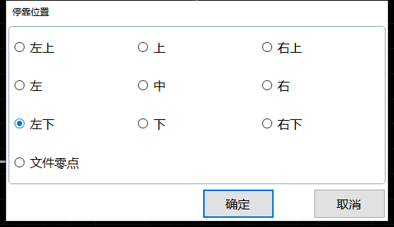

4.1.2 Find the zero point after anomaly
The machining operation can only be performed after the machine returns to zero. The zeroing state is shown in the following figure: The coordinate position shows a black and white icon, that is, the equipment returns to zero successfully. If there is no such icon, no zeroing or zeroing fails, the machining cannot be performed.
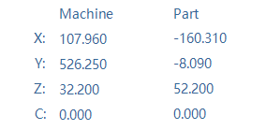
In case of emergency such as triggering the emergency stop, power failure and restart, or driver alarm, the zero return state will be cancelled. At this time, we need to click the operation interface and button, and wait for the machine to return to zero successfully before operating the processing.
When the collision is triggered during processing, the machine is in pause state. You can click the "Continue" button to continue processing and cutting.
! Note the spindle tool changer system. During the tool change process, pause, stop and continue operation are not supported.

4.2 Alarm
Alarm information can be seen in the status display bar and log bar at the bottom of the software. If the machine suddenly does not work, alarm information can be viewed below to troubleshoot the problem.
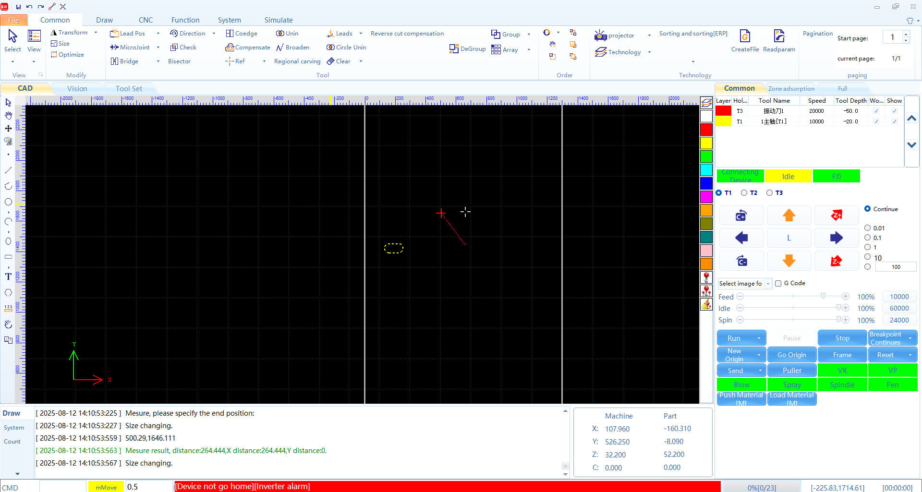
Urgent stop alarm: Check whether the emergency stop switch is open
Alarm: Check whether there are obstacles on the machine platform and around the machine
Driver alarm: open the control box, check the driver code and contact the manufacturer
Overdue alarm: Check the starting position and check whether the file is too large
Zero not returned alarm: Please operate after zero return
No connection alarm: Check the network cable connection, check the IP address. Check the status of the touch screen, contact the manufacturer
File generation failure: Check the following figure to see if the processing mode is checked and the layer parameters are processed.
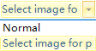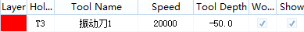

4.3 Soft limit
After the equipment resets to zero, it provides soft limit protection based on the preset mechanical stroke settings. In the system menu, under the "Parameters" section, select "General Parameters". Check the "Vendor Parameters" option in the top-left corner and search for the keyword "soft limit" as shown below: "1" enables soft limit functionality while "0" disables it. The rotation axis C is disabled by default.
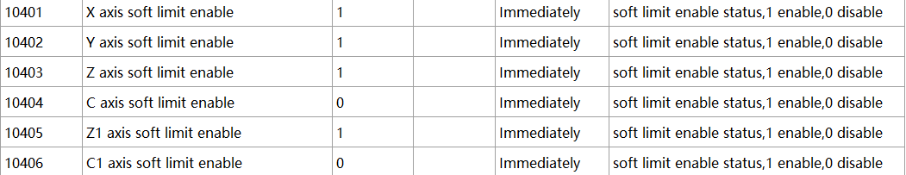
After the machine returns to zero, the equipment can only work and move within the effective maximum mechanical stroke. The manufacturer's parameters are modified by default, so please do not modify them arbitrarily. During the movement of the equipment, if it exceeds the range, the log will report a soft limit alarm, and it needs to move in the opposite direction.

4.4 Manual testing
The manual control part of the console is shown in the figure below: The following function buttons can be used to quickly manually operate the equipment
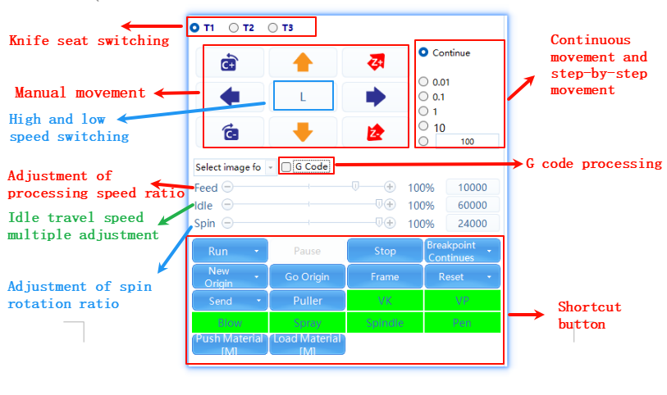

4.5 Blade cutting
Before starting machining or after tool change, reconfigure the tool depth as follows: For non-G code files: As these files lack built-in tool depth parameters, first move the tool tip to the workpiece surface, then click "Set Tool Depth" to complete configuration. For G code files: Although these files already contain built-in tool depth parameters, you must still move the tool tip to the material surface and click "Set Tool Depth" to confirm the settings take effect.
If the equipment supports tool setting, please select the tool to be set in the "tool setting" interface and click "tool setting". The equipment will automatically perform the tool setting. After the tool setting is successful, the processing can be started directly.
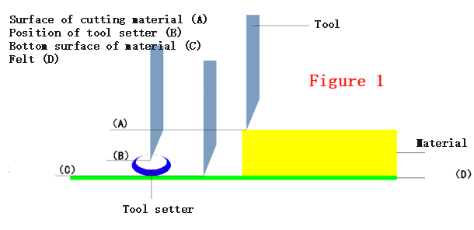

4.5.1 Manual tool setting
Select the tool that needs to set the depth of the tool. Move the tool to the surface of the felt (D) by moving the Z-axis. In the tool adjustment interface, click the button, and the Z-axis will be automatically raised to the zero point. The setting of the depth of the tool is complete.

4.5.2 Automatic tool cutting
Select the tool that needs to set the depth of the blade. In the tool adjustment interface, click the button, and the equipment will automatically perform the blade alignment. After the blade alignment is completed, lift Z to the zero point.
At present, the automatic tool cutting function only supports the following types of tools: vibration tool, circular tool, drag tool and spindle.

4.5.3 Fine-tuning the blade depth
Under the knife adjustment interface, as shown in the figure below: The depth of the knife can be fine-tuned. If there are problems such as cutting depth or not cutting through after processing, it is because the depth of the knife is not set properly. You can fine-tune the depth of the knife by clicking the button below.
You can choose the step distance and click the up and down arrows to fine-tune the depth of the knife. For example, if the current depth of the knife is "-23.21" and you want to adjust it to "-23.31", select the step "0.1", then click the button, a prompt dialog box will pop up, and click OK.

4.6 Walk the border
After setting the starting position, click the console button. The red light will move a rectangle along the outer frame of the entire graphic to be processed, so that you can see the maximum processing size range and the size of the required material. If you need to modify the speed of walking along the frame, contact the manufacturer.

4.7 Processing, stopping, pausing and continuing

4.7.1 Processing
After the parameters are set and the border can be moved, you can directly click the processing button on the PC interface, and the equipment will start automatic processing operation. Alternatively, you can click the button to send the program to the panel, and then click the processing button on the panel to execute the processing operation.
Check the G code shortcut button when using the G code file.
G code machining supports spindle, vibration tool, and press wheel processing. Spindle machining is supported by default in G code machining. For vibration tool and press wheel G code machining, add the G code instruction to the first line of the G code file as shown in the figure below:
T501: The spindle is processed on the left
T502: The spindle has two heads for simultaneous processing
T503: Right spindle head machining
T601: Vibration knife left machine head processing
T602: The vibration knife is processed by two heads at the same time
T603: Vibration knife right machine head processing
T701: Processing of left machine head of pressure wheel
T702: The press wheel has two heads for simultaneous processing
T703: Processing of right machine head of pressure wheel
The above is the machining code instruction for double head model, which is also applicable to single head G code machining.
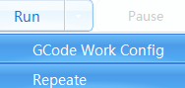Click the triangle arrow on the left side of the processing button to perform the ordinary graphic processing operation in a loop. Enter the number of cycles and the interval between each cycle, and click OK to start the processing. If you need to pull the material, check "Pull the material after each processing".
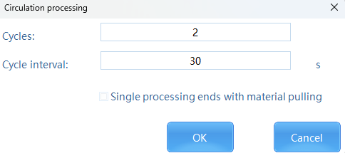

4.7.2 Stop
To stop processing, click the console button. After stopping, the program will terminate processing. At this time, click processing to start processing again. To continue processing at the stopped position, click the button. After stopping processing, the equipment is in standby mode and other functions can be operated.
Note: If you click stop during the patrol, the program will terminate the patrol action and you need to restart the patrol.

4.7.3 Suspension and continuation
If you want to pause the processing, please click the console button. After pausing, you can modify the depth of cut, processing speed, lifting height and other operations. If you want to continue the processing, please click the console button, and the machine will continue processing from the paused position.

4.7.4 Advanced Start
The G code machining supports advanced starting, which allows users to input any line number as the starting point. In standby mode, navigate to the "Advanced Start" tab in the menu bar and click the button (as shown in the figure below). Select "Current File" and enter the "starting line number". Click OK to initiate machining from the specified line number.
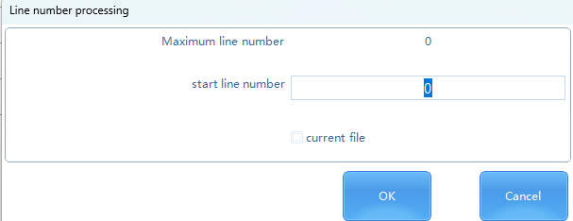

4.8 Partitioning
Before processing, you can open the partition adsorption interface to set the partition adsorption mode before processing
4.8.1 Partition adsorption mode
The partition adsorption system operates in four modes: Manual Mode, Adaptive Mode, Automatic Tracking Mode, and Manual Memory Mode. Users can switch between these modes based on the size of the cutting element and material type to achieve optimal vacuum adsorption performance. In the ICUT system, green indicates disabled partition function while red denotes enabled partition function.
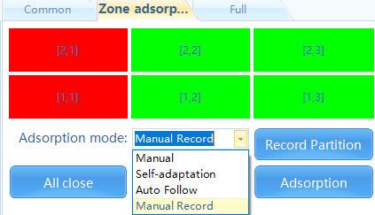

4.8.2 Application scenarios of partitioned adsorption mode
Manual mode refers to manually selecting specific zones to activate during processing. For example, you might select zones [1,1] and [2,1]. These zones will be automatically activated during operation. This mode is commonly used in machines with fixed worktables that don't pull materials, or when cutting graphic elements at predetermined positions.
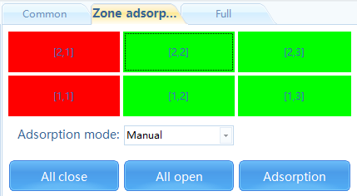
Manual memory refers to: Select the memory mode and select the partition area we want to open. For example, after selecting [1,2] or [2,2], click the memory partition. The device will open these two partitions every time it processes
It is often used to cut the same material in batches at fixed locations
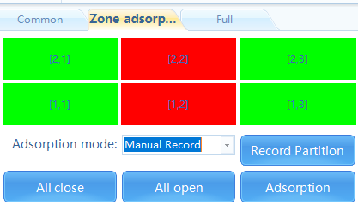
Automatic follow mode: Based on the machine's current moving cutting trajectory and the corresponding CAD worktable element position, the machine sequentially opens the adsorption areas in zones as shown in the figure below. The default worktable has 8 zones. As shown by the elements and processing trajectories, the zones [1,1], [1,2], [2,3], and [1,3] are opened sequentially.
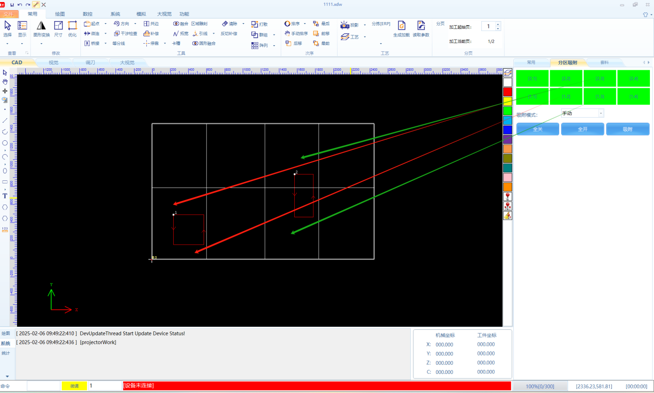
Adaptive partition refers to: as shown in the figure, the two rectangles processed by default are a whole, and all partitions in the range where the two rectangles are located are opened
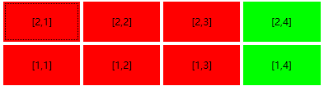
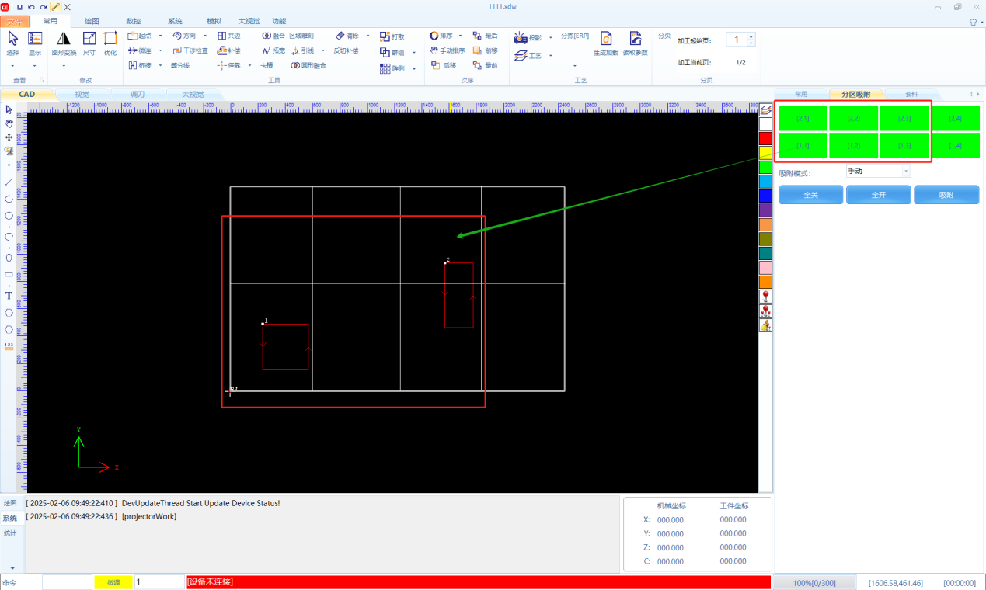

4.9 Pulling material
For graphics exceeding the working area, segmented cutting can be performed to divide large-sized patterns into smaller sections. Repeated processing of identical documents across multiple versions can be automated through material pulling. Automation in roll cutting processes can also be achieved via automatic material pulling functions. Please follow manufacturer configuration parameters and training procedures to properly utilize these features. Incorrect parameters or operations may result in failed material pulling or improper execution. Common scenarios include: material pulling after single-sheet processing, repeated processing material pulling, long-section processing material pulling, and roll processing material pulling.
There is no need to elaborate on the material pulling here. After the manufacturer has adjusted it, please do not modify the parameters easily. The following are several processing operations:

4.9.1 Multiple machining operations for general machining
There are three kinds of general processing: "single page processing", "single page circular processing" and "page processing"

4.9.1.1 Single page processing As shown in the following figure:
Open the software-open the machine-reset the system-open the file-optimize the figure
Set the color of the graphic-set the layer parameters
Set the depth of the knife-set the starting point-process
If the material needs to be pulled after processing, check and pull the material after processing.
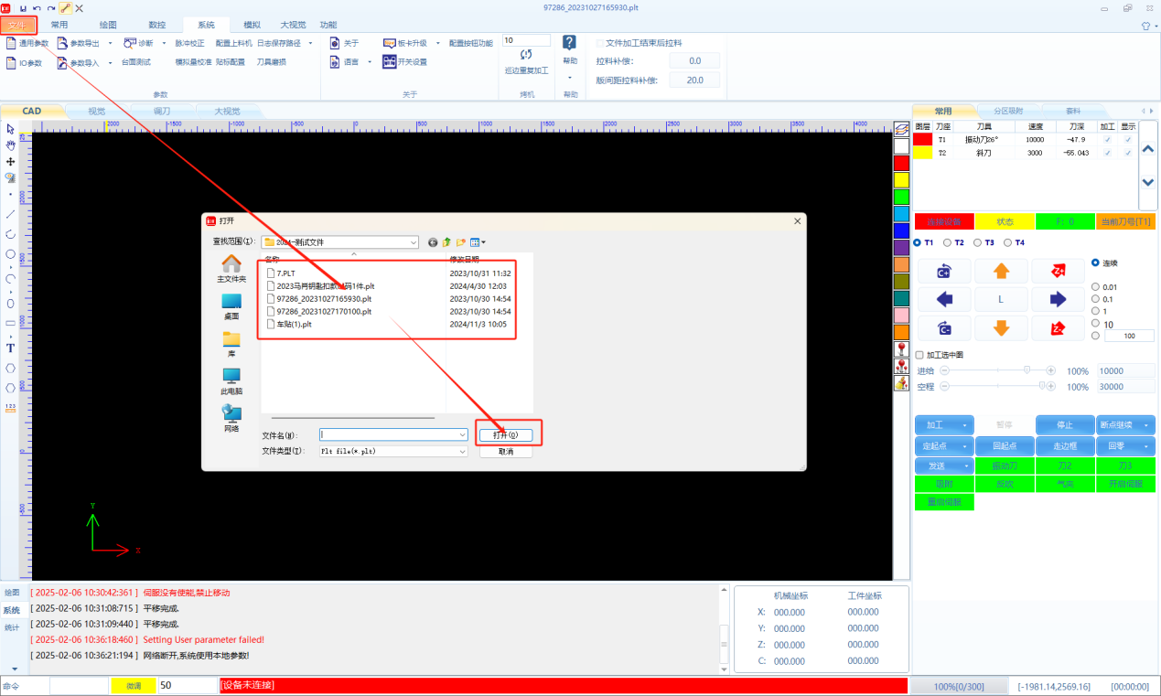

4.9.1.2 Single page cycle processing
Open the software-open the machine-reset the system-open the file-optimize the figure
Set the color of the graphic-set the layer parameters
Set knife depth-set starting point
Page down-check pull material after processing-process pull menu-cycle processing (as shown below):
[Cycle number]: The number of times the process is repeated.
[Interval time]: The interval between each processing and the next processing.
After the single processing is finished, check the pull material, click OK, and start the cycle processing.

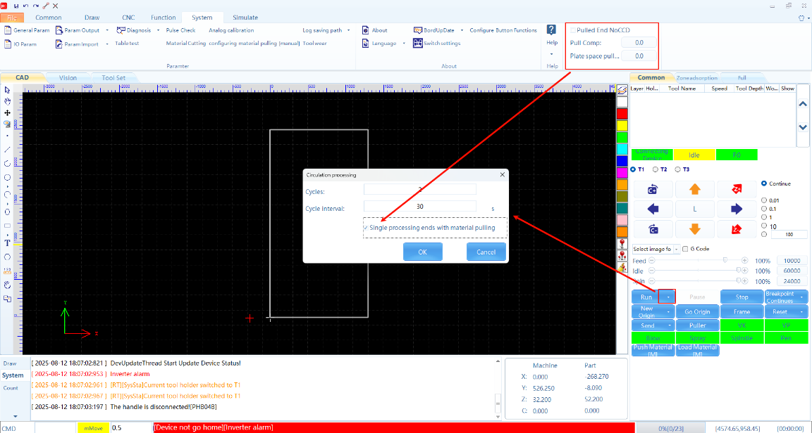

4.9.1.3 Page processing
Open the software-open the machine-reset the system-open the file-optimize the figure
Set the color of the graphic-set the layer parameters
Set knife depth-set starting point
Automatic page division processing beyond the drawing element of the workbench. As shown in the figure below: The current page number is on the first page. Click process, and a prompt dialog box will pop up. [Yes] starts processing from the current page, [No] starts processing from the first page, and [Cancel] cancels processing.
If the material needs to be pulled after processing, check and pull the material after processing.

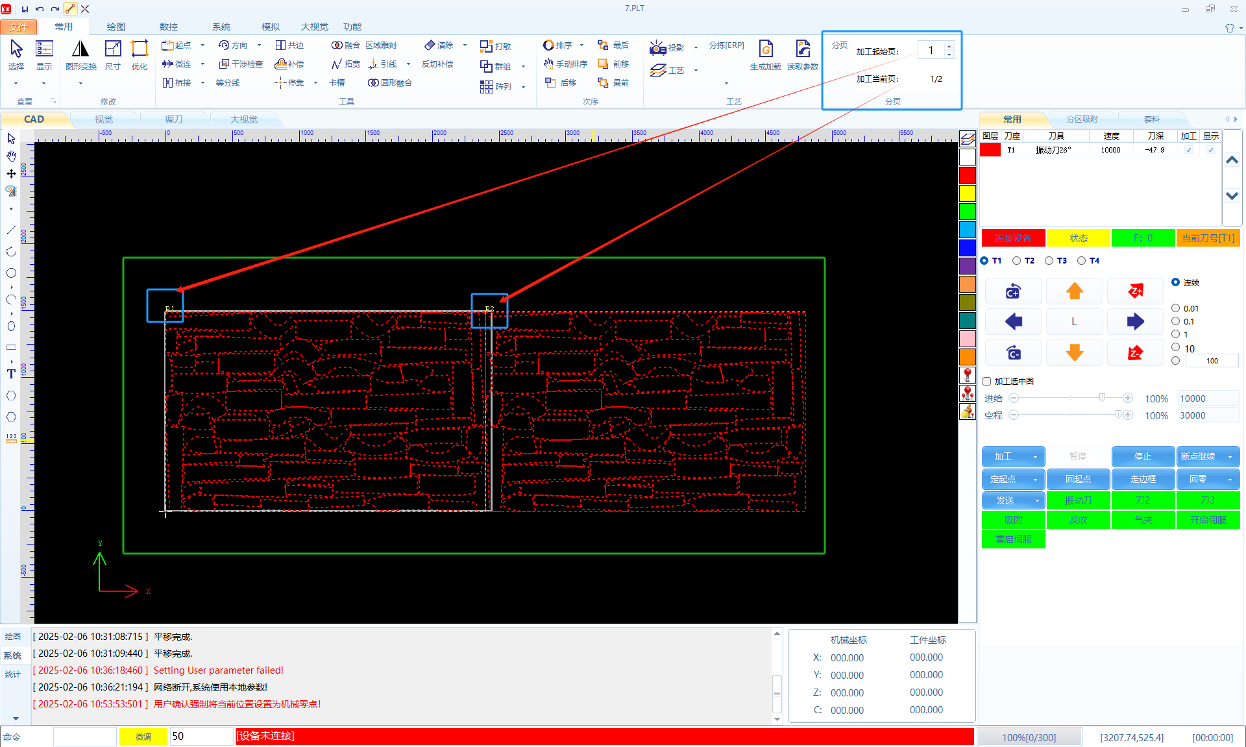

4.9.2 Various processing operations of border patrol
The edge processing supports a variety of processing methods: "single page edge processing", "single page edge processing", "page edge processing", "cutting Mark point mirror processing", and "scanning code edge processing"

4.9.2.1 Add templates and visual interface introduction
[Visual Interface]: Open the floating menu bar in the visual interface: you can add templates, set the camera, test the camera offset, select the camera list, and select the Mark point coordinate list. As shown in the figure below:
【】：Turn the camera on and off
【】：The border patrol begins processing
【】：Add M point, and search whether M point is recognized at the position of M point.
【】：After adding M point, the camera can see the position of M point and recalibrate the pixel of M point
【】：Stop processing the patrol
【】：Load the position coordinates of M1
【】Click back to M1 position
Add template:
Visual interface-Add template- (as shown below)
Select the circular template, visual interface, and scroll the mouse wheel to zoom in and out of the green reference circle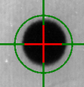. After the green reference circle completely covers M point, click to add M point.
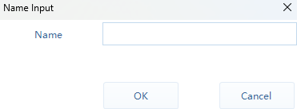Add M point and set the name to confirm. Add M point successfully.
Then click "Calibrate" to check whether the calibration is successful.
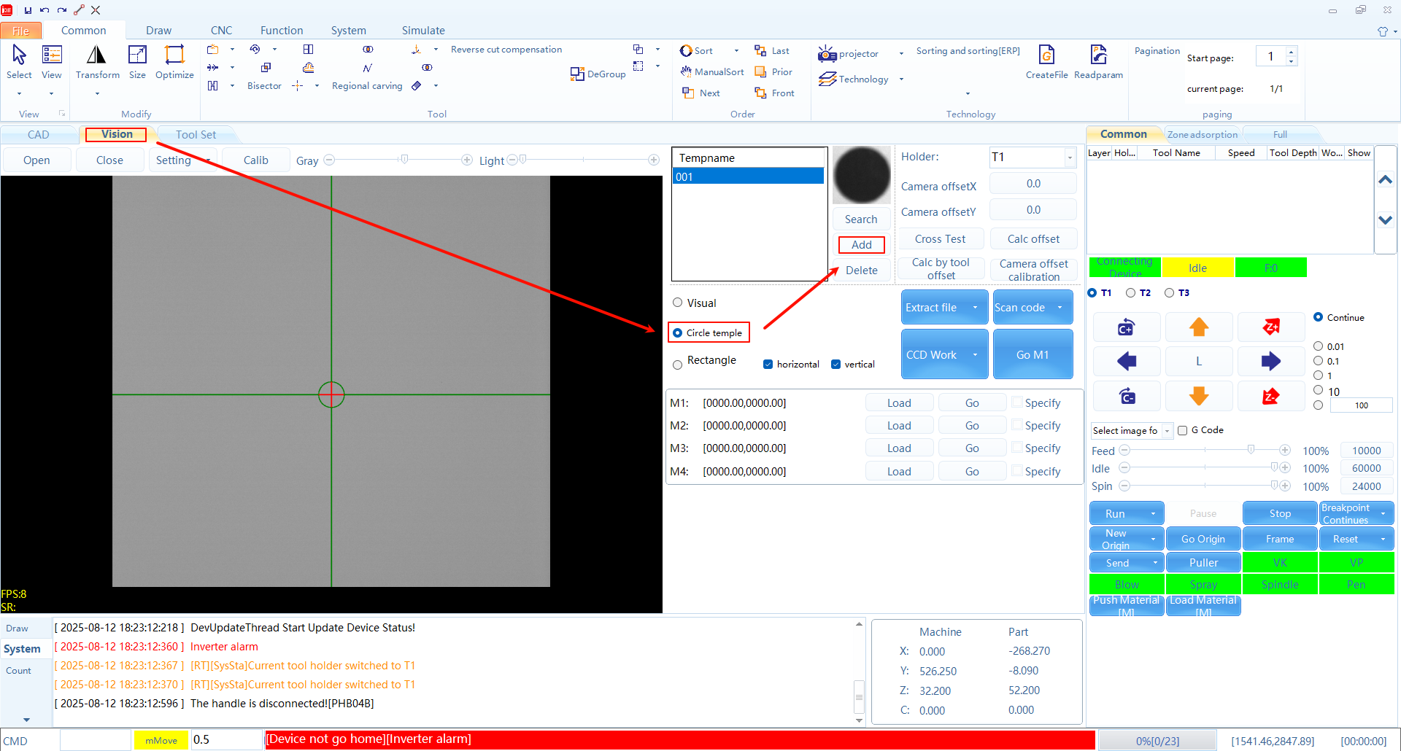

4.9.2.2 Single page patrol processing
Open the file, and the M point can be automatically marked under user parameters
Mark point M1-M4 automatically when importing the file. If the point is not automatically marked, mark it manually after importing the file.
Mark M point alone.  Mark all M points.
Enter the visual interface and open the camera. Move the machine to the first M-point position of the material.
Add template. After the template is added successfully, you can click search to check whether the template is added successfully
The camera is at the first M point. Click the edge processing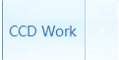. The equipment will automatically start the edge processing. After the edge processing is completed, the machine will automatically download the file for processing.
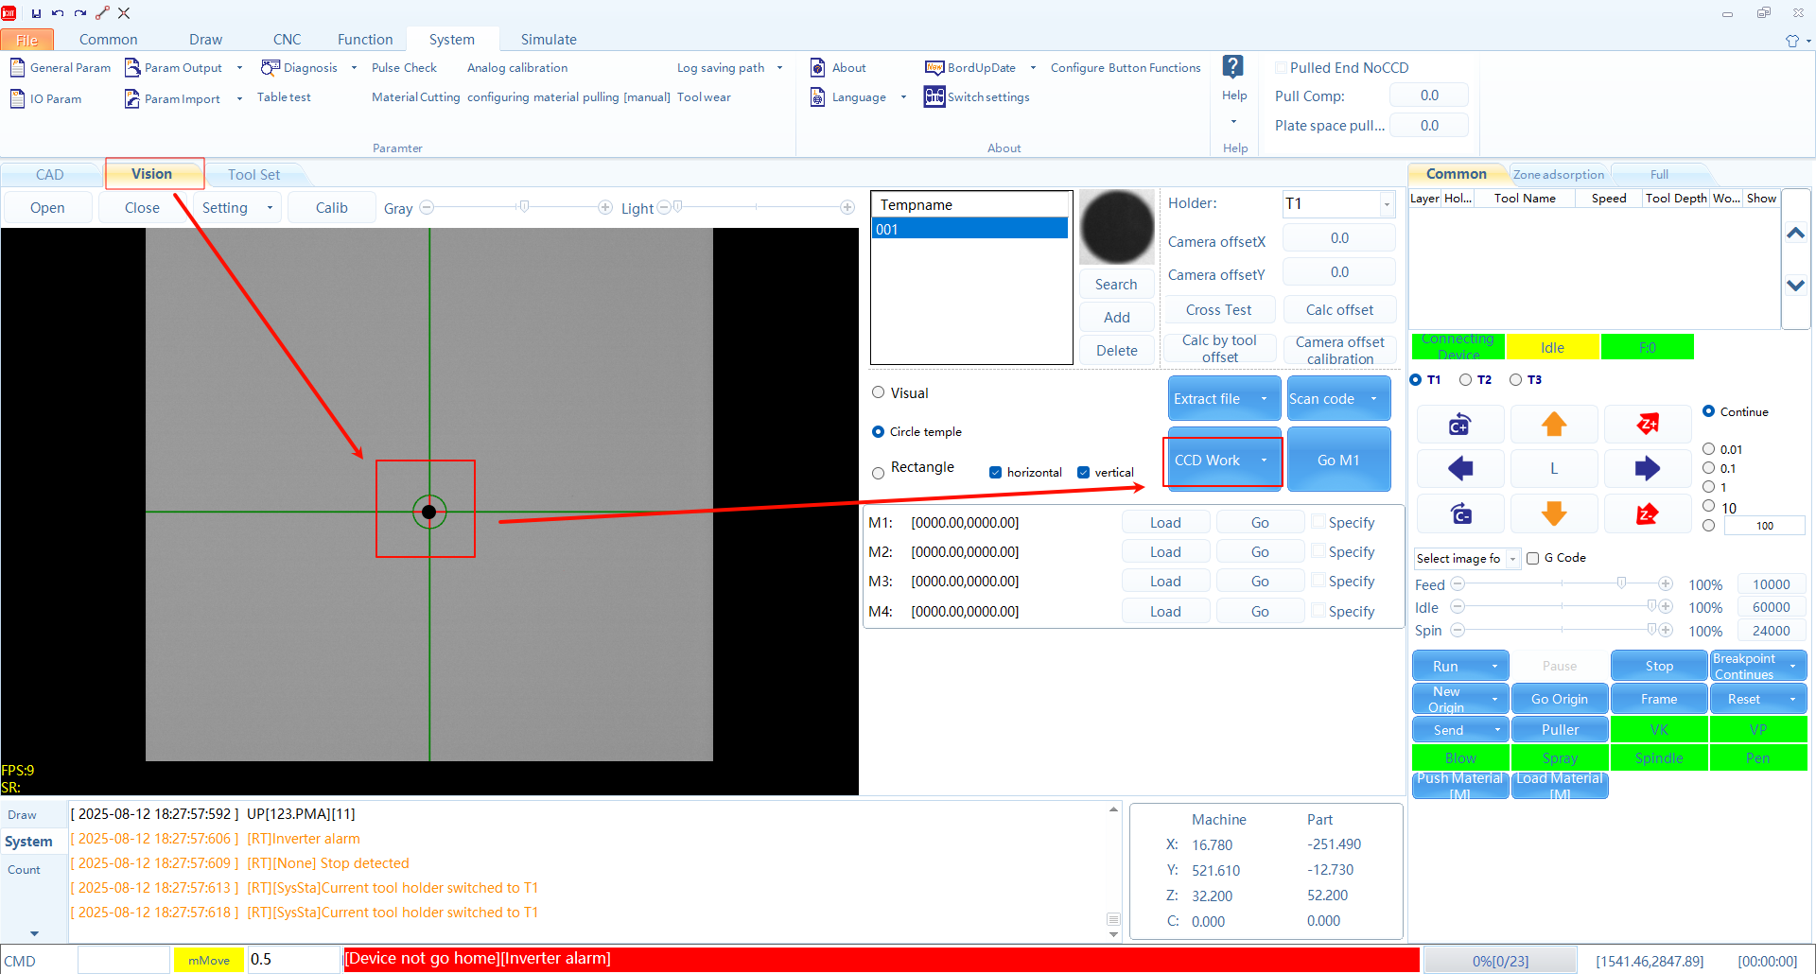

4.9.2.3 Single page patrol cycle processing
Open the file, and the M point can be automatically marked under user parameters
Mark point M1-M4 automatically when importing the file.
If M point is not automatically marked, you can manually mark it after importing the file
Mark M point alone. Mark all M points.
Enter the visual interface and open the camera. Move the machine to the first M-point position of the material.
Add template. After the template is added successfully, you can click search to check whether the template is added successfully
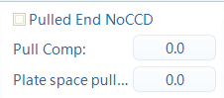Menu bar-System-After file processing, check the pull material. After the first processing, the system needs to pull material by default, and then cut for the second processing after pulling material.
The camera is at the first M point. Click "tour the edge" 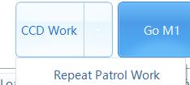to repeat processing.
Enter the processing times. After the equipment completes a round of edge processing, pull the material and return the camera position to the first M point to repeat the edge processing.
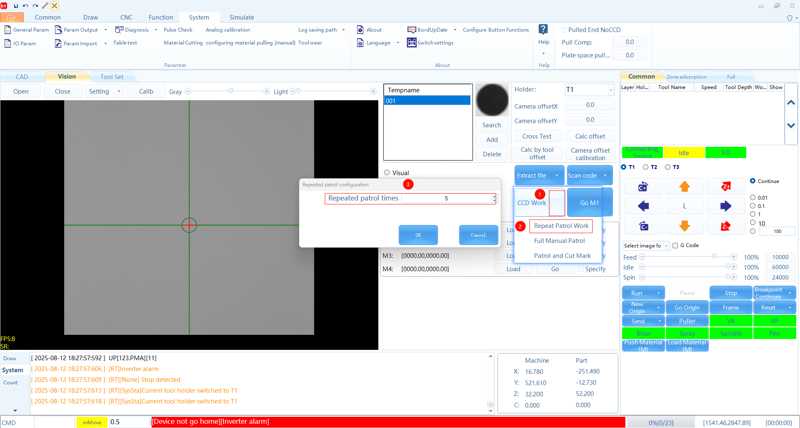

4.9.2.4 Page border processing
Page-by-page edge processing is suitable for different graphic elements in coil processing. Each page uses 4*M points. Page breaks are automatically generated at the M-point position. As shown in the figure below: The distance between the M-point and the M-point in the pulling direction should not exceed the set worktable size.
Open the file, and the M point can be automatically marked under user parameters
Mark point M1-M4 automatically when importing the file.
If M point is not automatically marked, you can manually mark it after importing the file
Mark M point alone. Mark all M points.
Enter the visual interface and open the camera. Move the machine to the first M-point position of the material.
Add template. After the template is added successfully, you can click search to check whether the template is added successfully.
Menu bar-System-Check the material pulling after file processing. After the first page is processed, the system needs to pull the material by default. After pulling the material, the second page is processed by edge patrol.
Move the camera to the first M point position, click the edge processing, the equipment will automatically start the edge processing. After the edge processing, the file is automatically downloaded and the cutting element is cut. The first page is processed, and the material is automatically pulled to start the edge processing of the second page
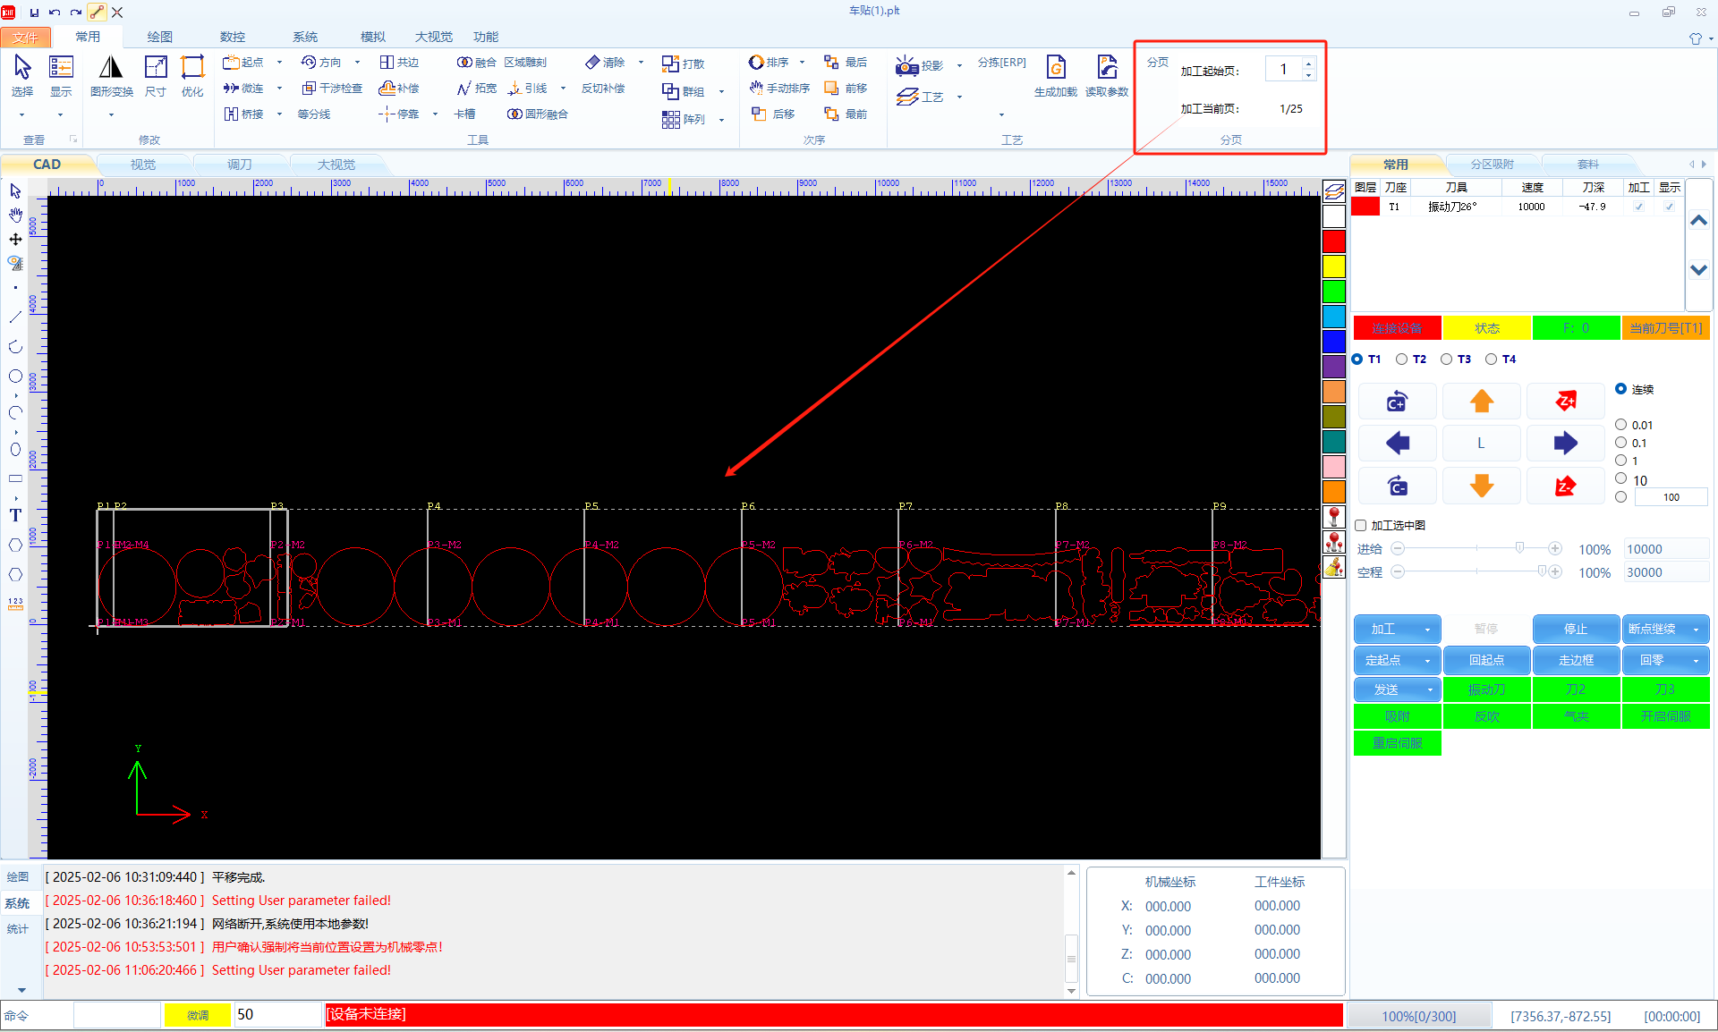

4.9.2.5 Cutting Mark mirror processing
Cut Mark mirror processing is often used in packaging, gift box processing, card paper and other processing industries.
Open the file, and the M point can be automatically marked under user parameters
Mark point M1-M4 automatically when importing files.
If M point is not automatically marked, you can manually mark it after importing the file
Mark M point alone. Mark all M points.
Enter the visual interface and open the camera. Move the machine to the first M-point position of the material.
Add template. After the template is added successfully, you can click search to check whether the template is added successfully.
Move the camera to the first M point position, click "tour the edge and cut Mark" to pop up a dialog box, you can select the specified knife seat to cut the M point (the default size of cutting the M point is 8MM)
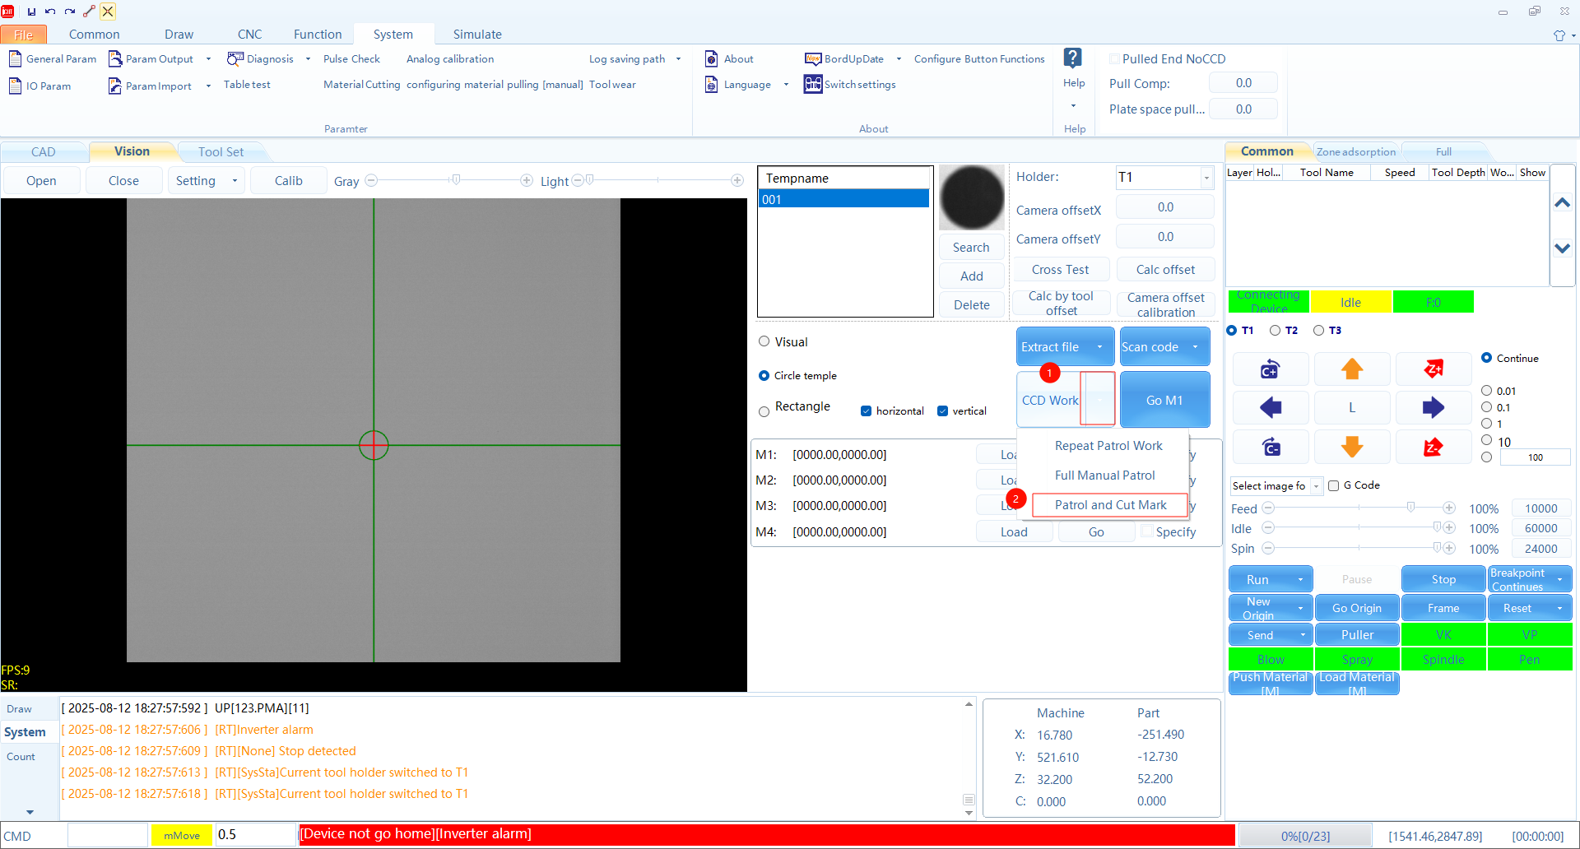
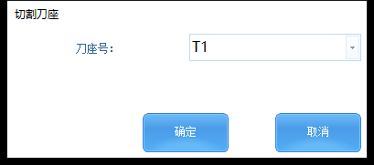
The equipment starts to patrol automatically. After the patrol is completed, the equipment starts to cut M point automatically.
After cutting point M is completed, a dialog box will pop up automatically to prompt material flipping. Here we need to manually flip the material processed on the platform. As shown in the figure below: The flipping direction must be consistent with the system selection direction, X/Y mirror.
After flipping, the edge checking starts automatically. Click OK, and the processing file is automatically mirrored according to the flipping direction. The equipment automatically processes the edge.
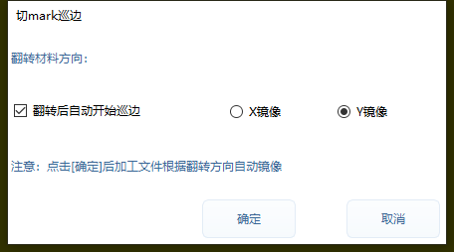

4.9.2.6 Scanning code for border processing
The ICUT scanning and processing system supports small cameras, where the scanner can load files by scanning QR codes. This significantly improves operational efficiency and saves time. The ICUT system features an "external scanning activation button" for edge inspection, enabling one-click scanning and processing.
Scan and process refers to the process of scanning the text information of the QR code on the printed material through a small camera or a scanner, so as to directly load the file under the file directory. It saves the step of manually opening the file.
Note: When printing the material, the QR code should be printed near the first M point. For the edge processing of the roll material QR code, the position of the QR code in each individual file must be consistent with the X/Y position of the first page.
Scan code setup
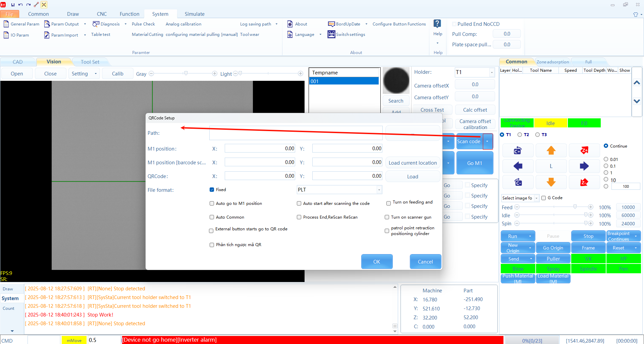
[Scan path]: The location where the scanned file is saved
[M1 position]: The offset between the QR code and the M1 position
[File format]: Supports PLT and DXF files
[Automatic return to M1 position]: Check to enable. Scan code processing will automatically return to M1 position. Page scan processing must be checked.
[Start automatically after scanning]: Check to enable. Whether to start edge processing automatically after scanning
[Scan code again after document processing]: Check to enable. After the current document processing is completed, the equipment returns to the M1 axis. Do you want to scan the next page automatically? Page scanning must be checked.
[Open the code scanner]: Check to enable. Whether to use the external code scanner to scan the code
Set parameters before scanning and processing
1: Under the user parameter, the automatic Mark is checked. The range size is modified accurately
2: Open the file in advance to check whether the direction of the file is consistent with the direction of the printing material on the machine? If not, you can modify the "rotation Angle" under "User Parameters". Open the file several times to confirm whether the M point is calibrated successfully and whether the direction is consistent with the direction of the material.
3: open the file in advance, set the layer, and set the processing parameters under the layer.
4: Set the scanning code processing parameters, file path, automatically return to M1 position, scan code and start automatically... and other parameters
Scan and process
After the parameters are set, open the camera and move the camera position to the QR code position. Ensure that the camera view can see the QR code completely. Click scan and process.
Scan the code to process the edge. Check "Pull material after file processing", and fill in the offset of M-point position between each version according to the printed material under "Pull material compensation for plate spacing".
The processing of the external QR code scanning button switch is shown in the following figure: System-IO Parameters-Input-Parameter No.730. Corresponding to the wiring port number, fill in the corresponding parameter to port No.730. When the machine moves to the QR code position, the "external button" can be directly scanned and processed.
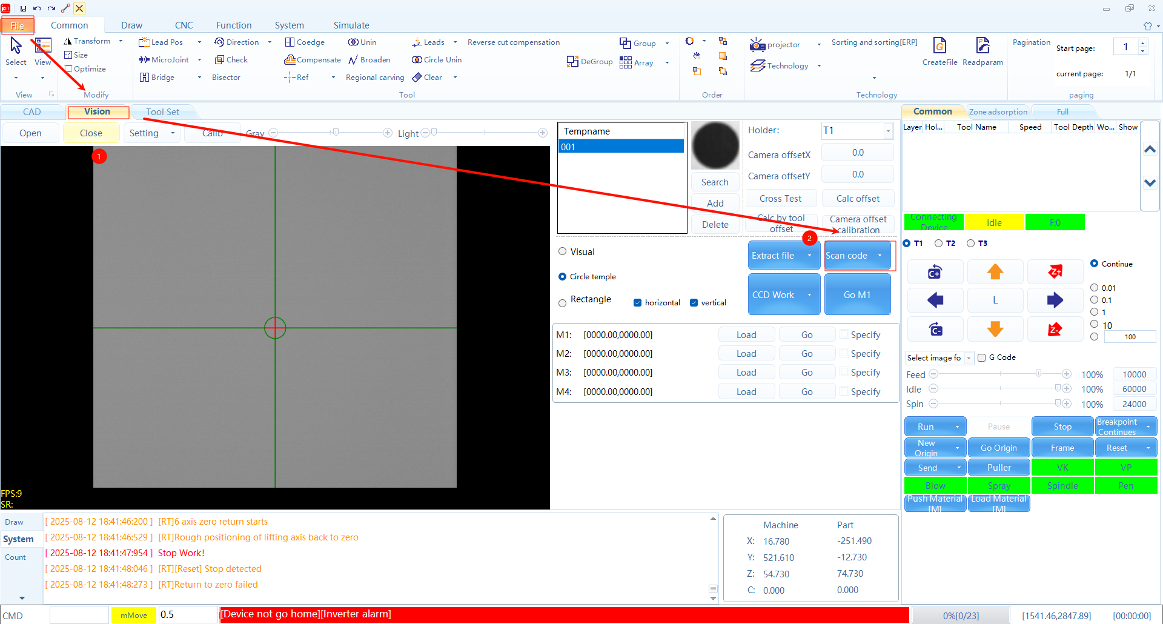
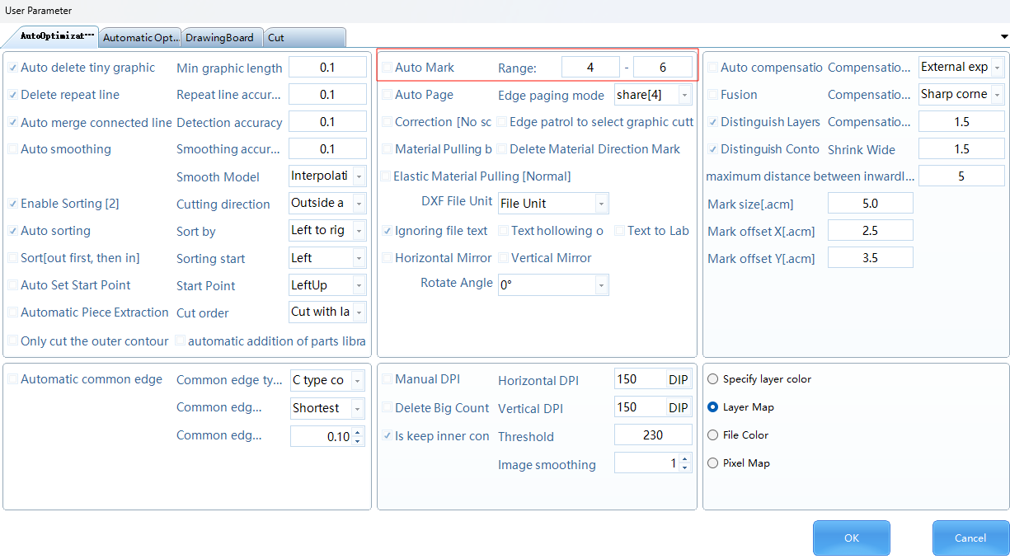

5. System auxiliary functions

5.1 Board upgrade
After installing the latest software, Icut requires a board upgrade. The controller upgrade file should be synchronized with the PC software. Simply installing new software without upgrading the controller may result in some functions being unavailable. Under the "About" section of the menu bar system, click the button.A dialog box appears. Click OK:
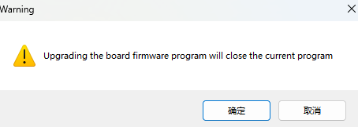
The following is shown: The controller upgrade interface is displayed. In this interface, click: Open the file, find and open the software package, and select and open the "PKG" file that matches your machine.
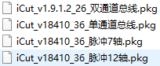
If you are not sure which file to upgrade, please contact us
After opening the file, click the "Upgrade" button, and the system starts to upgrade. After the "Output message" indicates that the upgrade is successful, the upgrade is complete. Power off the device and restart it
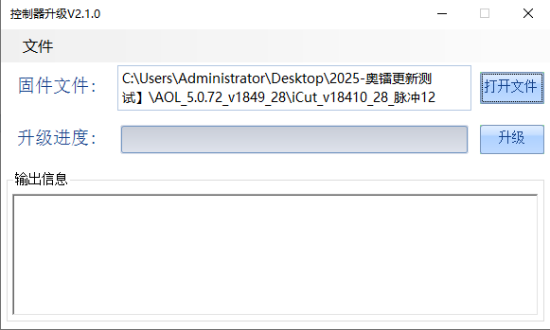

5.2 Parameter export and parameter import
Icut supports real-time synchronization of any parameters. Normally, any parameters modified by us will be automatically synchronized to the controller. Changing the computer does not affect the parameters. After installing new software and connecting to the controller, the parameters will be automatically synchronized to the PC software.
If a new controller is replaced, we need to export the parameters to the computer in advance, and then import the parameters from the computer after replacing the new controller.
Parameter export: Click the button in the "Parameter" column of the menu bar, a dialog box will pop up. Enter the "file name" and save the type as ".cof", then click save. A dialog box will pop up, indicating that "parameter saved successfully", click OK to complete.
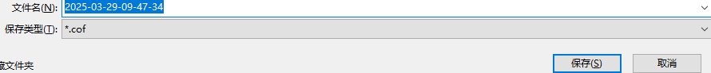
Parameter import: Click the button in the "parameter" column of the menu bar, a dialog box will pop up. Find and select the previously saved parameters, click open, and prompt "input password". After entering the password, it will prompt "import parameter successfully", and click OK to complete the process.
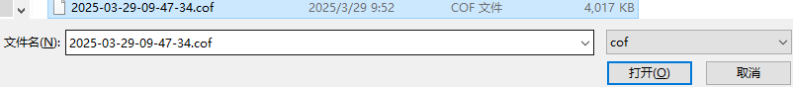
Note: Do not import parameters lightly. Only after replacing the controller or completely losing parameter data should you import previously saved parameters. After importing new parameters, first check through the control console to ensure normal movement. The tool depth needs to be reset after importing new parameters!

5.3 Table test
The ICU system supports a table compensation function, which can better ensure the cutting precision of the Z-axis depth at different positions during processing. Long-term use can better protect the felt from damage. Before the test platform, you need to prepare the "leveling instrument" as shown in the figure below:
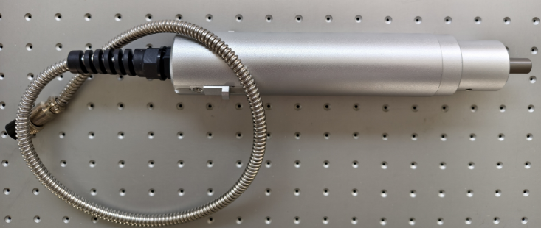

5.3.1 Configure the test IO signal on the console
System-IO parameter-input-606 bench tester
Fill the corresponding port number of the board connector into the corresponding port under the IO parameter. Trigger the test bench signal to detect whether there is a signal trigger.
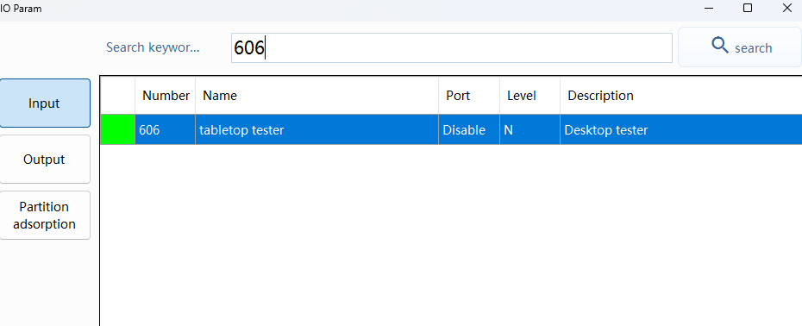

5.3.2 Configuration of desktop data
System-Console Test-Open the console calibration interface, as shown in the figure below:
Open the configuration panel data and enter the panel data calibration parameter interface
[Enable Table Compensation]: Check to enable. Turn off "Table Compensation" when measuring table data. After measuring and saving the table data successfully, turn on "Table Compensation". Check to enable.
[XY Direction Distance]: The distance between test points during table test.
[X/Y calibration starting point/end point]: The default starting point of the Icut system calibration is at the lower left corner, and the upper right corner is the end point.
After moving the machine to the lower left corner of the platform, click to load the X/Y starting point. Then move the machine to the upper right corner of the platform and click to load the X/Y end point.
[Z-axis calibration starting point]: The starting position of the Z-axis measurement during platform test, and the position of the empty travel after the Z-axis is lifted.
[Z-axis calibration endpoint]: The lowest point of the Z-axis during the calibration table process. Move the Z-axis downward until the platform tester signal is triggered. Then lower it by approximately 1-2MM. Load the Z-axis calibration endpoint coordinates.
After the configuration of the surface data parameters is modified, click OK to exit the current window.
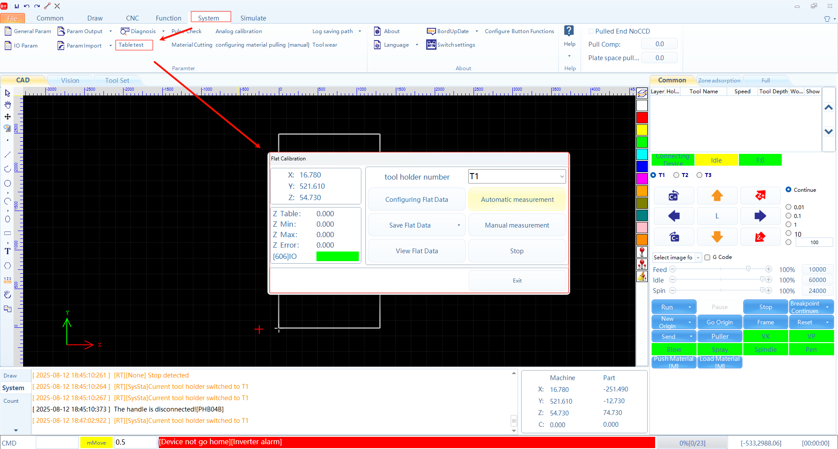
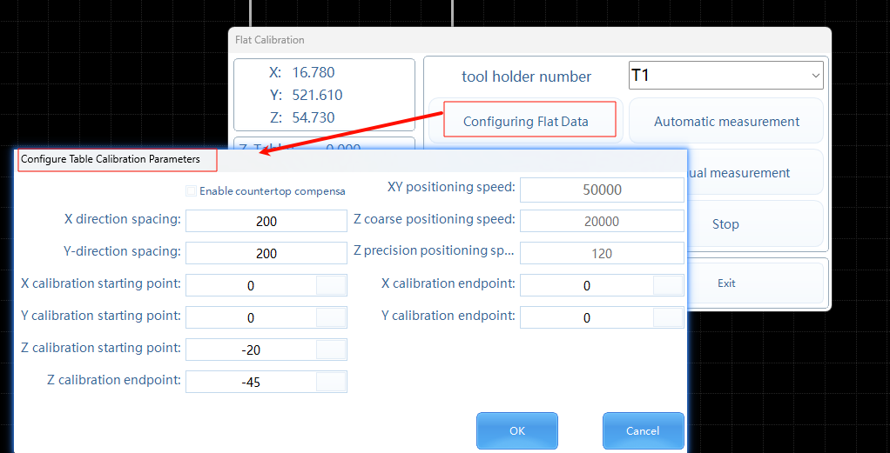

5.3.3 Bench test
The default knife holder for the table test is T1
Click "Manual Measurement", and a prompt will appear: "Before leveling, manually trigger the IO signal of the measurement instrument, and check if it is valid before leveling". Click "OK" to manually trigger the signal of the measurement instrument. If the signal exists, automatic measurement can be performed.
Click "Automatically measure" to start leveling the device
After the leveling is successful, the equipment stops lifting the Z-axis. The system prompts "The measurement table is successful" and clicks OK
Click "Save desktop data" to confirm and save the desktop data successfully.
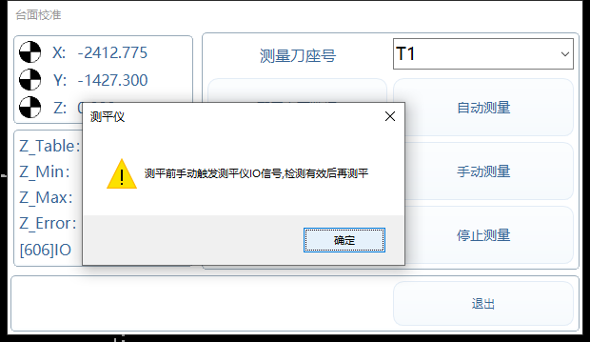

5.3.4 View the surface data
Click "View the table data" to view the measured table data, as shown in the figure below: you can view the "highest point", "lowest point" and "maximum error value".
[Return measurement position]: You can manually select a measurement point and click the "Return measurement position" point
[Manual measurement]: If there is a foreign object or the measurement is not accurate at a certain point during measurement, you can click the "manual measurement" function by clicking "return to measurement position". Then measure the current position.
[Save Desktop Data]: In the current desktop data interface, after "manual measurement" of some points, you can save the "manual measurement" desktop data here.
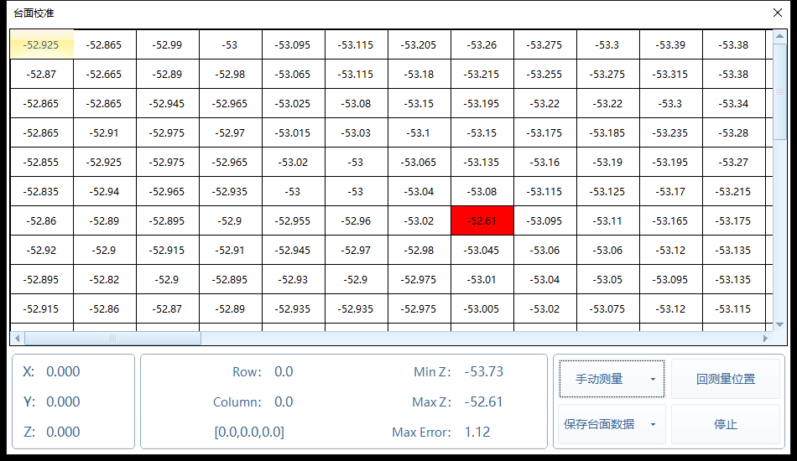

5.3.5 Export/import of console data
Desktop calibration interface-Save desktop data drop-down menu-Export desktop data / Import desktop data
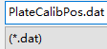Desktop data by default. DAT format file
Note: To import the desktop data, you need to restart the touch. The imported desktop data corresponds to the parameters configured for the desktop data.
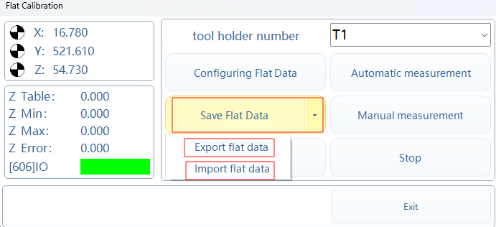

5.3.6 Enable surface compensation
Table calibration-configure table data-check to enable table compensation
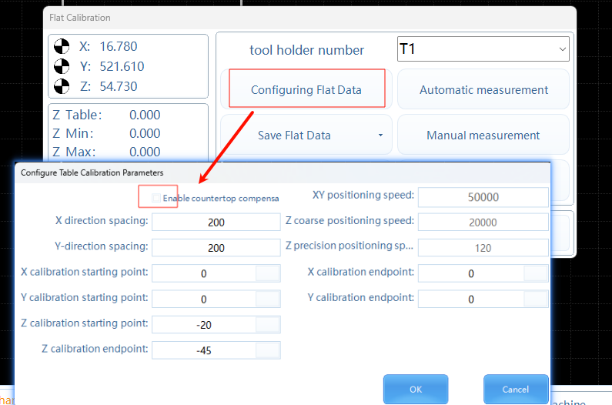

5.4 Language modification
In the "About" column of the menu bar system, click the triangle arrow button and select the language to be modified in the drop-down menu. The controller will restart and switch the language successfully after this connected machine is connected.

5.5 Diagnosis and log viewing
If some signals of the device are faulty, you can open the diagnosis interface by clicking the button in the "parameter" column of the menu bar system, as shown in the figure below: In this interface, you can view the status of input and output signals.
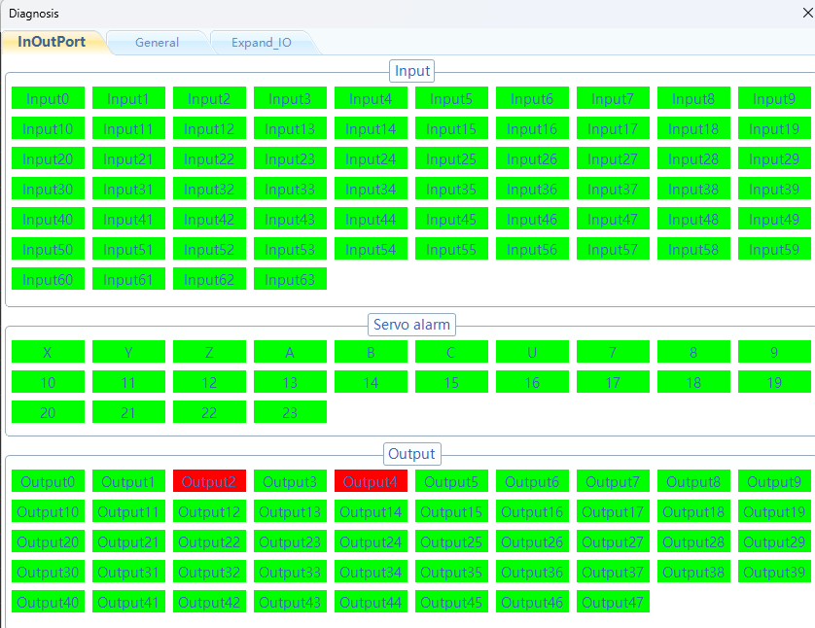
Click the small arrow triangle on the right side of the diagnosis. In the diagnosis drop-down menu, you can export logs (log), export XNC files, and export processing trajectory ((Debug). If there is a problem, exporting these three files can help you find the problem more quickly and solve it in time.
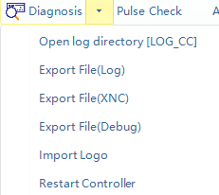
View the log file, double-click the exported log file, select "notepad" to open, you can view the recent operation records and alarm information.
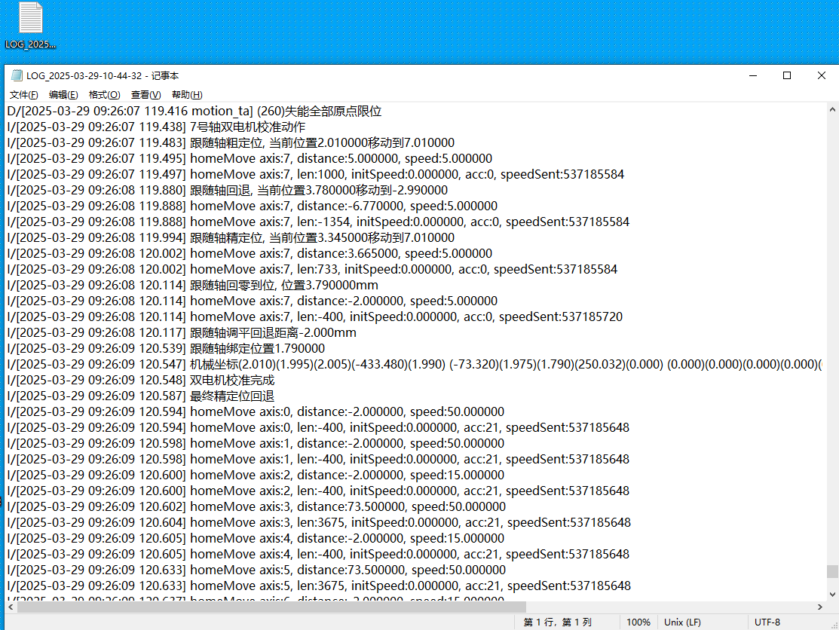

5.7 Shortcuts
Ctrl＋F1 | The drawing interface gets bigger and smaller
Ctrl＋B | Return to the main view, which is the final appropriate size
Enter | In the CAD interface, press Enter to automatically focus the command input bar
Middle mouse button | Drag the graphics by holding down the middle mouse button
Alt＋Q | Draw a circle quickly
Alt＋W | Draw rounded rectangle quickly
Alt＋F | Quickly draw a rectangle
Alt＋S | Change the size of the selected shape
Alt＋G | Park in the lower left corner
Esc | Interrupts the current operation
Ctrl+ directiion key | Move X/Y manually
R | Select shape rotation
space bar | The processing was suspended
There are other shortcuts, as shown in the figure below: different layers correspond to numeric keys
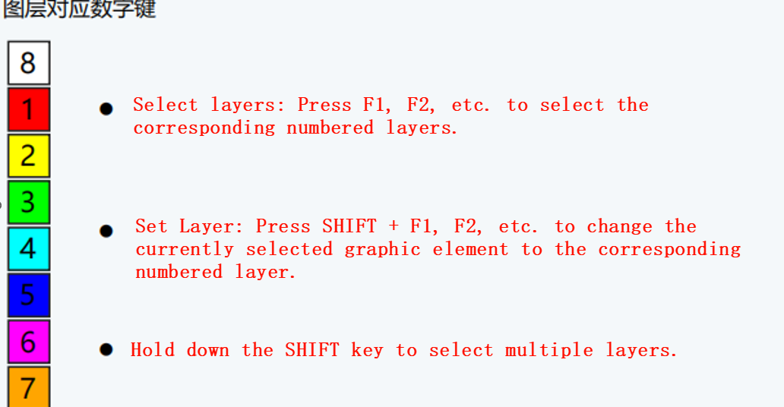

6.Common problems and treatment

6.1 Tool debugging
During operation, we may encounter issues such as suboptimal cutting performance, incomplete interface separation, abnormal overcutting, corner deformation, interface misalignment, or offsetting during edge trimming. These problems may stem from incorrect tool angle settings, tool eccentricity, or improperly adjusted tool holder offsets. Below are troubleshooting guidelines for various tool adjustments:

6.1.1 Angle offset
As shown in the figure below: The upper figure shows the normal processing effect, and the lower figure shows the displacement caused by the processing effect. This is likely due to the deviation of the tool Angle. The cutting at 0 degrees of rotation axis and 180 degrees of rotation axis are not on the same straight line.
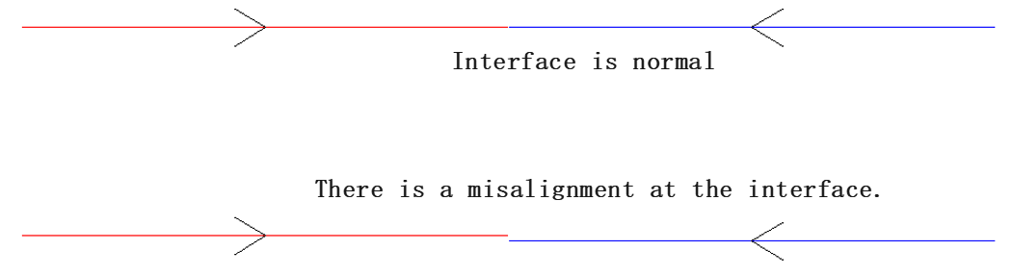
First, check if the installed tool is properly mounted. Ensure the tool is correctly positioned. After installation, when returning to position C, the tool's blade should face X+ direction. If the blade orientation is reversed, verify the tool's installation or check the tool holder's alignment. For most tool holders, the blade should align with the direction of the fixed screw. As shown in the diagram below:
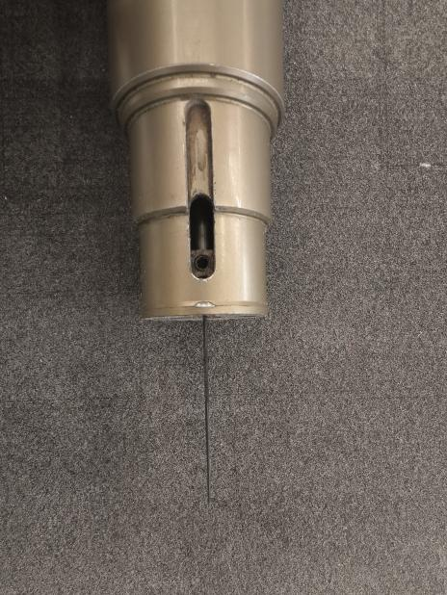
Blade Angle adjustment: as shown in the figure below:
Select the tool that needs to be tested at an Angle, set the depth of the tool on the surface of the material (the depth should be about 0.2MM below the surface of the material, not too deep). Finally, use a harder material to ensure that the cutting does not deform.
In the "tool" interface, select the tool to be tested at the required Angle, open the "tool debugging" window, and select "angle offset".
Move the tool above the material and click the button. The machine will cut three line segments on the surface of the material, among which the shortest line segment is the cutting direction prompt line segment, which is convenient for you to better determine the cutting direction of the two outer line segments.
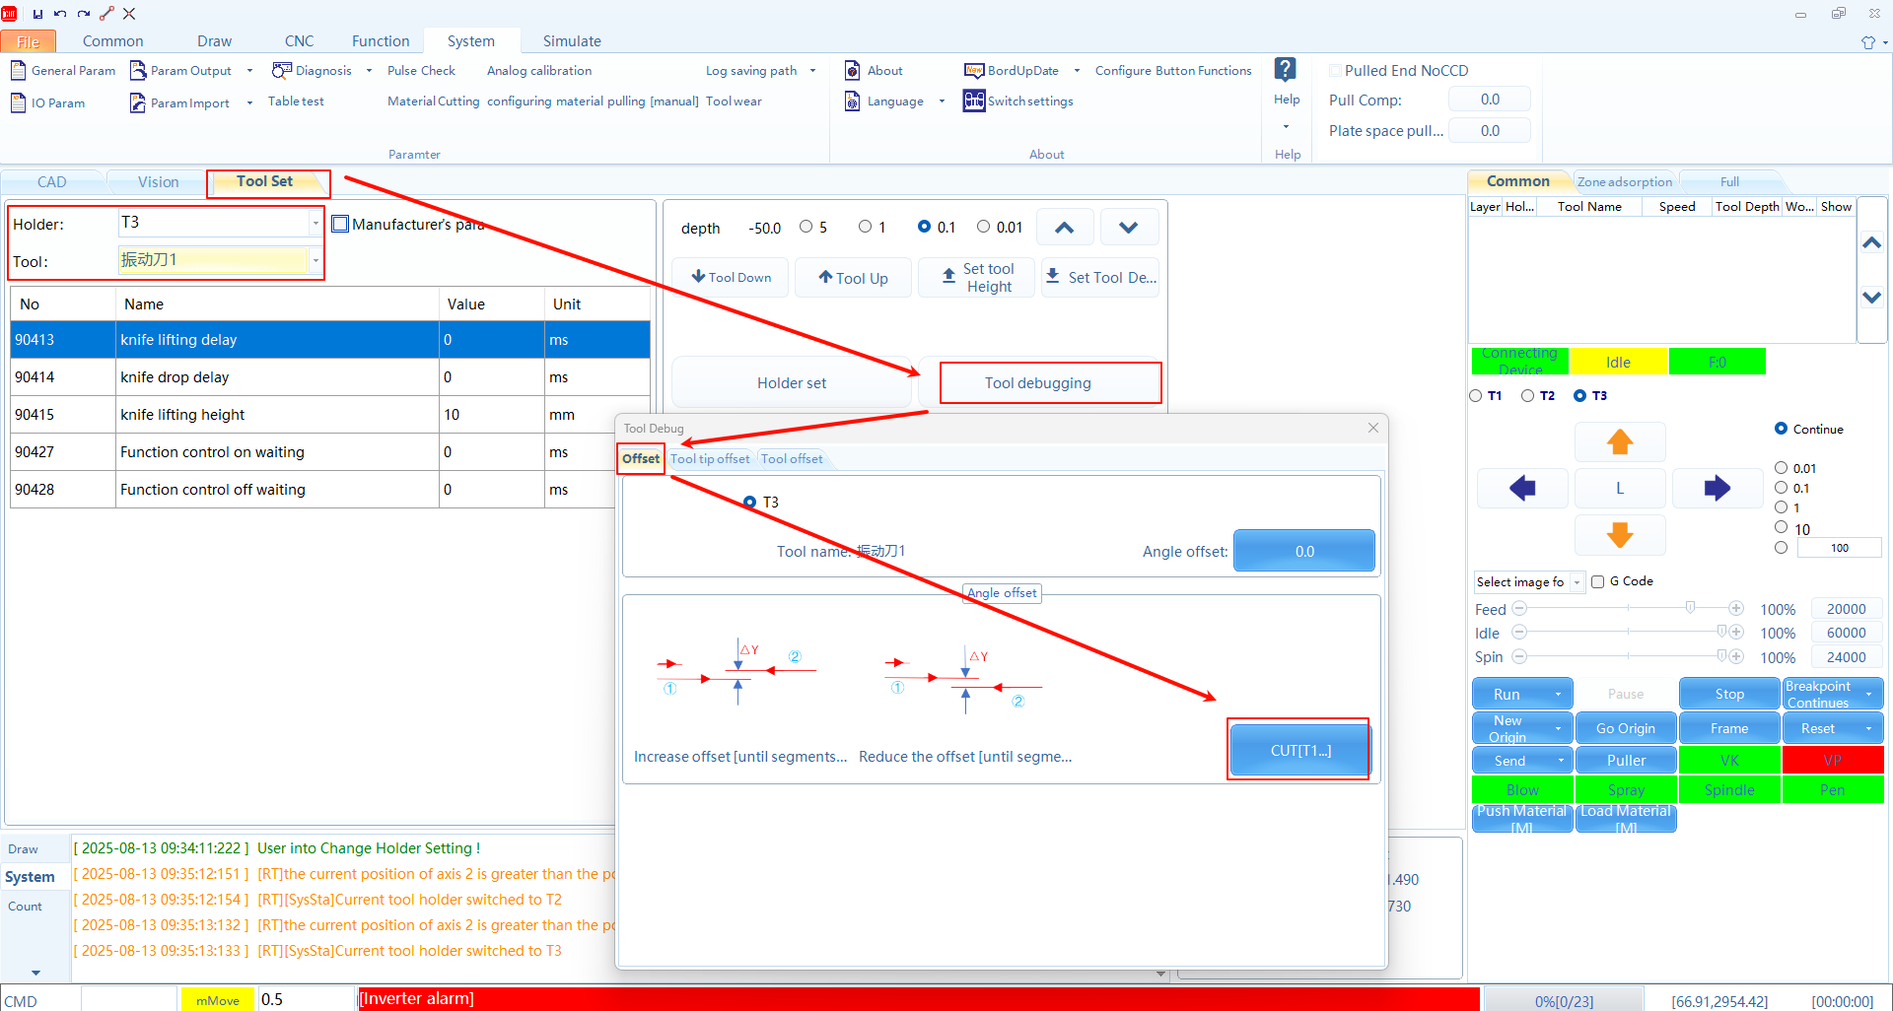
After cutting, check the cutting effect:
Effect 1: As shown in Figure 1 below, this effect requires an increase in the offset. Here, click open and enter the value to be offset.
Effect 2: As shown in Figure 2 below: This effect requires a reduction in the offset. Here, click open and enter the value to be offset.
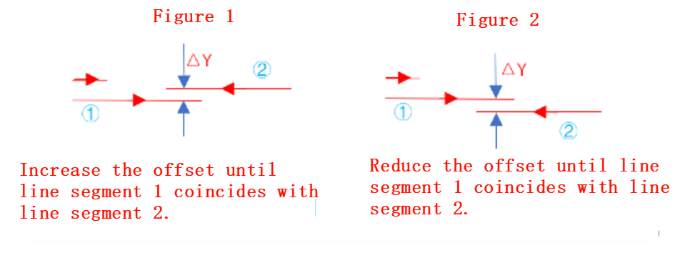
If the cutting is ineffective after adjusting the Angle offset, it may be that the tool has an eccentricity in the Y direction. The tool eccentricity needs to be adjusted

6.1.2 Blade tip offset
Tool eccentricity means that the installed tool is tilted! It is not parallel or perpendicular to the X/Y axis. To measure tool eccentricity, you need to fine-tune the depth of the tool first.
When the blade tip contacts the material surface, set the Z-axis depth of 0.1-0.2 to leave a slight mark on the material surface. At this point, adjust the tool depth. Cut a "square" or "cross" to better observe whether the cutting effect shows tool eccentricity.
Y-axis eccentricity of the tool will lead to inaccurate cutting size, either too large or too small
X-eccentricity of the tool will cause the tip position to lift the knife or fall in front or behind, and also lead to irregular rounded corners and rectangles. As shown in the figure below:
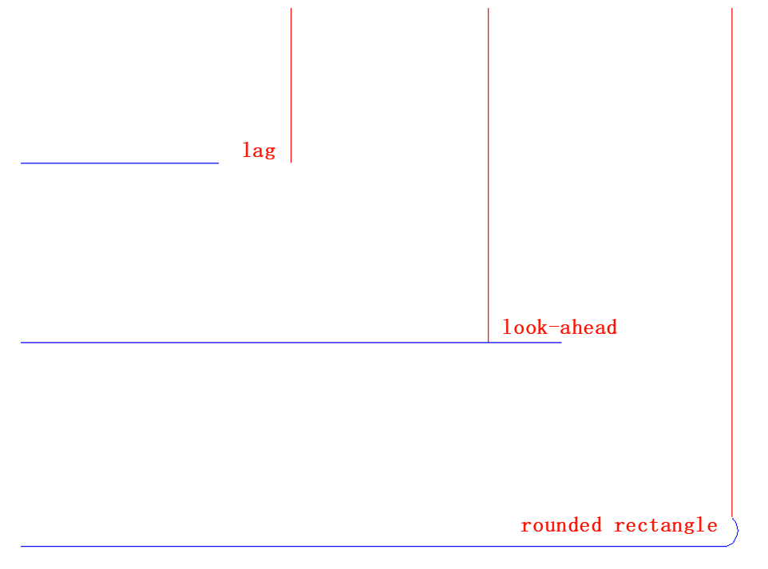
If the above situation occurs, first check whether the blade is installed correctly, whether the blade is installed in place, and whether all the fixing screws are locked. If the blade is installed correctly, we can test the tool eccentricity so that compensation can be made during machining.
The blade offset debugging is as follows:
Select the tool that needs to be tested at an Angle, set the depth of the tool on the surface of the material (the depth should be about 0.2MM below the surface of the material, not too deep). Finally, choose a harder material to ensure that the cutting does not deform.
In the "tool" interface, select the tool to be tested at the required Angle, open the "tool debugging" window, and select "tool tip offset".
Please move the tool above the material, click the button, the equipment will cut a rectangle on the surface of the material. After cutting, please carefully measure the size of the cut rectangle and observe the interface between the lifting and dropping of the knife.
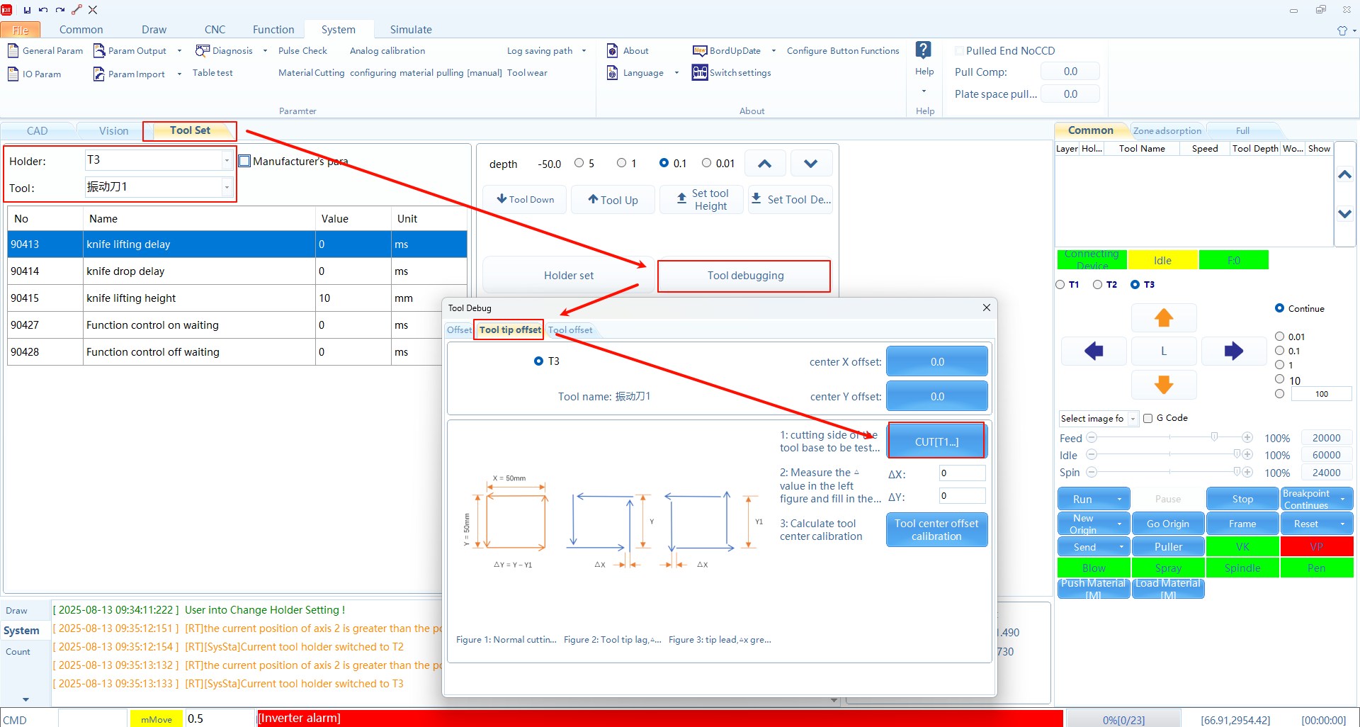
Y to eccentricity: As shown in the figure below: ΔY is the measured and calculated offset value. Y is the target size, and Y1 is the actual cutting size. The calculated error offset value is filled into the right ΔY.
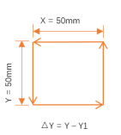
X eccentricity: As shown in the figure below: If the left figure occurs, it means that the tip of the blade lags behind, and ΔX is filled with a negative value. If the right figure occurs, it means that the tip of the blade is ahead, and ΔX is filled with a positive number.
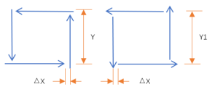

After filling in the error value below, click the button. The system will automatically calculate the tool tip offset value and fill it into the tool center offset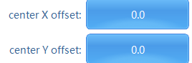. There is no need to manually fill in.
Method 2: Test the blade eccentricity by cutting the cross test. The drawing of the cross test must be cut in the direction shown in the following figure:
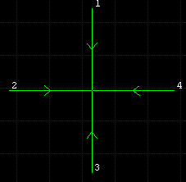
Below are several types of tool eccentricity, adjust the tool eccentricity parameters according to the actual cutting effect:
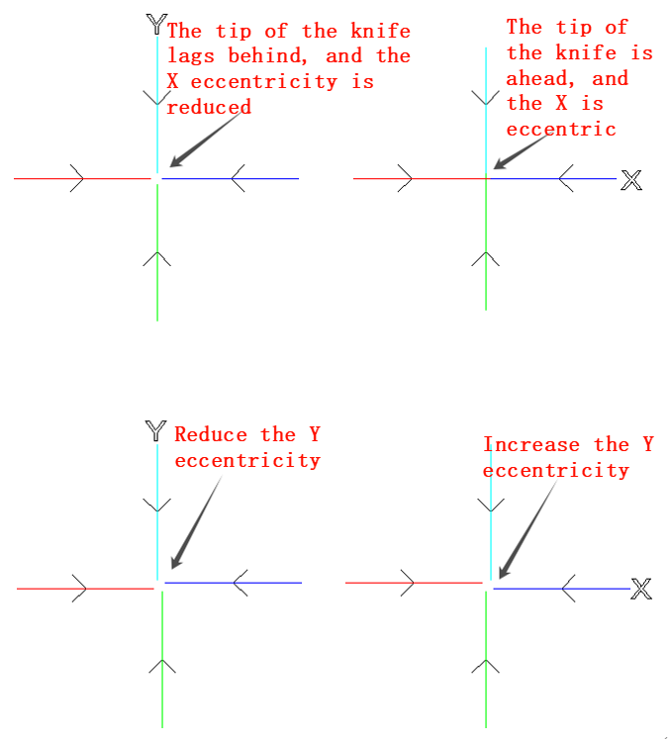
Eccentricity of fillet rectangle cutting tool: If the effect of fillet rectangle is not good, the following situation may be caused by X eccentricity problem. Please adjust the X eccentricity parameter test according to the cutting effect shown in the figure below.
This is for thin materials, as shown in the figure below. For thicker materials, you may need to add some "blade compensation". The following questions will be discussed.
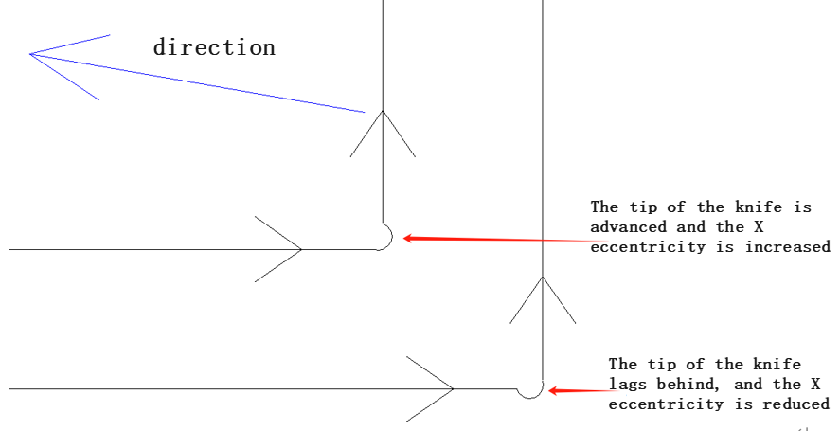

6.2 Offset test
There are two types of offsets: one between tool holders, and another between the camera and tool holder. The offset between tool holders is measured using T1 as the reference point to determine deviations among other tool holders. In edge processing, cameras are employed as the reference point to measure offsets between other tool holders and the camera.
In our processing, we will encounter the situation that multiple tool seats process one figure at a time, and at this time, there are deviations in the cutting trajectory of multiple tool seats. It may be that the offset between the tool seats is not tested well, so it is necessary to test the tool offset.
During the processing of the circuit, the cutting trajectory sometimes deviates to one side. In this case, the camera offset may not be adjusted properly. Therefore, it is necessary to perform cross test and offset correction on the deviated knife holder.

6.2.1 Tool holder offset
The tool holder offset is based on the tool holder 1. Under the tool adjustment interface, open the "tool debugging" interface and click "tool offset".
Select "T1", click cut, and confirm. The equipment will cut a cross on the material. After cutting, move the tools of T2-T* and other tool holders to the center of the cross in sequence, click the button respectively, and the system will automatically calculate the tool holder offset.
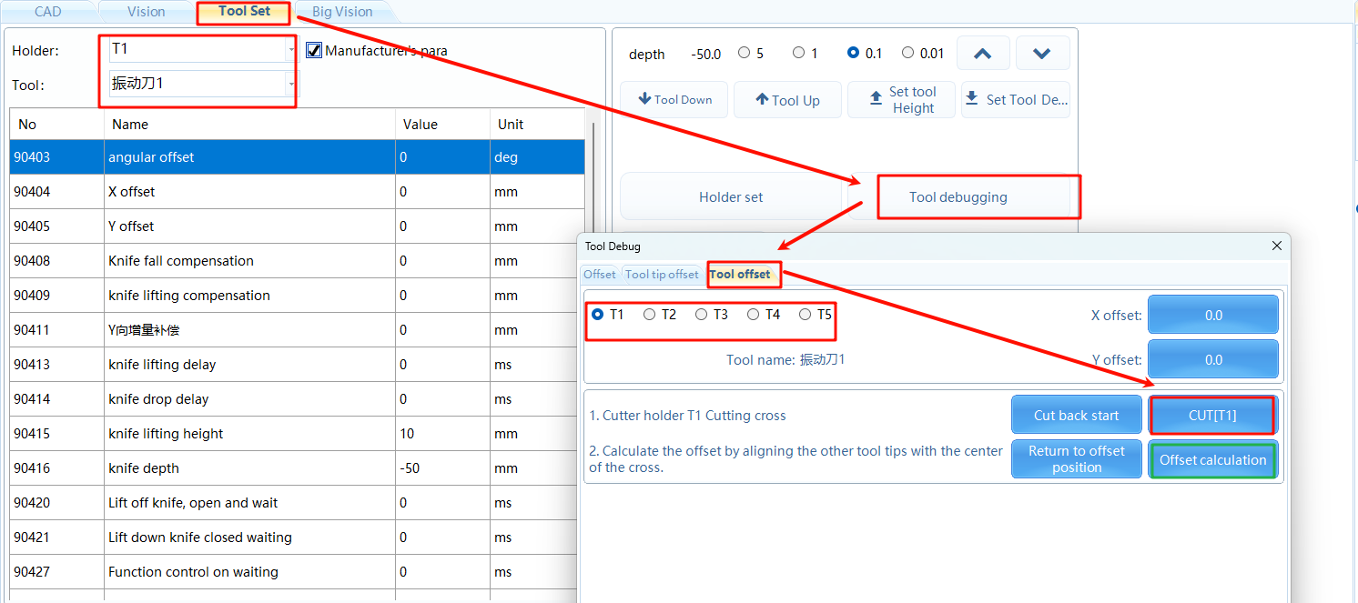

6.2.2 Camera offset test
To calibrate the camera, first turn it on in the visual interface. Select "Test Blade Holder Number" and choose the blade holder to be tested using the small triangular arrow on the right. Click "Cross Test" to start cutting a cross on the material. After completion, move the camera above the cut cross to align the green cross in the frame with the actual cut. Finally, click.The system automatically calculates the offset. Select another tool holder in turn and repeat the above steps to test the offset
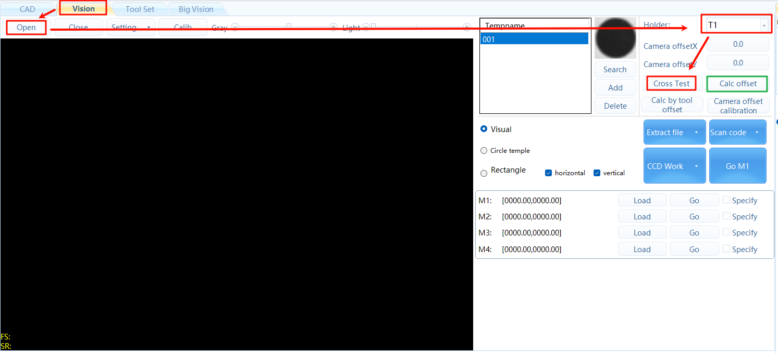

6.2.3 Dual head offset test
The offset between the two machine heads refers to the distance between the tool tips of the two machine heads after they return to zero. This parameter refers to the upper limit of the X/X1 stroke in the system and parameter 57301 (the mechanical origin coordinates of the machine head 2X1 returning to zero).
First, after the two machine heads return to zero, please measure the distance between the two machine head tips with a measuring tool (ruler). Fill in the measured value to the upper limit position of X/X1 mechanical stroke and parameter 57301.
To obtain more precise spacing measurements, we first need to move Machine Head 1 to position A (anywhere). At this location, mark a point on the material as a reference while recording its X-axis coordinates and taking a photo. Next, move Machine Head 1 to the left side and position Machine Head 2 at the previously marked point, ensuring the cutting edge of Machine Head 2 perfectly aligns with position A. Record the X1 coordinates and take another photo. By ± subtracting the previously recorded X-axis coordinates of both heads, we calculate the error value. This result is then entered into the X/X1 travel limit parameter and parameter No.57301.
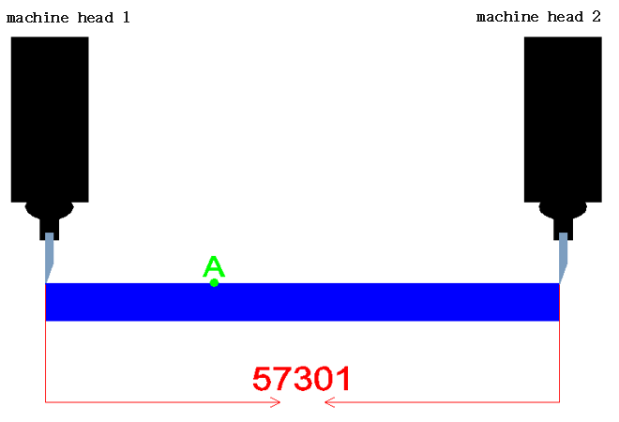

6.3 Tool compensation
Tool compensation includes lifting tool compensation, falling tool compensation, blade compensation, tool radius compensation and so on. The following is a list of different situations.
Click the process parameter button in the upper right corner of the CAD interface. Open the "Layer Parameters" interface. Compensation parameters can be modified
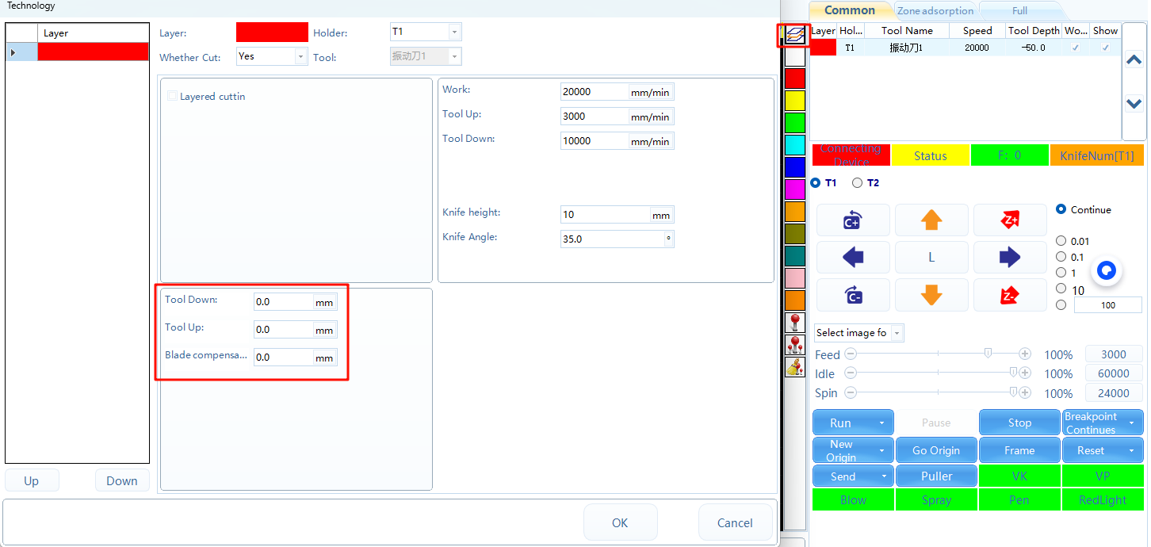

6.3.1 Blade lifting and blade falling compensation
First, we need to observe the direction of the graphics. As shown in the figure below: The direction is counterclockwise. The left side of the green-lined straight line represents the blade landing position, and the right side represents the blade lifting position. Compensation can be applied at either the blade lifting or landing position to adjust the cutting trajectory's lag or lead. The parameter value can be ±.

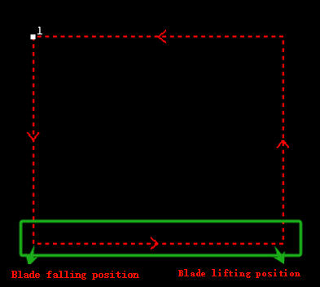
As shown in the figure below: the left is without compensation, the middle is when the blade compensation is 10MM, and the right is when the blade compensation is-10MM.
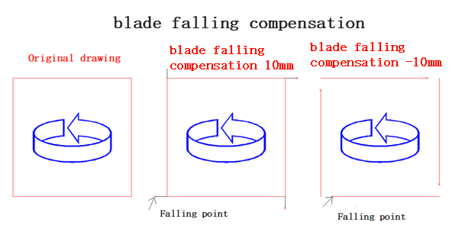
The following figure shows: the left is without compensation, the middle is when the blade lift compensation is 10MM, and the right is when the blade lift compensation is-10MM.
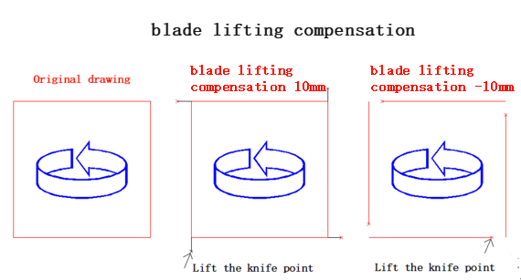

6.3.2 Blade compensation
To use blade compensation, you need to close the processing general parameters and change the parameters shown in the figure below to 1.
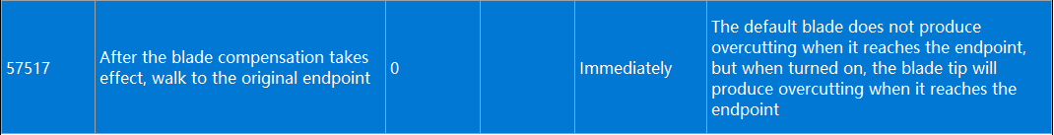
Edge compensation refers to cutting the circular arc track in advance of the turn. It avoids excessive cutting or deformation of the circular arc when cutting thick materials
The following figure shows the cutting effect without blade compensation:
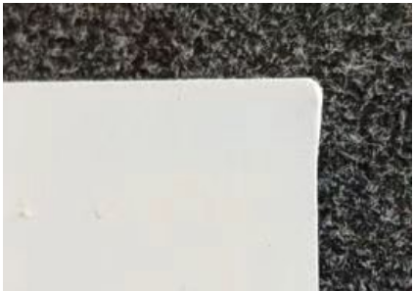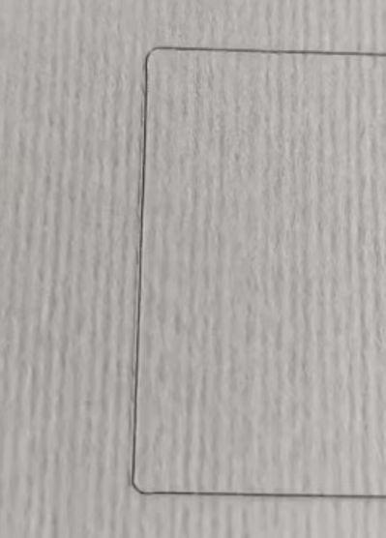
You can increase the "Blade Compensation" appropriately under "Layer Parameters". Blade Compensation can only be filled with positive numbers.
The value of blade compensation depends on other factors such as material thickness and tool Angle.

6.3.3 Blade radius compensation
As shown in the figure below: Because the tool is a cone with a wide upper and narrow lower part, the upper blade width in the process of material processing leads to a large amount of cutting on the upper side, which is much larger than that on the bottom side. As a result, the conical effect is produced when cutting a circle.
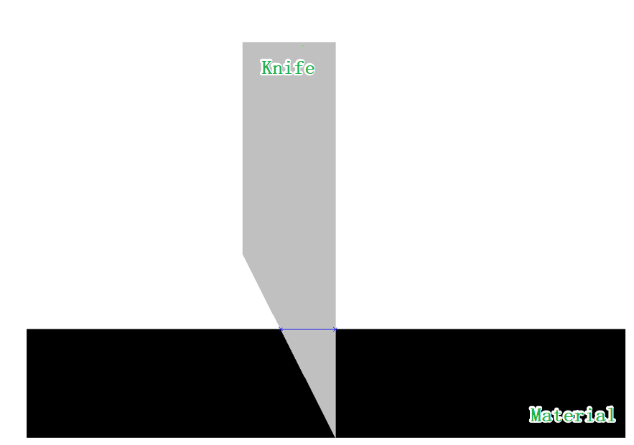
The addition of "tool radius compensation" refers to the tool C-axis steering in advance during machining to compensate for the defect of upper width and lower width, so as to achieve the desired cutting effect.
Note! "Blade radius compensation" does not support layered cutting.

6.4 The device is not connected
Sometimes we encounter a "device not connected" situation, as shown in the following figure: The status is displayed directly below the software
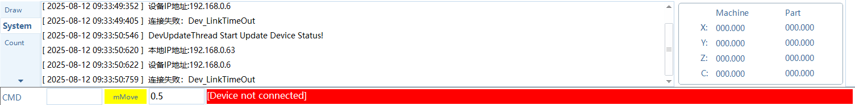

This situation is caused by a variety of problems, and we can conduct a preliminary investigation ourselves. First, check the network cable connection. If there is a CCD camera, check whether the switch is powered on. Check the network status; if this state is displayed, it indicates a problem with the network cable or port.
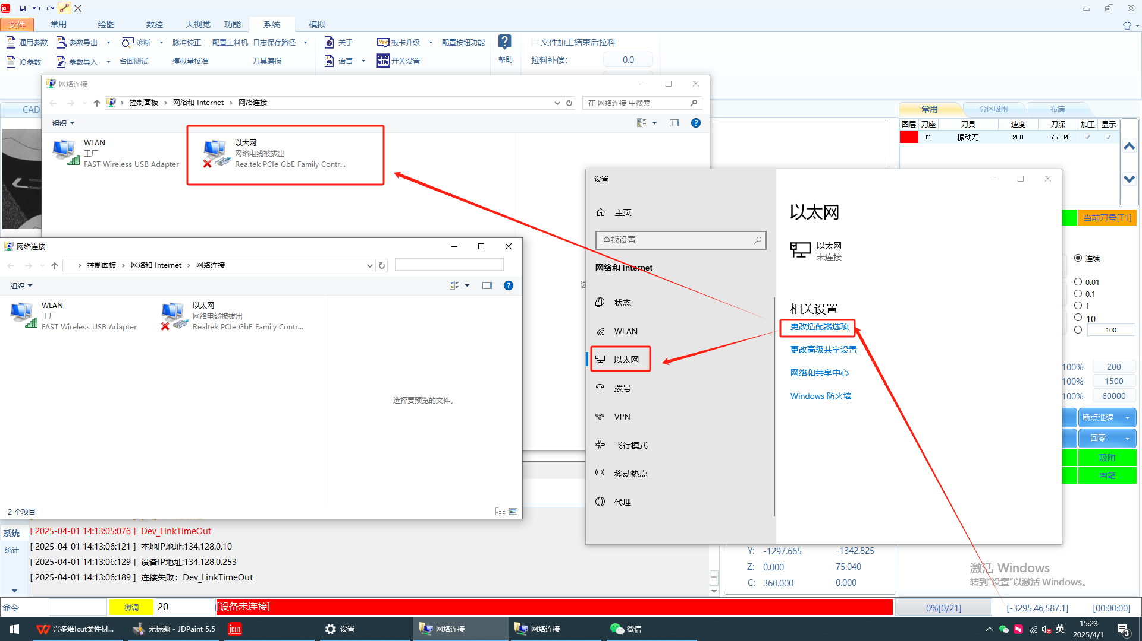
Check protocol address 4 to see if the IP address is set correctly.
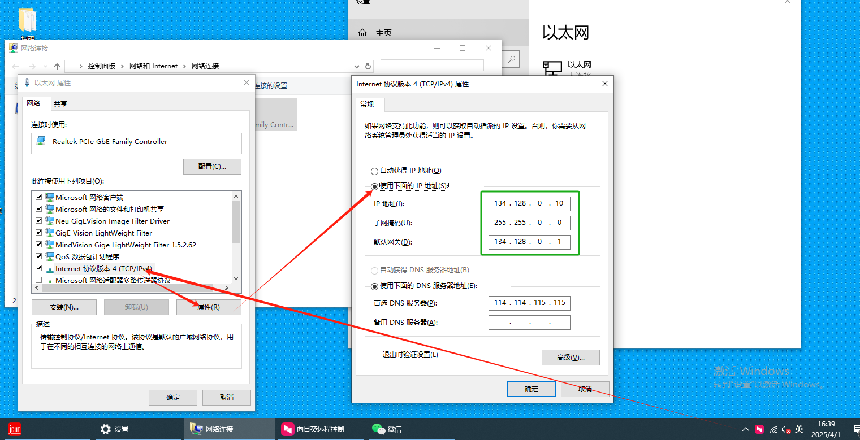
If the controller cannot be connected after configuration, it may be that the controller IP has changed. The default IP address 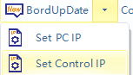of the system is 134.128.0.100. To open the software, go to the system, click the triangle arrow drop-down on the right side of the board upgrade, and click "Set Controller IP".
Open the "Configure Device IP Address" window and click "Refresh Device". The device serial number will then be refreshed. Click on the device shown in the serial number display. In the "SN" column, you'll see the board serial number, and in the "IP" column, you'll see the IP address. At this point, click "Auto Configure". Wait for a moment until a dialog box appears, then click OK. Finally, close the window to complete the configuration, and the device will connect automatically.
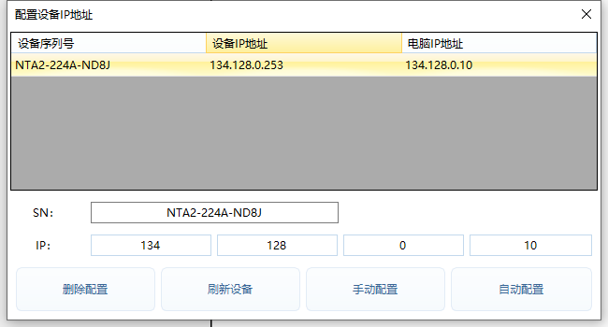
If you still can not connect through the above steps, please contact us

