CDR mapping procedure

1，Open the CDR software, set the layout size。

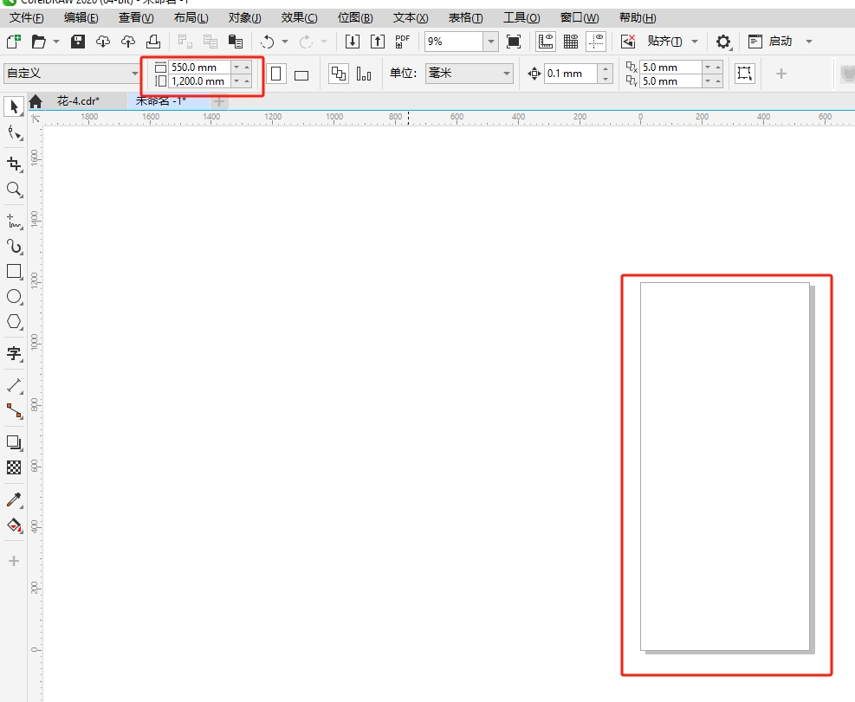  
2.Import images, tif, jpg, png, psd and other formats。

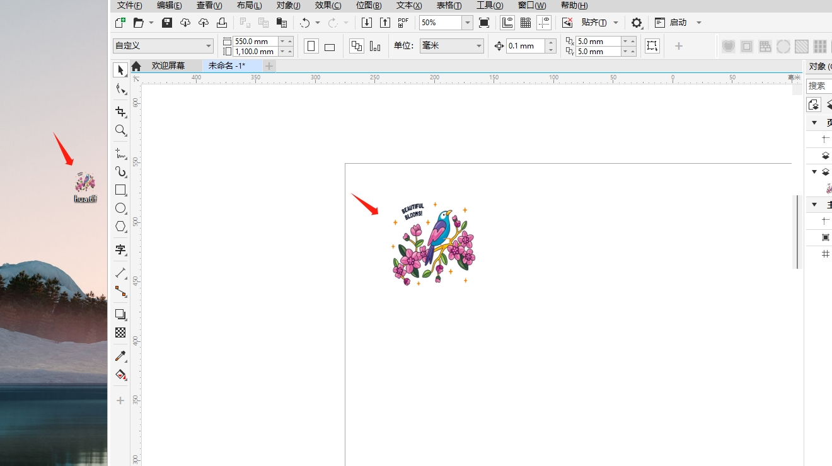

3，After selecting the picture, the plug-in icon will light up, typeset, and set the spacing between the front and back to 10mm (recommended parameter value)。

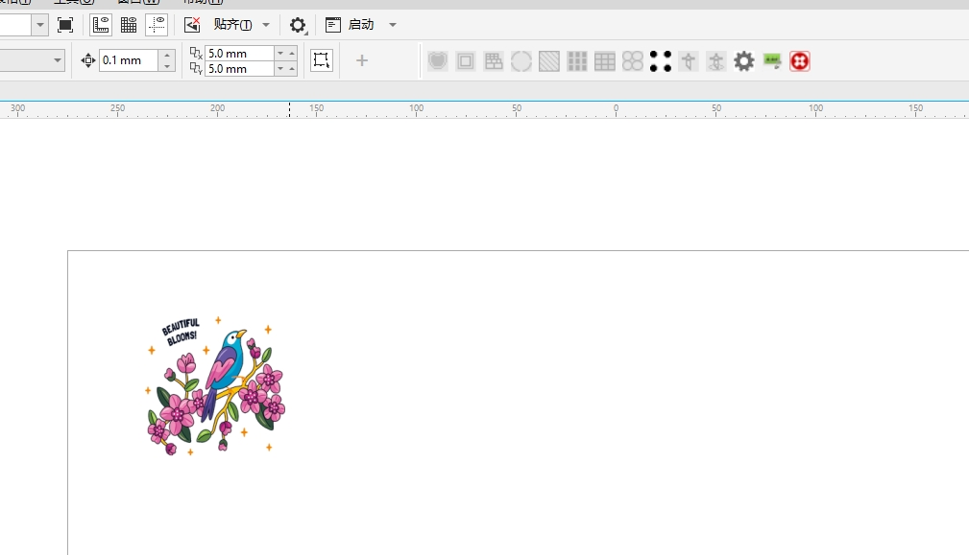

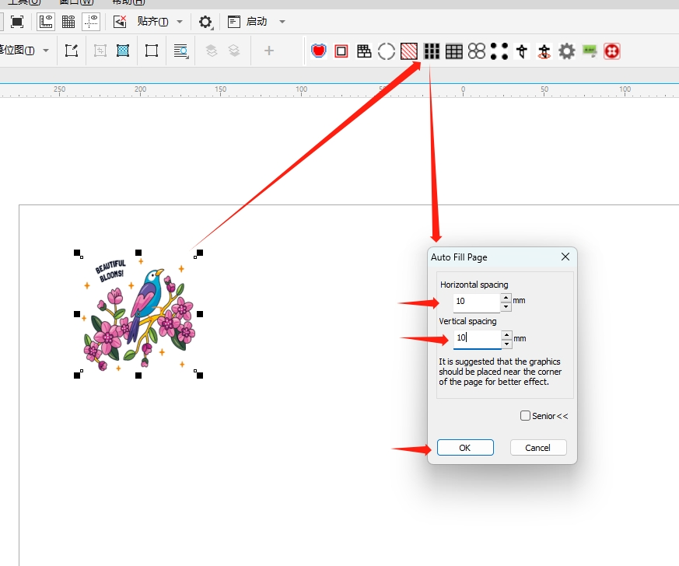

4，Keep track of how many objects there are in each row and column。

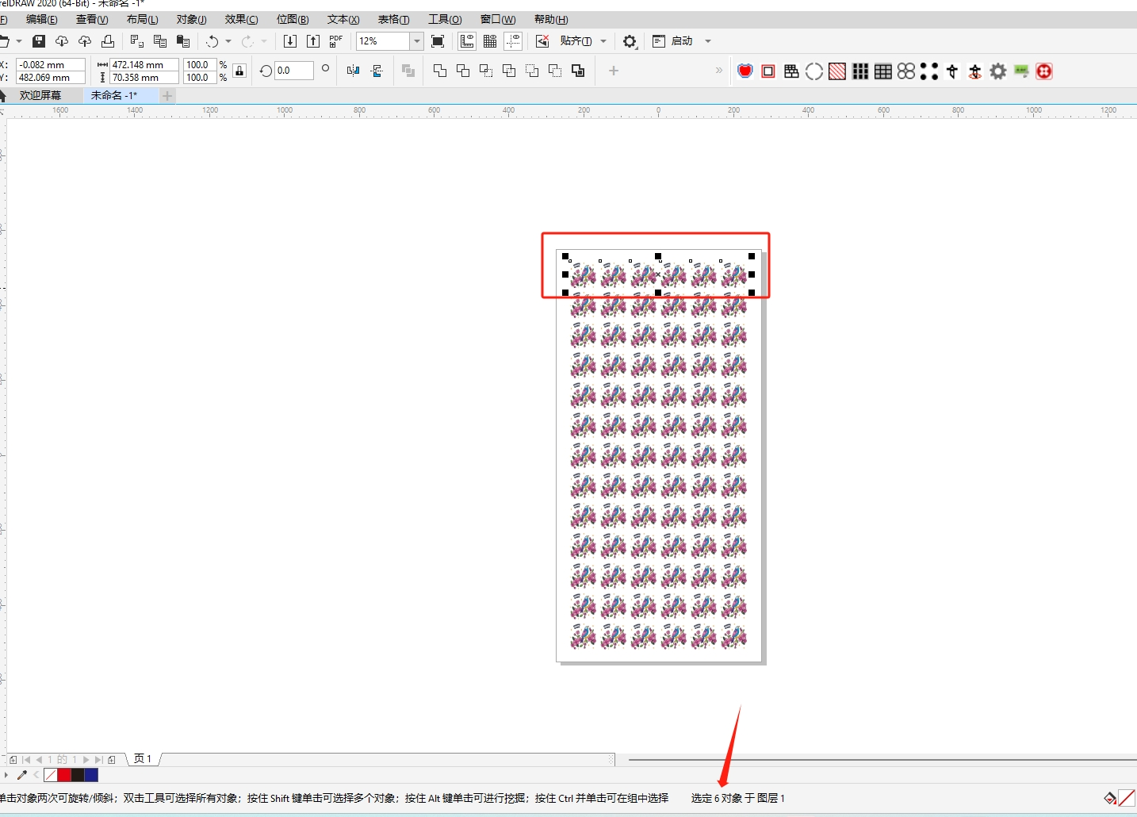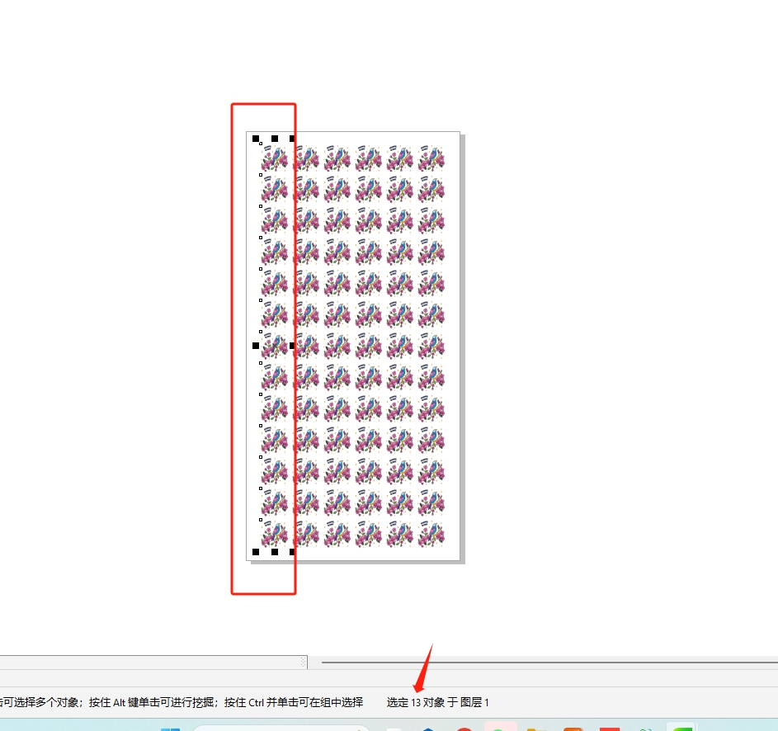

5，Select all, create the cutting path, fill in the “column” and “row parameters”, and set the EXTEND parameters to 1mm。Then click ok App。

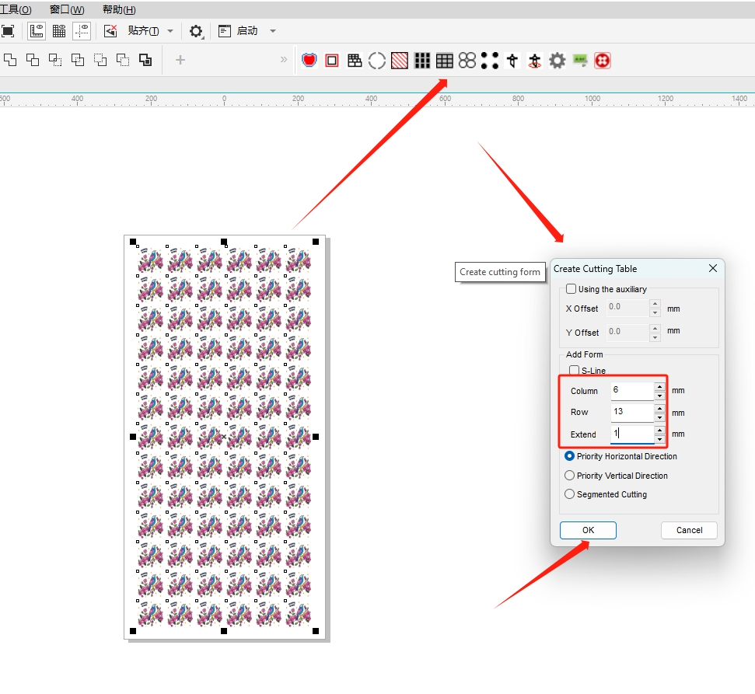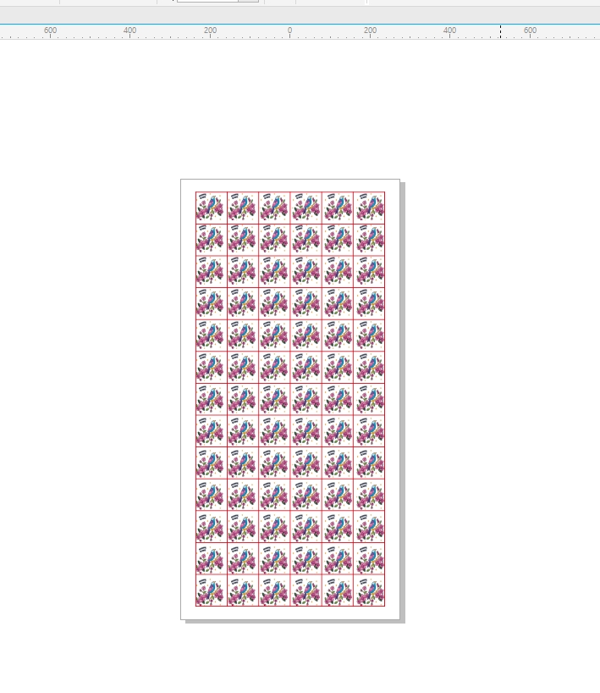

6，Select all, add mark points (default parameters are recommended), click Apply。

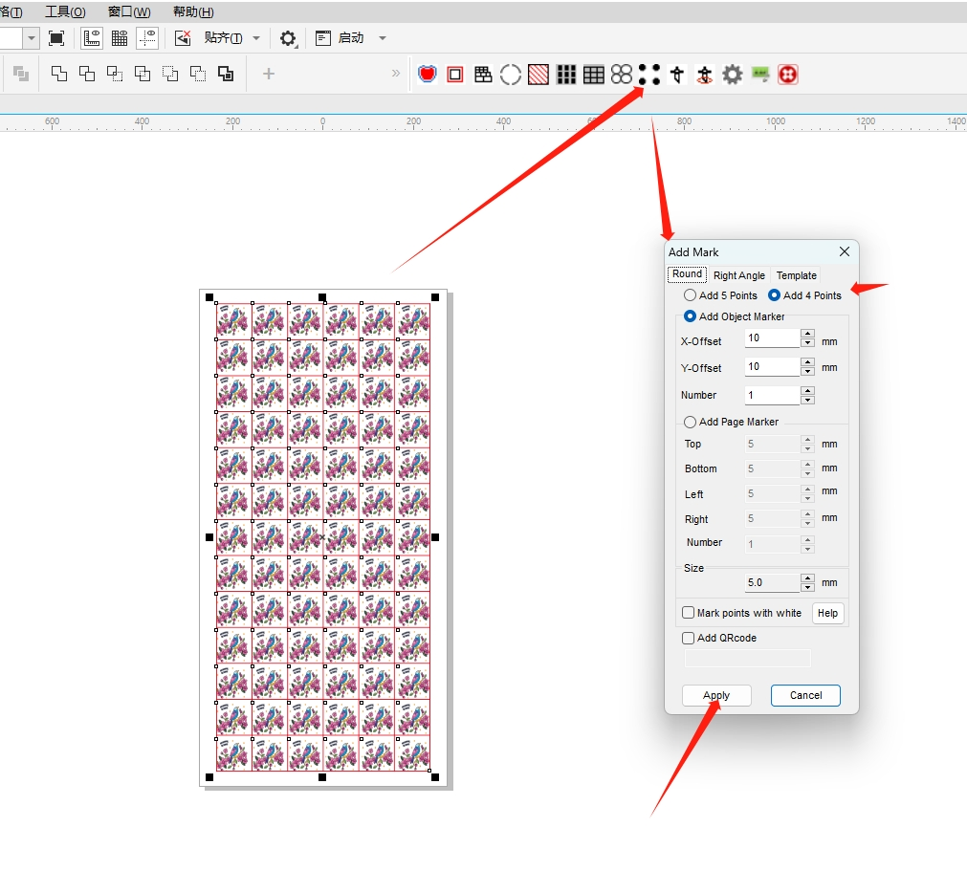

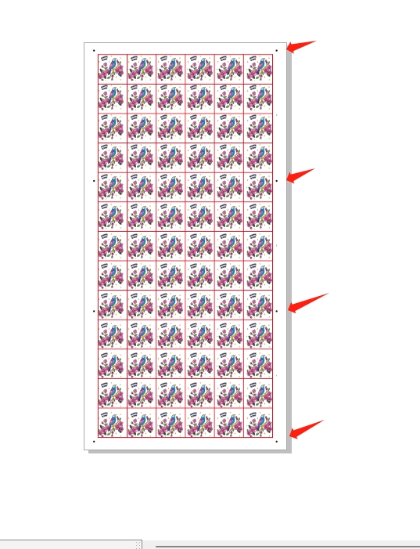

7，Select all, click the edge cutting icon, and save the USB flash drive file。

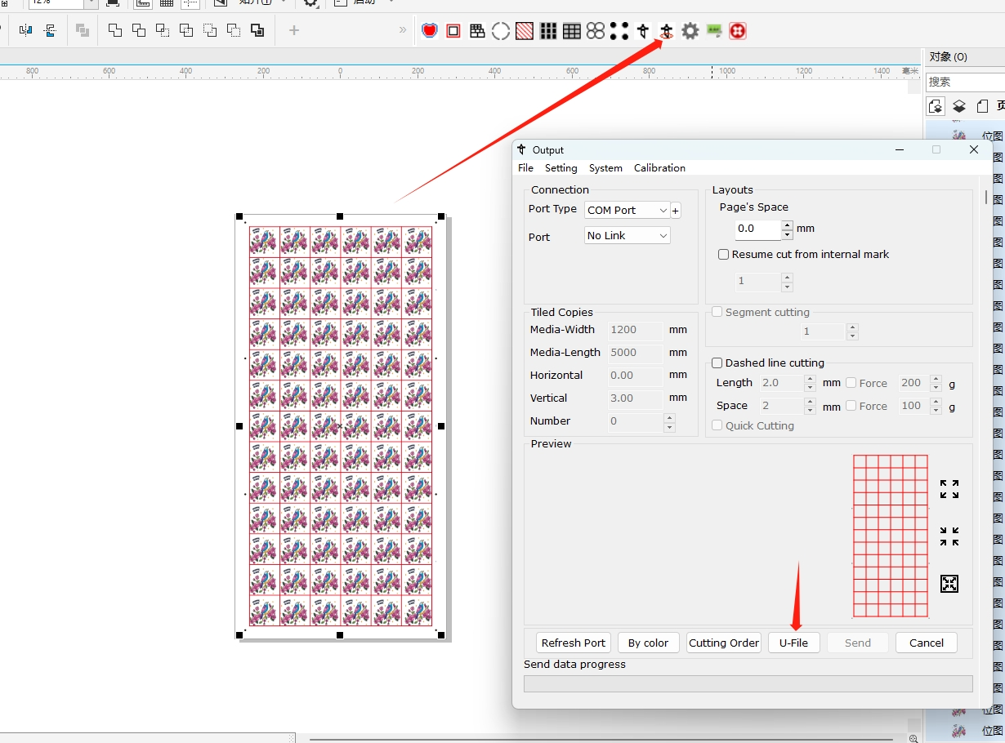

8，File export print picture format, tif, jpg, etc. Default point acknowledgement。

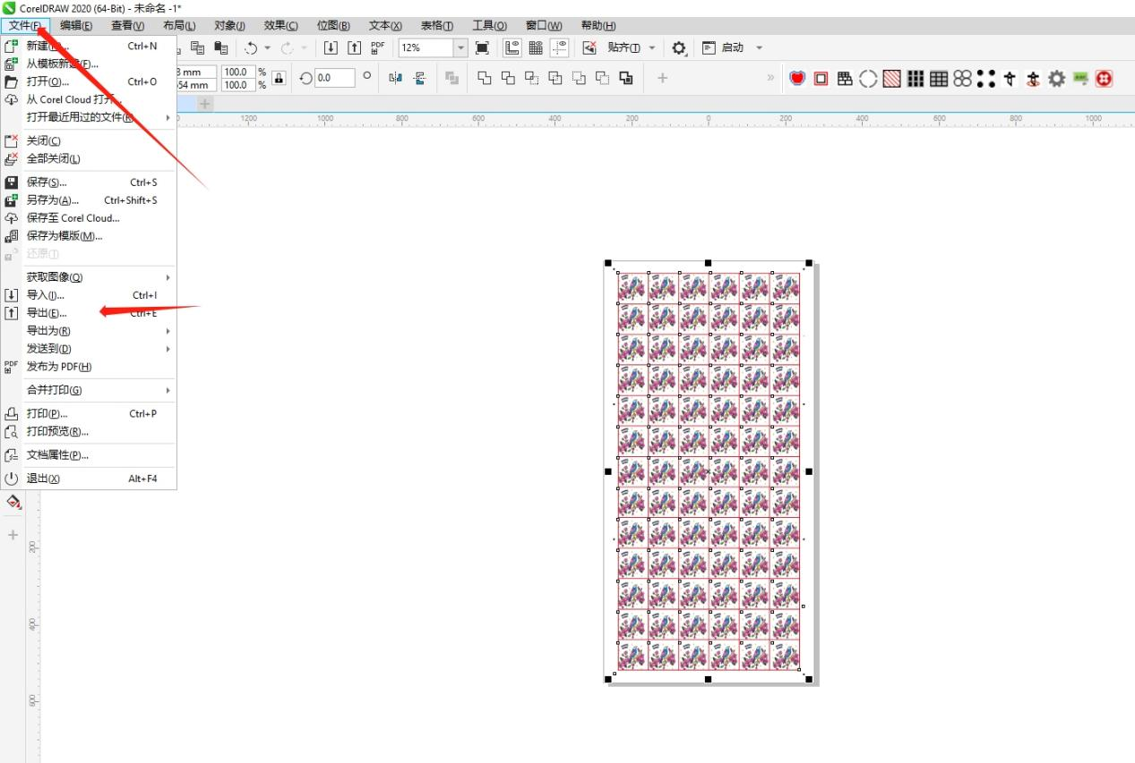

9，Save three files, CDR original file, tif print file, plt U disk cutting file。

