Wiring About Optical Coupling Grating Belt Reader
for product:
F-OCP/READ | Generic Optical Coupling Grating Reader with Cable, GND 5V A/B Signal, Rewiring May Needed

Buy online:
https://buythis.co.za/f-ocp-read

Please pay attention to the wiring!!!
Because this is a generic product, so the wiring may NOT BE suitable for your machine and modifications may require.
Our reader needs 5V power with GND, then return A/B Signal.
Example:
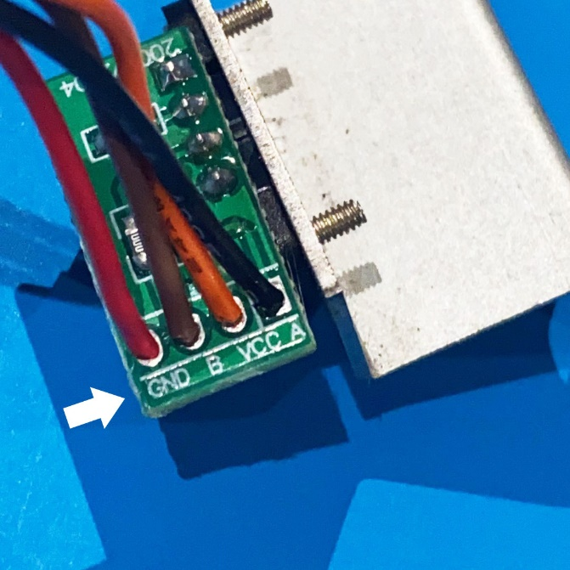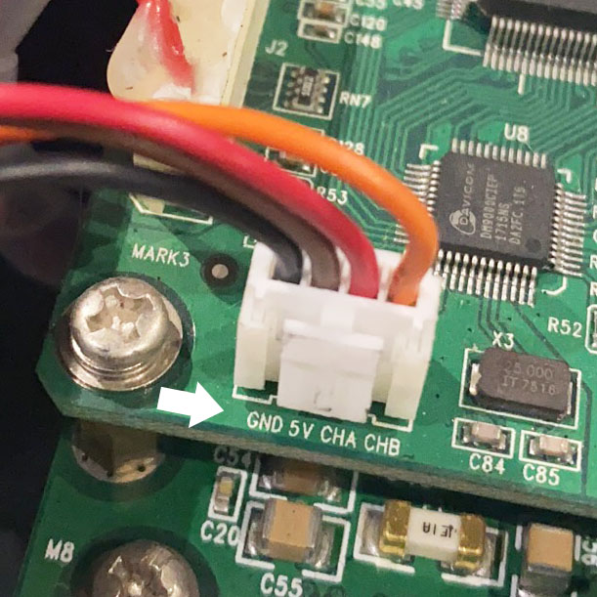
Left is the reader, reads GND / B / VCC / A
Since this is a generic product, each batch of wiring or marking might be different.
VCC means positive DC voltage of 5V (we only sell 5V reader), GND is 0V, or DC ground.
Then return signal A and B.
Right is a carriage board need the signal, reads GND / 5V / CHA / CHB
Means GND (Ground) 5V+ and Channel A and B (means signal)
So, you need to change PIN order in the plug (or change plug in not match) to 5V-VCC, A-CHA, B-CHB, GND-GND. (You can use a tiny pin (or SIM Card PIN) to push each wire out).
If you are using machines from AM.CO.ZA, please contact our support on WhatsApp 060 600 6000.

