E550 Inverter Settings and Wirings for EasyRoute CNC Router
https://am.co.za/
F0.00 = 0 Digital setting
F0.02 = 1 External terminal control
F0.04 = 400Hz Upper limiting frequency
F0.05 = 10 Seconds, Acceleration time
F0.06 = 10 Seconds, Deceleration time
F0.11 = 0 Torque boost
F0.12 = 400Hz Basic running frequency
F0.13 = 220V Maximum output voltage (Depends on spindle)

F1.04 = 400Hz Maximum set frequency
F1.08 = 11 Default (Function selection of input terminal 1) Wiring X1 below
F1.14 = 8 Default (Relay output TA/TC function selection)

F3.00 = 100Hz Multi-speed frequency 1 S1
F3.01 = 150Hz Multi-speed frequency 2 S2
F3.02 = 200Hz Multi-speed frequency 3 S3
F3.03 = 250Hz Multi-speed frequency 4 S4
F3.04 = 300Hz Multi-speed frequency 5 S5
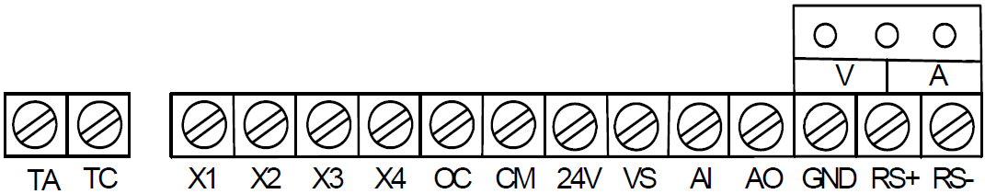
F3.05 = 350Hz Multi-speed frequency 6 S6
F3.06 = 400Hz Multi-speed frequency 7 S7 speed on Panel

