BEST FC300 Inverter Settings and Wirings for EasyRoute CNC Router
https://am.co.za/
P087 = 101 Set this value to reset Inverter Parameter to Factory Default, all below settings are based on default
(Reboot after Reset, then change:)
P017 = 0.5 Stop Breaking Time, 0.5 seconds
P018 = 5 DC Breaking Voltage, 5%
P038 = 4 Acceleration Time, 4 seconds
P039= 5 Deceleration Time, 5 seconds
(Those should be on default, unless you want to change each gear frequency)
P021 = 400 Maximum frequency for our spindles is 400MHz
P030 = 0 Multi-speed frequency 0 SOFF
P031 = 100 Multi-speed frequency 1 S1
P032 = 150 Multi-speed frequency 2 S2
P033 = 200 Multi-speed frequency 3 S3
P034 = 250 Multi-speed frequency 4 S4
P035 = 300 Multi-speed frequency 5 S5
P036 = 350 Multi-speed frequency 6 S6
P037 = 400 Multi-speed frequency 7 S7 Speed on Panel
Reboot One More Time After All Parameters Changed.
BEST FC300 Manual on CNCU.CO.ZA
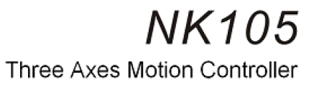
Page 18, section “3. 4. Parameter modification method” explained how to change above values.
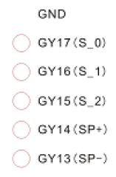
Wiring:

You may need to connect GND to PE/COM if its not ground already.

