Laser Beam Alignment[Adjustment Method]
Introduction
This tutorial is for assisting the laser machine maintenance person in aligning the laser beam. The most important thing about getting your laser machine to work correctly is to have the alignment correct. Doing the initial machine alignment can take as little as 15 minutes. A machine that has exceptional problems can take three hours to align the laser tube, brackets, mirrors, focal head, and lens.
This method is should not be considered to be the only method or even considered as a professional method. This method works great so far and uses minimal tools. After a bit of reading and thinking about the procedure, a competent maintenance person should be able to complete the alignment.
Overview:
Alignment is done in steps. These steps are specifically in an order such that the total alignment gets done correctly. We expect that the laser tube excites properly, the mirrors are clean and free of damage, the lens is clean and in good condition. If the beam alignment is done right, then the machine will perform to top potential.
Materials:
Masking tape: The best masking tape.This tape has a low plastic content on the top surface and it has less adhesive on the bottom. It will be easier for the laser to leave a mark on the tape for us to see. The weak adhesive will not stick to the brackets permanently and is easy to reposition.
Phillips-head screwdriver: Used to loosen/tighten the spring-loaded screws that tension the mirror brackets.
Methaylated Spririts and Cutton buds :For cleaning.

1. Step 1
Make sure the laser tube is installed correctly. The laser tube needs to be situated so that the laser beam exits and points into the first mirror. Allow about 25,4 mm between the end of the laser tube and the mirror bracket. Please look at the picture and see how to space the laser tube and first mirror under. It does not matter if the electrical connectors are rotated top or bottom, but make sure the electrical connectors will be safe from accidental pressure (the glass nipples are tender and easy to break). We have secured the electrical connectors with basic electrical tape. The tape also acts as a strain relief so the wire does not produce torque on the glass nipple.
Rotate the laser tube so that the coolant will automatically purge the air. The coolant should exit the glass chamber at the top right of the laser tube. Notice the coolant exits the cooling chamber of the glass. Do not be so concerned about the orientation of the silicone tubes. You need to ensure the coolant will automatically exit the laser tube without leaving a bubble. The bubble will prevent any fluid from cooling the laser tube and output coupler lens. An overheated lens will become damaged and greatly reduce the output power. The laser tube would need to be replaced.
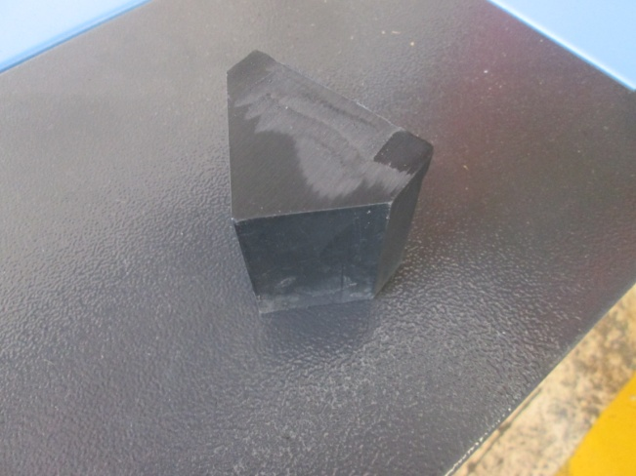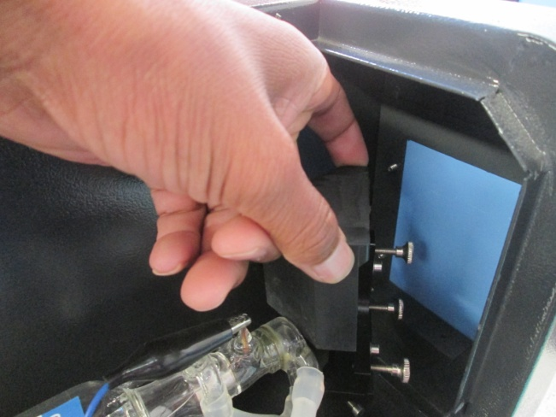

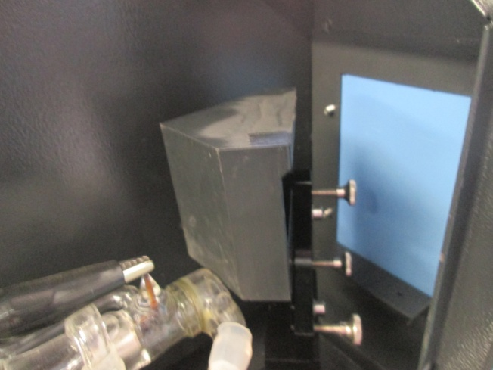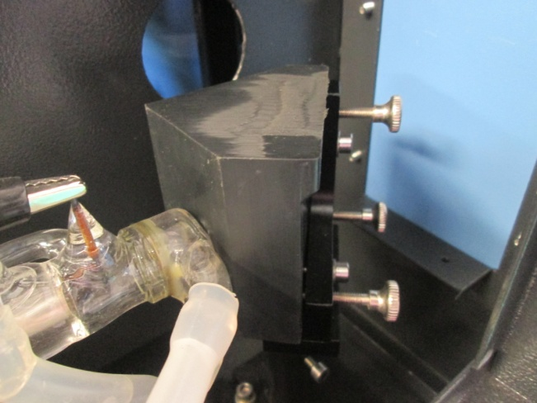

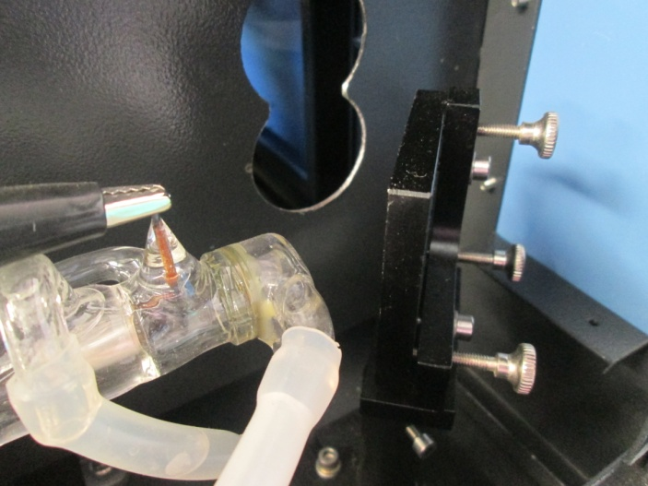

The mounting straps should be snug, but not overly tight. Excessive pressure could break the laser tube. The foam rubber pads are placed between the laser tube and the mounting brackets to absorb pressure and ensure an even pressure for holding the glass tube in place. Make sure that the "U" brackets are securely mounted. The base screws should be tight enough that the base does not move. There are set-screws that prevent the height adjustment from moving. These set screws must be tight. If the set screws are not tight, then the tube could move after alignment and waste the entire procedure. Once the laser tube is installed, connect the high voltage wire and ground wire. This white silicone tape is the high voltage tape. It needs to be layered with thickness enough to prevent the High Voltage from sparking to the frame. Be VERY careful with this electrical connector. Breaking the glass nipple is NOT covered by warranty.

- Step 2

Close the doors. Turn the machine on. Make sure coolant is flowing. Move the Focal head to the top left of the machine. This puts all the mirrors at the closest locations. If you expect the laser alignment to be somewhat close, then it maybe easy to place a small piece of wood under the air nozzle. Test that the laser tube excites (fully lights up for a moment) when the "Laser" button is pressed. This is also often said that the laser tube "fires". Now is a good time to check the menu configuration for what power percentage and how much time is set for the "Laser" pulse. For a 40 watt laser, the Laser power should be set to 40 (percent) and the timing should be set to about 40mS (milliseconds). The laser should excite for about 16 watts for40 milliseconds.
A damaged laser tube may not excite at all. A dying laser tube might produce a short flame at the end of the tube with RED wire. If the glass is cracked, then the tube should not excite. It is possible that the spark from the laser power supply could have burned a hole to the cooling chamber of the laser tube. The coolant passes through the bulkhead fitting as it exits the machine. This fitting protects from allowing the high voltage to pass through the coolant and onto the floor. If the laser tube excites correctly, then we can proceed with the alignment. If not, then call for technical help.

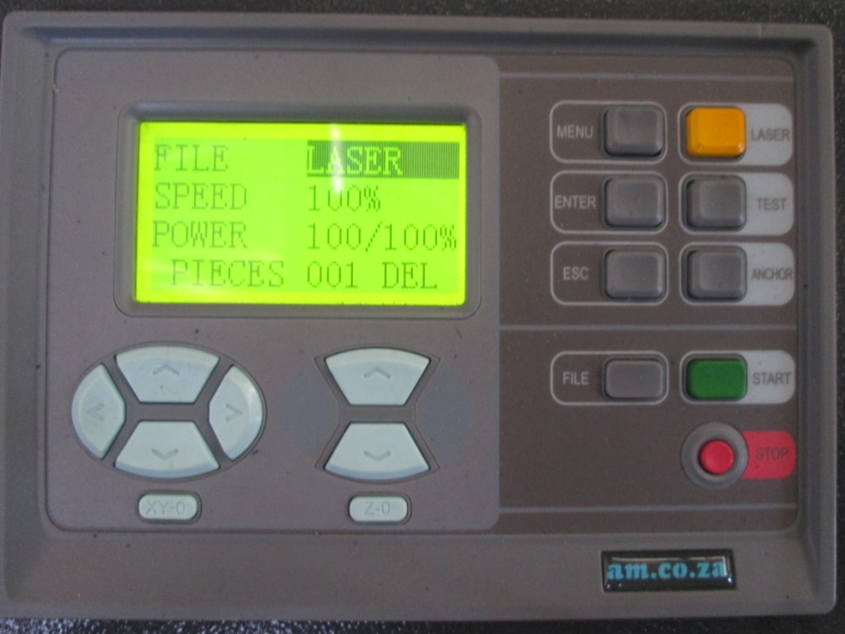

3. Step 3
Use the tape to make a "target" and "cover-strips". The target is made by layering about 15pieces of tape together. There sulting target board should be about 152.4 mm and thick. The idea is that the laser pulse will not be able to pass through it. If the target is too thin, then the laser pulse could burn through or catch fire. If the laser burns through, then the fumes and laser heat could damage the mirror.
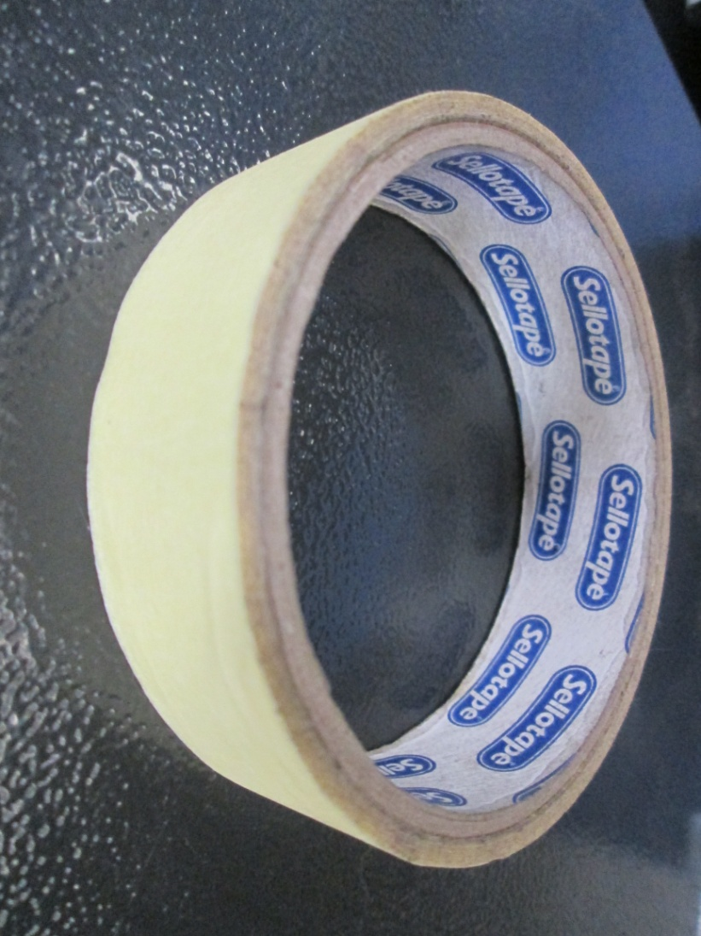

4. Step 4
Inspect that the laser beam is going to hit the first mirror as the beam exits the laser tube. It would be difficult to adjust if the beam doesn't even hit the first mirror. Picture 1 indicate that the laser tube is not level, adjust the laser tube, see on picture 2 and 3 how to adjust the laser tube. Picture 4 is the result after laser tube adjustment. (NB:don’t touch the first mirror)

Picture 1 Picture 2
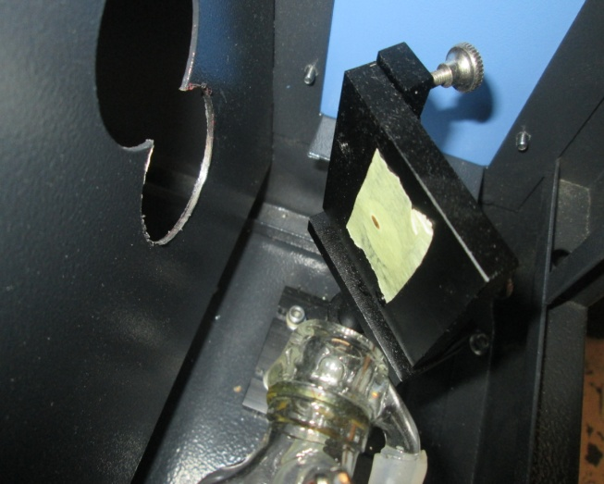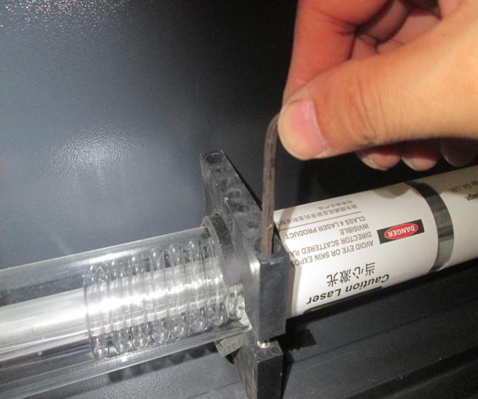

Picture 3 Picture 4
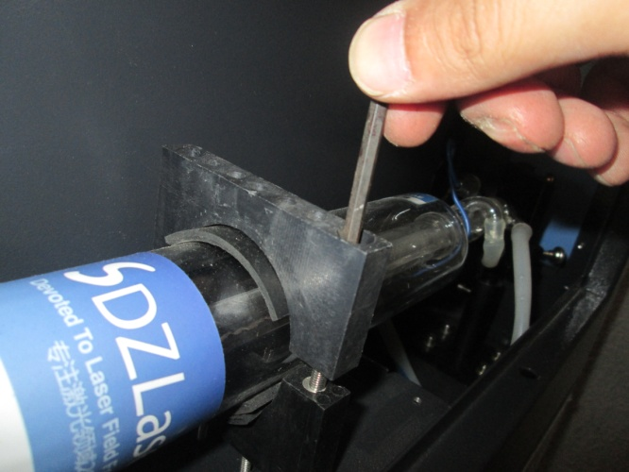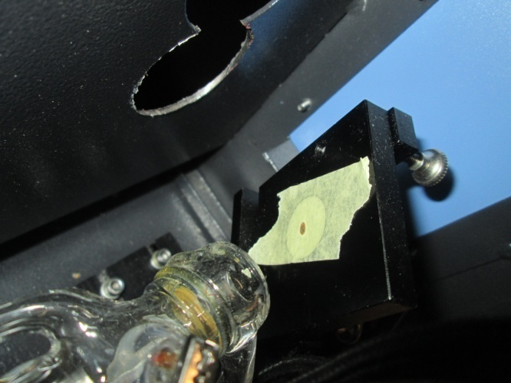

5. Step 5
Place the target onto the mounting bracket of the second mirror. Notice that there are no screws protruding from the bracket and that the target does not actually stick to the mirror.
6. Step 6
Use the operator control pad to move the gantry to the rear of the work space. This position is where the first and second mirrors are closest together.

7. Step 7
Close all doors and press the "laser" button. Notice the mark that the laser makes on the target. You should press the "Laser" button just enough times that the new mark reveals a well-defined oval. The oval shape is because the mirror is at 45 degrees angle off of the laser beam axis. The oval could be as small as 4,76mm or as large as 12,7mm. This depends on the laser tube power. Don't be scared if you see a flash of light or flame. It could be the paper vaporizing as it burns instantly from the laser heat. Make sure to observe if the tape catches fire. (Quickly put out the fire and make sure all the mirrors are clean.)

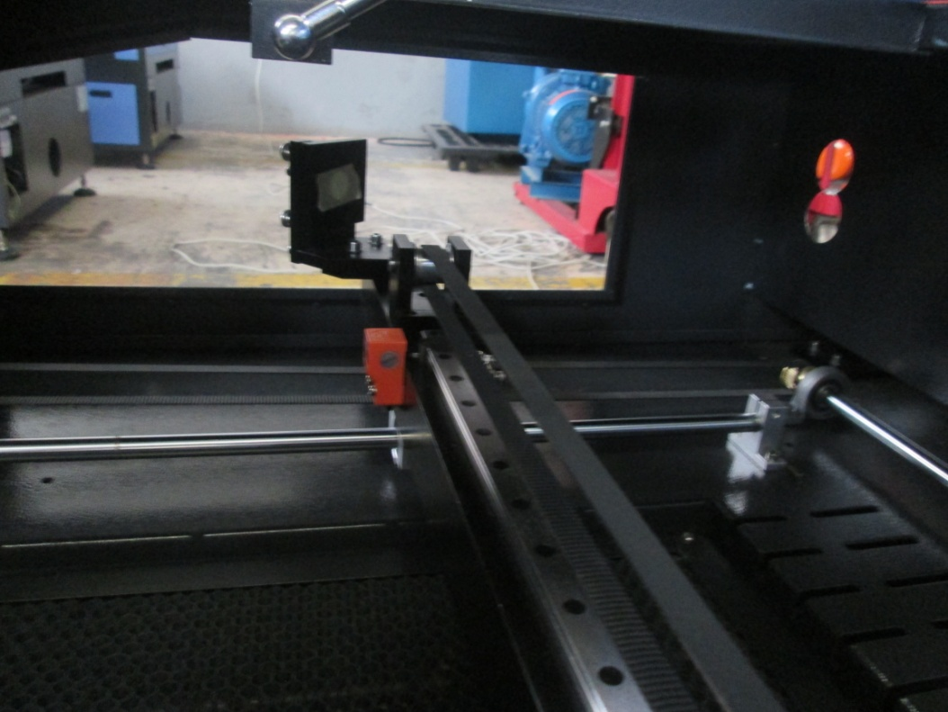

8. Step 8
Now the laser has been made on the tape target. Move the gantry closer to the front of the machine.

9. Step 9
Place a small piece of masking tape over. This will allow you to see where the new laser mark will be.
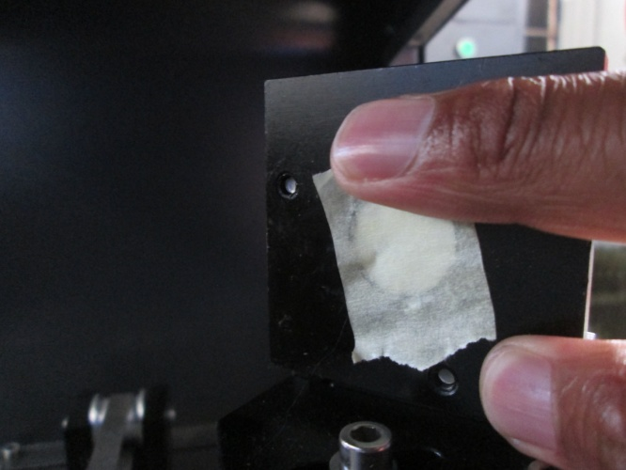

10. Step 10
This is the odd step. If you think the alignment is already close, then you can move the gantry all the way to the front. If the alignment is considerably in error, then the laser beam may not be pointed onto the tape target at all. If the alignment is close, then the laser beam may land on top of the previous mark. Move the gantry away from the first mirror. Close the doors. Press the "laser" button to produce a new circular laser mark.
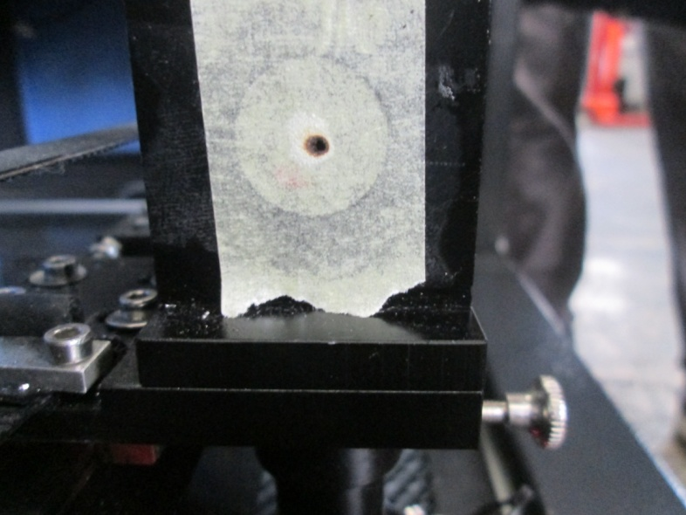

11. Step 11
Open the doors and observe where the new laser mark is located. Remember that the target (stack of tape) is located on the second mirror's mount. You will need to adjust the angle of the first mirror to make the laser beam land on the inside of the circle of oval.

12. Step 12
Adjust the first mirror angles to make the laser beam reflect onto the original mark. If the new mark is too high, then turn the top adjuster-screw clockwise. Make sure to only move the screw the slightest amount. I have seen that 1,59 mm of a turn could be too much adjustment. If the new laser mark is left of the target, then turn the bottom-left adjuster-screw clockwise. This will pivot the first mirror such to reflect the laser beam more to the right.

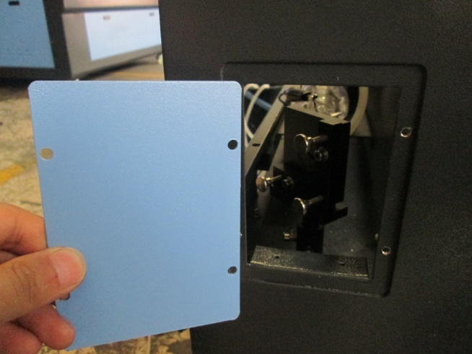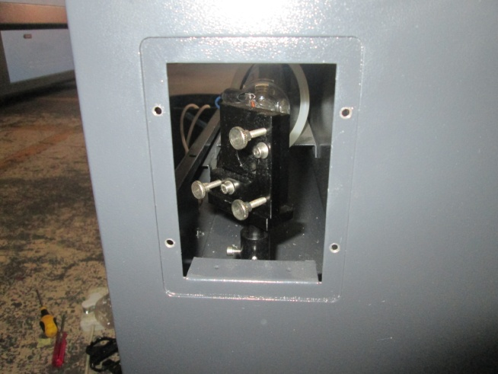

13. Step 13
Now that you have made some adjustments to the mirror, we need to see what the results are. Remove the small piece of tape. Replace the tape with a fresh piece of cover-strip tape. If the old piece of cover-strip tape has space available, then you could use an unburned section.

14. Step 14
We are basically back at step 10. Close the doors. Press the "laser" button a few times to produce a new circular laser marks.

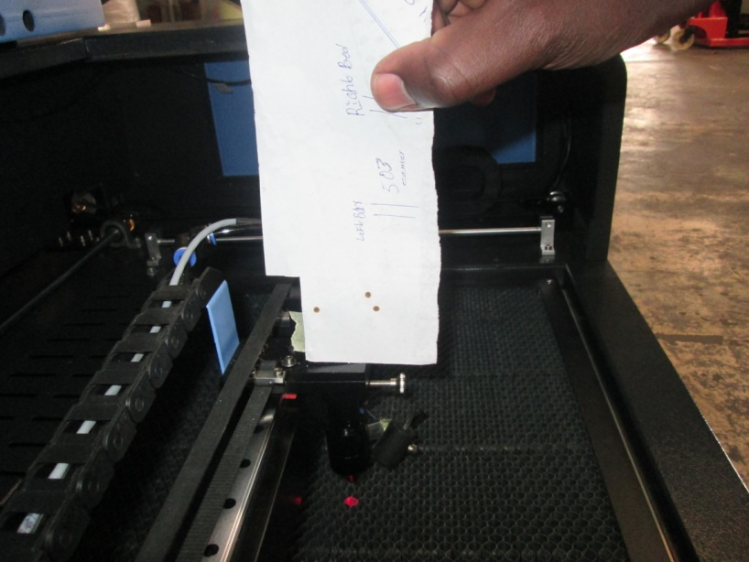

15. Step 15
Continue to use steps 10 through 14 until the new laser spot is directly inside the oval circle or in centre.This can be considered as a rough alignment phase. If the original mark(mirrors close together) and first test shot (mirrors apart) was within 6,35 mm, then you do not need to go through another phase of step5-step14. If your alignment was already very close, then producing concentric marks will end this phase of the alignment.

16. Step 16
The first axis is aligned. This axis isn't completely done until after we know that the laser beam is high enough to enter the focal tube correctly(slightly above center) and shifted out enough to enter the focal assembly on the center axis of that third mirror. This axis is in good condition for aligning the next axis. We need to move the gantry to the center position while we align the gantry axis. Moving the gantry to center position averages any error coming from the first axis.
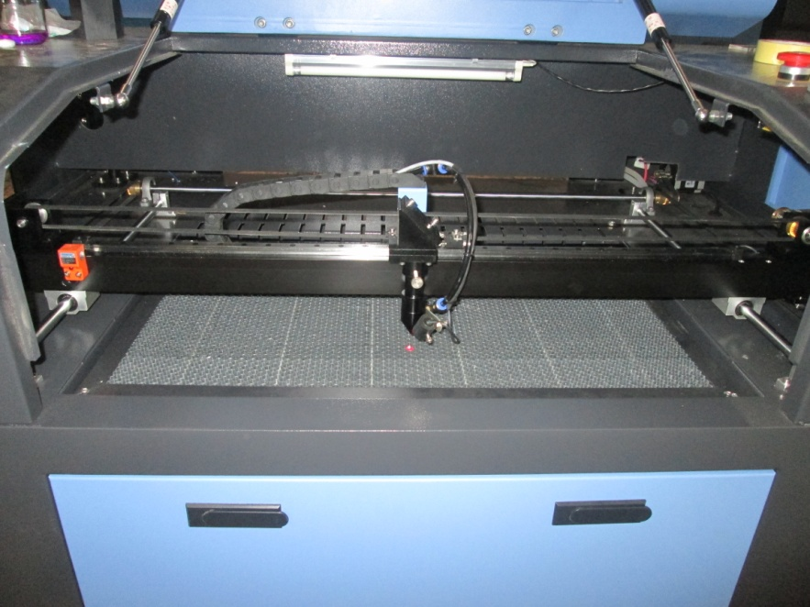

17. Step 17
There are three set screws that need to be tightened for the mirror on the left side of the gantry. Tighten these so the spring compresses as shown in the figure.

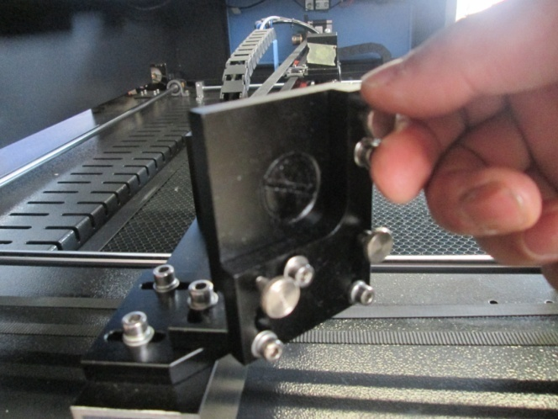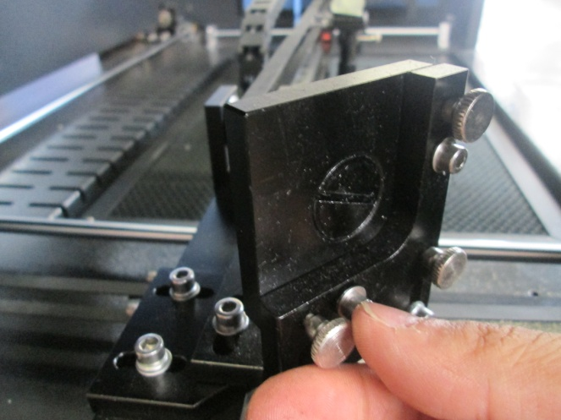

18. Step 18
Place the target on the third mirror located at the top of the focal head assembly.
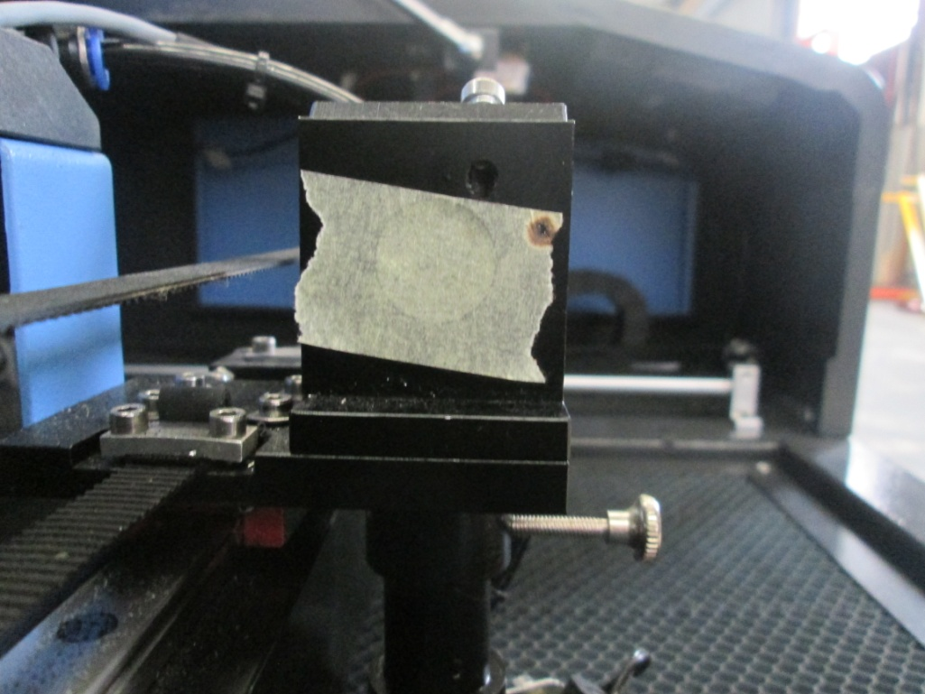

19. Step 19
Move the x-axis all the way to the left. Press the laser button a few times so that you have another dark circle.
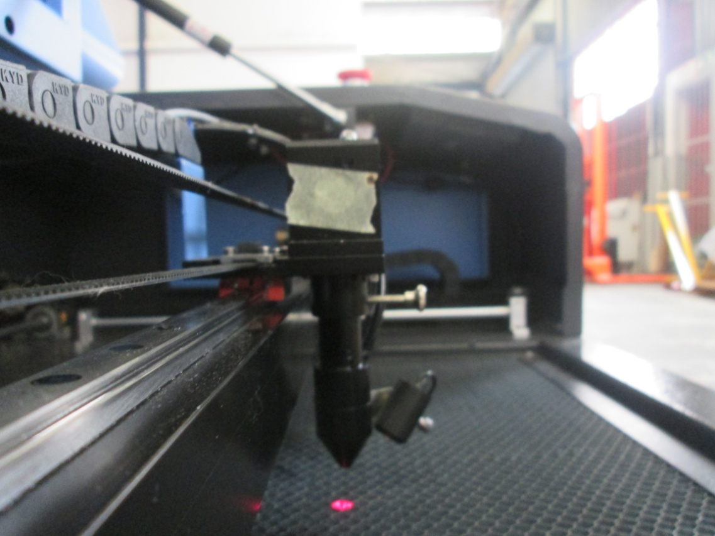

20. Step 20
Move the x-axis all the way to the right.

21. Step 21
Close lid and press the laser button.

22. Step 22
Check the alignment.
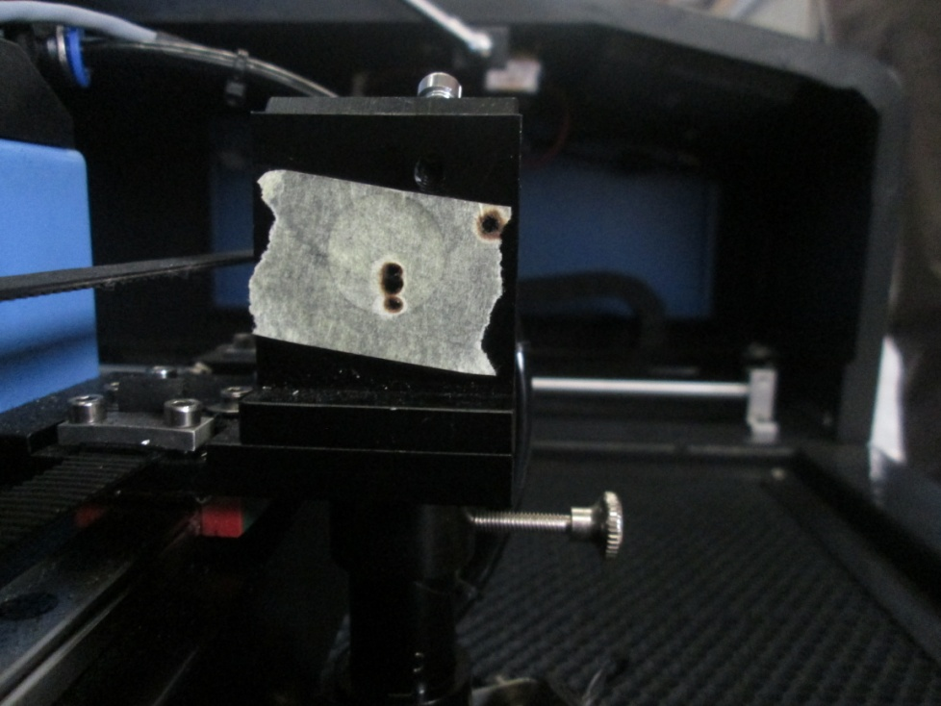

23. Step 23
There are three screws that can be tightened by hand on the mirror on the left of the gantry. These three screws will change the location of the beam on the target. If the spot is high but on center vertically tighten the bottom screw. If the spot is low but on center vertically tighten the top two screws. If the spot is low and to the left, tighten the top right screw. If the spot is low and to the right, tighten the top left screw. If the spot is high and to the right tighten the top left and bottom screw. If the spot is high and to the left tighten the top right and bottom screw. If the spot is on center horizontally but to the left, tighten the top right and bottom screws. If the spot is to the right tighten the top left and bottom screws.

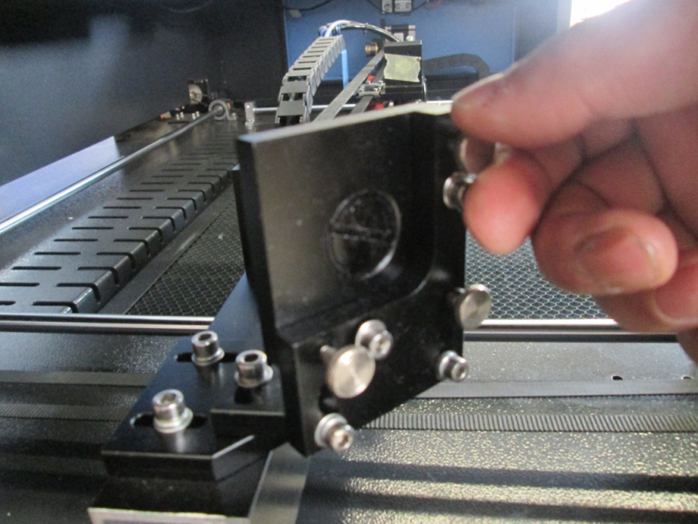

24. Step 24
Move the fresh tape so that you can see where the new laser spot will hit. Close the lid and press the laser button to see where the new spot landed. Repeat step 23 and 24 until the spots are concentric.

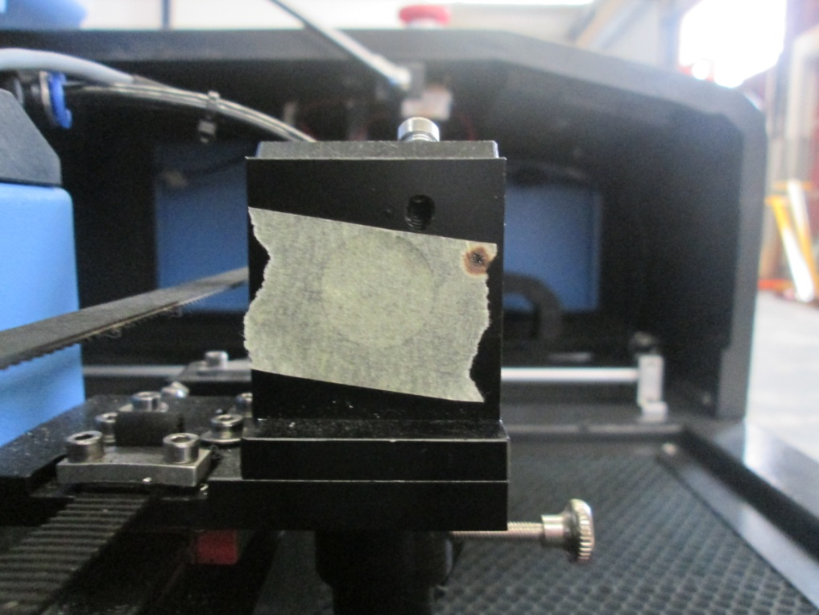

25. Step 25
Using a three layer target of masking tape, cover the hole at the top of the focal head entry. With your fingernail, locate the edges of the circular entry.

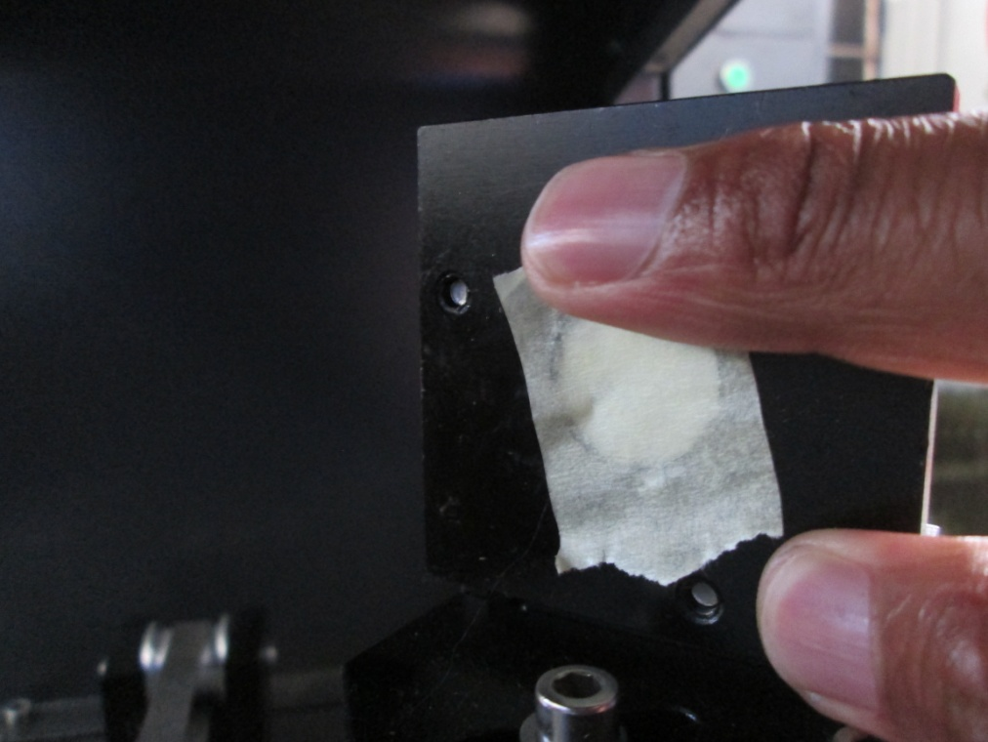

26. Step 26
Masking tape should be paste as shown in the figure.

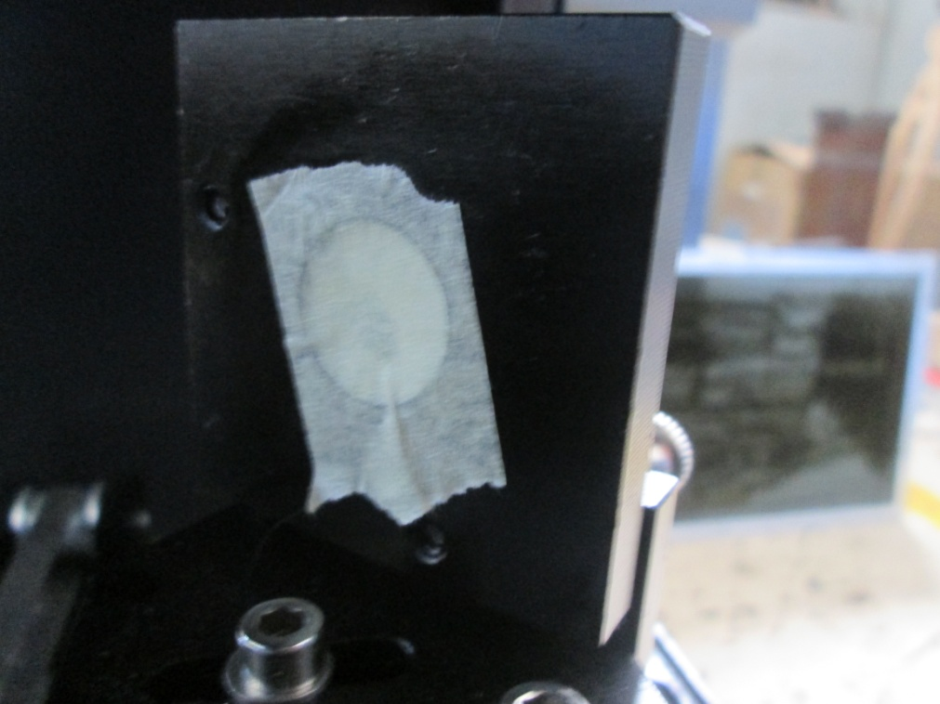

27. Step 27
Move the x-axis to the center of the table. Close the lid and press the laser button once or twice. Check to see if the spot is high and centered as shown in the figure. If it is not, repeat steps 23 and 24 until the spot is as shown in the figure below.

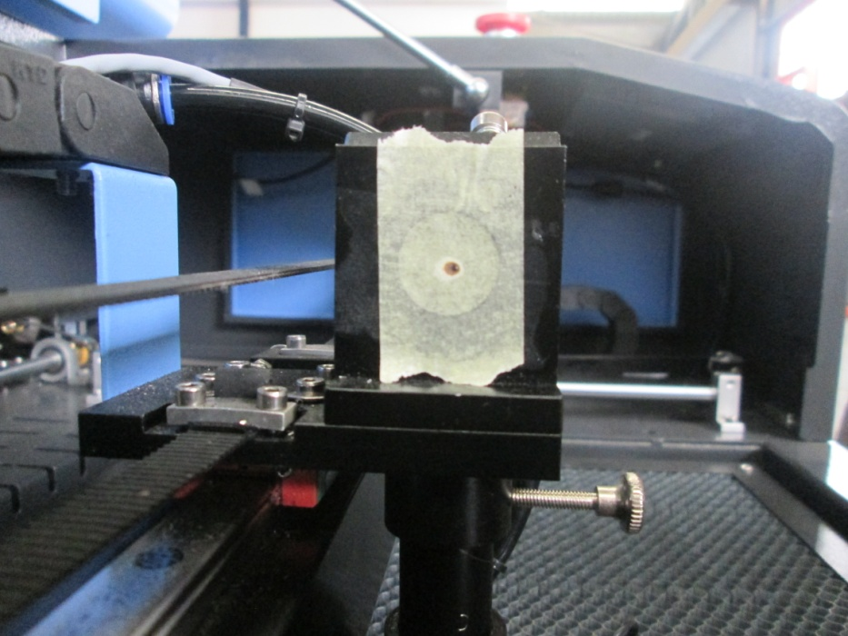

28. Step 28
Remove the focal tube from the focal head. Remove the air assist hose first. There is a knurled fitting that can be loosened by hand, loosen this and slide out the focal tube. This is also a good time to check that the focal head is mounted to the linear bearing square to the table. You can do this with a small T-square.

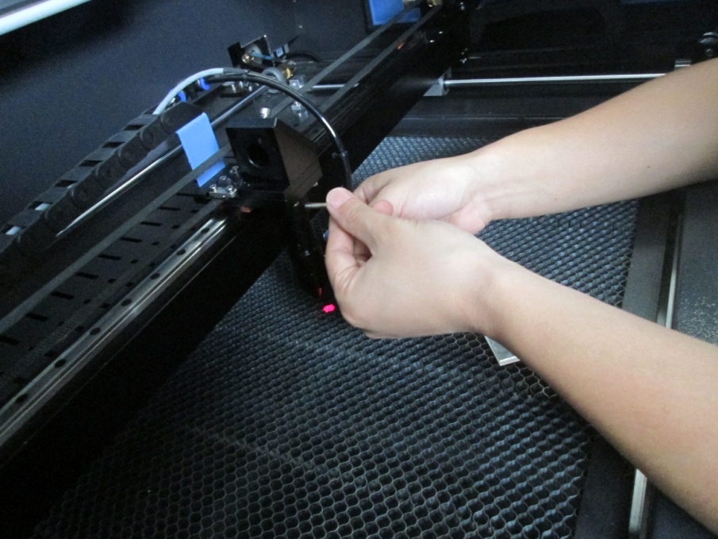

29. Step 29
Unscrew the top of the focal tube exposing the lens.

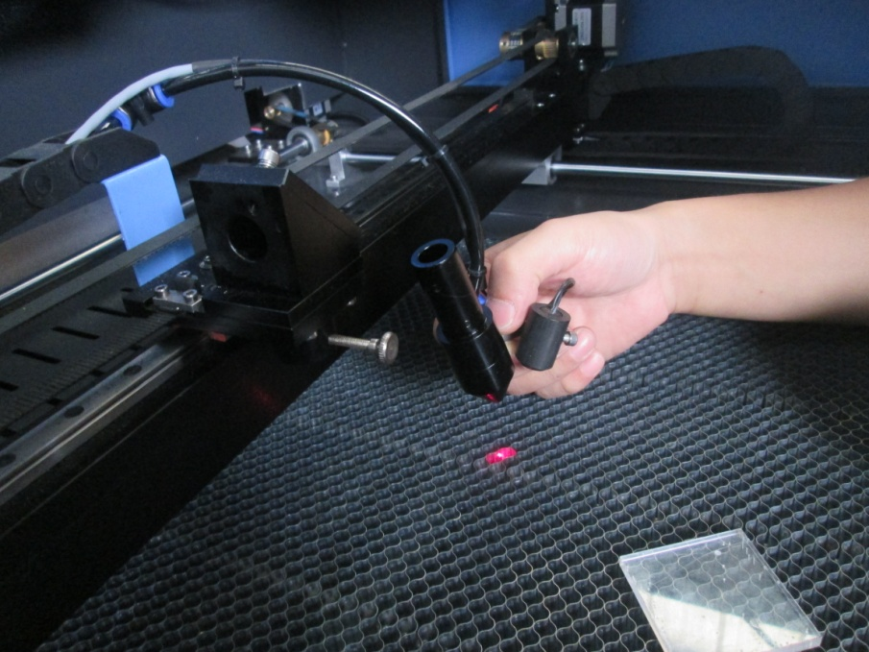

30. Step 30
Replace the Masking tape on the focal head.

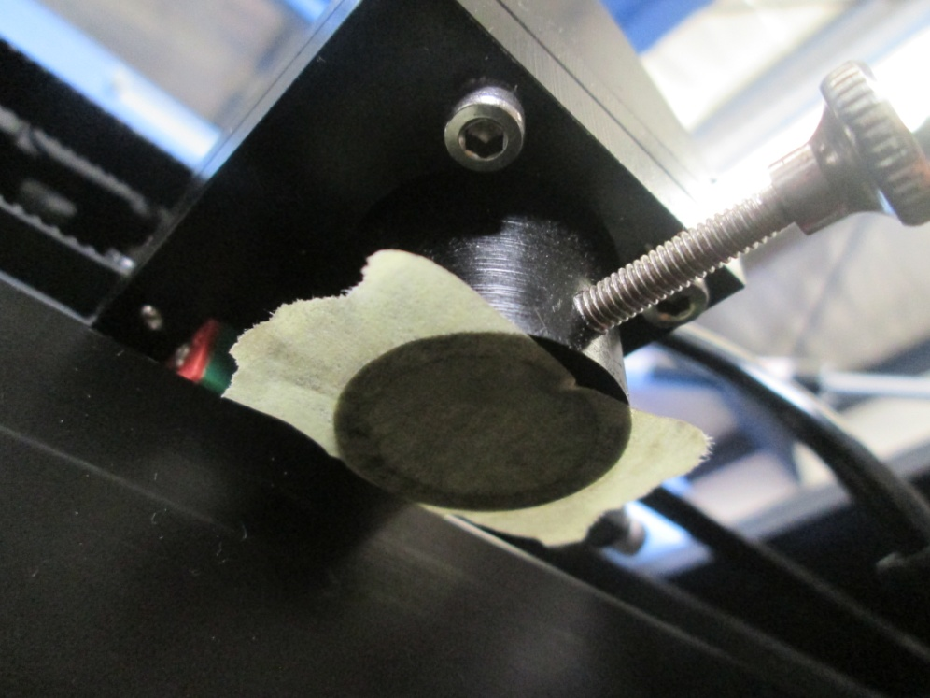

31. Step 31
Move the Z-Axis table to the top position. Place the focal tube into the focal head far enough so that with the table at maximum height a single sheet of paper is in focus. Make sure the air assist inlet is facing the correct direction and not obstructing movement. Then tighten the knurled fitting so that the focal tube is snug.Place the air assist hose back onto the hose-barb fitting.

32. Step 32
Using the focal tool, move the table so that the machine is out of focus like shown in the picture.

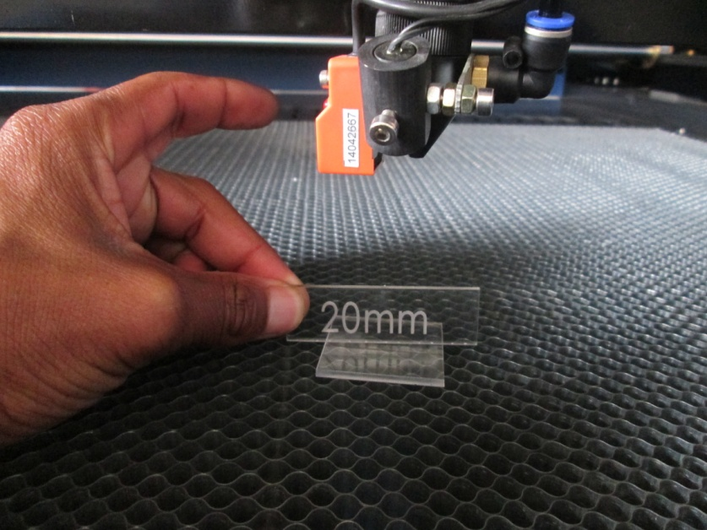

33. Step 33
Tighten the set-screws on the focal head assembly until the springs are snug.

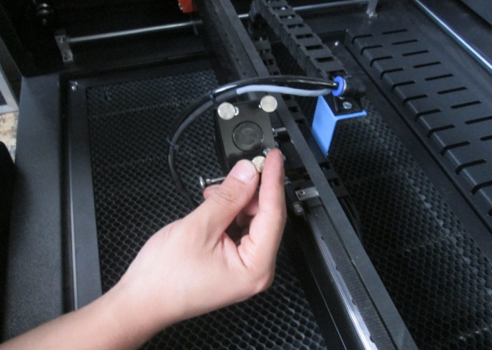

34. Step 34
Close the lid and press the laser button. The result should be a circular laser spot about 6,35 mm in diameter. Make sure the spot is dark and easily seen. If the laser spot is shaped like a cat-eye, then the laser may be striking the aluminum nozzle.

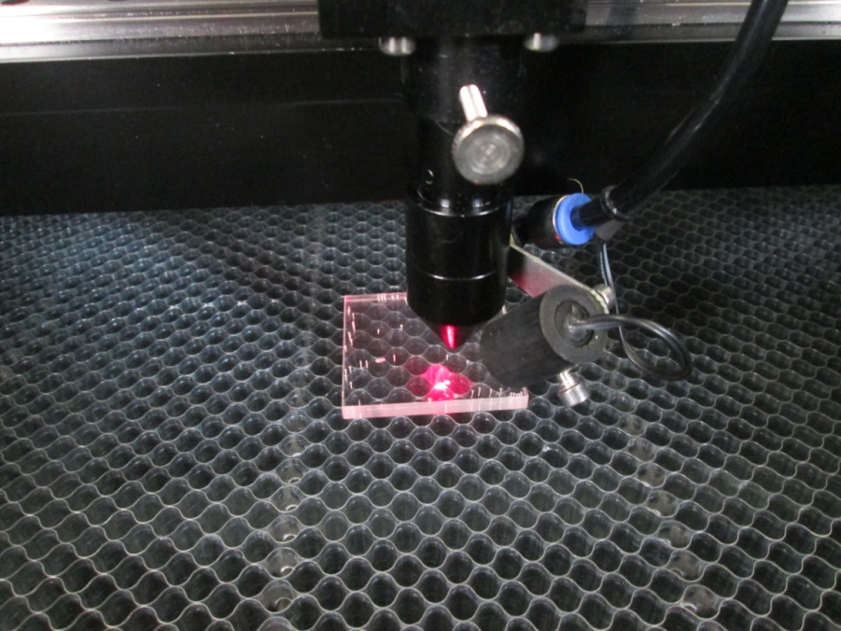

35. Step 35
Use the focus tool as a square, check the spot to insure that it is coming out of the center of the focal tube in the y-axis plane. We remember that the laser should come into the focal head assembly center and high(step 29). The spot might be slightly to the left of center nozzle. If the mirror #3 is elevated out, then the spot will shift to the right. Do not excessively tilt the mirror#3. Tilting the mirror#3 could make the laser beam strike the aluminum nozzle. AN indicator of hitting the aluminum nozzle is to see a “D” shape or shadow curve around the focal spot.

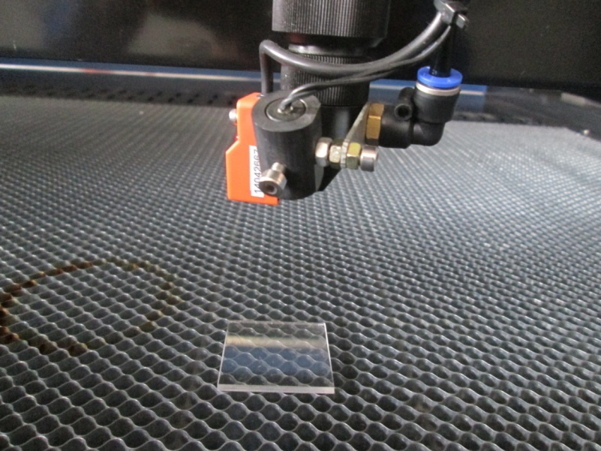

36. Step 36
Using the focus tool as a square, check the spot to insure that it is coming out of the center of the focal tube in the x-axis plane.

37. Step 37
Bring the table up so that the masking tape target is in focus. Close the lid and press the laser button once. Check if the dot is in the center of the 1/4 spot. If the dot is high(to the rear of the machine), tighten the left and back-right screws. If the dot is low(to the front of the machine), tighten the front-right and left screws.If the dot is to the right, tighten the left screw. If the dot is to the left tighten both right screws.

