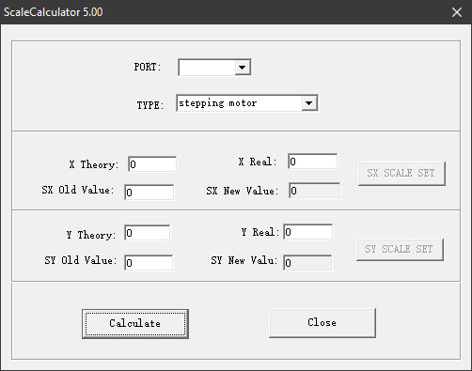

PORT: (Ignore)
TYPE: Stepping for V-Smart
Servo for V-Smart Plus

Step 1: Get Old Value on Your AM.CO.ZA V-Smart Vinyl Cutter Machine
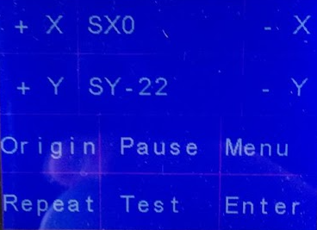
SX=0 and SY=-22 is default value in most machines.
Step 2: Draw a BIG Square by Pen Holder on Back of Your Vinyl.
Draw as big as possible square, normally use 500x500mm or 1000x1000mm depends on your machine size. Bigger drawing gives more accurate on calculate result.
The designed size is “Theory”
Drawn square on vinyl is “Real”
Then click “Calculate” and put New Value back to machine.

