Preparing & Sending files for White/Varnish printing
Underbase:
Effects>Underbase will apply a layer of SpotColor Underbase underneath the selected object. Make sure the object has the “overprint” option checked when it’s send to print, or the Underbase will be ignored.
_Solid Underbase: The Solid Underbase will be a single coat following the outlines of your Vector object exactly (with no bleed or choke applied) at 100% density.
-Variable Underbase: A Variable Underbase will vary the density to mirror the Gradient or Color of the top object (See Figure (1)
Solid Underbase Original image Variable Underbase
Figure 1

Choke/Bleed
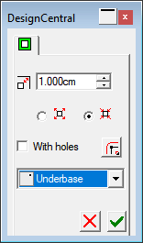
- The Choke symbol (Arrows pointing inwards) will bring the “White” layer in by the defined value.
- The Bleed symbol (Arrows outwards) will make the white layer print further outside of the image boundaries by the defined value.
- Choose the distance, choose the method, make sure the “Underbase” is selected for White and the “Finisher” is selected for Varnish and select OK.

Sending the file to “Production Manager”.
Once the file is prepared, select the “RIP & Print” option (See Figure 2)
There are a few things to check at this stage:
- The “Ignore Overprint” option Must be unchecked, or the White/Varnish will not print
- If your driver has a “ColorMode” for White/Varnish, this must be selected
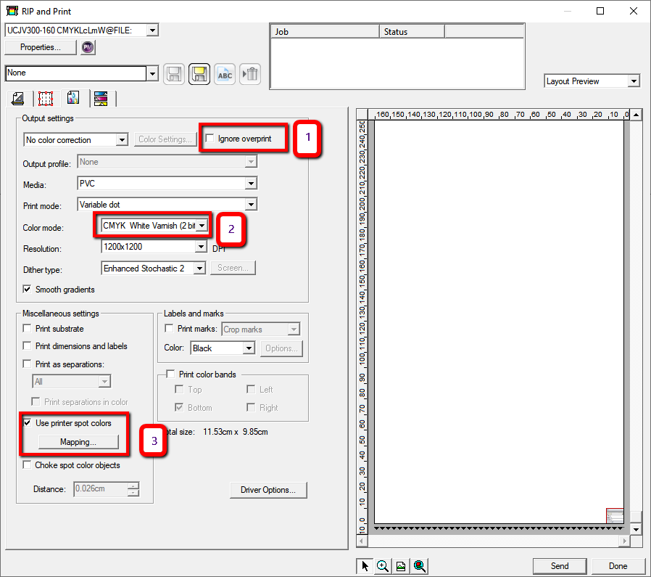
- Make sure to check the “Use Printer SpotColors”

Figure 2
Once this is complete, select the “mapping” option under the “use Printer SpotColors” section to bring up the mapping interface. Here, check that the “Underbase” is mapped to the White channel, and the “Finisher” is mapped to the “Varnish” Channel(See Figure 3). If not, just click on the Drawing Color then select the Map To color from the dropdown box.

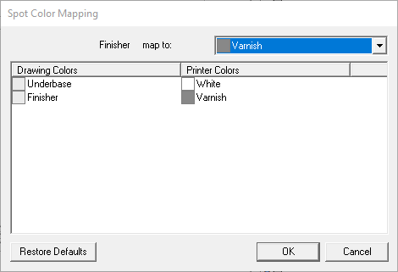

Figure 3
Assigning Driver Options
This Section will Vary for each Driver. If your driver uses Spot_1 and Spot_2 instead of White/Varnish, the mapping is complete. If your Driver has a “Colormode” for White/Varnish, open the “Driver Options” tab in the RIP & Print window.
Here, you will need to find the “Spot Settings” or “White/Varnish” Settings (see Figure4). It’s important that the “Print As” is set to “SpotColor” in order for the Underbase/Finisher layer that we created to be used. There may also be options for “Order” or “Layering” in this section. For the “White” layer, we need to select “Color After White” and for the Varnish, we need to select “Varnish Over Color”.
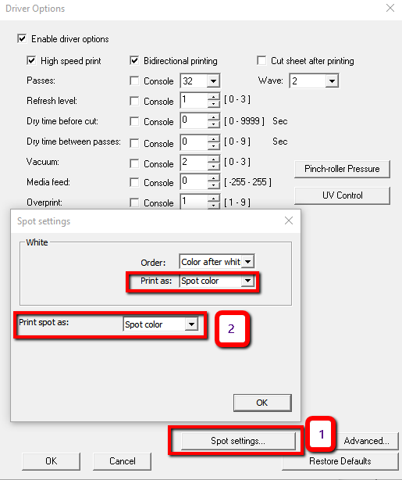

Figure 4
Other Application methods
There are also other “Print as”/”Application” Methods that will Vary between different drivers, depending on the capability of the machine. Typically, these will be used for other layering effects.
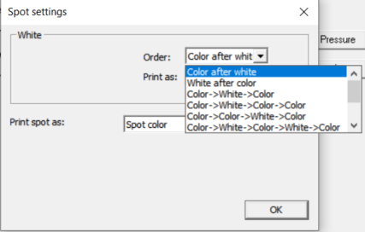

In this Example, the driver is very clear about the ordering. Color after White is going to use white as an underbase, White After Color is going to put a layer of White over the layer of Color. The other layering methods are self explanatory.
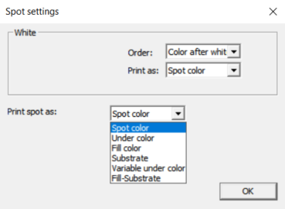

The “Method” or “Print As” can Vary but will usually contain the options as above.
-Spot Color – this will use the assigned SpotColor for the channel to map the area for White
-Under Color – This will put a dot of White under each Dot of Color
-Fill Color – Like Variable color but also fills the Printable area
-Substrate – This will cover our entire print area for the job in a layer of white beforehand.
-Variable Under Color – This will use Less White under darker colors and more White under light colors
-Fill-Substrate – Fill Minus substrate. It works almost as an opposite to Variable under Color – will not put white in the “holes”
Preparing Documents externally for White/Varnish
When preparing White/Varnish layers in external applications, any SpotColor can be mapped to White or Varnish The file will need to be in EPS, PDF or Ai format – a postscript format that will maintain the SpotColor layer. However for White to be mapped automatically, it needs to be named “Spot_White”. For Varnish to be mapped correctly, it needs to be named “Spot_Varnish. The Color doesn’t matter as long as it’s a SpotColor. Any other name will have to be mapped in the Separations tab. Once the job is prepared:

- Add the job to production manager
- Double-click on the job to open “job properties” and check that a Color mode with White/Varnish is selected
- Go to the “Separations” tab and check that the colors are mapped correctly.
- If not, double-click on the name of the SpotColor and select the channel to map it to.
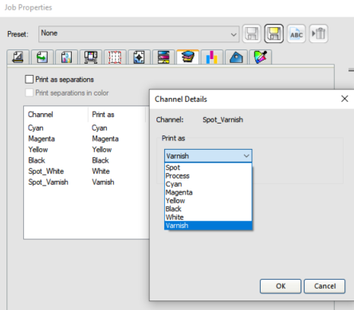

In the Above screenshot, I named my SpotColors as Spot_White, and Spot_Varnish so the “Channel” is automatically mapped to the correct output channel. If they are not, you just need to double-click the SpotColor in the “Channel” section and change the “Print as” in the dropdown to the correct output channel. If you don’t see White or Varnish in the “print as” section, you need to go back to the “Color management” tab and select the Colormode that supports White and Varnish.

