Large Format Printer setup in Maintop Software.
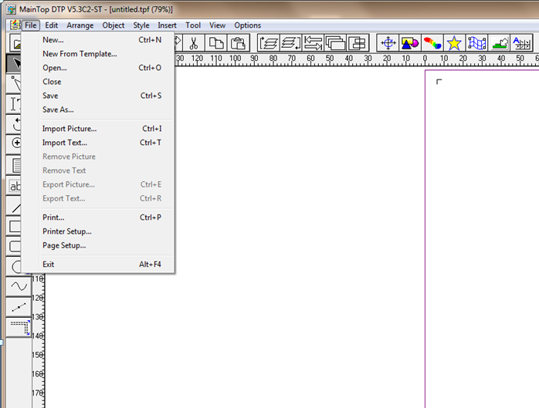
1.Open your Maintop Software and access Printer Setup via File Menu

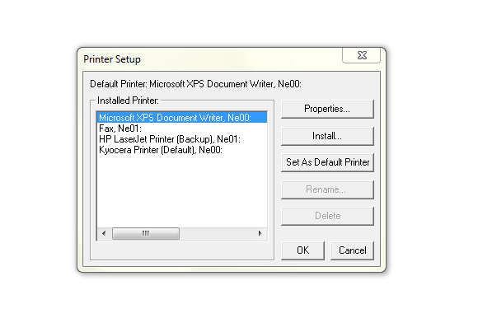
2. On the pop-up window click on Install

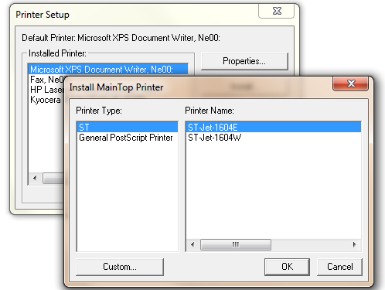
3. Click on Custom

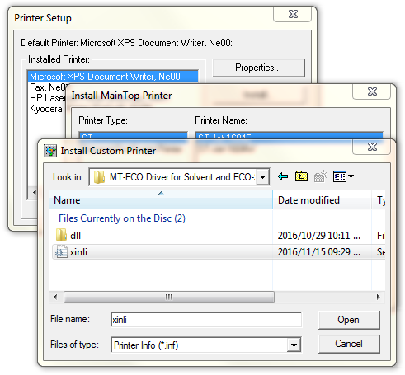
4. From the Utility disc locate the Driver(.inf) and click Open. Link given below

\FastCOLOUR Printer\Maintop Driver for FastCOLOUR DX5,DX7 Single Head\MT-ECO Driver for Solvent and ECO-Solvent Ink
If you are no longer in possession of the utility disc you can access it from am.co.za/utility/disc

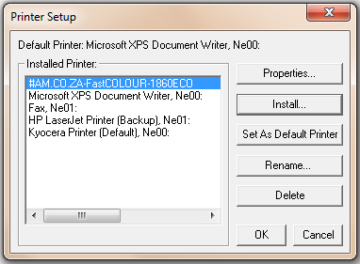
5. Printer will then appear under “Installed Printers” Click OK to finish

Printing from Maintop Software
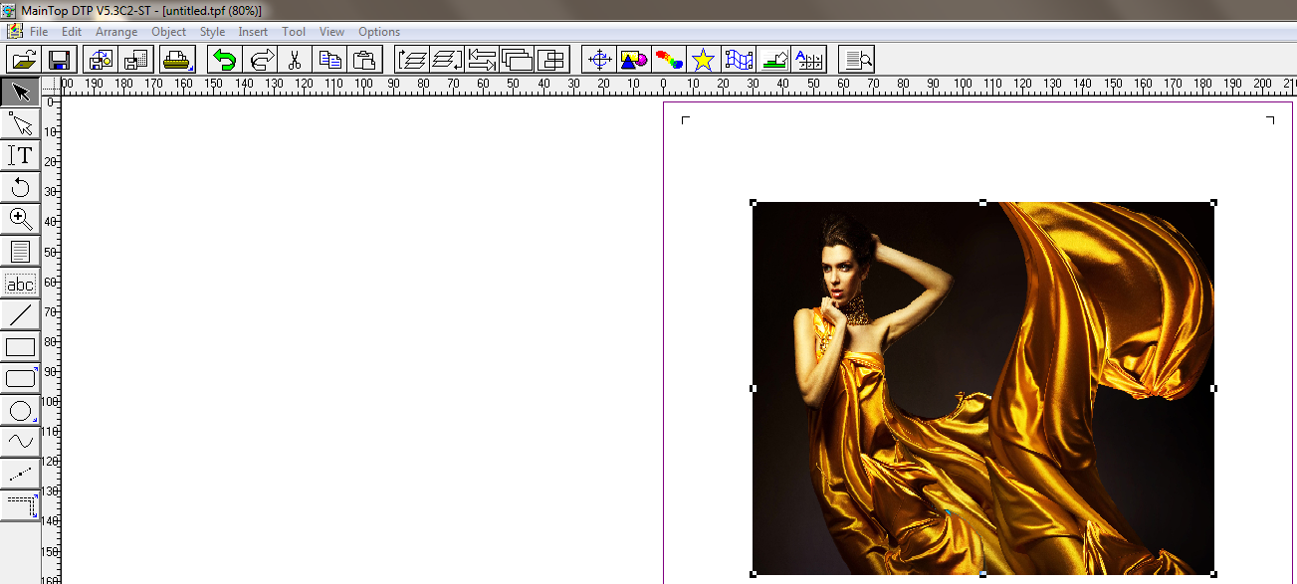
1.From your toolbar click on the Print Icon

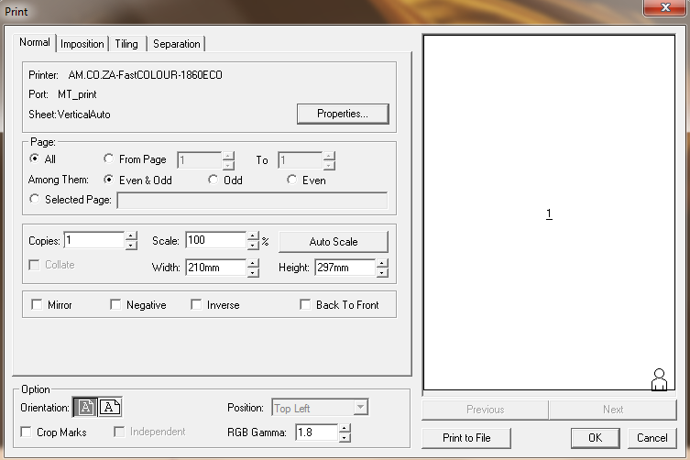
2.Click on Properties
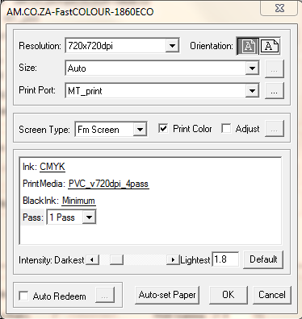
1.Change resolution to 720*2160dpi
2.Under Print Media select the required number of Passes. Please note the selection has to correspond to the number of passes on the Pass option.
3.Click OK to save the desired settings

4.Click OK to print

