Versatile print head cleaner

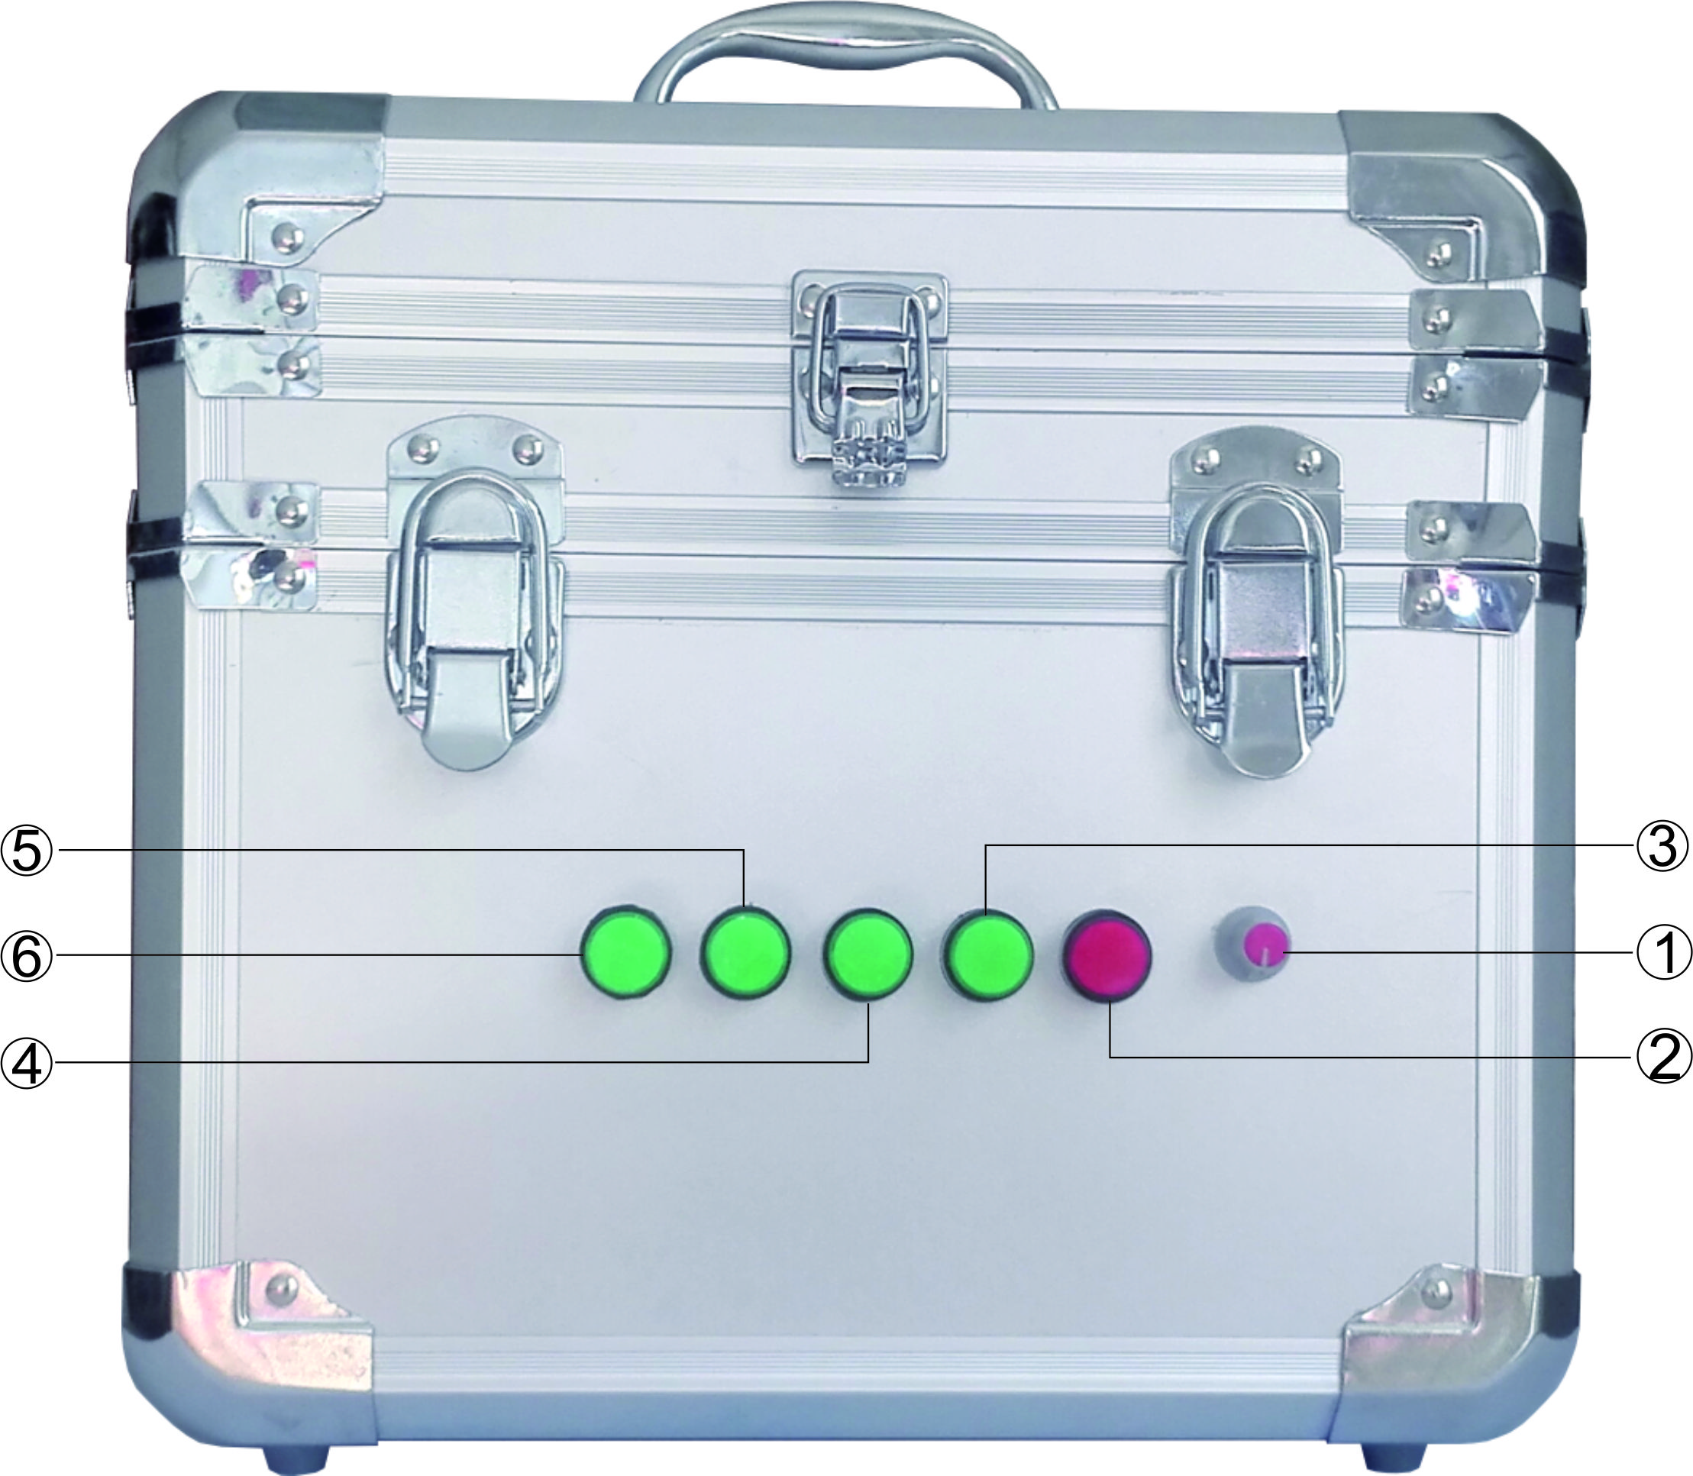
1: 清洗液流量控制旋钮。 1：Cleaning Fluid Flow Control Knob
2：超声波控制开关。 2：Ultrasonic Control Switch
3：冲洗控制开关。 3：Flush Control Switch
4：冲洗备用开关。 4：Flush Spare Switch
5：反抽控制开关。 5：Anti - Pumping Control Switch
6：反抽备用开关。 6：Anti - Pumping Spare Control Switch

Note:Please clean the remaining ink in the print head and it’s surface first prevent the filter from premature plugging . 注意：喷头取下来后先把余墨和外表清洗一下，以免过滤器过早堵塞。
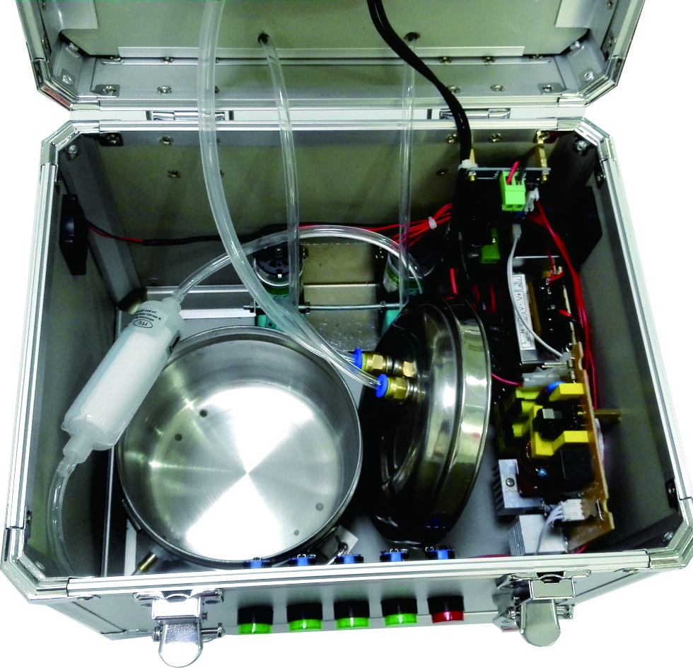 | 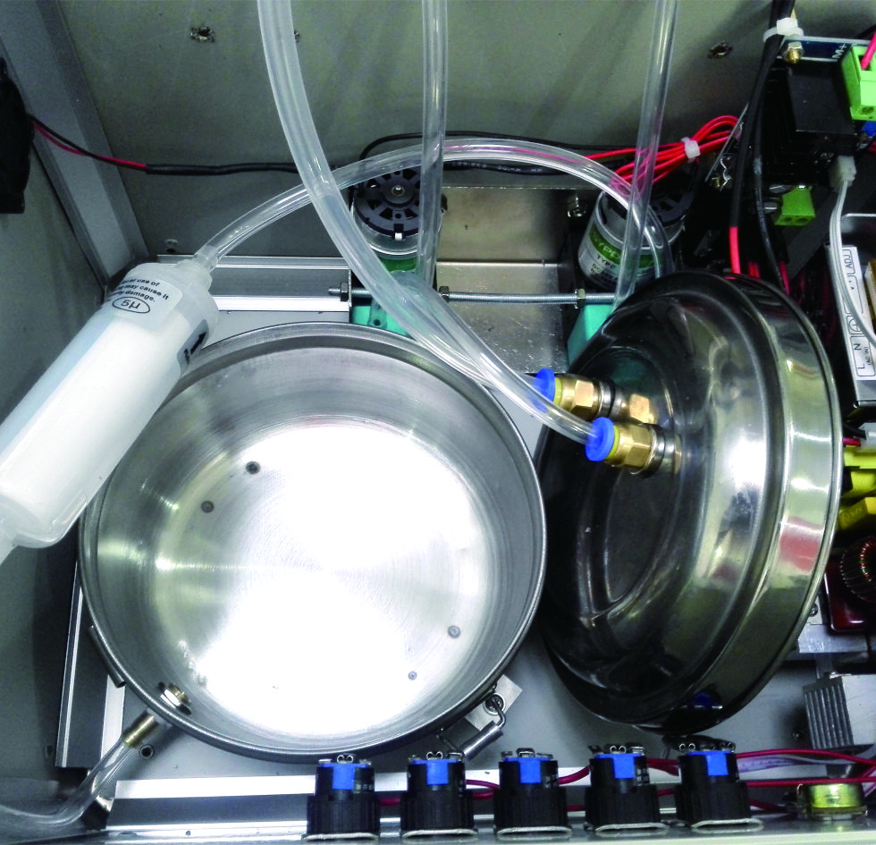
Step1 打开机器底盖，及清洗液存贮罐盖子。  Open the bottom lid of the machine and the lid of cleaning fluid tank | Step2 往清洗液存贮罐中倒入清洗液，最少量要没过罐子的出水口。  Pour cleaning fluid into the cleaning fluid tank.. The minimum should be over the water outlet port of the tank
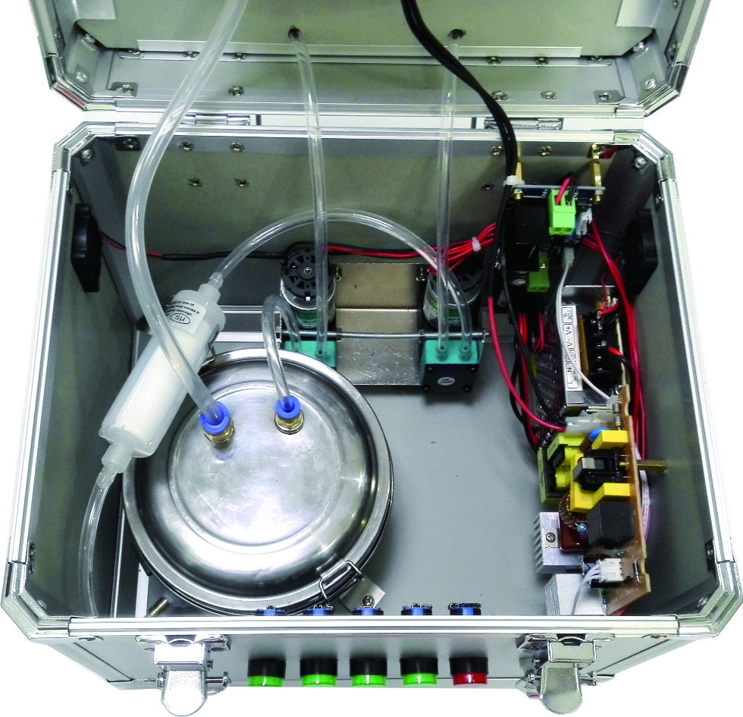 | 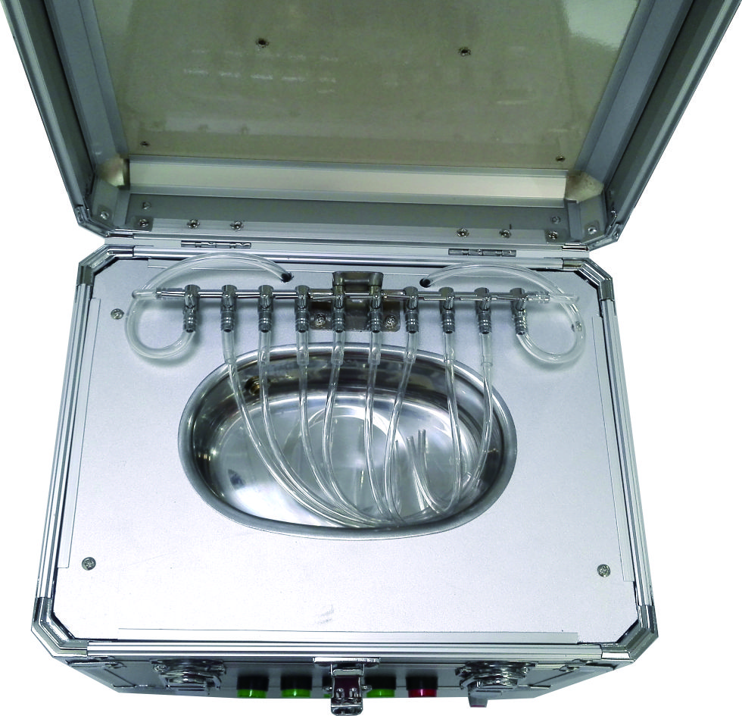
Step3 盖上清洗液存贮罐的盖子，然后盖上清洗机下盖。  Cover the cleaning fluid tank lid .and then the bottom lid of the machine | Step4 打开机器上盖  Open the top lid and put on nozzle holder
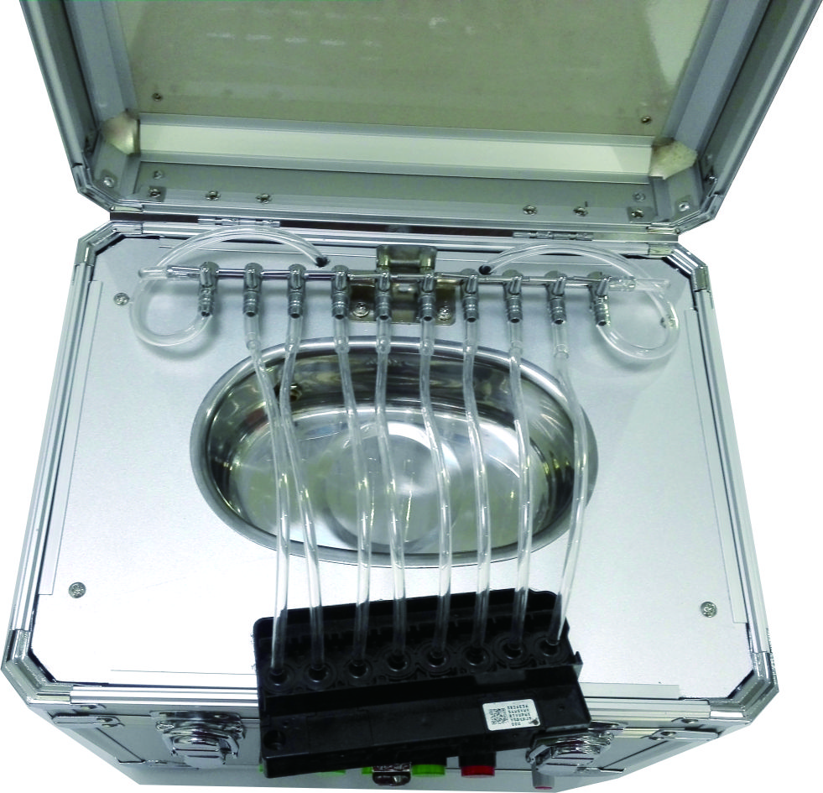 | 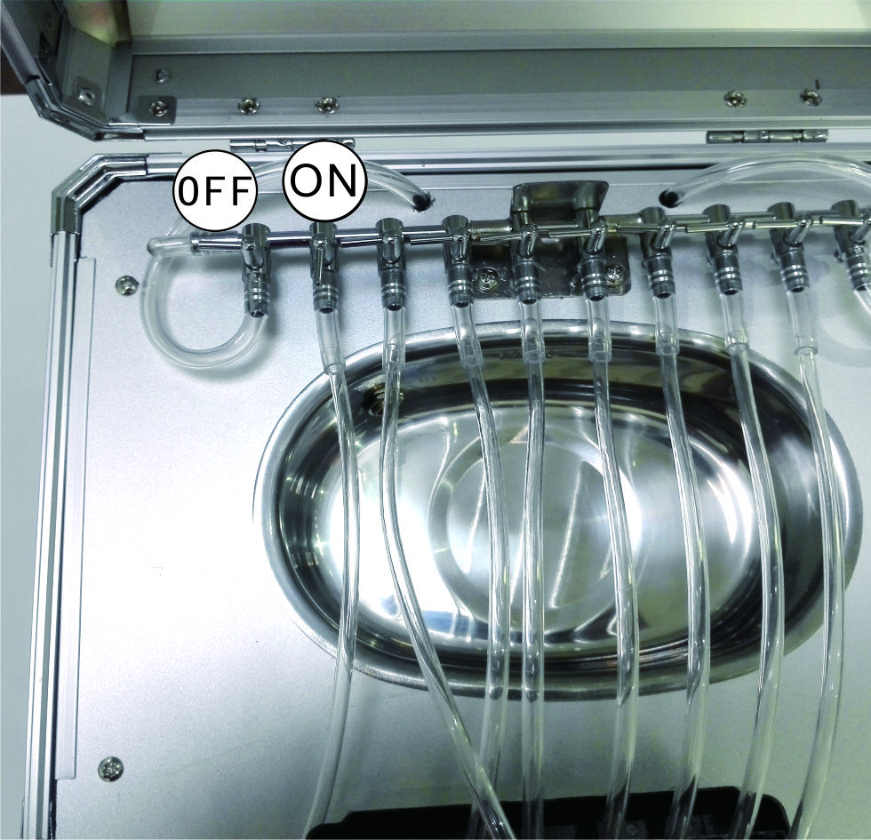
Step5 把喷头的进墨口接上清洗机的冲洗管。  To connect the inlet of print head to the flushing pipe | Step6 根据自己的需要打开开关。  Open the switch according to your own needs
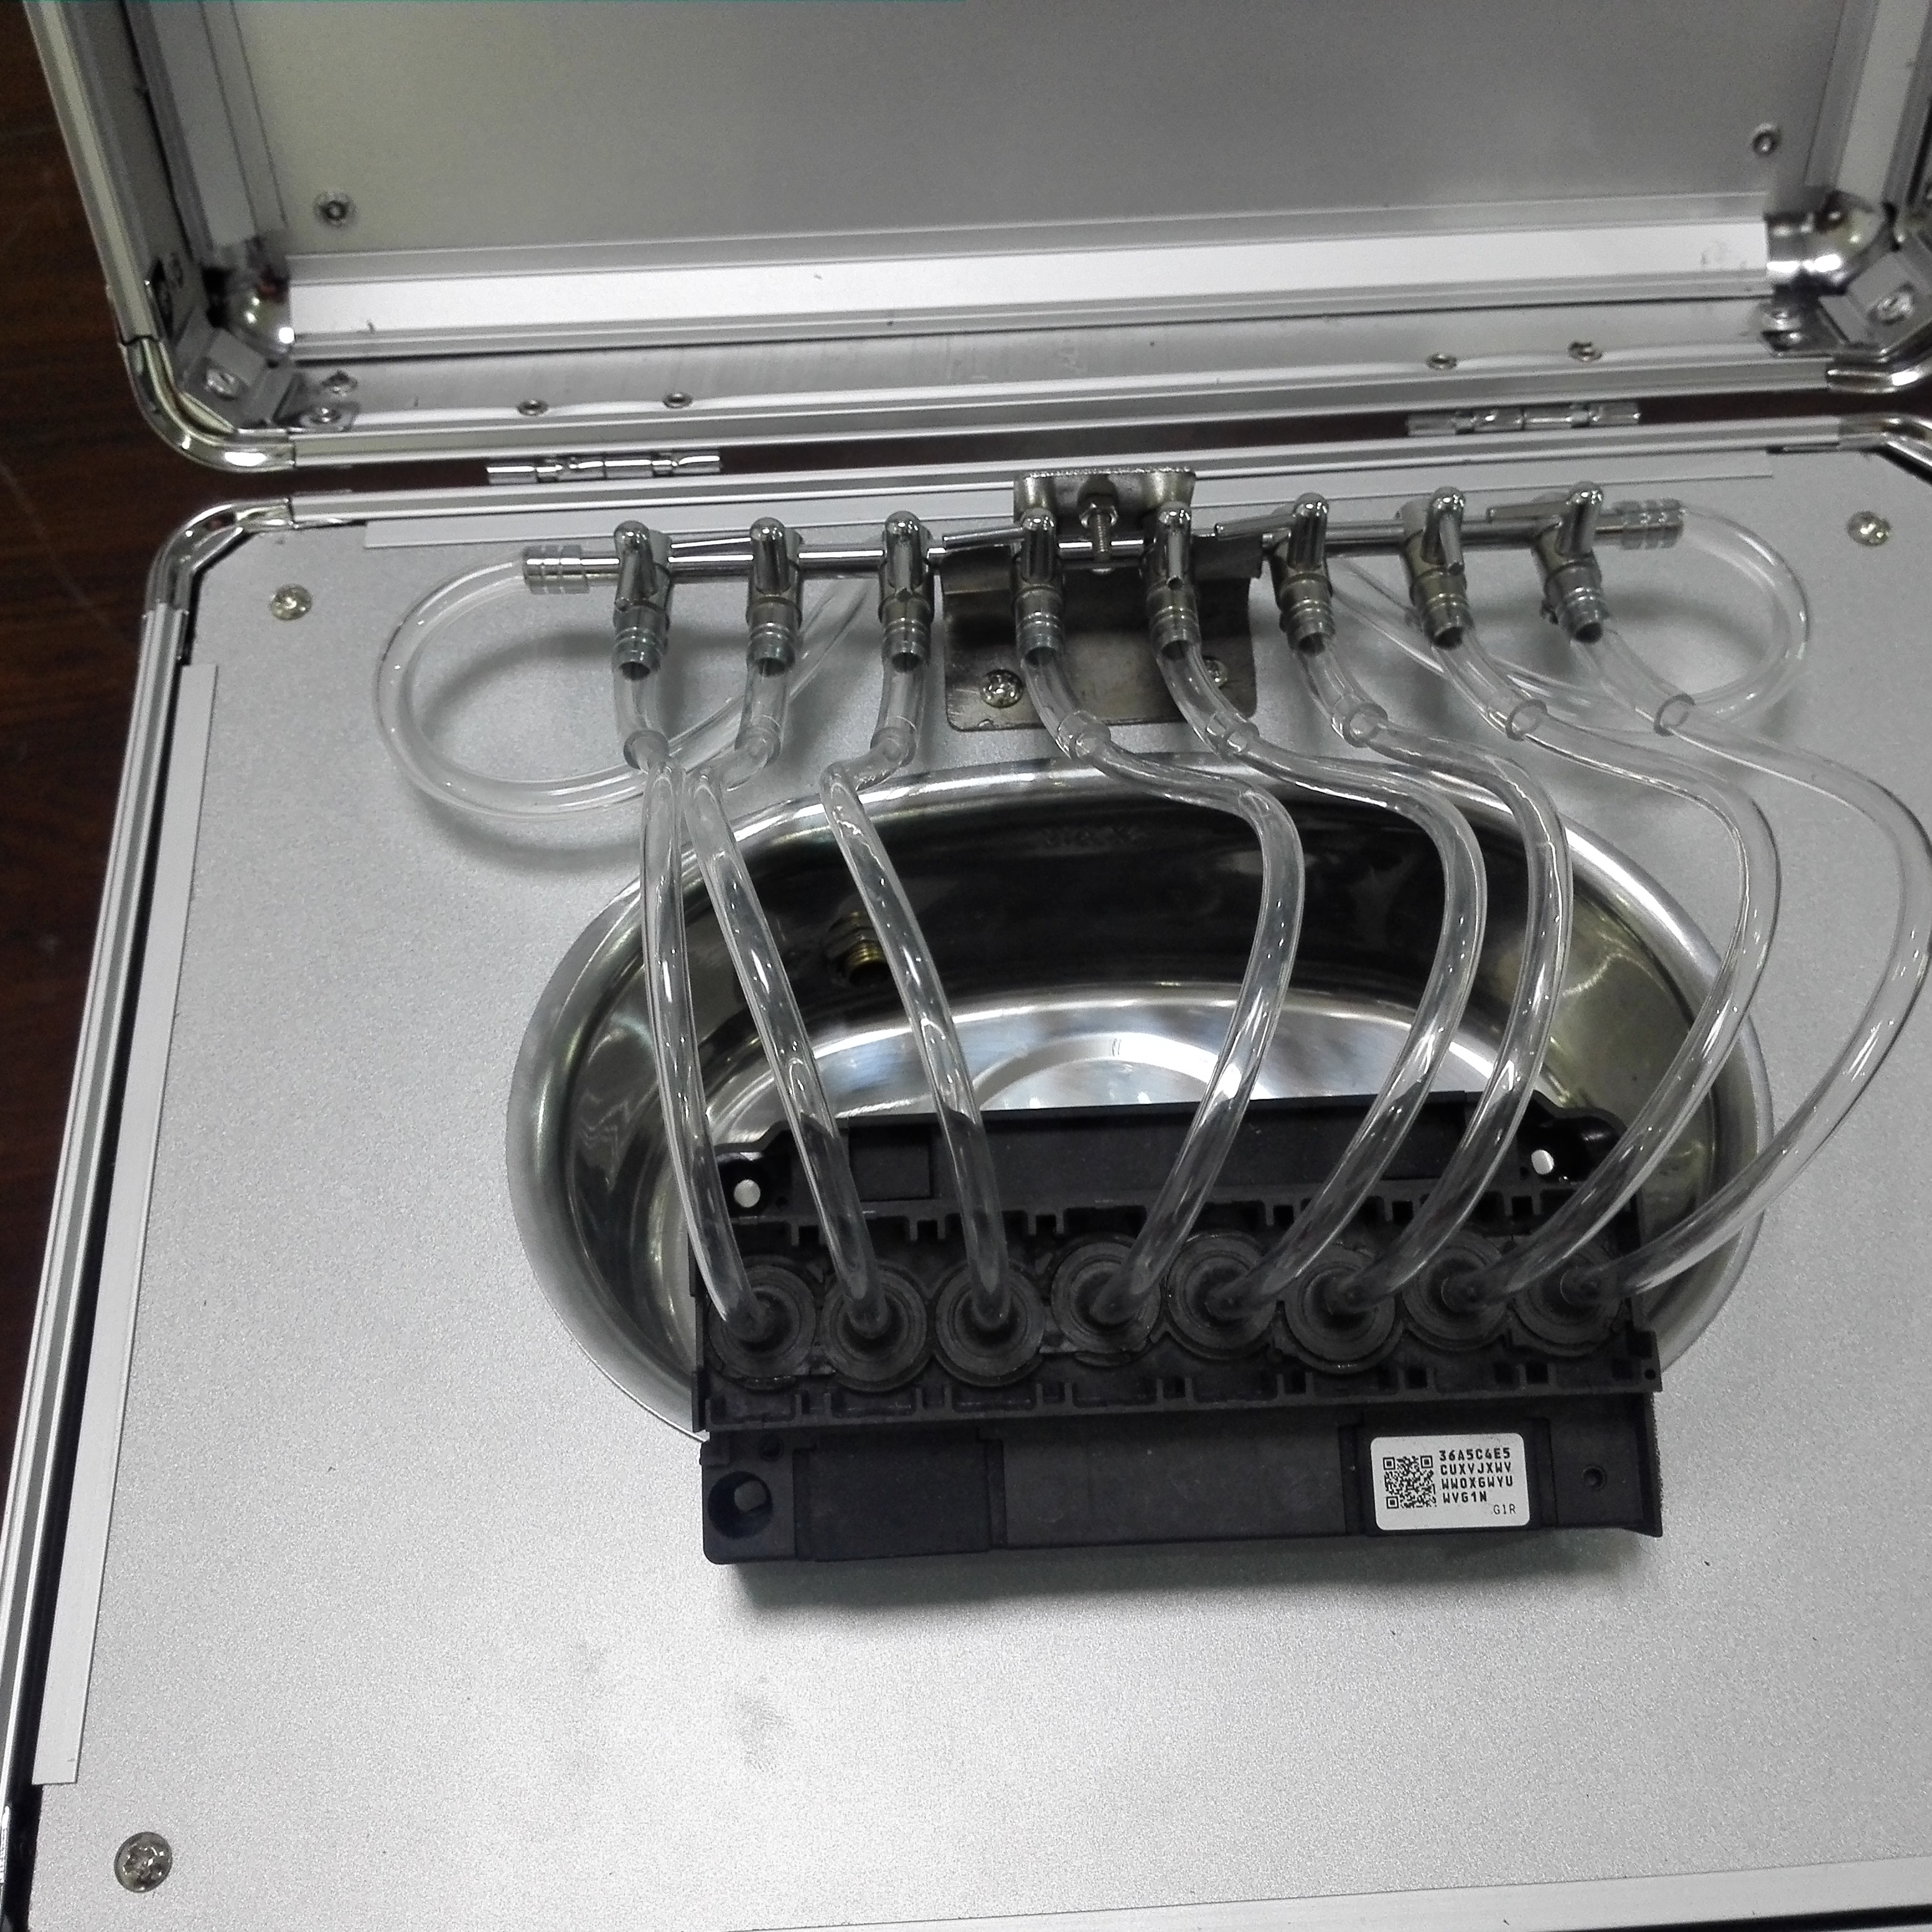 | 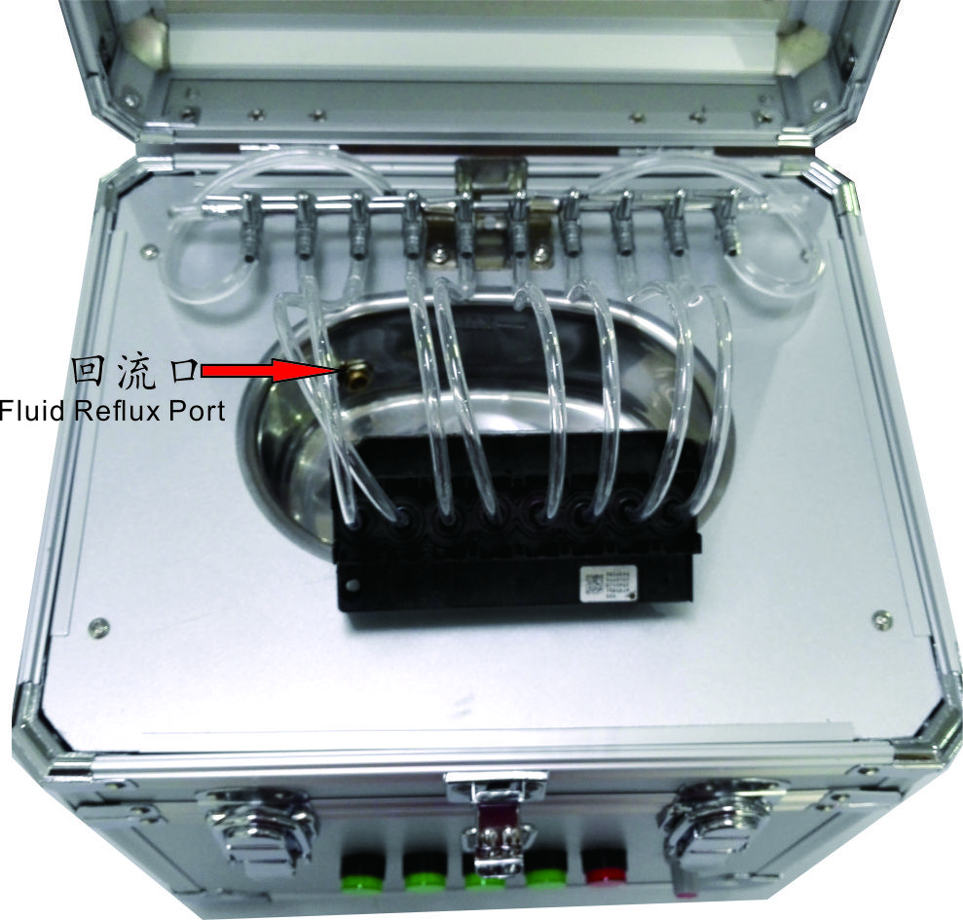
Step7 根据自己的需要插好管路。打开开关。  Plug the pipeline according to their own needs | Step8 往清洗槽中倒入清洗液，一直到液面接近回流口。  Pour cleaning fluid into the cleaning tank ,to close to the water outlet port
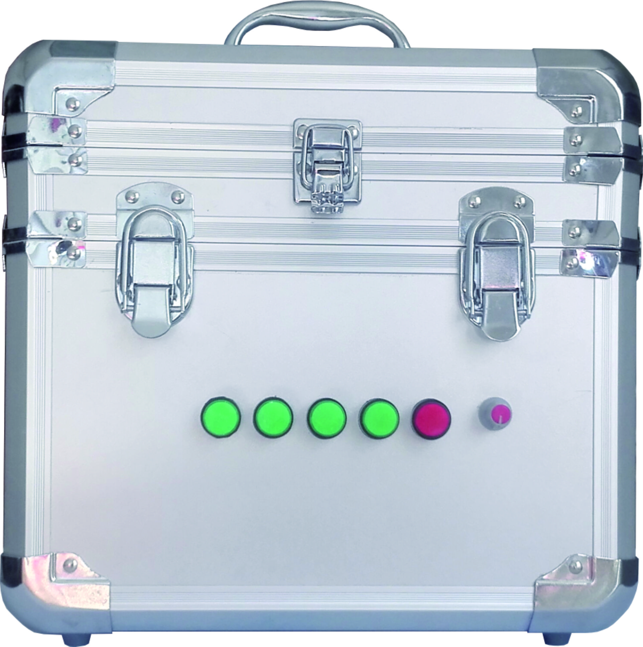 | 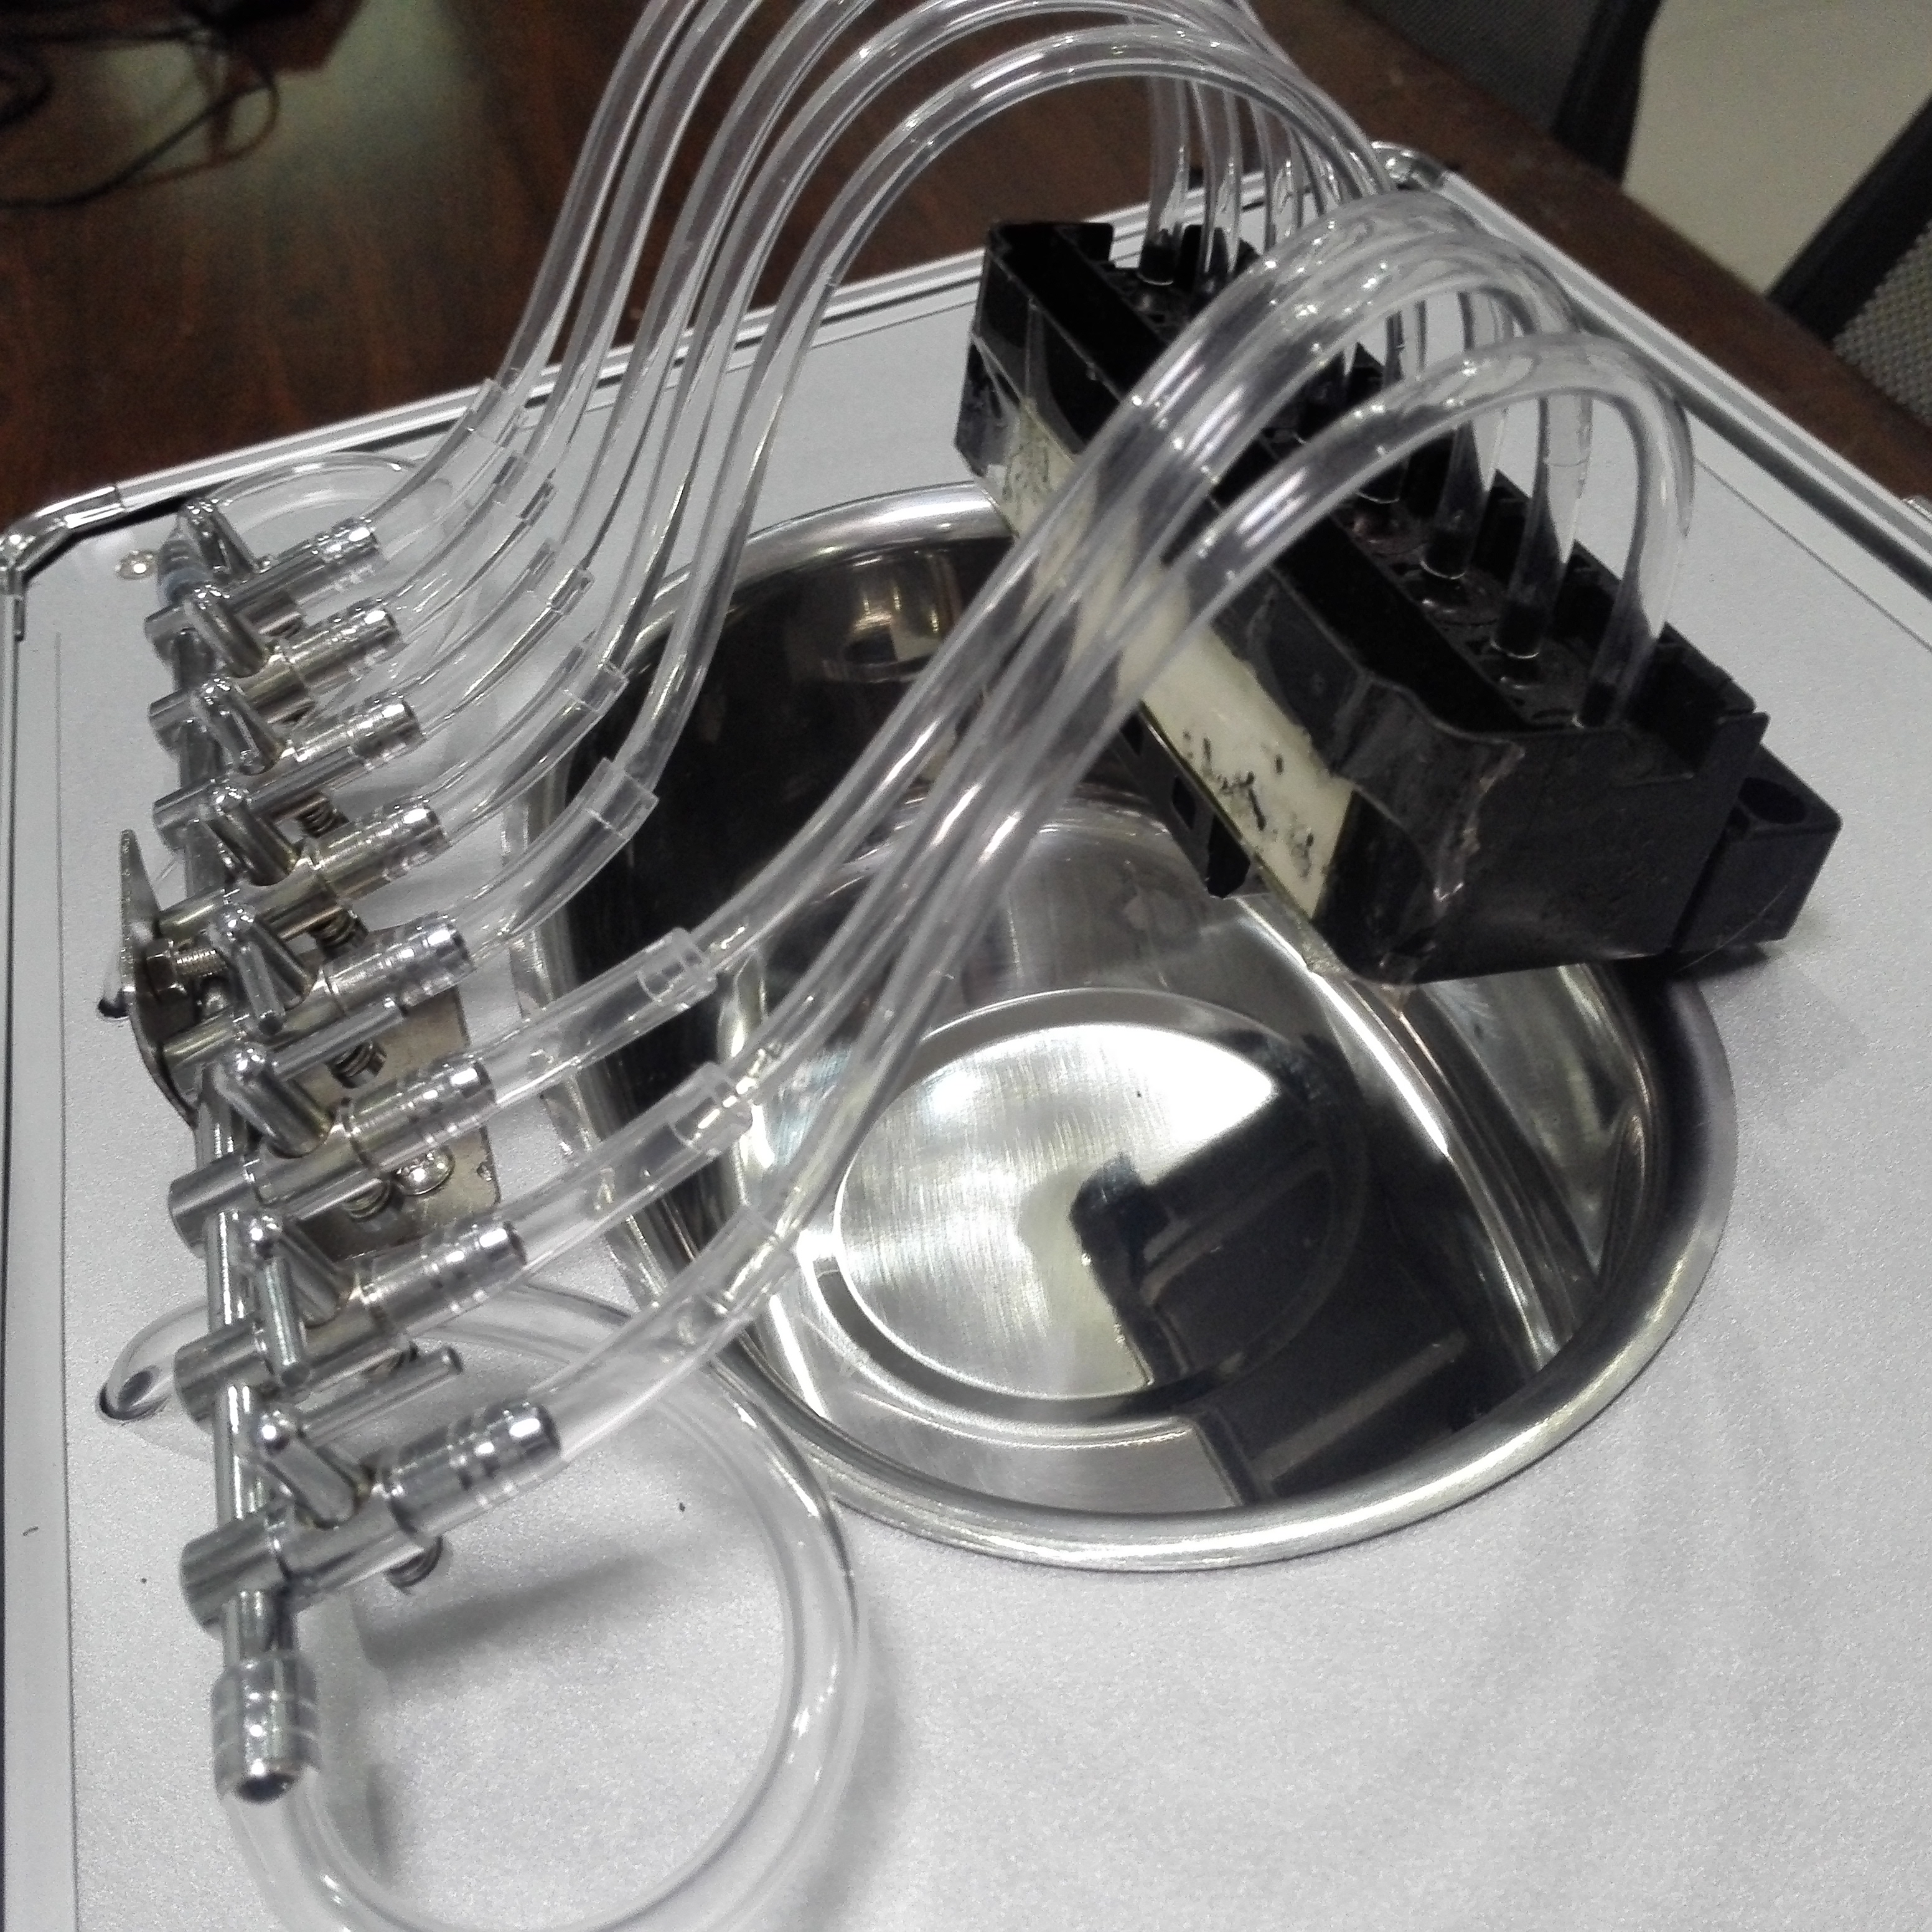
Step9 把流量控制旋钮开到最小位置。开启冲洗按钮。  Turn the flow control knob to the minimum position. Then open the flush button | Step10根据清洗喷头的情况慢慢地旋转流量控制旋钮，以免冲坏喷头。反抽操作要把喷头喷嘴浸入液面2mm。  According to the situation of cleaning the nozzle slowly rotate the flow control knob, so as not to rush the nozzle. Anti-pumping operation need put nozzle into the liquid surface 2mm.
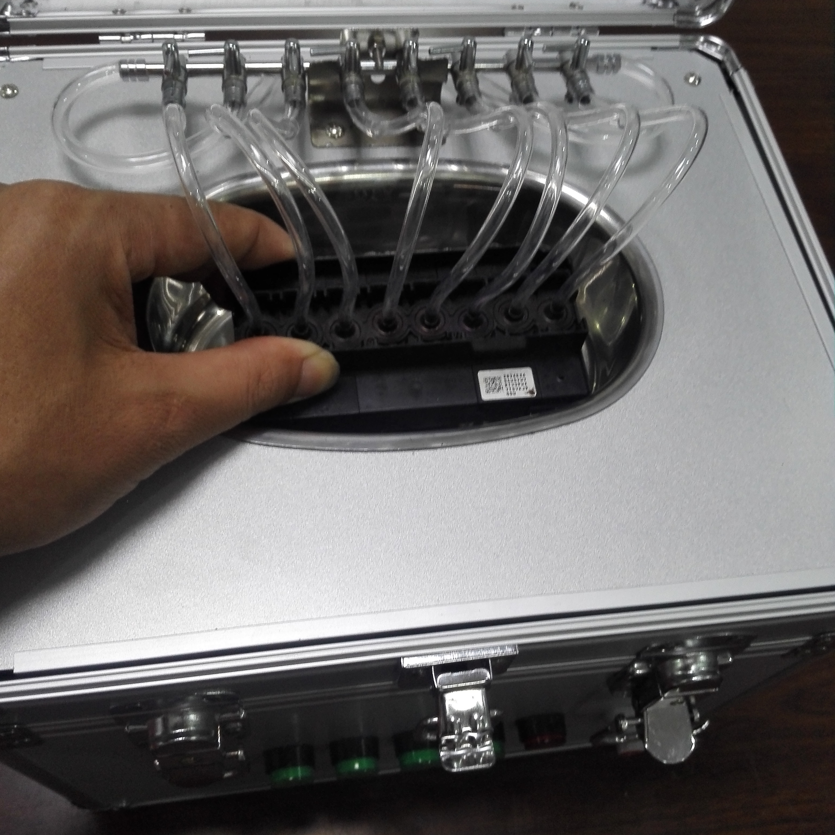 | 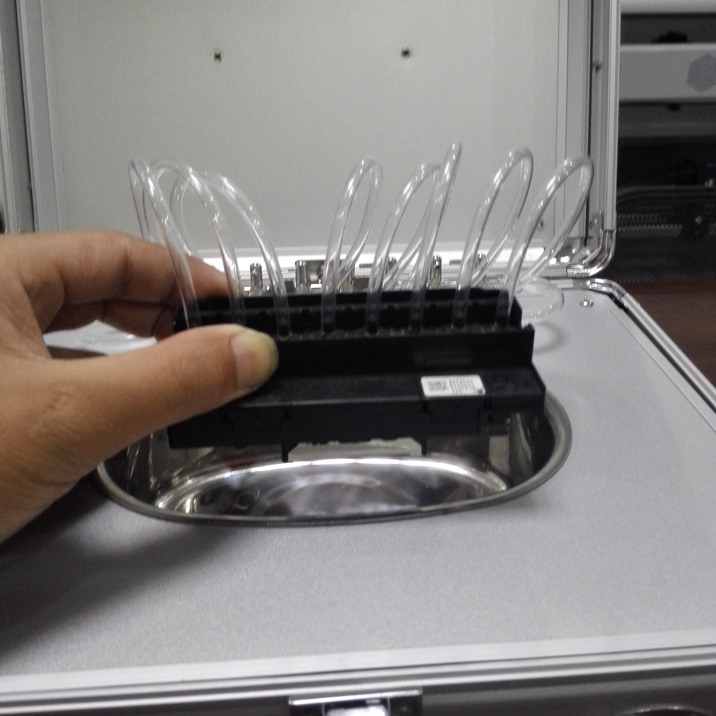
Step11 把喷头喷嘴浸入液面2mm,开启超声波清洗，开启时间约30秒后关闭，休息3分钟再开启30秒。超声波循环开启不要超过5次。  The head nozzle should be immersed in the liquid surface 2mm. Open the ultrasonic cleaning after about 30 seconds , rest 3 minutes and then open 30 seconds. Do not cycle more than 5 times. | Step12 反复清洗几次，再按干净的清洗液清洗。直到冲洗时，从喷孔里射出的清洗液整齐，干净后，把喷头清理干净，重新安装上打印机即可。  Repeated cleaning for several times.and Cleaning the print head again after changing the cleaning fluid . Until the cleaning fluid which jet from the nozzle is neat and clean. Then re-install it on the printer after cleaning up the print head

